|  |
| --- |
| Vicmap™ Product Development |
| Change Notice # 273 Advisory Notice |

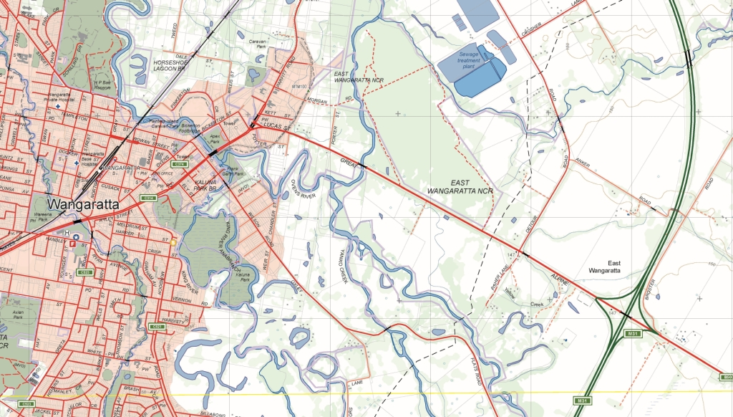

Vicmap Features of Interest – Renewable Features - New and modified features

## What is happening

Improvements to feature ‘power facility’ feature subtypes are being made within Vicmap Features of Interest, refer to Table 1 below:

|  |  |  |  |
| --- | --- | --- | --- |
| **feature** | **feature subtype** | **Change type** | **What is happening** |
| power facility | wind farm | Modify – spatial representation | The current multi point record will be modified to a single point. The single point will be located at the main depot of the wind farm operation |
| power facility | solar array | Add | Polygon representing the extent of the feature |
| power facility | battery bank | Add | Polygon representing the extent of the feature |

**Table 1: Changes to the spatial representation of feature subtypes in Vicmap Features of Interest.**

## Why this change is occurring

The improvements to feature ‘power facility’ feature subtypes will improve the visualisation of the data and support new and current renewable facilities.

## Who will it affect

Vicmap Features of Interest, VMREFTAB.FEATURE_CATALOGUE and Geomark.

## When the change will occur

Changes will be reflected in the data from the **10/8/2021.**

For Vicmap Product change notices and updates, visit [Vicmap change notices (land.vic.gov.au)](https://www.land.vic.gov.au/maps-and-spatial/spatial-data/updates-to-vicmap/vicmap-change-notices). For further information & feedback please email [vicmap.help@delwp.vic.gov.au](mailto:vicmap.help@delwp.vic.gov.au)

|  |  |
| --- | --- |
| © The State of Victoria Department of Environment, Land, Water and Planning 2021  LogoThis work is licensed under a Creative Commons Attribution 4.0 International licence. You are free to re-use the work under that licence, on the condition that you credit the State of Victoria as author. The licence does not apply to any images, photographs or branding, including the Victorian Coat of Arms, the Victorian Government logo and the Department of Environment, Land, Water and Planning (DELWP) logo. To view a copy of this licence, visit http://creativecommons.org/licenses/by/4.0/  Disclaimer  This publication may be of assistance to you but the State of Victoria and its employees do not guarantee that the publication is without flaw of any kind or is wholly appropriate for your particular purposes and therefore disclaims all liability for any error, loss or other consequence which may arise from you relying on any information in this publication.  **DELWP spatial disclaimer**  The State of Victoria:   1. does not give any representation or warranty as to the accuracy or completeness of DELWP spatial data, Vicmap data (including metadata) or Vicmap product specifications or the fitness of such data or products for any particular purpose; 2. disclaims all responsibility and liability whatsoever for any errors, faults, defects or omissions in such data or products.   Any person using or relying upon such data or products must make an independent assessment of them and their fitness for particular purposes and requirements. | Accessibility  If you would like to receive this publication in an alternative format, please telephone the DELWP Customer Service Centre on 136186, email [customer.service@delwp.vic.gov.au](mailto:customer.service@delwp.vic.gov.au), or via the National Relay Service on 133 677 [www.relayservice.com.au](http://www.relayservice.com.au). This document is also available on the internet at [www.delwp.vic.gov.au](http://www.delwp.vic.gov.au). |