Customer Information Bulletin 223
October 2023

New Administrative notices
Following the Land Use Victoria (LUV) Consultation in December 2021 and as the next phase in the transition to full digital functionality, new functionality has been developed which will enable the Registrar of Titles to hold control of electronic certificates of title (eCT). This option will be available to Subscribers currently holding eCT Control or paper certificates of title and in some cases at the end of a conveyancing transaction.
The new functionality will be available from 30 October 2023.
There will be no cost to Subscribers to use the new functionality.
To support the new functionality, two administrative notices will be available to Subscribers using the Electronic Lodgment Networks (ELN) known as PEXA and Sympli:
- Request to take control of electronic certificate(s) of title from the Registrar.
- Request to transfer control of electronic certificate(s) of title to the Registrar.
In addition, Subscribers will be able to select ‘Registrar of Titles’ under ‘CT Issued to’ in Lodgment Instructions where available in an ELN conveyancing transaction.
The eCT Control notation in the Register Search Statement will look substantially the same as any other eCT Control notation but without the Customer Code:

The Registrar will not take an active role in the management of the eCTs in the Registrar’s control or any conveyancing transaction affecting them.
eCTs in the control of the Registrar cannot be nominated to a transaction. The Subscriber entitled to control an eCT must first apply to take control of the eCT using the administrative notice ‘Request to take control of electronic certificate(s) of title from the Registrar’. That Subscriber can then nominate the eCT as appropriate.
The new administrative notice ‘Request to transfer control of electronic certificate(s) of title to the Registrar’ can be used in various circumstances, for example, when a Subscriber does not wish to be eCT Control or is closing its business.

The new administrative notices will look similar to other administrative notices:

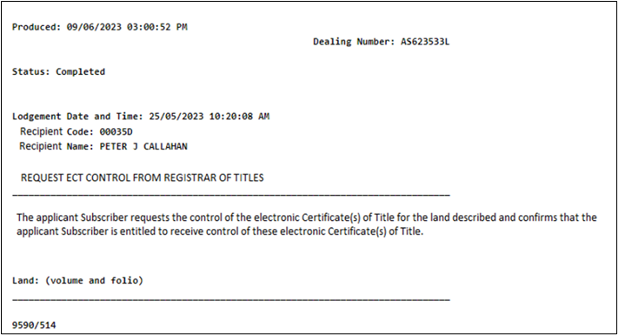
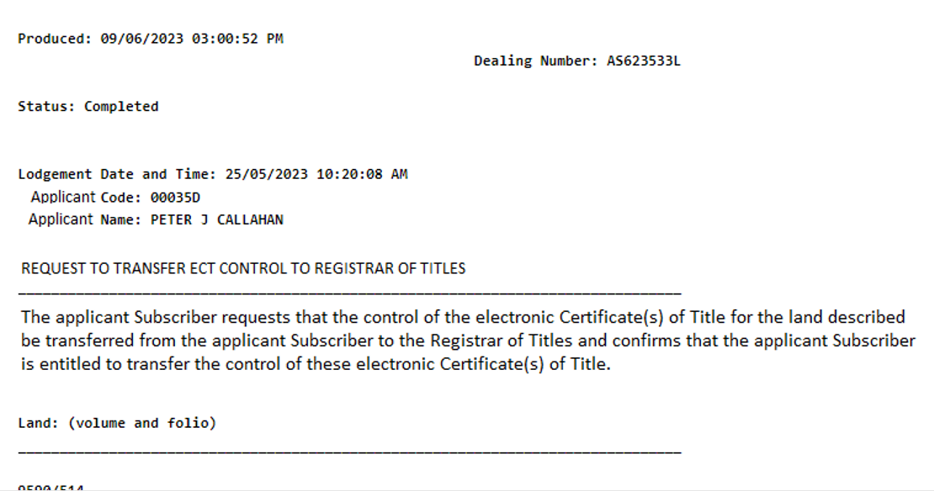

For further information about the new Administrative Notices including new requirements for parties transacting without using a Subscriber, please refer to our Frequently Asked Questions.
LUV recommends that parties use a conveyancer or a lawyer for land transactions as these are often complex and any errors are costly to resolve.
Any queries regarding the new administrative notices may be directed via the online enquiry form.

Contact us
For contact details, please go to www.land.vic.gov.au/contact-us.
Need more information?
Find out more about the government’s initiatives at dtp.vic.gov.au

