|  |
| --- |
| MyProfile: Register a User |
| November 2017 |

# Introduction

Access to the on-line services provided by Information Services Division, DELWP, requires user registration and authorisation. This information sheet describes the process of registering as an authorised user of these services.

## User Registration

a. Go to [http://services.land.vic.gov.au/MyProfile](http://services.land.vic.gov.au/MyProfile/) to register as a new user in My Profile

b. Select the Register button on the left hand side of the page, enter in all your details and then click the button at the bottom of the page (regrettably also called Register).

Keep the User Name simple e.g. use your existing SOEid if practical. Or your first initial and surname e.g. jsmith. Note: duplicate names are not allowed.

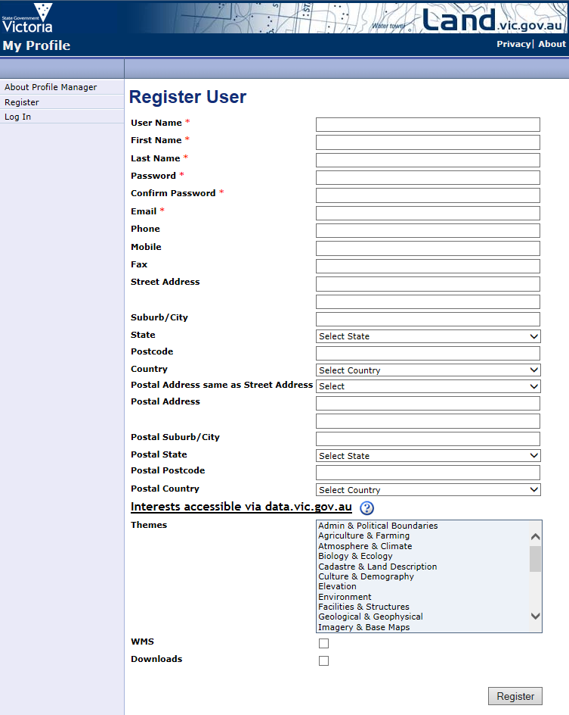

c. Selecting the “Register” button at the bottom of the page brings you to “Request Access to Application”.

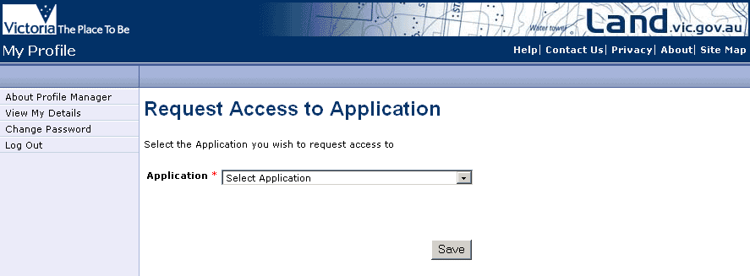

NOTE: Do not Request Access to applications via the resulting drop-down list. Do not select the Save button. Access to applications is controlled by Organisation so you do not need to perform this step.

## Request for User Membership of Organisation

1. Click on “View My Details” in the left hand menu.
2. You should now see your profile. From here you can modify your Details, view the Applications you have access to, view your Organisation membership and any Requests you have made.

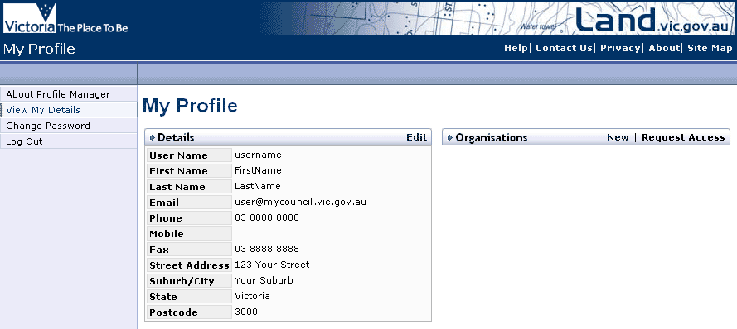

1. From the “Organisations” Menu bar select “Request Access”.
2. clickRequestAccessToOrganisOn the “Request for User Membership of Organisation” screen, enter the name of your organisation exactly as registered. If required please contact [GIS.Helpdesk@delwp.vic.gov.au](mailto:GIS.Helpdesk@delwp.vic.gov.au) to confirm your organisation name. Press the select button

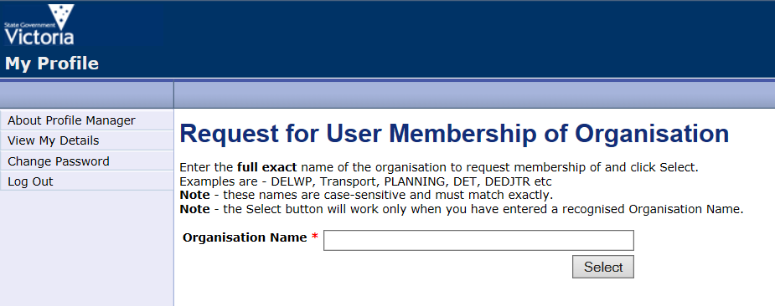Your MyProfile Organisation Administrator will now process your request for membership.

Once this has been approved you will have access to applications assigned to your organisation.

## Forgotten Your Password?

Click here to [reset your password](http://services.land.vic.gov.au/MyProfile/forgotPassword.html?method=edit)

## Need Help ?

Please email any feedback or queries to gis.helpdesk@delwp.vic.gov.au

|  |  |
| --- | --- |
| © The State of Victoria Department of Environment, Land, Water and Planning 2017  LogoThis work is licensed under a Creative Commons Attribution 4.0 International licence. You are free to re-use the work under that licence, on the condition that you credit the State of Victoria as author. The licence does not apply to any images, photographs or branding, including the Victorian Coat of Arms, the Victorian Government logo and the Department of Environment, Land, Water and Planning (DELWP) logo. To view a copy of this licence, visit http://creativecommons.org/licenses/by/4.0/  Disclaimer  This publication may be of assistance to you but the State of Victoria and its employees do not guarantee that the publication is without flaw of any kind or is wholly appropriate for your particular purposes and therefore disclaims all liability for any error, loss or other consequence which may arise from you relying on any information in this publication. | Accessibility  If you would like to receive this publication in an alternative format, please telephone the DELWP Customer Service Centre on 136186, email [customer.service@delwp.vic.gov.au](mailto:customer.service@delwp.vic.gov.au), or via the National Relay Service on 133 677 [www.relayservice.com.au](http://www.relayservice.com.au). This document is also available on the internet at [www.delwp.vic.gov.au](http://www.delwp.vic.gov.au). |