|  |
| --- |
| Vicmap Product Development |
| Change Notice # 261 |

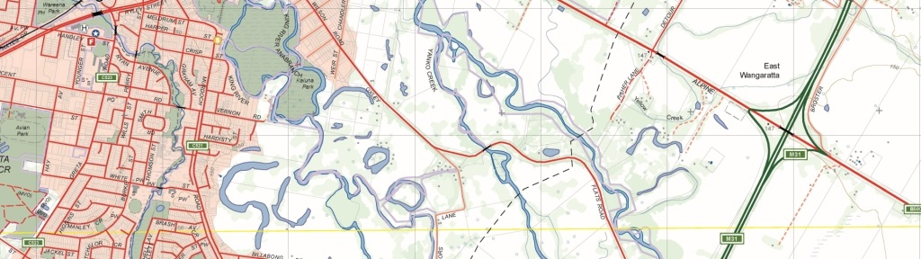

Vicmap Admin – Fire Rescue Victoria (FRV) Boundaries

## What is happening

From 26 October 2020, FRV_LEGISLATED_BOUNDARY is being added to Vicmap Admin. This dataset is a single polygon delineating FRV’s legislated boundary.

## Why this change is occurring

Fire Rescue Victoria (FRV) was established on 1 July 2020 as part Victoria’s Fire Services Reforms. It was established to take on the Metropolitan Fire Brigade’s (MFB) functions.

FRV_LEGISLATED_BOUNDARY is an amalgamation of FRV Regions (VMADMIN.FRV_REGION).

## Who it will affect

This change will affect all users of Vicmap Admin. Incremental Update Format (IUF) customers will not be affected as part of this change.

## When the change will occur

FRV_ LEGISLATED_BOUNDARY will be added to Vicmap Admin from 26 October 2020. The addition of a new datasets into Vicmap does not require prior customer notification given no prior dependencies exist.

## Background

Fire Rescue Victoria (FRV) was established on 1 July 2020 as part Victoria’s Fire Services Reforms. It was established to take on the Metropolitan Fire Brigade’s (MFB) functions.

## How to provide feedback

For Vicmap Product change notices and bulletins, go to the [News and Bulletins](http://www.delwp.vic.gov.au/parks-forests-and-crown-land/spatial-data-and-resources/news-and-bulletins) page.

For further information & feedback please email [vicmap.help@delwp.vic.gov.au](mailto:vicmap.help@delwp.vic.gov.au)

|  |  |
| --- | --- |
| © The State of Victoria Department of Environment, Land, Water and Planning 2021  LogoThis work is licensed under a Creative Commons Attribution 4.0 International licence. You are free to re-use the work under that licence, on the condition that you credit the State of Victoria as author. The licence does not apply to any images, photographs or branding, including the Victorian Coat of Arms, the Victorian Government logo and the Department of Environment, Land, Water and Planning (DELWP) logo. To view a copy of this licence, visit http://creativecommons.org/licenses/by/4.0/  Disclaimer  This publication may be of assistance to you but the State of Victoria and its employees do not guarantee that the publication is without flaw of any kind or is wholly appropriate for your particular purposes and therefore disclaims all liability for any error, loss or other consequence which may arise from you relying on any information in this publication. | Accessibility  If you would like to receive this publication in an alternative format, please telephone the DELWP Customer Service Centre on 136186, email [customer.service@delwp.vic.gov.au](mailto:customer.service@delwp.vic.gov.au), or via the National Relay Service on 133 677 [www.relayservice.com.au](http://www.relayservice.com.au). This document is also available on the internet at [www.delwp.vic.gov.au](http://www.delwp.vic.gov.au). |