www.delwp.vic.gov.au

Land Use Victoria

|  |
| --- |
| Land Registry Services Business Activity Report  2019-2020 Financial year |

|  |  |
| --- | --- |
|  |  |

|  |
| --- |
| © The State of Victoria Department of Environment, Land, Water and Planning 2020  Logo  This work is licensed under a Creative Commons Attribution 4.0 International licence. You are free to re-use the work under that licence, on the condition that you credit the State of Victoria as author. The licence does not apply to any images, photographs or branding, including the Victorian Coat of Arms, the Victorian Government logo and the Department of Environment, Land, Water and Planning (DELWP) logo. To view a copy of this licence, visit <http://creativecommons.org/licenses/by/4.0/>  Disclaimer  This publication may be of assistance to you but the State of Victoria and its employees do not guarantee that the publication is without flaw of any kind or is wholly appropriate for your particular purposes and therefore disclaims all liability for any error, loss or other consequence which may arise from you relying on any information in this publication. |

Contents

Land Registry Services 3

Business activity report 2019–2020 financial year 3

Lodgements 4

Number of dealings lodged 4

Yearly lodgements (1945–2020) 5

Monthly lodgements 6

Average daily lodgements (with trend line) 7

Financial year lodgements from 2011-2012 to 2019-2020 (by month) 8

Search 9

Title searches 9

Financial year title searches (by month) 10

Planning certificates 11

Instrument searches 11

Land Index searches 12

Lodgement and Support Services 1 (LSS1) 13

Landata Statistics with trend lines 13

Water share transactions 15

Lodgement by specific dealing types 16

Discharges of mortgage 16

Transfers of land 16

Mortgages 17

Differences in lodging levels and percentages of discharges, transfers and mortgages 17

Number of plans of subdivision lodged 20

Number of new parcels created from plans of subdivision 20

General law conversion 21

Top 40 dealings types, by number lodged 22

Other measures of Land Registry Services activity 24

Registrations 24

Number of dealings registered 24

Percentage of dealings registered within 5 days 24

Number of plans registered 24

Number of dealings refused 24

Number of dealings waiting to be processed 24

Electronic transactions processing 25

Electronic Conveyancing 25

# Land Registry Services

## Business activity report 2019–2020 financial year

This report provides statistics for land registration and property information services conducted at the Land Registry Services area of Land Use Victoria.

As well as figures for the 2019–2020 financial year, statistics are also provided for previous years.

# Lodgements

## Number of dealings lodged

The number of dealings lodged for the financial year was 853,227. This is a 3.09% per cent decrease on the 2018–2019 financial year. Recent financial years’ lodgings have been:

|  |  |
| --- | --- |
|  |  |
| 2019-2020 | 853,227 |
| 2018-2019 | 885,058 |
| 2017-2018 | 917,385 |
| 2016-2017 | 876,482 |
| 2015-2016 | 857,497 |
| 2014-2015 | 792,335 |
| 2013–2014 | 747,598 |
| 2012–2013 | 669,214 |
| 2011–2012 | 677,708 |
| 2010–2011 | 720,649 |
| 2009–2010 | 743,389 |
| 2008–2009 | 675,640 |
| 2007–2008 | 777,542 |
| 2006–2007 | 727,464 |
| 2005–2006 | 748,647 |
| 2004–2005 | 780,329 |
| 2003–2004 | 797,231 |
| 2002–2003 | 798,686 |
| 2001–2002 | 792,336 |
| 2000–2001 | 670,865 |

# Yearly lodgements (1945–2020)

This graph represents the yearly lodgements for each year since 1945.

A trend line has also been incorporated to give an indication of the growth in lodgements over time.

Since 1945, the trend line shows a 4.0 per cent increase per annum.

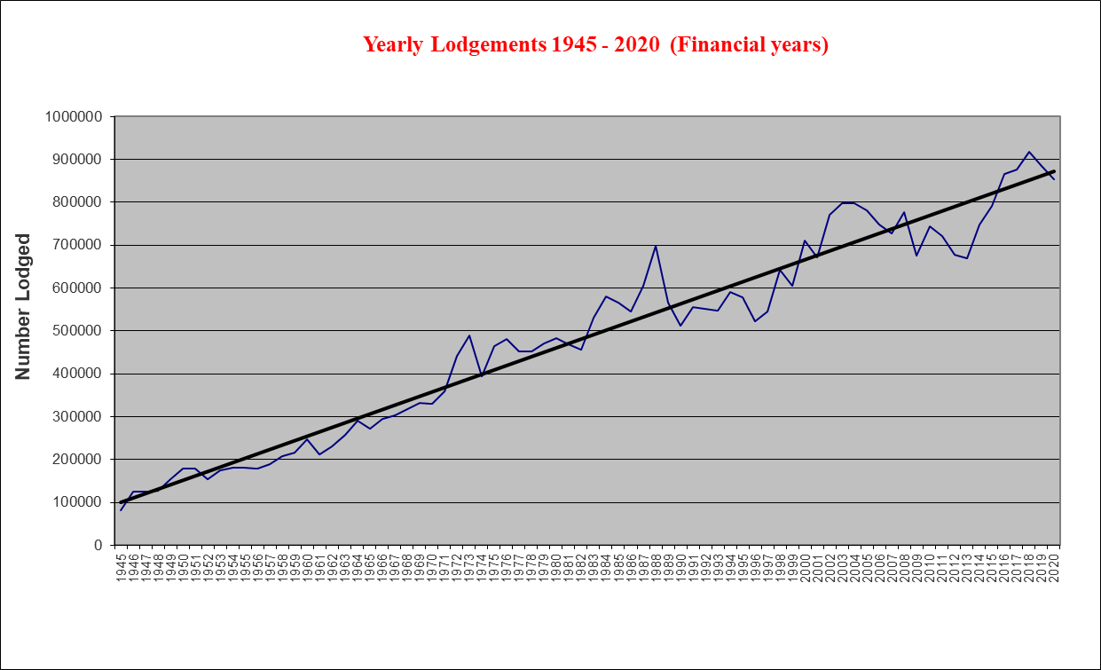

# Monthly lodgements

This graph shows the number of lodgements received for each month of the financial year.

In the 2019–2020 financial year, the average number of lodgements was 71,102 per month.

# Average daily lodgements (with trend line)

This graph shows the daily average lodgements for each week of the 2019–2020 financial year.

The average daily lodgement throughout the financial year was 3,236 per day.

The average daily lodgement is monitored on a daily basis (along with moving averages).

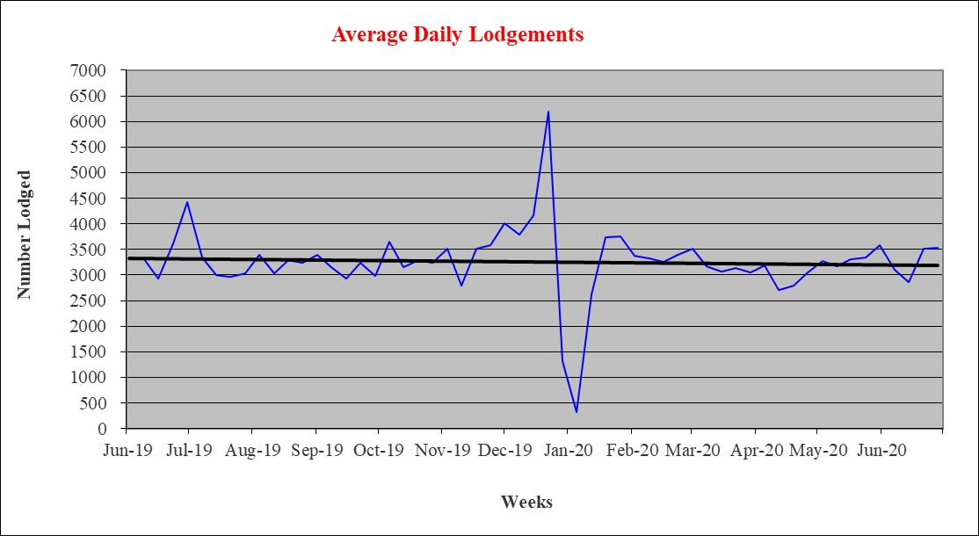

# Financial year lodgements from 2011-2012 to 2019-2020 (by month)

This graph compares monthly lodgements since the 2019–2020 financial year.

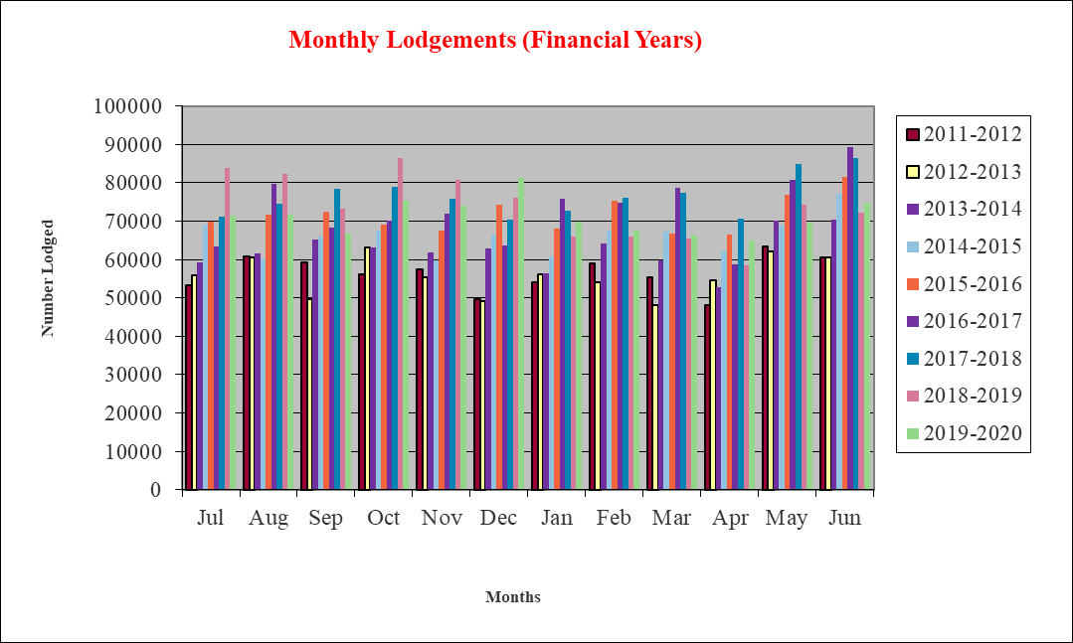

# Search

There are a number of search categories listed below, together with historical data to show trends.

## Title searches

Title searches increased by 2.28% per cent in the 2019-2020 financial year. (Note total figure re-adjusted from YTD in the June monthly report, due to a small calculation error being detected)

|  |  |
| --- | --- |
|  |  |
| 2019-2020 | 2,540,297 |
| 2018-2019 | 2,483,433 |
| 2017-2018 | 2,866,297 |
| 2016-2017 | 2,463,249 |
| 2015-2016 | 2,232,051 |
| 2014-2015 | 2,242,562 |
| 2013–2014 | 2,205,947 |
| 2012–2013 | 2,169,973 |
| 2011–2012 | 2,192,819 |
| 2010–2011 | 2,218,043 |
| 2009–2010 | 2,200,297 |
| 2008–2009 | 2,023,852 |
| 2007–2008 | 2,169,427 |
| 2006–2007 | 2,050,786 |
| 2005–2006 | 1,906,169 |
| 2004–2005 | 1,731,553 |

## Financial year title searches (by month)

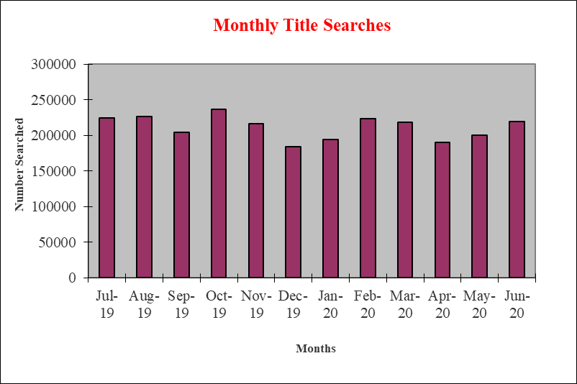

## Planning certificates

Planning certificates increased by 11.46 per cent in the 2019–2020 financial year.

|  |  |
| --- | --- |
|  |  |
| 2019-2020 | 75,695 |
| 2018-2019 | 67,658 |
| 2017-2018 | 71,771 |
| 2016-2017 | 63,161 |
| 2015-2016 | 57,078 |
| 2014-2015 | 55,461 |
| 2013–2014 | 50,090 |
| 2012–2013 | 42,018 |
| 2011–2012 | 38,196 |
| 2010–2011 | 37,131 |
| 2009–2010 | 37,695 |
| 2008–2009 | 32,893 |
| 2007–2008 | 40,716 |
| 2006–2007 | 33,259 |
| 2005–2006 | 37,301 |

## Instrument searches

Instrument searches decreased by 19.79 per cent in the 2019-2020 financial year.

|  |  |
| --- | --- |
|  |  |
| 2019-2020 | 466,912 |
| 2018-2019 | 582,125 |
| 2017-2018 | 677,407 |
| 2016-2017 | 673,628 |
| 2015-2016 | 667,018 |
| 2014-2015 | 667,648 |
| 2013–2014 | 682,478 |
| 2012–2013 | 683,604 |
| 2011–2012 | 668,858 |
| 2010–2011 | 721,380 |
| 2009–2010 | 757,195 |
| 2008–2009 | 618,854 |
| 2007–2008 | 613,296 |
| 2006–2007 | 587,682 |

**Property certificates**

Property certificates increased by 6.53 per cent in the 2019–2020 financial year.

|  |  |
| --- | --- |
|  |  |
| 2019-2020 | 663,119 |
| 2018-2019 | 622,465 |
| 2017-2018 | 630,885 |
| 2016-2017 | 619,212 |
| 2015-2016 | 541,176 |
| 2014-2015 | 521,891 |
| 2013–2014 | 367,172 |
| 2012–2013 | 271,449 |
| 2011–2012 | 213,692 |
| 2010–2011 | 243,917 |
| 2009–2010 | 188,155 |
| 2008–2009 | 126,380 |
| 2007–2008 | 134,288 |
| 2006–2007 | 109,355 |

## Land Index searches

Land Index searches increased by 1.15 per cent in the 2019–2020 financial year.

|  |  |
| --- | --- |
|  |  |
| 2019-2020 | 1,352,415 |
| 2018-2019 | 1,319,785 |
| 2017-2018 | 1,374,961 |
| 2016-2017 | 1,345,345 |
| 2015-2016 | 1,153,439 |
| 2014-2015 | 1,070,323 |
| 2013–2014 | 998,803 |
| 2012–2013 | 1,056,131 |
| 2011–2012 | 1,053,140 |
| 2010–2011 | 1,103,887 |
| 2009–2010 | 1,137,876 |
| 2008–2009 | 1,278,727 |
| 2007–2008 | 1,488,230 |
| 2006–2007 | 1,466,544 |

## Lodgement and Support Services 1 (LSS1)

This statistic refers to services provided to Electronic Lodgement Networks (ELN) on the creation of a workspace, consisting of pre-populaion of title data, title activity checks and lodgement verification. As LSS1 is required on the creation of a workspace in an ELN, this statistic is a measure of the number of such workspaces created.

|  |  |
| --- | --- |
|  |  |
| 2019-2020 | 476,167 |

# Landata Statistics with trend lines

**Water Register**

Water share records searches decreased by 36.93 per cent in the 2019–2020 financial year.

|  |  |
| --- | --- |
|  |  |
| 2019-2020 | 7,491 |
| 2018-2019 | 11,876 |
| 2017-2018 | 9,648 |
| 2016-2017 | 6,162 |
| 2015-2016 | 7,013 |
| 2014-2015 | 7,670 |
| 2013–2014 | 7,529 |
| 2012–2013 | 8,800 |
| 2011–2012 | 9,871 |
| 2010–2011 | 9,990 |
| 2009–2010 | 10,983 |
| 2008–2009 | 13,391 |
| 2007–2008 | 5,259 |

## Water share transactions

There are a number of water share transactions recorded each year. The total numbers in each category are shown below.

**Type of Transaction Number Lodged**

#### Transfers

Transfer within authority (including limited term transfers) 2,257

Transfer between authority (including limited term transfers) 171

#### Total Transfers 2,428

#### Party amendments

Address amendment 3,350

Name and address amendment 355

Party merge 4

#### Total party amendments 3,709

#### Mortgages

Mortgage create 351

Mortgage discharge 772

Mortgage variation 1

Mortgage amendment 5

Mortgage priority 0

Create MCP 2

#### Total Mortgages 1,131

#### Survivorships

Recording of LPR 153

Recording of survivorship 61

Recording of trustee in Bankruptcy 4

#### Total survivorships 218

#### Registrar notification on water share

Create notification 0

Remove notification 5

#### Total notifications 5

# Lodgement by specific dealing types

## Discharges of mortgage

For the 2019–2020 financial year, discharges of mortgage were 31.98 per cent of all dealings lodged

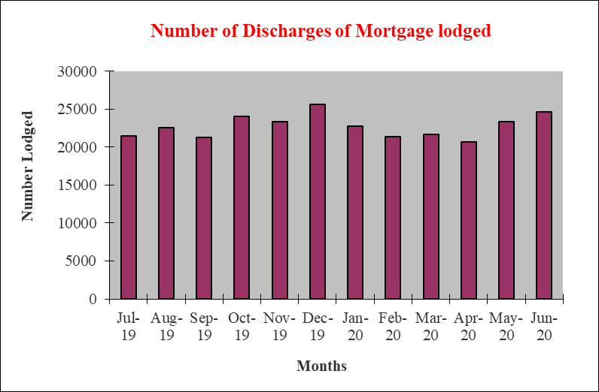

## Transfers of land

For the 2019–2020 financial year, transfers (45 and 45NM) were 23.72 per cent of all dealings lodged

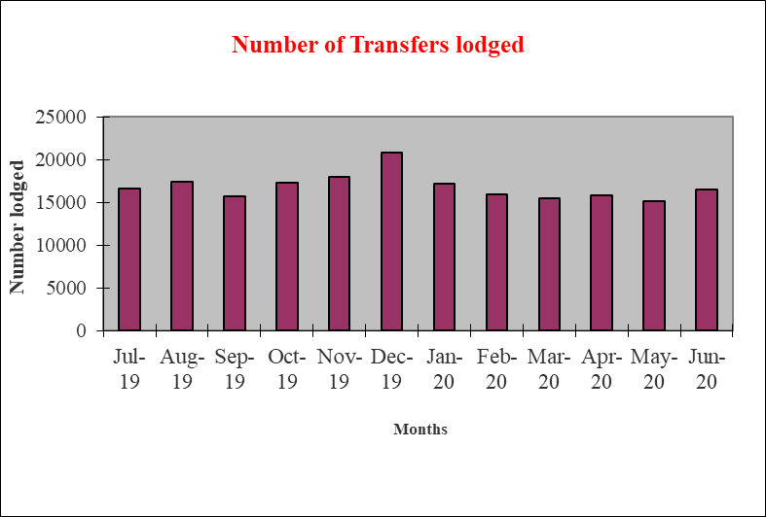

## Mortgages

For the 2019–2020 financial year, mortgages (includes 74 and 74D) were 30.80 per cent of all dealings lodged.

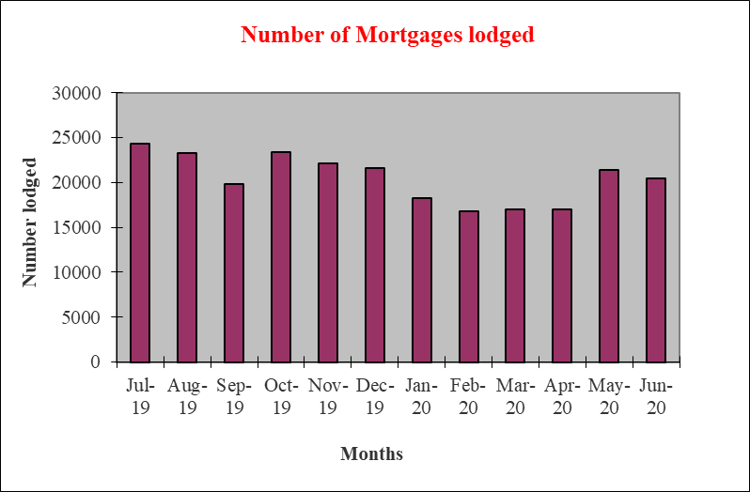

## 

## Differences in lodging levels and percentages of discharges, transfers and mortgages

Over time, the number and relative percentages in the lodgement levels of the three most common transactions vary.

These variations are shown below.

The average for each of the dealing types for this financial year is as follows:

|  |  |
| --- | --- |
|  |  |
| Transfers | 23.72 per cent |
| Discharges | 31.98 per cent |
| Mortgages | 30.80 per cent |

The three main dealing types as a percentage of all dealings lodged since 2000–2001 is shown below.

|  |  |  |  |
| --- | --- | --- | --- |
|  | Transfers | Discharges | Mortgages |
| 2000/01 | 28.81% | 29.74% | 26.14% |
| 2001/02 | 28.42% | 29.41% | 26.30% |
| 2002/03 | 27.93% | 30.33% | 27.29% |
| 2003/04 | 27.15% | 30.63% | 27.79% |
| 2004/05 | 25.05% | 29.53% | 26.75% |
| 2005/06 | 25.49% | 28.36% | 30.51% |
| 2006/07 | 25.87% | 28.13% | 29.85% |
| 2007/08 | 26.27% | 27.59% | 29.19% |
| 2008/09 | 25.95% | 27.21% | 28.42% |
| 2009/10 | 26.87% | 27.16% | 28.62% |
| 2010/11 | 26.22% | 27.20% | 27.68% |
| 2011/12 | 25.24% | 28.28% | 28.05% |
| 2012/13 | 25.04% | 28.15% | 27.80% |
| 2013/14 | 25.76% | 28.54% | 27.74% |
| 2014/15 | 25.44% | 29.15% | 28.25% |
| 2015/16 | 23.90% | 29.90% | 29.20% |
| 2016/17 | 28.05% | 30.60% | 28.69% |
| 2017/18 | 25.90% | 30.57% | 28.66% |
| 2018/19 | 23.03% | 29.22% | 27.72% |
| 2019/20 | 23.72% | 31.98% | 30.80% |

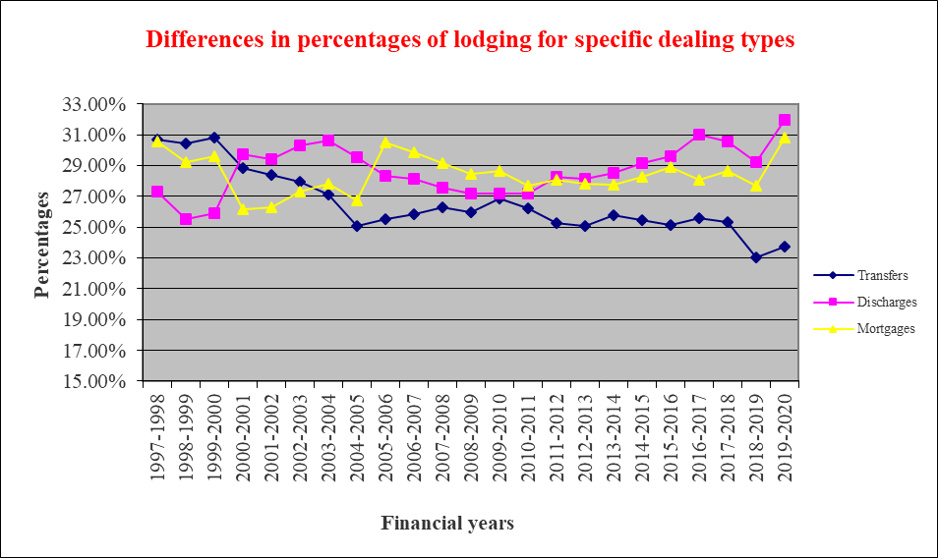

**Plans of subdivisions**

Plans of subdivision were 0.80 per cent of all dealings lodged.

These plans of subdivision are captured in the Victorian Online Title System (VOTS) as ‘PS’ transaction types.

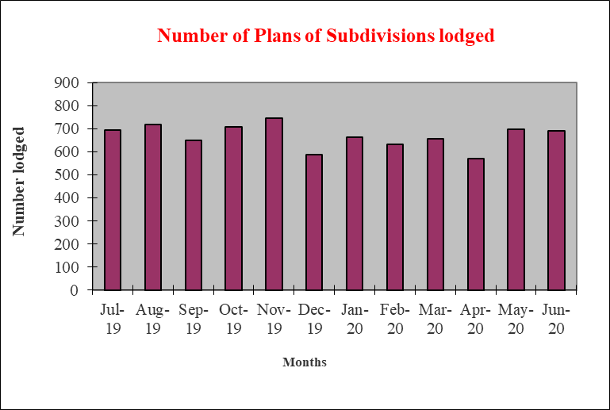

Another plan type of transaction is captured as a ‘PS35’. In the 2019-2020 Financial year there were 228 of this transaction lodged. These are for compulsory acquisitions of property to assist with, for example, the building of major roads.

A further plan type of transaction is a ‘SA32PS’. This plan type transaction occurs typically in the redevelopment of a plan with an owners corporation. In the 2019-2020 financial year there were 198 of this transaction lodged, a decrease from 2019-2020 financial year, when 208 of this transaction were lodged.

## Number of plans of subdivision lodged

The number of plans of subdivision lodged for the 2019–2020 financial year was 8,541

Recent financial year’s lodgings have been:

|  |  |
| --- | --- |
|  |  |
| 2019-2020 | 8,541 |
| 2018-2019 | 8,249 |
| 2017-2018 | 8,340 |
| 2016-2017 | 8,376 |
| 2015-2016 | 8,970 |
| 2014-2015 | 8,252 |
| 2013–2014 | 8,001 |
| 2012–2013 | 7,896 |
| 2011–2012 | 8,088 |
| 2010–2011 | 7,699 |
| 2009–2010 | 7,988 |
| 2008–2009 | 7,719 |
| 2007–2008 | 8,048 |
| 2006–2007 | 8,304 |
| 2005–2006 | 8,547 |
| 2004–2005 | 8,349 |
| 2003–2004 | 8,052 |
| 2002–2003 | 7,962 |
| 2001–2002 | 8,477 |
| 2000–2001 | 8,126 |

## Number of new parcels created from plans of subdivision

|  |  |
| --- | --- |
|  |  |
| 2019-2020 | 82,898 |
| 2018-2019 | 77,602 |
| 2017-2018 | 77,014 |
| 2016-2017 | 79,034 |
| 2015-2016 | 75,351 |
| 2014-2015 | 61,669 |

## General law conversion

The number of parcels created from General law conversions for the 2019–2020 financial year was 1,468. This compares to previous financial years as follows:

|  |  |
| --- | --- |
|  |  |
| 2019-2020 | 1,468 |
| 2018-2019 | 1,575 |
| 2017-2018 | 1,922 |
| 2016-2017 | 3,228 |
| 2015-2016 | 2,868 |
| 2014-2015 | 2,018 |
| 2013–2014 | 3,774 |
| 2012–2013 | 1,997 |
| 2011–2012 | 1,303 |
| 2010–2011 | 2,559 |
| 2009–2010 | 1,559 |
| 2008–2009 | 1,023 |
| 2007–2008 | 1,238 |
| 2006–2007 | 1,309 |
| 2005–2006 | 1,490 |
| 2004–2005 | 1,750 |
| 2003–2004 | 1,996 |
| 2002–2003 | 2,357 |
| 2001–2002 | 2,434 |

## Top 40 dealings types, by number lodged

Shown below are the top 40 dealing types lodged in Land Registry Services for the financial year.

|  |  |  |
| --- | --- | --- |
| Dealing type | Description | Lodged |
| 84M | Discharge of mortgage | 272,895 |
| 74 | Mortgage | 252,701 |
| 45 | Transfer | 180,559 |
| 89 | Caveat | 30,579 |
| 45NM | Transfer | 21,919 |
| 89W | Withdrawal of Caveat | 18,002 |
| 49 | Transmission Application | 13,383 |
| 74D | Mortgage | 10,180 |
| 50 | Survivorship Application | 9,965 |
| PS | Plan of Subdivision | 8,011 |
| OCAI | Additional information | 3,917 |
| 31 | Application for lost title | 2,729 |
| 173 | Agreement | 2,604 |
| PN | Priority Notice | 1,682 |
| 32-2 | Application for a new folio folio of the register | 1,038 |
| MCP | Memo of Common Provisions | 980 |
| LTD | Discharge land tax charge | 815 |
| 89A | Removal of caveat | 731 |
| PC | Plan of consolidation | 679 |
| 77 | Transfer by Mortgagee | 678 |
| 45N | Transfer with new title | 628 |
| 113A | Amend address on folio | 545 |
| 45E | Creataion of easement | 509 |
| LTC | Statuory Charge | 478 |
| 52-2 | Warrant | 465 |
| 23 | Application TLA | 375 |
| 183W | Removal of Agreement | 375 |
| 106C | Removal of encumbrance | 367 |
| OCR | Owners Corporation | 333 |
| 106AR | Registrars caveat | 326 |
| SACA | Change of address owners corporation | 255 |
| 103B | Amend proprietor name | 253 |
| 14 | Non-survey conversion | 247 |
| PS35 | Plan of Subdivision X35 | 228 |
| 45M | Transfer of Mortgage | 221 |
| SA32PS | Plan of Subdivision. X3 | 198 |
| 60 | Adverse Possession | 188 |
| XEN | Expiry of encumbrance | 181 |
| LACA | Notice | 179 |
| OCAR | Owners Corporation Rules | 149 |

# Other measures of Land Registry Services activity

## Registrations

### Number of dealings registered

The number of transactions registered in the 2019–2020 financial year was 852,327

### Percentage of dealings registered within 5 days

The average percentages achieved were greater than 99 per cent for the whole of the financial year.

### Number of plans registered

The number of plans registered for the financial year was 8,712 percentage of plans registered within 15 days.

The average percentage achieved was 95 per cent for the whole of the financial year.

### Number of dealings refused

The number of dealings refused for this financial year was 9,248. This represents 1.0 per cent of total dealings presented for acceptance at Land Registry Services for the financial year.

In the 2018–2019 financial year was 79,217. This represents 9.8 per cent of total dealings presented for acceptance at Land Registry Services.

### Number of dealings waiting to be processed

The number of dealings waiting to be processed in this financial year has stabilised. The ‘holding level’ at the commencement of the financial year was 2,553. For the majority of this year that figure has been less than 2,700. The majority, if not all of these dealings, will be in a processing state that requires attention from customers, or cannot be processed until a statutory period has elapsed. As at 1 July 2020 the figure was 2,872.

# Electronic transactions processing

## Electronic Conveyancing

The number of transactions lodged electronically in the 2019–2020 financial year was 806,643, up from 681,620 in 2018–2019. Transactions lodged electronically in 2019-2020 financial year accounted for 94.54 per cent of all lodgements.

This is made up of the following:

|  |  |
| --- | --- |
|  |  |
| Discharges of mortgage | 268,855 |
| Mortgage | 260,744 |
| Caveats | 30,179 |
| Withdrawal of caveat | 17,519 |
| Transfer of land | 197,145 |
| Transfer of mortgage | 169 |
| Transfer by mortgagee | 657 |
| Survivorship | 9,335 |
| Transmission | 12,393 |
| Land tax charge | 478 |
| Discharge of land tax charge | 814 |
| Discharge of charge | 27 |
| Statutory charge | 27 |
| Priority notice | 1,682 |
| Withdraw priority notice | 116 |

delwp.vic.gov.au