|  |
| --- |
| Guide to VICNAMES |
| Image size | | |



|  |
| --- |
| Land Victoria Department of Environment, Land, Water and Planning 570 Bourke Street Melbourne VIC 3000 Phone: (03) 8636 2525 Fax: (03) 8636 2776 Email: geonames@delwp.vic.gov.au Web: www.delwp.vic.gov.au>Property and land titles>Naming places, features and roads  Logo© The State of Victoria Department of Environment, Land, Water and Planning 2016    This work is licensed under a Creative Commons Attribution 4.0 Australia licence. You are free to re-use the work under that licence, on the condition that you credit the State of Victoria as author. The licence does not apply to any images, photographs or branding, including the Victorian Coat of Arms, the Victorian Government logo and the Department of Environment, Land, Water and Planning logo. To view a copy of this licence, visit [http://creativecommons.org/licenses/by/4.0](http://creativecommons.org/licenses/by/3.0/au/deed.en)/  **Accessibility**  If you would like to receive this publication in an alternative format, please telephone the DELWP Customer Service Centre on 136186, email [customer.service@delwp.vic.gov.au](mailto:customer.service@delwp.vic.gov.au) or via the National Relay Service on 133 677 [www.relayservice.com.au](http://www.relayservice.com.au).  **Disclaimer**  This publication may be of assistance to you but the State of Victoria and its employees do not guarantee that the publication is without flaw of any kind or is wholly appropriate for your particular purposes and therefore disclaims all liability for any error, loss or other consequence which may arise from you relying on any information in this publication. |

Contents

1 Glossary 2

2 Introduction 2

3 VICNAMES home page 2

4 VICNAMES general functionality 3

5 VICNAMES toolbar 4

6 VICNAMES place search 4

6.1 Features of interest search 8

6.2 VICNAMES place duplication search 8

7 VICNAMES road search 10

7.1 VICNAMES road duplication search 12

8 VICNAMES historical information search 14

9 VICNAMES data download 17

10 Adding historical information to VICNAMES 18

11 Additional functionality 20

12 Contact us 23

1 Glossary

FoI – Features of interest layer, maintained by Vicmap. VICNAMES is currently using the GEOMARK layer of Vicmap data.

GNR – Geographic Names Register, this is VICNAMES.

LASSI – Land and Survey Spatial Index.

OGN – Office of Geographic Names.

VICNAMES – The Victorian Geographic Names Register of geographic features, localities and roads.

2 Introduction

This guide details how you can operate the updated version of VICNAMES. VICNAMES was updated in October 2014 with improvements in search functionality, the user interface and the way in which data is displayed. There have been periodic updates since the initial release in October 2014. You can use VICNAMES to find the name of a place or road in Victoria. You can also learn the origins of a name and add historical information to any place or road.

The data in VICNAMES is available for download under a creative commons license.

3 VICNAMES home page

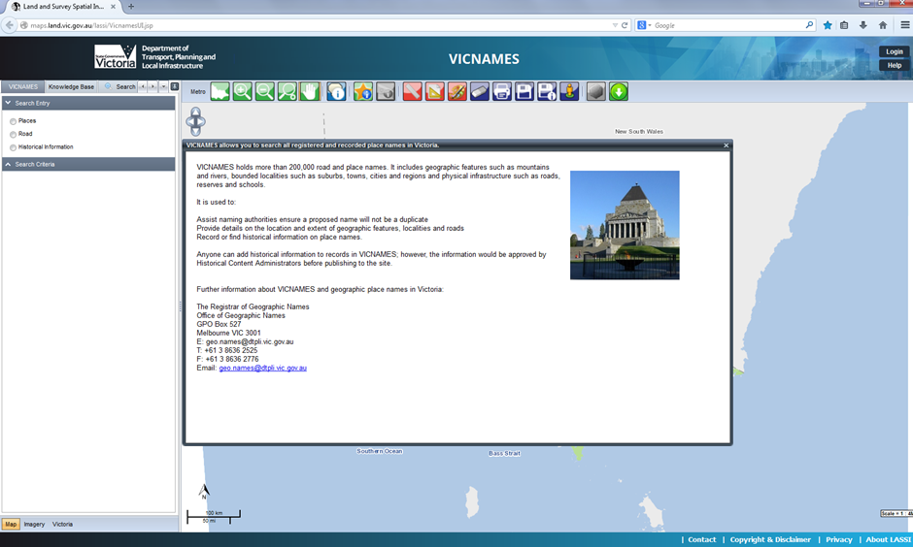

This screen provides a brief overview of VICNAMES and contact details for the Office of Geographic Names. You must close the screen to be able to use VICNAMES. Click the x in the red box.

4 VICNAMES general functionality

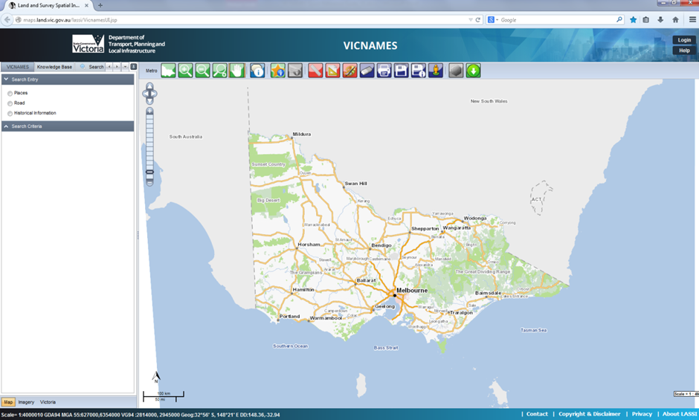

When the homepage screen has been closed, you will see the screen above: a map of Victoria. VICNAMES functionality can be accessed from this screen using the search pane to the left of the map.

You are able to perform the following VICNAMES search types:

* place search (including duplicate)
* road search (including duplicate)
* historical information search.

You are also able to perform the following actions or features from the VICNAMES toolbar:

* switch between map and imagery
* metropolitan only view (zooms to metropolitan)
* Victoria view (zooms to Victoria)
* zoom in and out
* zoom to a designated scale or municipality
* pan around the map
* identify property (property layer must be on)
* identify feature (scale-dependent)
* identify road (scale-dependent)
* measure distance
* measure area
* mark-up tools
* clear highlighted
* print and save images
* street view (Google)
* polygon search (scale-dependent)
* view results
* download data.

Beneath the VICNAMES search pane, three buttons alternate between aerial imagery and the map base.

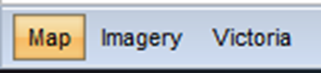

Directly above the map pane, the VICNAMES toolbar provides additional functionality, which is briefly outlined above.

5 VICNAMES toolbar



Hovering over these icons will provide further information about their use.

6 VICNAMES place search

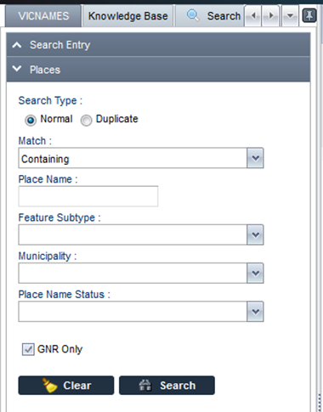

You can perform the following actions:

* search either normal or duplicate place names
* select the type of match
* add a place name
* select a feature sub-type
* select a municipality
* select a place name status.

Entering text to the place name field and clicking search (enter) will return the following screen.

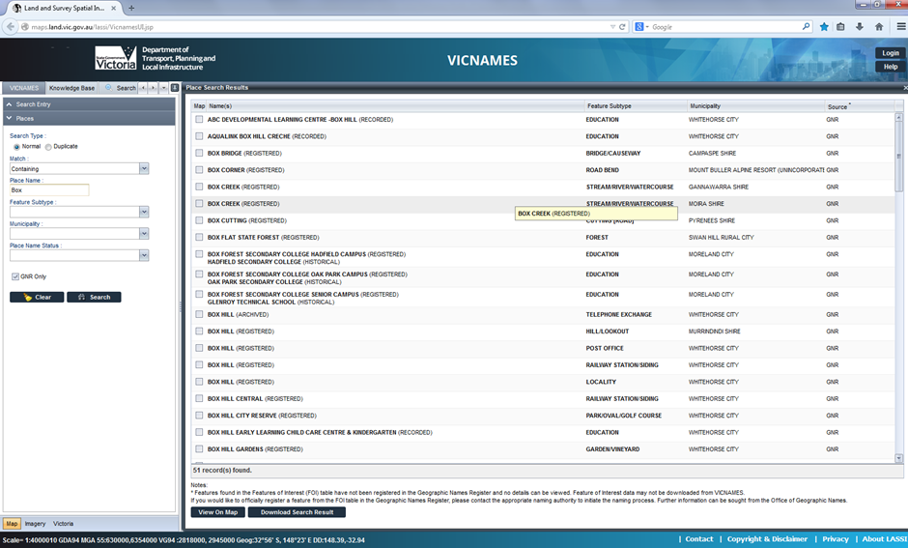

You are then able to perform the following actions:

* select a record from the screen to find further information
* select a record and click the ‘view on map’ button
* download the results displayed.

Select a record and the following screen is displayed.

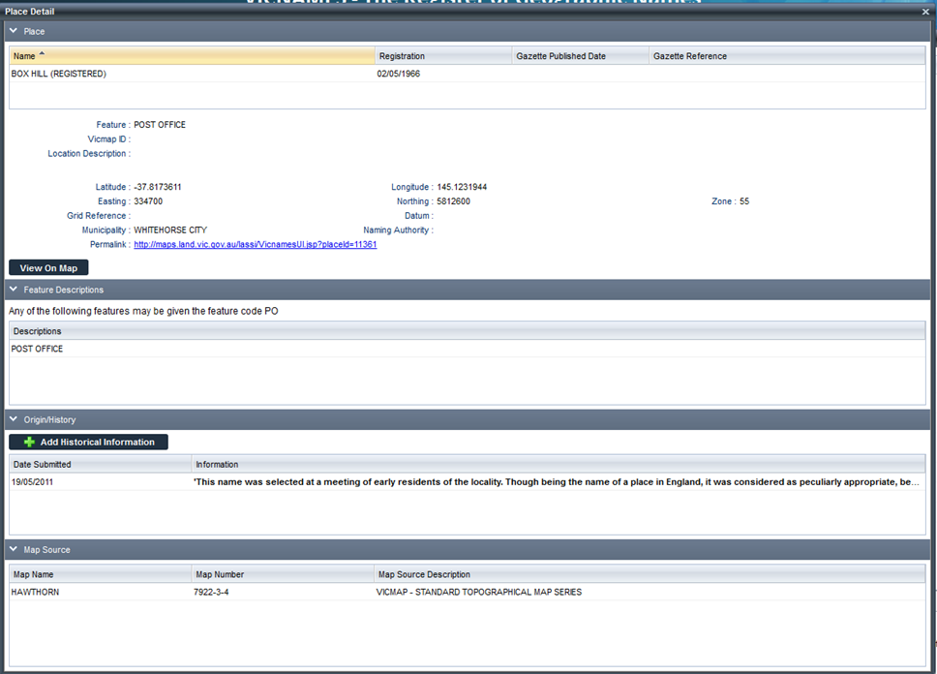

You are now able to perform the following actions:

* peruse the information
* select the ‘View on map’ button
* add historical information
* Copy the Permalink.

When selecting ‘View on map’ the place search results screen closes and the map opens displaying the selected places as point(s) in orange.

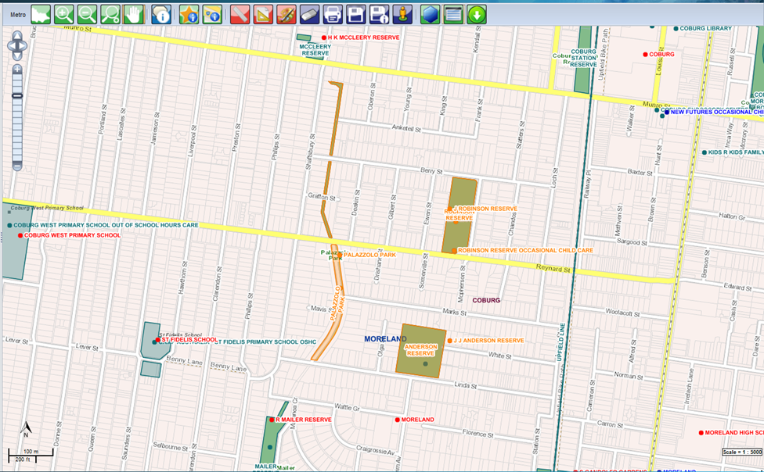

You can select additional tools from the tool bar or you can return to the place search results screen by selecting the ‘view search results’ button, second from the right-hand end of the VICNAMES toolbar. Select the button in the red box below.



You can download all search results by selecting the ‘download search results’ button. The following screen will be displayed.

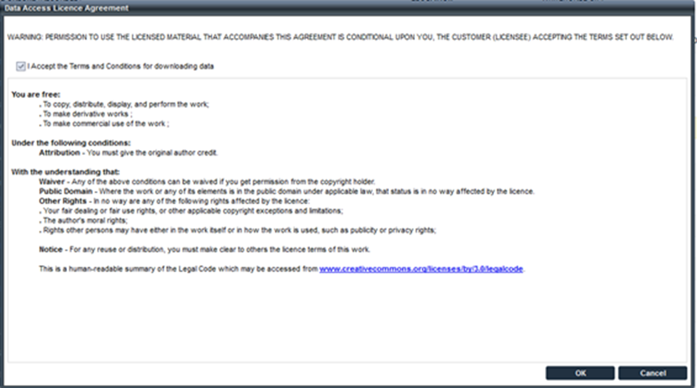

You can perform the following actions:

* add language of origin (if known)
* indicate if the name is an Australian Indigenous language
* indicate if the record is an Anzac related name
* indicate the date first recorded
* add the history or origin of the name
* indicate the type of source and add relevant information current approved sources include:
  + book
  + edited book section
  + journal
  + manuscript
  + oral history
  + maps
  + newspaper or magazine
  + artefact
  + website
  + council
  + OGN
* add relevant contact details of the submitter
* submit the historical entry.

All historical submissions will be reviewed by our historical content administrators before approval.

You are now able to submit corroborating historical information. You should email [geo.names@delwp.vic.gov.au](mailto:geo.names@delwp.vic.gov.au). Word documents, PDFs and images can all be uploaded to any given record that has historical information attached. The addition of documents allows the story behind the place name to be told, often in greater detail and with examples.

6.1 Features of interest search

You can search the Vicmap features of interest (FoI), which is currently displaying GEOMARK data within VICNAMES to find a place that is not listed in VICNAMES. To do this within the ‘VICNAMES place search’, un-tick the ‘GNR Only’ button. You will now be able to search using the place name and feature sub-type fields. Once searched, the results in the source column will be split between GNR and GEOMARK. See the screen shot below (right side).

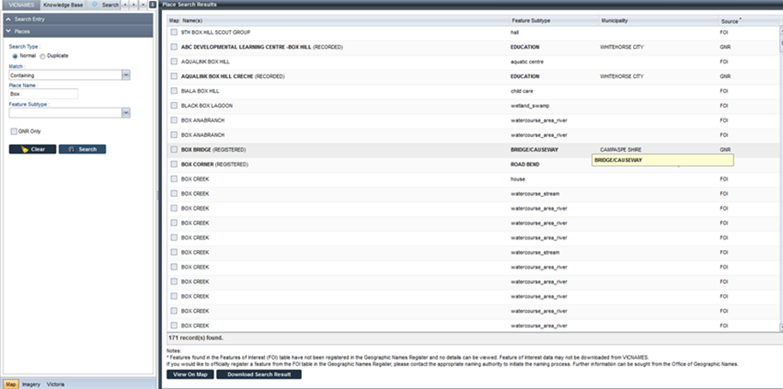

Note that only GNR records can be perused further; there is no information in VICNAMES on GEOMARK records, but you can view them on the map.

6.2 VICNAMES place duplication search

To do a search for duplicate place names, select duplicate search type.

When completing a ‘place duplication’ search under VICNAMES, the system defaults to including GNR and GEOMARK data.

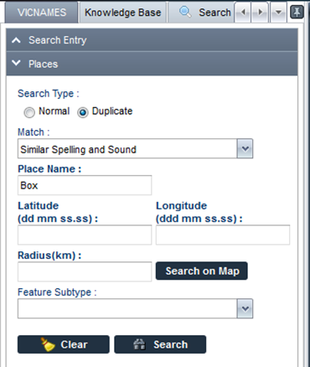

You must enter text into the ‘place name’ search field and then click the ‘Search on the map’ button.



Note that a cross-hair (+) will appear once the cursor has been moved over the map, after clicking ‘Search on map’. Once a point is selected, a purple circle will appear on the map. The system will default the radius search to 5, 15, or 30 kilometres. You can change the radius manually if needed.

Typically you can expect to receive one of two results – either ‘no results to display’ or the following screen.

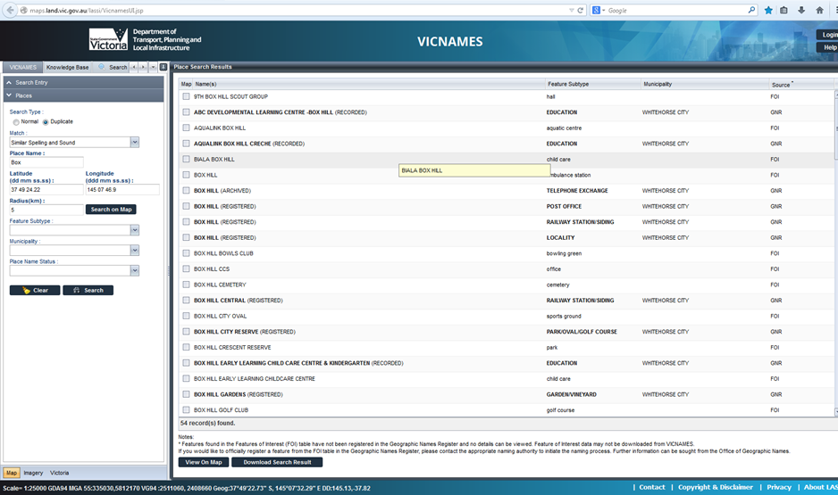

The results need to be interpreted to check whether a legitimate duplicate has been found, in which case any proposal to use the name would be rejected by OGN.

7 VICNAMES road search

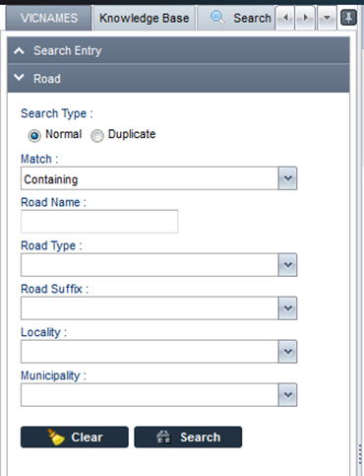

You can perform the following actions:

* search either normal or duplicate road names
* select the type of match
* add a road name
* add a road type
* add a road suffix
* select a locality
* select a municipality.

Entering text to the ‘road name’ field and clicking search (enter) will return the following screen.

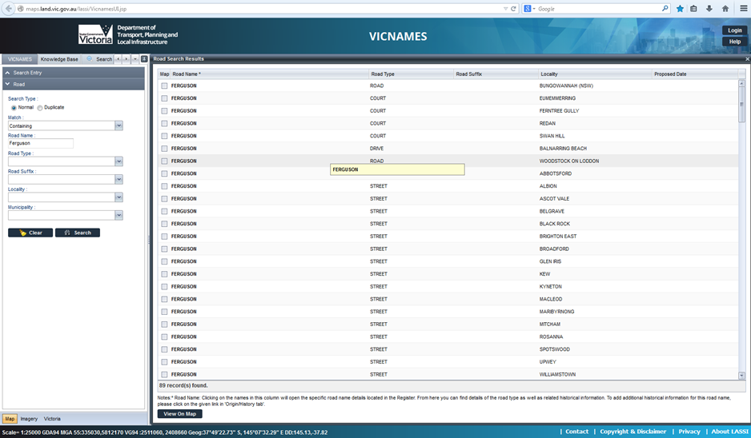

You can perform the following actions:

* select a record from the screen to find further information
* select a record and click the ‘View on map’ button, highlighted in the red boxes.

When selecting a record from the screen, the following screen is displayed.

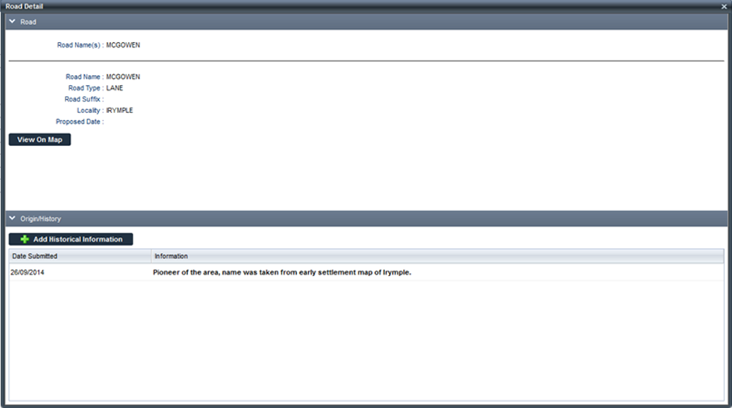

You can then perform the following actions:

* peruse the information
* select the ‘View on map’ button
* add historical information.

When selecting ‘View on map’, the ‘road search results’ screen closes and the map opens, displaying the selected roads as a line (s) in orange.

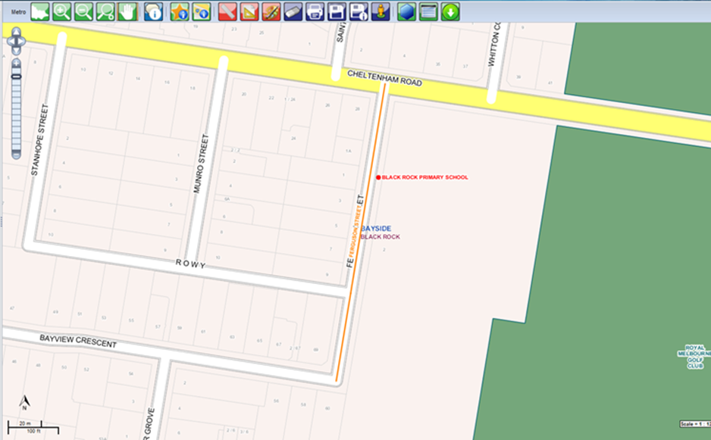

You can select additional tools from the tool bar; or, you can return to the ‘road search results’ screen by selecting the ‘view search results’ button, second from the right-hand end of the VICNAMES toolbar. Select the button in the red box below.



You can add historical information to a road name record and the following screen is displayed.

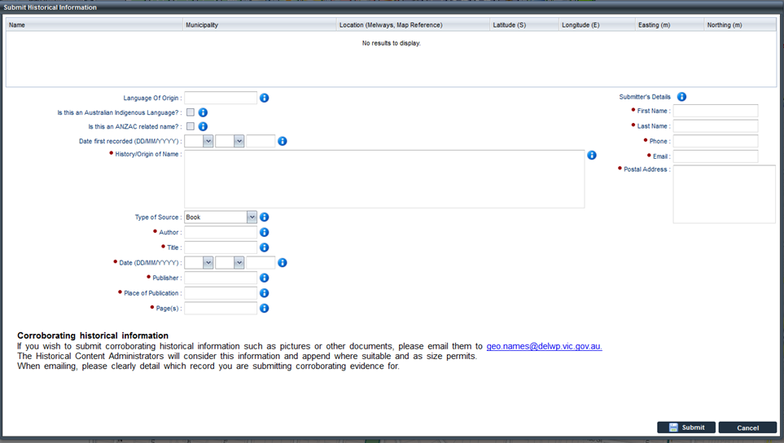

You have exactly the same functionality as under the ‘VICNAMES place’ search.

7.1 VICNAMES road duplication search

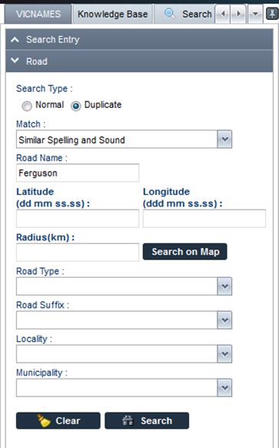

You first enter text into the ‘road name’ search field and then click Search on the map button.



A cross-hair (+) will appear once the cursor has been moved over the map, after clicking ‘Search on map’.

Once a point is selected, a purple circle will appear on the map. The system will default the radius search to 5, 15, or 30 kilometres, but you can change the radius manually.

You will receive one of two results – either ‘no results to display’ or the following screen.

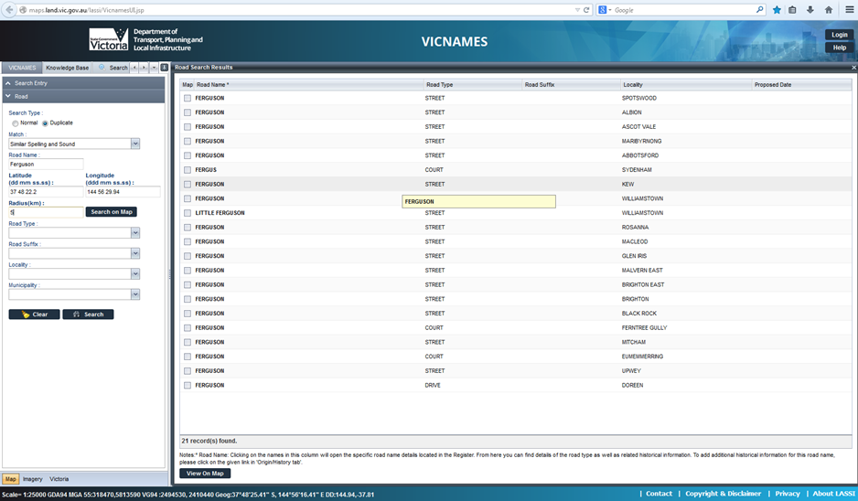

The results need to be interpreted to check if a legitimate duplicate is found, in which case any proposal to OGN would be rejected.

8 VICNAMES historical information search

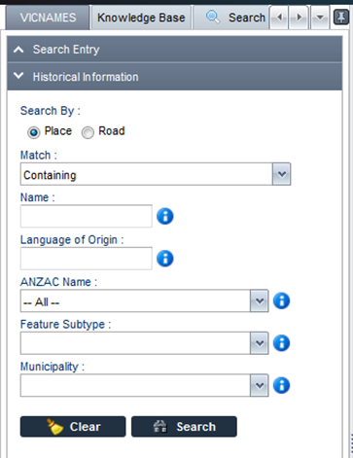

You can perform the following actions:

* search by place or road
* select the type of match
* type in the name of interest
* add the language of origin (if known)
* select whether the record is Anzac related
* select a feature sub-type (for places only, not roads)
* select a municipality.

Entering text into the ‘name’ field will display the following screen (assuming there is historical information in VICNAMES).

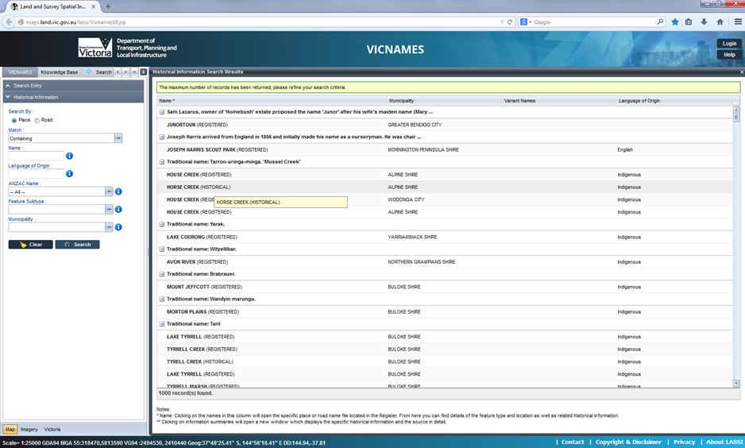

You can perform the following actions:

* complete a new historical information search
* select the historical information you want to view
* select the place or road name of interest
* return to the place or road search entry fields on the left of the screen to check if the name of interest is in VICNAMES, and then to add historical information.

Selecting the historical information record displays the following screen.

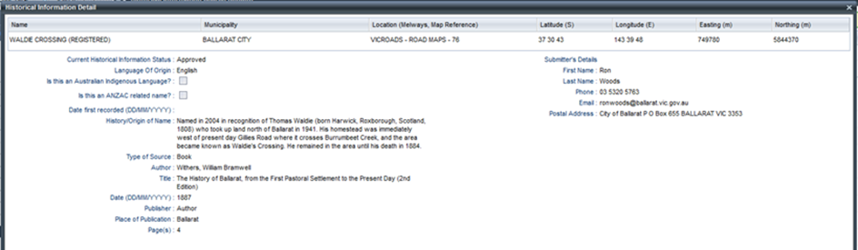

Selecting the place or road record displays the following screen.

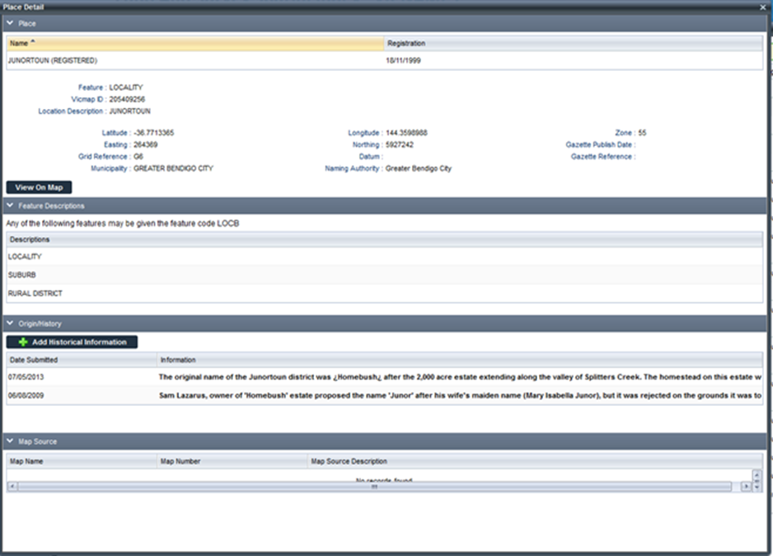

You can then perform the following actions for either a place or a road:

* peruse the information
* view the record on the map
* add historical information.

9 VICNAMES data download

If you select the ‘data download’ button from the toolbar, the following window is displayed.

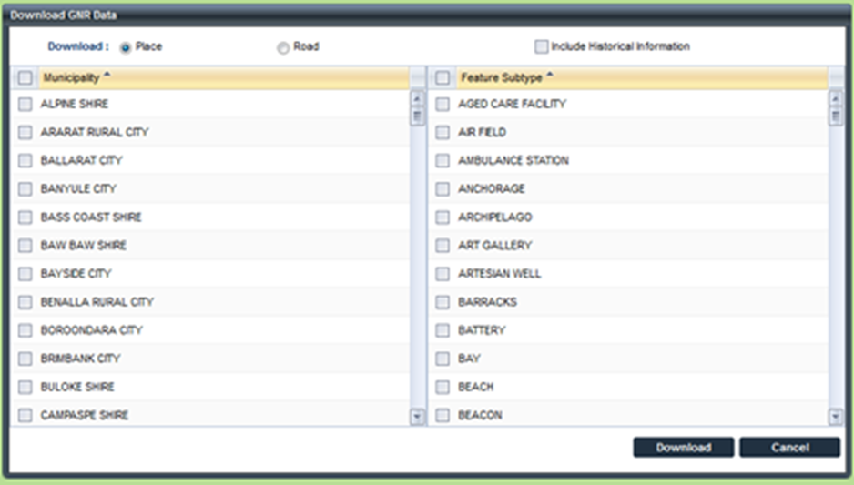

You can perform the following actions:

* download place or road data (you can only download historical information relating to roads if selecting roads, the system will default to Road Name Origin as the Feature).
* select one, municipality, several, or all (municipalities)
* select a feature type or all types
* include historical information
* download the data.

Before you can create a download, the terms and conditions must be accepted.

10 Adding historical information to VICNAMES

You can add historical information to any place or road record in VICNAMES. To add historical information select the ‘Add historical information’ once you have searched and selected a record.

**Place:**

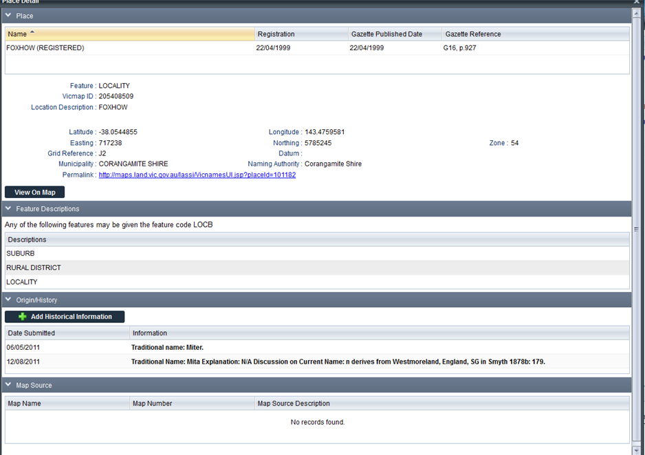

**Road:**

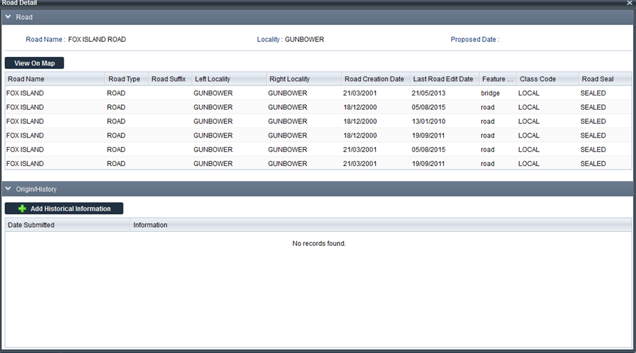

Once you selected the Add Historical Information button the following screen is displayed:

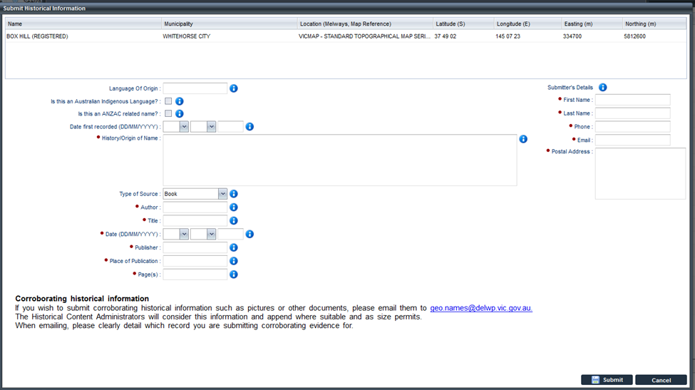

You can perform the following actions:

* add language of origin (if known)
* indicate if the name is an Australian Indigenous language
* indicate if the record is an Anzac related name
* indicate the date first recorded
* add the history or origin of the name
* indicate the type of source and add relevant information current approved sources include:
  + book
  + edited book section
  + journal
  + manuscript
  + oral history
  + maps
  + newspaper or magazine
  + artefact
  + website
  + council
  + OGN
* add relevant contact details of the submitter
* submit the historical entry.

All historical submissions will be reviewed by our historical content administrators before approval.

You are now able to submit corroborating historical information. You should email geo.names@delwp.vic.gov.au.

Word documents, PDFs and images can all be uploaded to any given record that has attached historical information. The addition of documents allows the story behind the place name to be told, often in greater detail and with examples.

11 Additional functionality

You are able to search for VICNAMES and other relevant information from the ‘knowledge base’ tab adjacent to the VICNAMES search tab.

Adjacent to the ‘knowledge base’ tab is a ‘search’ tab that provides general LASSI functionality.

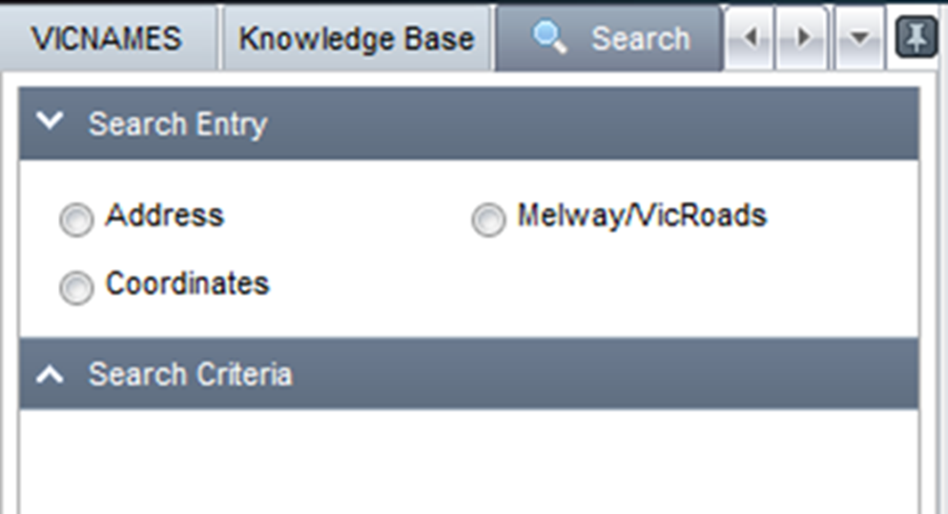

Adjacent to the search tab is the ‘build map’ tab. From here, you can determine which information is displayed on the map screen.

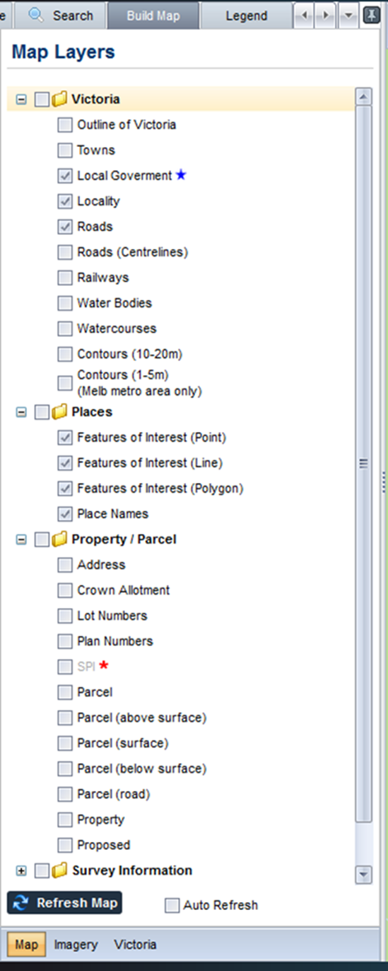

Adjacent to build map tab is the legend tab which enables you to interpret the map.

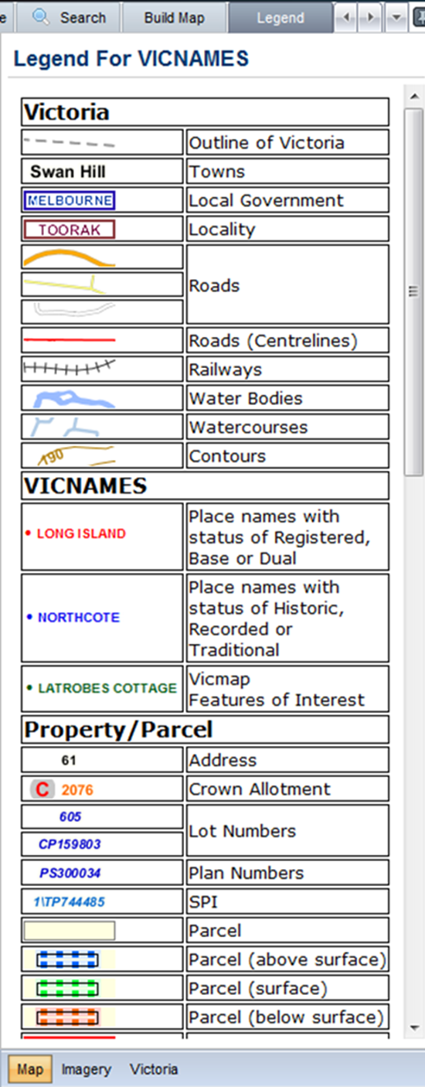

12 Contact us

For [contact details](http://www.dtpli.vic.gov.au/property-and-land-titles/naming-places), refer to www.delwp.vic.gov.au/namingplaces>Contact the Office of Geographic Names