|  |
| --- |
| My Profile: Register an Organisation |
| November 2017 |

## Introduction

Access to the on-line services provided by Information Services Division, DELWP, requires user registration and authorisation. This information sheet describes the process of registering an Organisation as an authorised user of these services.

## Registration

1. Go to <http://services.land.vic.gov.au/MyProfile>
2. Pending request screen capture
   Log-in with your username and password, if you have not already registered, you can do so by clicking “Register” in the left menu. Refer to the User Registration heading in the [Register a User](https://www2.delwp.vic.gov.au/__data/assets/pdf_file/0028/56953/IWS-4.2f-User-Registration.pdf) information sheet.  
     
   If you cannot see your profile details click on “View My Details” in the left menu.
3. Org_barClick on “New” from the Organisations menu bar.
4. 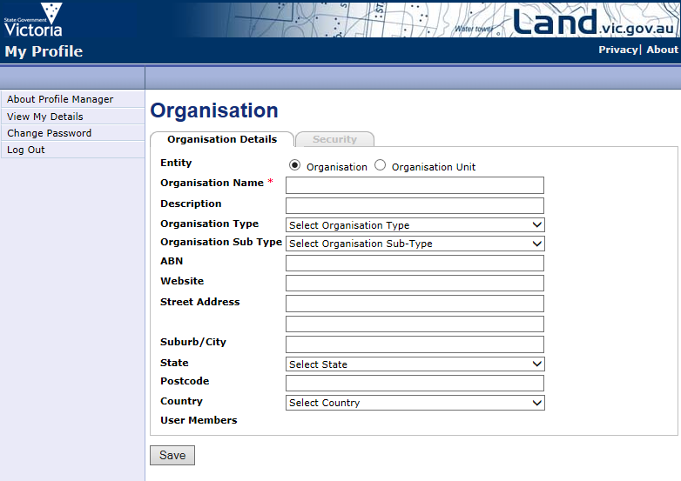Enter your organisation details and save:
5. As the Organisation requestor you also need to be a user member. To add yourself, click on the “Request Access” button, in the Organisations window.

request access to be part of an organisation screen capture

1. screen capture for requesting membership to an organisation
   Add the Organisation name and select
2. As the administrator, you will need to approve your request to join the organisation. To do this select the “Add user to organisation” text in the Pending Requests window
3. 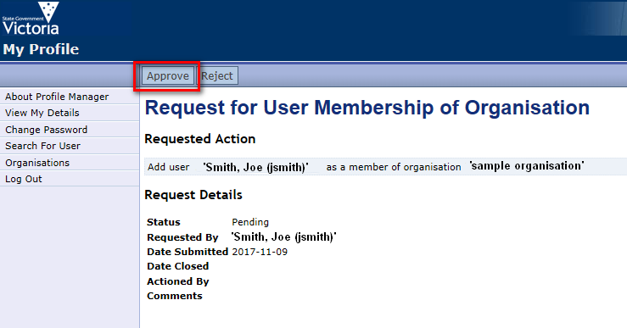Select the Approve button
4. The MyProfile Administrator will now assess your request. You will receive confirmation via an email.

## Access to Applications:

To access an application, the application (for example, the Image Web Server) needs to be linked to your organisation. To do this

1. If not already logged into My Profile, Log-in
2. 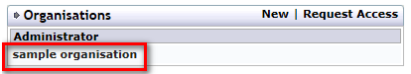Click on your Organisation name in the “organisation window“.
3. Click on the “Request Access” button above the Organisation details.
4. linking an application to an organisation
   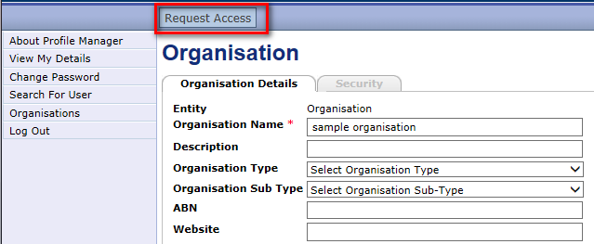Select your Organisation and the application your organisation requires access to from the options available. Click “Save”.

Confirmation of your request will be emailed to you by the appropriate Application Administrator. Once this has been received all users of your Organisation will have access to the application. Users can verify their access via the “View My Details” page under Applications.

## Need Help?

Please email any feedback or queries to gis.helpdesk@delwp.vic.gov.au

|  |  |
| --- | --- |
| © The State of Victoria Department of Environment, Land, Water and Planning 2017  LogoThis work is licensed under a Creative Commons Attribution 4.0 International licence. You are free to re-use the work under that licence, on the condition that you credit the State of Victoria as author. The licence does not apply to any images, photographs or branding, including the Victorian Coat of Arms, the Victorian Government logo and the Department of Environment, Land, Water and Planning (DELWP) logo. To view a copy of this licence, visit http://creativecommons.org/licenses/by/4.0/  Disclaimer  This publication may be of assistance to you but the State of Victoria and its employees do not guarantee that the publication is without flaw of any kind or is wholly appropriate for your particular purposes and therefore disclaims all liability for any error, loss or other consequence which may arise from you relying on any information in this publication. | Accessibility  If you would like to receive this publication in an alternative format, please telephone the DELWP Customer Service Centre on 136186, email [customer.service@delwp.vic.gov.au](mailto:customer.service@delwp.vic.gov.au), or via the National Relay Service on 133 677 [www.relayservice.com.au](http://www.relayservice.com.au). This document is also available on the internet at [www.delwp.vic.gov.au](http://www.delwp.vic.gov.au). |