LAND VICTORIA
CUSTOMER INFORMATION BULLETIN No. 126/2010

Section 35 plans

From 4 April 2011 Land Victoria will implement improvements to the way in which we treat acquisition of land by authorities through Plans of Subdivision (Section 35 Subdivision Act 1988).
Currently, Land Victoria registers these plans without all the documentation required to achieve vesting. For plans where the vesting has not been completed, Land Victoria places a ‘Plan Affects’ notation on the folio. This practice creates dual land descriptors and has led to confusion in searching as well as concerns from members of the public and industry. In approximately 1000 cases, no action has ever been taken to complete the vesting after lodging the plans. In other cases, action commenced but was not completed.
Practice Change

The following practice change will eliminate the need for ‘Plan Affects’ on Plans of Subdivision and importantly ensure that vesting actually occurs.

- Section 35 Plans of Subdivision containing land acquired by agreement must be accompanied by the vesting transfer and Certificate(s) of Title when lodged with Land Victoria.
- Section 35 Plans of Subdivision containing land acquired by compulsory acquisition must be accompanied by the relevant Government Gazette when lodged with Land Victoria.

These processes have been successfully trialled. For the past four months Land Victoria’s Subdivision Branch has requested vesting documentation prior to registration of each acquisition plan. After explaining the reasons for the practice change, customer feedback has generally been positive.
Should you require further information, please contact Neil Coupar, Manager Subdivision Branch on 8636 2121.

Land Victoria payment methods

Land Victoria is introducing direct debit as an optional payment method for lodgement fees from mid-December 2010.

Customers who wish to pay by direct debit need to complete a direct debit request form. These are available from the Level 9 reception counter at 570 Bourke Street or at www.dse.vic.gov.au/property. Go to the ‘quick link’ on the right-hand side for Land Victoria forms, guides and fees.

Completed forms can be returned to the Level 9 reception counter or mailed to:

Land Victoria
Department of Sustainability and Environment
PO Box 500
East Melbourne 8002

The existing non-cheque payment methods of cash, debit card and credit card will continue to be available to customers who wish to use them.

The previously advised proposal to phase out cheques as a payment method has been deferred until mid-2011 to enable further consultation with customers. In the interim, bank cheques and lawyers’ and conveyancers’ trust or office account cheques will continue to be accepted. Other third party cheques are not acceptable; this payment method was phased out in January 2010.

Any enquires should be directed to Land Victoria Customer Service on (03) 8636 2010.


Single signing in Electronic Conveyancing

Electronic Conveyancing (EC) subscribers will be able to use ‘single signing’ functionality in mid-December 2010. It will significantly improve the system’s efficiency, especially when separation of duties requires documents to be created and signed by different users.

In essence, this exciting new initiative allows subscribers to sign all their documents at the same time – currently, all documents in an ELF need to be individually signed, which can result in up to six signing events.

This development has been eagerly awaited by the financial, conveyancing and legal industries and has been a frequent source of feedback from all subscribers.

How does single signing work?

Accessing the single signing process is as simple as selecting a link marked ‘Review and Sign’ from EC’s side bar menu.

This navigates to a document selector displaying documents available for selection (shown below).

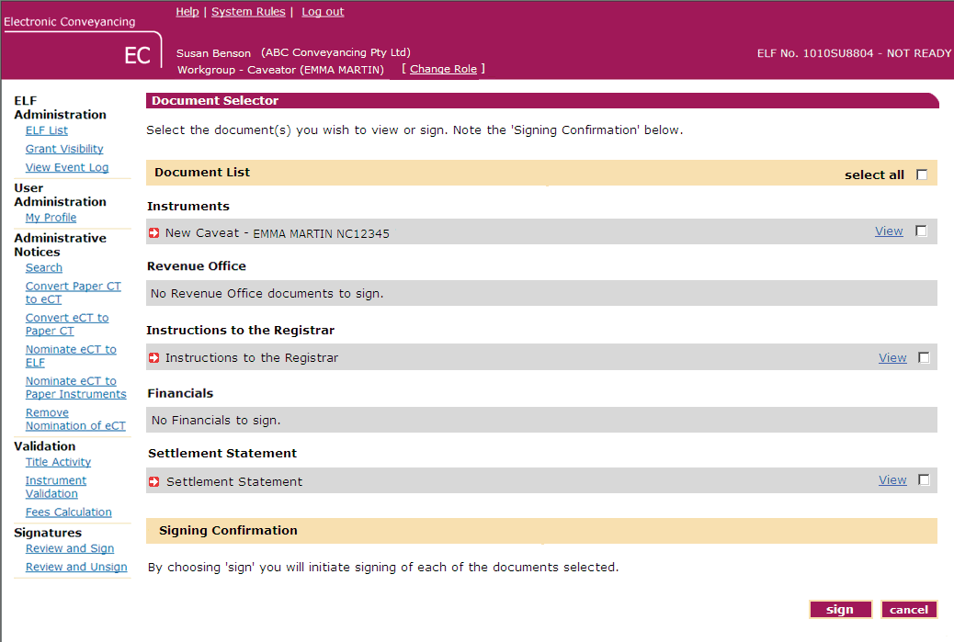

The user then selects the documents to be signed or chooses the ‘select all’ option and initiates the signing process – at this point the subscriber’s digital signing password is required (shown below).

The end result is that the selected documents are all signed electronically in one simple process.

