# Changes to the Transfer of land forms

New requirements for creating restrictive covenants in transfers and restrictions in plans will come into effect on 1 July 2018. This article will explore the requirements for restrictive covenants in transfers and how they relate to forms, for further information about restrictions in plans please see [Customer Information Bulletin 175](https://www.propertyandlandtitles.vic.gov.au/customer-information-bulletins/).

In the *Registrar’s Requirements for Paper Conveyancing Transactions* Version 4*,* requirement 12.2 provides that:

The details of any restrictive covenant to be created in a transfer:

(a) for which any contract of sale is signed on or after 1 July 2018; or

(b) when there is no contract of sale, the transfer is signed on or after 1 July 2018;

must be contained in a Memorandum of Common Provisions (MCP) or MCPs and referred to in the transfer by the MCP number(s).  
  
To allow customers to comply with the new requirements, changes have been made to the *Transfer of land* and *Transfer of land – creating an easement/restrictive covenant* *(formerly T2)* forms. The *Memorandum of Common Provisions* *(MCP)* form has also been updated. Customers will be notified when changes to the *Transfer of land by mortgagee or annuitant 77TLA (formerly T3)* are made.

## Summary of changes

### Transfer of land

* The *Transfer of land form* (with version LV-V33-May-2017 in footer) has been removed from the website and replaced with versionLV-V34-Mar-2018.
* The *Transfer of land form (LV-V34-Mar-2018)* has a new panel **8. Covenants**, described on the next page.

### Transfer of land (formerly T2)

* The current *Transfer of land – creating an easement/restrictive covenant* remains available on the website for a limited transitional time.
* A new Transfer of land form has been created and named *Transfer of land – creating an easement.*

### Memorandum of common provisions

* The MCP form has been updated to provide some rich text functionality. This includes: bullet points, bolding, italics.

## Customer use

All versions of forms available on the [Land Use Victoria Transfer of Land Act page](https://www.propertyandlandtitles.vic.gov.au/forms-guides-and-fees/transfer-of-land/) and can be used and lodged at Land Use Victoria.

Although not available on the [Land Use Victoria website](https://www.propertyandlandtitles.vic.gov.au/forms-guides-and-fees/transfer-of-land/), the preceding version of the Transfer of land form (LV-V33-May-2017) will continue to be accepted for lodgment if it complies with Registrar’s requirement 12.2.

Updated guides for each form are available on the [Land Use Victoria website](https://www.propertyandlandtitles.vic.gov.au/forms-guides-and-fees/transfer-of-land/) by clicking on the  symbol under the form name.

## How to complete section 8. Covenants in the Transfer of land (former T1) form

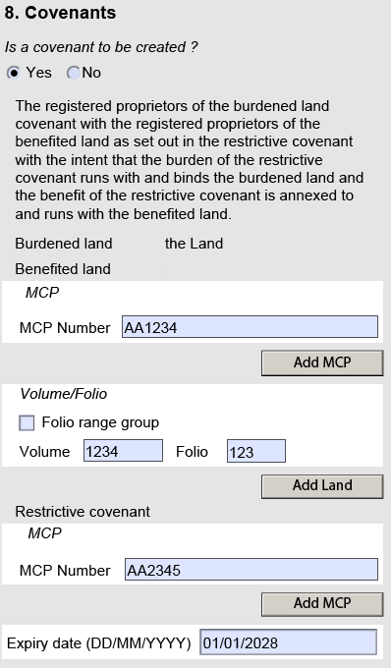

Restrictive covenant is a mandatory field. Enter the MCP number(s) that contains the restrictive covenant - multiple MCPs can be entered by clicking ‘Add MCP’ button.

Benefited land is a mandatory field and requires a MCP number(s) and/or Volume/Folio reference(s).

Multiple MCPs can be entered by clicking the ‘Add MCP’ button.

Multiple Volume/Folio references can be entered by clicking the ‘Add Land’ button.

Select ‘Yes’ only if a restrictive covenant is to be created in the Transfer.

If applicable, enter the expiry date of the restrictive covenant. If there are more than one expiry dates, enter the latest date.

**Subscribe**

To receive notification when a Customer Information Bulletin is published, please send an email to lv.cib@delwp.vic.gov.au with SUBSCRIBE in the subject line – include your name and email address in the body of the email.

# Contact us

|  |  |
| --- | --- |
| © The State of Victoria Department of Environment, Land, Water and Planning 2018  LogoThis work is licensed under a Creative Commons Attribution 4.0 International licence. You are free to re-use the work under that licence, on the condition that you credit the State of Victoria as author. The licence does not apply to any images, photographs or branding, including the Victorian Coat of Arms, the Victorian Government logo and the Department of Environment, Land, Water and Planning (DELWP) logo. To view a copy of this licence, visit http://creativecommons.org/licenses/by/4.0/  Disclaimer  This publication may be of assistance to you but the State of Victoria and its employees do not guarantee that the publication is without flaw of any kind or is wholly appropriate for your particular purposes and therefore disclaims all liability for any error, loss or other consequence which may arise from you relying on any information in this publication. | Accessibility  If you would like to receive this publication in an alternative format, please telephone the DELWP Customer Service Centre on 136186, email [customer.service@delwp.vic.gov.au](mailto:customer.service@delwp.vic.gov.au), or via the National Relay Service on 133 677 [www.relayservice.com.au](http://www.relayservice.com.au). This document is also available on the internet at [www.delwp.vic.gov.au](http://www.delwp.vic.gov.au). |

For [location and contact details](http://www.dtpli.vic.gov.au/property-and-land-titles/contact-us), go to [www.propertyandlandtitles.vic.gov.au/contact-us](http://www.propertyandlandtitles.vic.gov.au/contact-us).