|  |
| --- |
| Vicmap Product Development |
| Change Notice # 234, November 2017 |

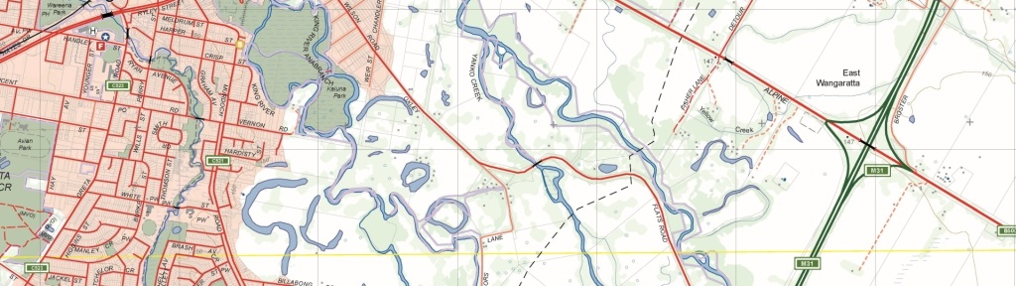

Vicmap Admin – Ward boundaries

## What is happening

From 20 November 2017, WARD_2017 is being added to Vicmap Admin.

WARD_2017 has been created for two reasons:

* To reflect changes to the Greater Geelong City Council structure as gazetted on 29 June 2017. Ward boundaries for all other councils remain unchanged from the WARD_2016 file.
* To add a new column ‘GAZETTAL_DATE’ (Date) to WARD_2017. The ‘GAZETTAL_DATE’ is the date when ward boundaries are published in the Government Gazette.

From 1 March 2018, WARD_2016 will be removed from Vicmap Admin.

## Why this change is occurring

The two changes are explained in more detail below:

* The City of Greater Geelong has undergone significant changes in its electoral structure. The previous council, which was elected in 2012, was dismissed in 2016 and the directly elected mayor position was removed. During this time, Greater Geelong had overlapping objects in the WARD_2016 dataset. There were individual ward objects, and a separate LGA-sized ‘Mayor at Large’ object. Elections for Greater Geelong, including a new mayor, were held in October 2017 and these new boundaries are represented in WARD_2017.
* The ‘GAZETTAL_DATE’ field is the date when ward boundaries are published in the Government Gazette. Previous versions of ward data have not included this field.

## Who it will affect

This change will affect all users of Vicmap Admin. Incremental Update Format (IUF) customers will not be affected as part of this change.

## When the change will occur

WARD_2017 will be added to Vicmap Admin on 20 November 2017 and WARD_2016 will be removed from Vicmap Admin on 1 March 2018.

|  |  |
| --- | --- |
| © The State of Victoria Department of Environment, Land, Water and Planning 2017  LogoThis work is licensed under a Creative Commons Attribution 4.0 International licence. You are free to re-use the work under that licence, on the condition that you credit the State of Victoria as author. The licence does not apply to any images, photographs or branding, including the Victorian Coat of Arms, the Victorian Government logo and the Department of Environment, Land, Water and Planning (DELWP) logo. To view a copy of this licence, visit http://creativecommons.org/licenses/by/4.0/  Disclaimer  This publication may be of assistance to you but the State of Victoria and its employees do not guarantee that the publication is without flaw of any kind or is wholly appropriate for your particular purposes and therefore disclaims all liability for any error, loss or other consequence which may arise from you relying on any information in this publication. | Accessibility  If you would like to receive this publication in an alternative format, please telephone the DELWP Customer Service Centre on 136186, email [customer.service@delwp.vic.gov.au](mailto:customer.service@delwp.vic.gov.au), or via the National Relay Service on 133 677 [www.relayservice.com.au](http://www.relayservice.com.au). This document is also available on the internet at [www.delwp.vic.gov.au](http://www.delwp.vic.gov.au). |

## Contact us

E: [vicmap.help@delwp.vic.gov.au](mailto:vicmap.help@delwp.vic.gov.au)

W: <https://www2.delwp.vic.gov.au/maps>