|  |
| --- |
| Vicmap™ Product Development |
| Change Notice # 235 Intention of Change Notice |

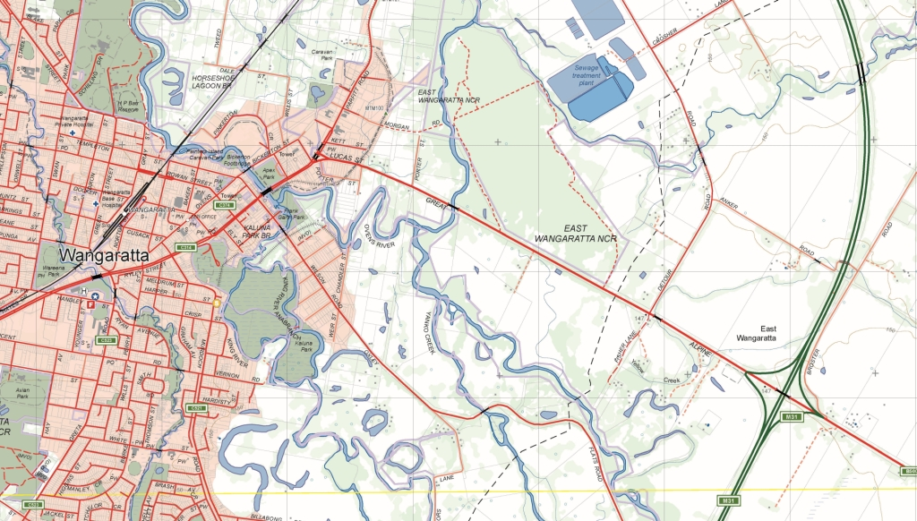

Vicmap Features of Interest Update to sub-feature terminology 24/11/2017

## What is happening

The Vicmap feature catalogue (VMREFTAB.FEATURE_CATALOGUE) holds feature terminology utilised by Vicmap Features of Interest. The feature terminology should align with national feature terms wherever practical. The file can be downloaded from <http://services.land.vic.gov.au/reftab/>

1. Vicmap Feature of Interest (VMFoI) data to be retired or modified. These subtypes will not be available in VMFoI.

Data to be either retired or issued with a different sub-feature term.

The identified data will:

|  |  |  |  |
| --- | --- | --- | --- |
| **CURRENT *feature subtype*** | **What is happening** | **Number of records** | **Reason** |
| flagpole | records to be moved to ‘monument’ or ‘historic site’ | 1 | Feature sub type is no longer relevant in this database as the low number of records suggest. |
| fountain | records to be moved to ‘monument’ | 1 | Feature sub type is no longer relevant in this database as the low number of records suggest. |
| light pole | records to be moved to ‘tower’ | 0 | Feature sub type is no longer relevant in this database as the low number of records suggest. |
| over burden pile | records to be removed | 547 | Feature sub type is no longer relevant in this database. |
| ruin | records to be retained as ‘historic site’ if named or to be retired | 483 | Feature sub type is no longer relevant in this database. |
| sheriffs office | records to be moved to ‘justice service’ | 21 | Feature sub type is better described by the new term as advised by authoritative source |
| tailings | records to be retired | 43 | Feature sub type is no longer relevant in this database. |
| tank | Records to be moved to ‘tank_water’ in VMHYDRO.WATER_STRUCTURE_POINT | 1,042 | Feature sub type is no longer relevant in this database as it duplicates hydro_water_structure _point within Vicmap Hydro. |
| factory | Records to be distributed to better describe | 85 | Feature sub type is no longer relevant in this database. |

2. Sub-feature terms to be modified, data to be retained.

Current sub-feature terms to be retired and new sub-feature terms issued.

|  |  |  |  |
| --- | --- | --- | --- |
| **NEW *feature subtype*** | **To be RETIRED feature subtype** | **Number of records** | **Reason** |
| Justice service | Custodial service | 66 | Feature sub type is better described by the new term as advised by authoritative source |

3. Sub-feature terms added, data to be sourced.

|  |  |  |  |
| --- | --- | --- | --- |
| **NEW *feature subtype*** | **Spatial Change** | **Number of Records** | **Reason** |
| prison complex – currently held as a point record | To be held with a spatial extent and will only exist where an authoritative sourced ‘prison’ record exists | 14 | Feature subtype is better depicted as a polygon rather than a point to conform with similar complex type features. |

4. Sub-feature term’s spatial representation to be changed.

|  |  |  |  |
| --- | --- | --- | --- |
| **CURRENT *feature subtype*** | **Spatial Change** | **Number of Records** | **Reason** |
| retirement village - currently held as a point record | To be held with a spatial extent, all point records to be modified. | 665 | Feature subtype is better depicted as a polygon rather than a point to conform with similar complex type features. |

## Why this change is occurring

Vicmap Feature of Interest data to be removed because these features are either:

I. no longer relevant in this database, or

II. are better described by another term.

Sub-feature terms to be modified and the data to be retained. Sub-feature terms have been improved because they are better described by another term as advised by authoritative source.

New sub-feature to be added to conform with similar complex site features.

Sub-features term spatial representation changes have been made to conform with similar complex site features.

## Who will it affect

All Vicmap users, particularly those using: VMREFTAB.FEATURE_CATALOGUE, Vicmap Features of Interest, and/or Geomark.

## When the change will occur

The change will be implemented **on the 12/12/2017.**

## How to provide feedback

For further information or feedback please email [vicmap.help@delwp.vic.gov.au](mailto:vicmap.help@delwp.vic.gov.au).

For changes to Vicmap Products please visit the [Updates to Vicmap](https://www2.delwp.vic.gov.au/maps/spatial-data/updates-to-vicmap) page on the DELWP website <www2.delwp.vic.gov.au>

|  |  |
| --- | --- |
| © The State of Victoria Department of Environment, Land, Water and Planning 2017  LogoThis work is licensed under a Creative Commons Attribution 4.0 International licence. You are free to re-use the work under that licence, on the condition that you credit the State of Victoria as author. The licence does not apply to any images, photographs or branding, including the Victorian Coat of Arms, the Victorian Government logo and the Department of Environment, Land, Water and Planning (DELWP) logo. To view a copy of this licence, visit http://creativecommons.org/licenses/by/4.0/  Disclaimer  This publication may be of assistance to you but the State of Victoria and its employees do not guarantee that the publication is without flaw of any kind or is wholly appropriate for your particular purposes and therefore disclaims all liability for any error, loss or other consequence which may arise from you relying on any information in this publication. | Accessibility  If you would like to receive this publication in an alternative format, please telephone the DELWP Customer Service Centre on 136186, email [customer.service@delwp.vic.gov.au](mailto:customer.service@delwp.vic.gov.au), or via the National Relay Service on 133 677 [www.relayservice.com.au](http://www.relayservice.com.au). This document is also available on the internet at [www.delwp.vic.gov.au](http://www.delwp.vic.gov.au). |