|  |
| --- |
| Guide to Dealing Requirements |
|  |

# Overview

Dealing Requirements have been introduced to enable a more streamlined lodging and examination process. Dealing Requirements apply to instruments lodged using an Electronic Lodgment Network (ELN), except for the SPEAR ELN. If used, the likelihood of a faster registration is increased. In most cases Dealing Requirements remove the need for the lodging party to provide evidence to the Land Registry. Dealing Requirements may be mandatory in that they must be selected to support lodgment and progression of a specific instrument type or general in nature and applicable to many instrument types (see tables 1 and 2).

# What are Dealing Requirements?

If additional information is required to support registration or recording of an instrument, ELN Subscribers must specify in the Lodgment Instructions the appropriate Dealing Requirement from the tables below. Selection of the Dealing Requirement indicates that the ELN Subscriber holds the necessary supporting evidence. It does not remove the requirement for the ELN Subscriber to obtain the supporting evidence.  It simply removes the requirement to physically produce the evidence to the Registrar.

The Registrar will rely on selection of the Dealing Requirement, together with the standard certifications given in relation to the instrument, as confirmation that the instrument may be processed. Supporting evidence must be held by the ELN Subscriber.

In a compliance examination, the ELN Subscriber will be required to produce the evidence supporting any selected Dealing Requirement.

# Types of Dealing Requirements

There are two types of Dealing Requirements:

Mandatory Dealing Requirements - Dealing Requirements that must be selected to support lodgment and progression of specific instrument types.

**General Dealing Requirements** - Selection of these Dealing Requirements is not specific to an instrument type and may apply to several instrument types.

# Mandatory Dealing Requirements

These Dealing Requirements must be selected to enable the corresponding instrument type to be accepted for lodgment. If not selected, the ELN Subscriber may receive an error message and the instrument may be refused lodgment.

There is no requirement for supporting evidence to be physically produced to the Registrar to enable lodgment of the instrument. The necessary evidence must be obtained and held by the ELN Subscriber and produced to the Registrar upon request, including in a compliance examination.

Mandatory Dealing Requirements and the instrument to which they relate are set out in the table below and an explanation for what they mean is in the ‘Dealing Requirements explained’ table 1? below.

*Table 1 – Mandatory Dealing Requirements*

|  |  |
| --- | --- |
| **Dealing Requirement** | **Instrument Type** |
|  |  |
| Grant of Probate/Administration/Administration with limitations | Transmission (Legal Personal Representative) |
| Evidence of death | Notice of Death (Survivorship) |
| Lease not required to be assessed for duty or lease assessed for duty | Leases and sub-leases |
| Dealing with Crown lease or Crown sub-lease – any necessary consents obtained | Any dealing with a Crown lease |
| Consent of subsequent registered mortgagee or chargee, if required | Variation of mortgage or charge |

# General Dealing Requirements

These Dealing Requirements may apply to several instrument types depending upon the encumbrances affecting the folio of the Register (title) being dealt with or the specifics of the individual instrument.

There is no requirement for supporting evidence to be physically produced to the Registrar to enable lodgment of an instrument. The necessary evidence must be obtained and held by the ELN Subscriber and produced to the Registrar upon request, including in a compliance examination.

If a Dealing Requirement is not selected, but should have been selected, registration or recording of the instrument(s) may be delayed.

|  |  |
| --- | --- |
| **Dealing Requirement** | **Instrument Type** |
| Consent of Caveator, if required | Many |
| Consent of Council, if required | Many |
| Court Order | Many |
| VCAT Order with supporting statutory declaration | Many |
| State Trustees Section 19 Certificate | Many |
| GAIC – evidence that transfer may proceed | Many |
| Enduring Power of Attorney – this is not a conflict transaction under legislation | Many |
| Trustee – evidence of compliance with section 30 of Trustee Act 1958 | Many |
| Evidence of compliance with Settled Land Act 1958 | Many |

General Dealing Requirements are set out in the table below and an explanation for what they mean are in the ‘Dealing Requirements explained’ table 2? below.

*Table 2 – General Dealing Requirements*

# How to use Dealing Requirements in an ELN

An ELN has Dealing Requirements built into the workspace. If used, the Dealing Requirements will appear in the *Lodgment Instructions* section.

**Example**

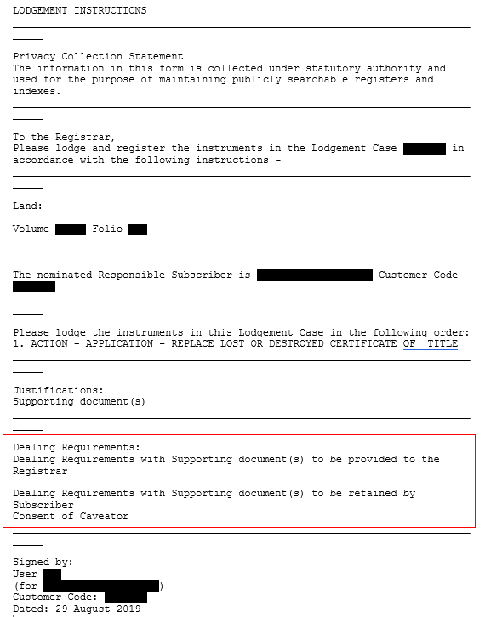

In the example the Dealing Requirement *Consent of Caveator* has been selected. The ELN Subscriber has obtained and retained evidence of the Caveator’s consent. The Registrar will not give notice to the Caveator under section 90(1) of the *Transfer of Land Act 1958* and the dealing will be processed without delay.

# Dealing Requirements explained

### Grant of Probate/Administration/Administration with limitations

When to use – when making an application by a legal personal representative under section 49 of the *Transfer of Land Act 1958* following the death of a sole proprietor or a tenant in common.

Evidence required – the Grant of Probate, Letters of Administration or Letters of Administration with limitations.

### Evidence of death

When to use – when making an application of survivorship under section 50 of the *Transfer of Land Act 1958* following the death of a joint proprietor.

Evidence required – evidence may vary but could include the deceased’s death certificate or a statutory declaration by someone with requisite knowledge (explaining how they have that knowledge) setting out that the registered proprietor has died.

### Lease not required to be assessed for duty or lease assessed for duty

### When to use – when a lease or sub-lease is being lodged for registration under sections 66 and 71 of the *Transfer of Land Act 1958* respectively.

Evidence required – that the Subscriber has assessed that the lease or sub-lease need not be assessed for duty or the State Revenue Office (SRO) has assessed the lease or sub-lease for duty.

### Dealing with Crown lease or Crown sub-lease - any necessary consents obtained

### When to use – when a Crown lease or Crown sub-lease is lodged for registration under the *Transfer of Land Act 1958* or is dealt with in any way, for example, a transfer of lease or variation of lease.

Evidence required – the consents (if any) required under the legislation under which the lease is granted and all consents necessary under the terms of the Crown lease or Crown sub-lease, for example, a Minister’s consent.

### Consent of subsequent mortgagee or chargee, if required

When to use – when a mortgage or charge is being varied under section 75A of the *Transfer of Land Act 1958*, the consent of any subsequent mortgagee or chargee is required.

Evidence required – the written consent of the subsequent mortgagee(s) or chargee(s).

### Consent of Caveator, if required

When to use – when lodging an instrument over a folio affected by a caveat.

If the consent of the caveator is required and this Dealing Requirement is not selected, notice will be given to the Caveator under section 90(1) of the *Transfer of Land Act 1958*.

Consent is not required if the instrument satisfies the Caveator’s claim or notice is not required under section 90(1) of the *Transfer of Land Act 1958*.

Evidence required – the written consent of the Caveator.

### Consent of Council, if required

When to use – when an instrument creates, varies or removes a carriageway easement or when an application is made under section 88(1B) of the *Transfer of Land Act 1958*.

Evidence required – the written consent of the Council of the municipality in which the land is situated.

### Court Order

When to use – if an instrument is the result of a Court order, for example:

(a) a transfer is ordered by a Court; or

(b) a party other than the registered proprietor is dealing with the land pursuant to a Court order.

Evidence required – the Court order.

### VCAT Order with supporting statutory declaration

When to use – if a party to an instrument has an administrator appointed by an order of the Victorian Civil and Administrative Tribunal (VCAT) under the *Guardianship & Administration Act 1986*.

Evidence required –the VCAT order and a statutory declaration by someone with requisite knowledge (explaining how they have that knowledge) stating that the order has not lapsed or been revoked and that the represented person is identical with the party to the instrument.

### State Trustees Section 19 Certificate

When to use – if an instrument relies on a certificate issued under section 19 of the *State Trustees (State Owned Corporation) Act 1994*, whether State Trustees Ltd acts in the capacity of administrator under the *Guardianship & Administration Act 1986*, a manager of a protected person’s estate or as executor or administrator of a deceased estate.

Evidence required – the section 19 Certificate.

### GAIC – evidence that transfer may proceed

When to use – when lodging a transfer over a folio affected by a Growth Areas Infrastructure Contribution (GAIC) Notice. If the GAIC Notice is not being removed, the consent from the SRO to registration of the transfer is required.

Evidence required – the written consent of the SRO.

If this Dealing Requirement is not selected, then the transfer will be accepted for lodgment, but not processed until the SRO’s consent is produced to the Land Registry.

Note - the GAIC Notice remains on the folio.

Enduring Power of Attorney - this is not a conflict transaction under legislation

### When to use – when an attorney under an enduring power of attorney signs a Client Authorisation or gives any other authorisation or instruction in relation to an instrument.

Evidence required – the Subscriber’s assessment that the instrument is not a conflict transaction under section 64 of the *Power of Attorney Act 2014* or any other legislation under which the enduring power of attorney was made. See Customer Information Bulletin 170 for more information.

### Trustee – evidence of compliance with section 30 of the Trustee Act

When to use – if a trustee is a party to an instrument and the trustee has never resided in Victoria, is absent from Victoria, or is about to depart from Victoria. If one of these circumstances applies, the trustee may appoint an attorney to execute or exercise (while the trustee is out of Victoria) all or any trusts, powers and discretions vested in the trustee.

Evidence required –the power of attorney and a statutory declaration by someone with requisite knowledge (explaining how they have that knowledge) explaining that the trustee has never resided in Victoria, is absent from Victoria, or is about to depart from Victoria.

### Evidence of compliance with Settled Land Act 1958

When to use – when the *Settled Land Act 1958* applies. For example, when a person under the age of 18 (a minor) is the registered proprietor of land and seeks to deal with it in some way, for example, transfer it, mortgage it, grant or take an easement. See Customer Information Bulletin 174 for further guidance.

Evidence required –the trust deed or court order, evidencing the appointment of the trustee(s).

1. **Retention of evidence**

All evidence must be retained for at least 7 years. If production of evidence is required, copies and certified copies of documents may be acceptable depending on the circumstances.

1. **Compliance examinations**

In an ELN Subscriber compliance examination, the ELN Subscriber will be required to produce copies of the evidence held in support of each Dealing Requirement selected.

# Contact us

To contact us go to - [www.land.vic.gov.au/contact-us](http://www.land.vic.gov.au/contact-us)

|  |  |
| --- | --- |
| © The State of Victoria Department of Environment, Land, Water and Planning 2022  LogoThis work is licensed under a Creative Commons Attribution 4.0 International licence. You are free to re-use the work under that licence, on the condition that you credit the State of Victoria as author. The licence does not apply to any images, photographs or branding, including the Victorian Coat of Arms, the Victorian Government logo and the Department of Environment, Land, Water and Planning (DELWP) logo. To view a copy of this licence, visit http://creativecommons.org/licenses/by/4.0/  Disclaimer  This publication may be of assistance to you but the State of Victoria and its employees do not guarantee that the publication is without flaw of any kind or is wholly appropriate for your particular purposes and therefore disclaims all liability for any error, loss or other consequence which may arise from you relying on any information in this publication. | Accessibility  If you would like to receive this publication in an alternative format, please telephone the DELWP Customer Service Centre on 136186, email [customer.service@delwp.vic.gov.au](mailto:customer.service@delwp.vic.gov.au), or via the National Relay Service on 133 677 [www.relayservice.com.au](http://www.relayservice.com.au). This document is also available at [www.delwp.vic.gov.au](http://www.delwp.vic.gov.au). |