Land Victoria
Customer Information Bulletin No. 139/2012

Changes to ‘Made Available’ process

From Monday 4 February 2013, Land Victoria will alter the Made Available process, where one party provides a Certificate of Title to facilitate the lodgement of a transaction by another party.

The new process will require the customer who produces the Certificate of Title to present with it a Nomination Request form. Land Victoria staff will record that the Certificate of Title has been 'nominated’ and will also record the issuing instructions contained in the form received from the nominating party.

This process will entirely replace the existing 'Order to Register' process.

When the transaction is subsequently presented, it will not contain an Order to Register or any other information regarding issuing. The transaction will be processed and the Certificate of Title will issue in accordance with the instructions already held in Victorian Online Titles System (VOTS).

The Nomination Request form will shortly be available on the DSE website. An example of the form is included in this bulletin.

The new process has significant advantages for both lodging parties and customers that routinely produce Certificates of Title, principally financial institutions. For lodging parties, the main advantage is that a transaction document no longer needs to be sent to the nominating party, which reduces delays and eliminates the risk of losing the transaction document.

The main advantage of the new process to nominating parties is that it eliminates the need to handle transaction documents. When a customer requests a Certificate of Title be produced to the Registrar, the nominating party simply needs to produce it with a completed Nomination Request form.

Business rules regarding issuing a Certificate of Title

Under the revised process, when a Certificate of Title is produced by a nominating party, the issuing instructions provided by that party will be entered and retained in VOTS. When the subsequent transaction document(s) is/are registered, the Certificate of Title will issue according to the instructions held. This applies to all lodgements when the folio is not cancelled.

When a folio is cancelled

If the parent folio is cancelled and a new folio or folios is/are created, the Certificate of Title for the child folio(s) will issue to the controlling party of the dealing or plan, unless the child folio remains subject to a mortgage in favour of the nominating party of the parent Certificate of Title. In this case, the Certificate(s) of Title will issue in accordance with instructions held in VOTS for the parent Certificate of Title. The dealings to which this rule applies include plans of subdivision or consolidation and applications for new folios under Section 32 of the Transfer of Land Act 1958.

In cases where a new folio is created from multiple parent folios, the Certificate of Title for the child folio(s) will issue to the controlling party of the dealing or plan, unless the child folio remains subject to a mortgage in favour of a nominating party of a parent Certificate of Title. In this case it will issue in accordance with instructions held in VOTS for the parent Certificate of Title.

If a child folio remains subject to multiple mortgages in favour of one or more nominating parties of the parent Certificates of Title (typically from plans of subdivision or consolidation that create Not in Common Ownership (NICO) folios), the Certificate of Title for the child folio will issue to the nominating party of the mortgage that has first priority (usually, but not always, the one that was first registered).

Followers

Specific rules will apply to a transaction document lodged as a ‘follower’. (Follower in this context means a transaction document that is lodged for registration when the Certificate of Title is already in another unregistered dealing – the ‘leader’ transaction).

In such cases, the Certificate of Title will issue from the registration of the follower transaction to the controlling party of that transaction document, unless the folio remains subject to a mortgage in favour of the nominating party in the leader transaction. In this case it will issue to that party.

There will be a transition period

Business rules have been developed to manage processing of transaction documents up to 180 days after the new nomination process commences. During this period, there will be a mix of Certificates of Title produced with and without a Nomination Request form. There will also be a mix of transaction documents lodged with and without Orders to Register.

During the transition period, transaction documents will be processed as follows:

1. If there is no Order to Register on/with the transaction document – Land Victoria will rely on the issuing instructions held in VOTS.

- If there is an Order to Register on the transaction document – Land Victoria staff will check the date the Certificate of Title was nominated. If the date is prior to the commencement of the new process, the Certificate of Title will issue according to the Order to Register. If the date is subsequent to the commencement of the new process, the Certificate of Title will issue according to the instructions held in VOTS.

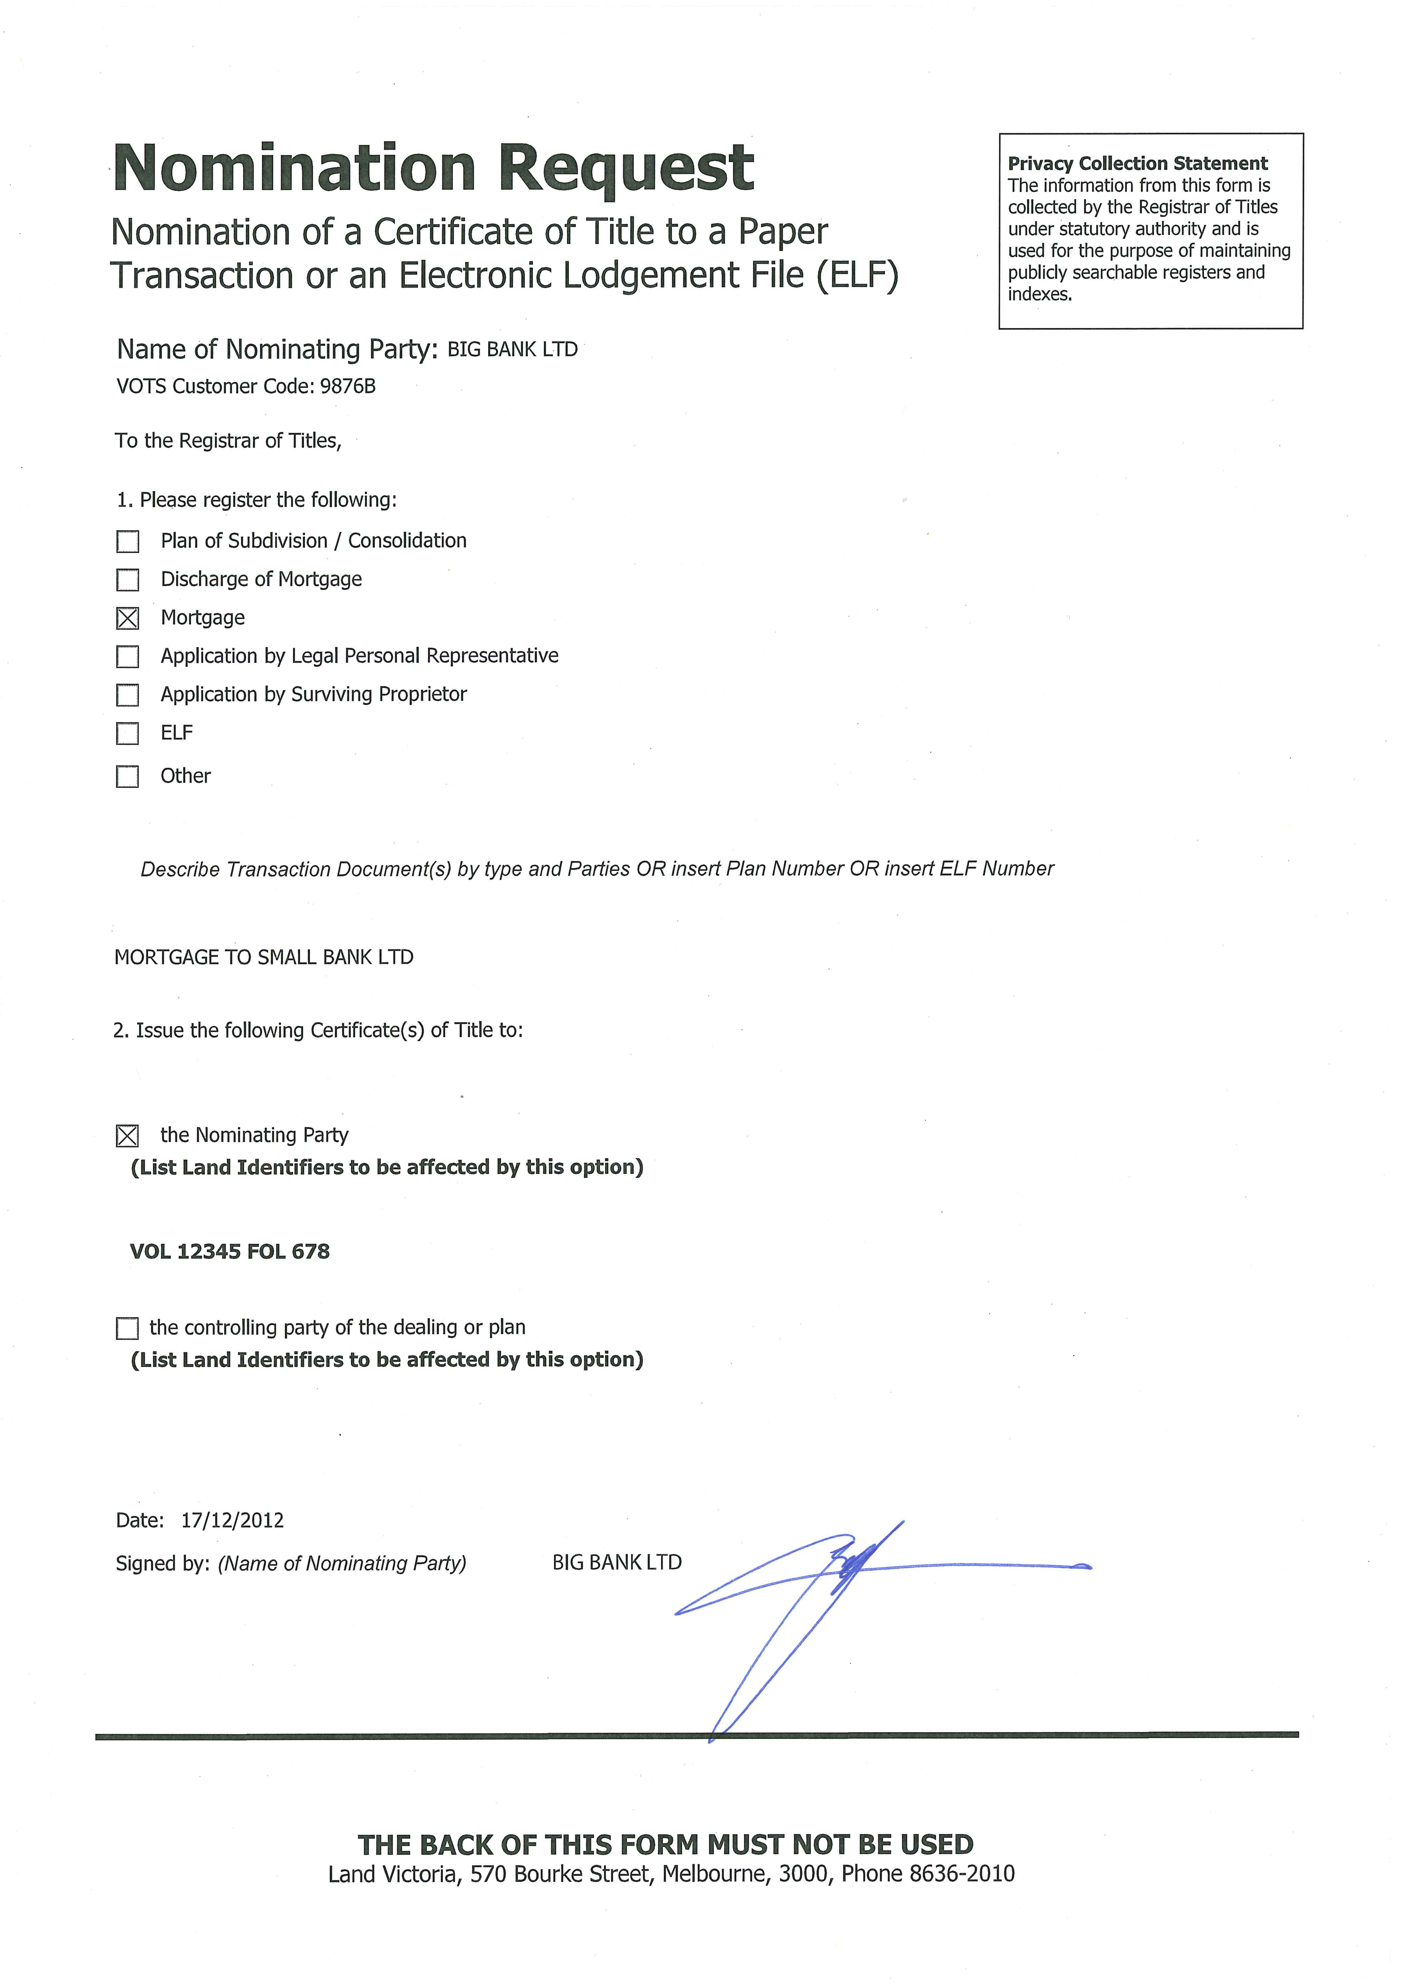
Dealings by insolvent companies

Customer Information Bulletin No. 91 (Oct 2005) contained an article advising customers of the evidence required by Land Victoria (by way of Statutory Declaration) to support dealings by insolvent companies – when a company is in liquidation or under administration; or, a receiver, manager or controller has been appointed.

Land Victoria will not, in the future, require production of evidence if the execution clause in the instrument is in the following terms:

Executed by (receiver/manager/controller/liquidator/administrator) in accordance with the Corporations Act 2001 (Cth) and the court order or instrument appointing him or her self.

Signature/s
Full name/s
(Please print)

If this execution clause is used, the usual statutory declarations and the date and description of the court order or instrument of appointment will not be required. Further, a witness is not required unless the controller [etc.] is affixing the company seal and witnessing the affixing him or her self.

Enhanced search services

LANDATA® has introduced two services that enable customers to get timely answers online without having to attend or telephone Land Victoria.

Accompanying these changes and to improve processing efficiency, Land Victoria staff will direct enquirers to our website for information on Made Available statuses or the Certificates of Title issuing from a plan.

Made Available Alert

You no longer need to call Land Victoria or perform multiple Pre-Lodgement Checks: simply subscribe to the new Made Available Alert.

As part of the LANDATA® suite of property transaction alerts, the new Made Available Alert provides customers with an email alert when a nominated Certificate of Title has been received by Land Victoria. You can simply ‘set and forget’ your alert until the Certificate of Title is made available.

When are email alerts sent?

Alerts are sent when:
•the Certificate of Title is provided to Land Victoria and details are entered into VOTS
•a dealing or plan affecting the folio is lodged
•the Made Available Alert six month subscription period is about to expire.

How do I subscribe?

A six month subscription can be purchased through:
•www.landata.vic.gov.au/Document Tracking
•your LANDATA® Self Service Search account
•your title information broker.

Title allocation from a plan (Lot List):

Land Victoria offers customers an Internet service that provides up-to-the-minute notification about a plan of subdivision’s progress – from notification at the time of lodgement through to registration. Emails are sent as a plan progresses, which eliminates the need to repeatedly make a dealing enquiry or search, make telephone or in-person enquiries about a plan’s progress.

At the completion of the alert you are advised of the plan’s registration, at which time you can immediately request a ‘lot list’ or ‘title allocation’ to find the volume/folio number for each lot.

This service is now available from your title information broker and through your LANDATA® Self Service Search account, and will be available from April 2013 at www.landata.vic.gov.au/Document Tracking.

If you require more information on these services, please call (03) 8636 2456 or email Landata.enquiries@dse.vic.gov.au.
Building subdivision boundaries

As noted in Customer Information Bulletin No. 133 (Oct 2011), the Subdivision (Registrar’s Requirements) Regulations 2011 introduced improvements to facilitate industry-wide consistency in the representation and interpretation of building subdivision boundaries, including introducing default locations for building boundaries with associated explanatory diagrams.

The regulations also provided a number of examples. Consistent with the Interpretation of Legislation Act 1984, the examples depicted at regulation 10 and 11 are not exhaustive. Each example may extend, but does not limit, the meaning of the provision.

There has been some confusion across the industry about whether it was a requirement under the regulations to show changes in a vertical boundary when the boundary ran along the face of a wall, and up and around eaves and guttering.

The examples only illustrate the operation of the provision and do not impose any additional requirement.

A plan that adopts a building boundary that is exterior face, interior face or median does not need to include a cross-section corresponding to the examples in regulation 10(4). A cross-section is only necessary when there is a step in a vertical boundary not defined by 10(4). The examples are included in the regulations to clarify how a building boundary will be interpreted in accordance with regulation 10(4).

The cross-section example below of exterior face is an excerpt from the regulations and is not required to be shown on the plan. The boundary need only be shown on the plan diagram as a thick line, providing there is a notation indicating that Subdivision (Registrar’s Requirements) Regulations 2011 apply. An acceptable plan diagram is shown on the following page.

For further information, please email Land Victoria’s Subdivision Branch -Subdivision.Branch@dse.vic.gov.au.

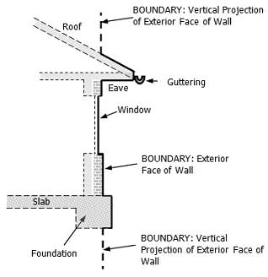

Subdivision (Registrar’s Requirements) Regulations 2011
Apply to boundaries defined by buildings

Location of boundaries defined by buildings;
exterior face: all boundaries

How to subscribe to the Customer Information Bulletin
To receive the CIB online, send an email with your name and email address to lv.cib@dse.vic.gov.au with SUBSCRIBE in the subject line.

Subscribers receive an email including a link to each new issue available for download from the Department of Sustainability and Environment website.

Unsubscribe by sending an email with UNSUBSCRIBE in the subject heading.

For further information:
Land Registration Services
Land Victoria
Level 9, 570 Bourke Street
Melbourne VIC 3000
PO Box 500
East Melbourne VIC 8002
DX 250639
Telephone (03) 8636 2010
Fax (03) 8636 2299

Published by the Victorian Government Department of Sustainability and Environment Melbourne December, 2012
© The State of Victoria Department of Sustainability and Environment 2012
This publication is copyright. No part may be reproduced by any process except in accordance with the provisions of the Copyright Act 1968.

Authorised by the Victorian Government, 570 Bourke Street, Melbourne.
ISSN 1441-1504 PP 349181/01650

For more information contact the DSE Customer Service Centre 136 186

Disclaimer
This publication may be of assistance to you but the State of Victoria and its employees do not guarantee that the publication is without flaw of any kind or is wholly appropriate for your particular purposes and therefore disclaims all liability for any error, loss or other consequence which may arise from you relying on any information in this publication.

Accessibility
If you would like to receive this publication in an accessible format, such as large print or audio, please telephone 136 186, or email customer.service@dse.vic.gov.au

Deaf, hearing impaired or speech impaired? Call us via the National Relay Service on 133 677 or visit www.relayservice.com.au

