Vicmap Elevation 1m DEM Sample Services

User Guide

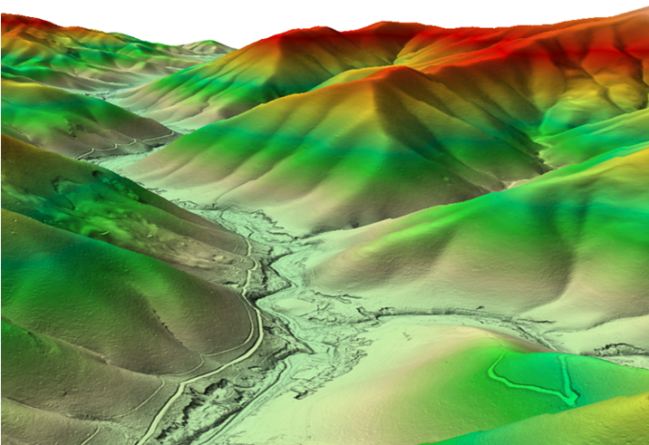



Contents

Part A: Service Descriptions 2

Vicmap 1m DEM Sample Service – Mount Bogong 3

Vicmap 1m DEM Sample Service – Mount Buffalo 4

Vicmap 1m DEM Sample Service – Mount Delegate 5

Vicmap 1m DEM Sample Service – Snowy River 6

Vicmap 1m DEM Sample Service – Wilsons Promontory 7

Vicmap 1m DEM Sample Service – Tower Hill 8

Vicmap 1m DEM Sample Service – Koondrook 9

Vicmap 1m DEM Sample Service – Great Ocean Road 10

Vicmap 1m DEM Sample Service – Lakes Entrance 11

Vicmap 1m DEM Sample Service – Sandbelt 12

Vicmap 1m DEM Footprints 13

Vicmap 1m DEM Servers 14

Part B: Service Connection Guidelines 15

Connecting via ArcGIS Pro v2.8 16

Adding a Web Map Service (WMS) Connection 16

Adding a Web Map Tile Service (WMTS) Connection 18

Adding an ESRI Rest Server (ArcGIS Server) Connection 20

Adding an ESRI Rest Service from an ESRI Rest Server (ArcGIS Server) Connection 21

Adding a Web Feature Service (WFS) Connection 22

Connecting via QGIS V3.36 24

Adding an ESRI Rest Server (ArcGIS Server) Connection 24

Adding Services from an ESRI Rest Server (ArcGIS Server) Connection 26

Adding a Web Coverage Server (WCS) Connection 27

Adding Services from a WCS connection 29

Adding a Web Map Server (WMS) or Web Map Tile Server (WMTS) Connection 30

Adding Services from a WMS/WMTS Connection 32

Adding a Web Feature Service (WFS) Connection 33

Adding Services from a Web Feature Service (WFS) Connection 35

Part C: Available Vicmap 1m DEM Sample Viewers 36

DTV Platform 37

Vicmap 1m DEM Sample Viewer 39

# Part A: Service Descriptions

## Vicmap 1m DEM Sample Service – Mount Bogong

|  |  |  |
| --- | --- | --- |
| **Description** | The Vicmap 1m DEM Sample services represent a set of free to use subsets of the Vicmap 1m DEMand are published with the same symbology and coordinate reference system as the Vicmap 1m DEM Relief service**.** Each sample reflects a typical landscape setting or well-known location in Victoria.  This sample service is over a section of Mount Bogong in the Victorian Alps region showing Victorias highest peak and the foothills towards Mount Beauty. | |
| **Key Design Purpose** | To provide a unlicensed user with preview of the detail available in the Vicmap 1m DEM. | |
| **Available Service Interfaces** | |  |  |  |  |  | | --- | --- | --- | --- | --- | | **ESRI REST** | **WMS** | **WCS** | **WMTS** | **WFS/OGC API** | | ✔ | ✘ | ✘ | ✔ | ✘ | | |
| **Service URLs** | **WMTS** | https://tiles-ap1.arcgis.com/P744lA0wf4LlBZ84/arcgis/rest/services/Vicmap_1m_DEM_Sample_Mount_Bogong_v2/MapServer/WMTS/1.0.0/WMTSCapabilities.xml |
| **ESRI REST Service** | https://tiles-ap1.arcgis.com/P744lA0wf4LlBZ84/arcgis/rest/services/Vicmap_1m_DEM_Sample_Mount_Bogong_v2/MapServer |
| **Coordinate Reference System** | |  |  | | --- | --- | | **EPSG Code** | 3857 | | **Name** | Web Mercator | | |
| **Default Symbology (ArcGIS)** |  | |

## Vicmap 1m DEM Sample Service – Mount Buffalo

|  |  |  |
| --- | --- | --- |
| **Description** | The Vicmap 1m DEM Sample services represent a set of free to use subsets of the Vicmap 1m DEMand are published with the same symbology and coordinate reference system as the Vicmap 1m DEM Relief service**.** Each sample reflects a typical landscape setting or well-known location in Victoria.  This sample service is over a section of Mount Buffalo in the Victorian Alps region demonstrating a high-altitude plateau landscape with steep drop off. | |
| **Key Design Purpose** | To provide a unlicensed user with preview of the detail available in the Vicmap 1m DEM. | |
| **Available Service Interfaces** | |  |  |  |  |  | | --- | --- | --- | --- | --- | | **ESRI REST** | **WMS** | **WCS** | **WMTS** | **WFS/OGC API** | | ✔ | ✘ | ✘ | ✔ | ✘ | | |
| **Service URLs** | **WMTS** | https://tiles-ap1.arcgis.com/P744lA0wf4LlBZ84/arcgis/rest/services/Mount_Buffalo/MapServer/WMTS/1.0.0/WMTSCapabilities.xml |
| **ESRI REST Service** | https://tiles-ap1.arcgis.com/P744lA0wf4LlBZ84/arcgis/rest/services/Mount_Buffalo/MapServer |
| **Coordinate Reference System** | |  |  | | --- | --- | | **EPSG Code** | 3857 | | **Name** | Web Mercator | | |
| **Default Symbology (ArcGIS)** |  | |

## Vicmap 1m DEM Sample Service – Mount Delegate

|  |  |  |
| --- | --- | --- |
| **Description** | The Vicmap 1m DEM Sample services represent a set of free to use subsets of the Vicmap 1m DEMand are published with the same symbology and coordinate reference system as the Vicmap 1m DEM Relief service**.** Each sample reflects a typical landscape setting or well-known location in Victoria.  This sample service is over Mt. Delegate in Northeast Victoria, illustrative of a typically forested mountain landscape. | |
| **Key Design Purpose** | To provide a unlicensed user with preview of the detail available in the Vicmap 1m DEM. | |
| **Available Service Interfaces** | |  |  |  |  |  | | --- | --- | --- | --- | --- | | **ESRI REST** | **WMS** | **WCS** | **WMTS** | **WFS/OGC API** | | ✔ | ✘ | ✘ | ✔ | ✘ | | |
| **Service URLs** | **WMTS** | https://tiles-ap1.arcgis.com/P744lA0wf4LlBZ84/arcgis/rest/services/Vicmap_1m_DEM_Sample_Mount_Delegate/MapServer/WMTS/1.0.0/WMTSCapabilities.xml |
| **ESRI REST Service** | https://tiles-ap1.arcgis.com/P744lA0wf4LlBZ84/arcgis/rest/services/Vicmap_1m_DEM_Sample_Mount_Delegate/MapServer |
| **Coordinate Reference System** | |  |  | | --- | --- | | **EPSG Code** | 3857 | | **Name** | Web Mercator | | |
| **Default Symbology (ArcGIS)** |  | |

## Vicmap 1m DEM Sample Service – Snowy River

|  |  |  |
| --- | --- | --- |
| **Description** | The Vicmap 1m DEM Sample services represent a set of free to use subsets of the Vicmap 1m DEMand are published with the same symbology and coordinate reference system as the Vicmap 1m DEM Relief service**.** Each sample reflects a typical landscape setting or well-known location in Victoria.  This sample service is over a section of the Snowy River in East Gippsland, demonstrating the 1m DEM appearance over the lower reaches of a meandering river system. | |
| **Key Design Purpose** | To provide a unlicensed user with preview of the detail available in the Vicmap 1m DEM. | |
| **Available Service Interfaces** | |  |  |  |  |  | | --- | --- | --- | --- | --- | | **ESRI REST** | **WMS** | **WCS** | **WMTS** | **WFS/OGC API** | | ✔ | ✘ | ✘ | ✔ | ✘ | | |
| **Service URLs** | **WMTS** | https://tiles-ap1.arcgis.com/P744lA0wf4LlBZ84/arcgis/rest/services/Vicmap_1m_DEM_Sample_Snowy_River/MapServer/WMTS/1.0.0/WMTSCapabilities.xml |
| **ESRI REST Service** | https://tiles-ap1.arcgis.com/P744lA0wf4LlBZ84/arcgis/rest/services/Vicmap_1m_DEM_Sample_Snowy_River/MapServer |
| **Coordinate Reference System** | |  |  | | --- | --- | | **EPSG Code** | 3857 | | **Name** | Web Mercator | | |
| **Default Symbology (ArcGIS)** |  | |

## Vicmap 1m DEM Sample Service – Wilsons Promontory

|  |  |  |
| --- | --- | --- |
| **Description** | The Vicmap 1m DEM Sample services represent a set of free to use subsets of the Vicmap 1m DEMand are published with the same symbology and coordinate reference system as the Vicmap 1m DEM Relief service**.** Each sample reflects a typical landscape setting or well-known location in Victoria.  This sample service is over the well-known Wilsons Promontory National Park in South Gippsland. | |
| **Key Design Purpose** | To provide a unlicensed user with preview of the detail available in the Vicmap 1m DEM. | |
| **Available Service Interfaces** | |  |  |  |  |  | | --- | --- | --- | --- | --- | | **ESRI REST** | **WMS** | **WCS** | **WMTS** | **WFS/OGC API** | | ✔ | ✘ | ✘ | ✔ | ✘ | | |
| **Service URLs** | **WMTS** | https://tiles-ap1.arcgis.com/P744lA0wf4LlBZ84/arcgis/rest/services/Wilsons_prom/MapServer/WMTS/1.0.0/WMTSCapabilities.xml |
| **ESRI REST Service** | https://tiles-ap1.arcgis.com/P744lA0wf4LlBZ84/arcgis/rest/services/Wilsons_prom/MapServer |
| **Coordinate Reference System** | |  |  | | --- | --- | | **EPSG Code** | 3857 | | **Name** | Web Mercator | | |
| **Default Symbology (ArcGIS)** |  | |

## Vicmap 1m DEM Sample Service – Tower Hill

|  |  |  |
| --- | --- | --- |
| **Description** | The Vicmap 1m DEM Sample services represent a set of free to use subsets of the Vicmap 1m DEMand are published with the same symbology and coordinate reference system as the Vicmap 1m DEM Relief service**.** Each sample reflects a typical landscape setting or well-known location in Victoria.  This sample service is over Tower Hill in Southwest Victoria and contains the Tower Hill Wildlife Sanctuary situated on a large volcanic crater with extractive industries land use nearby. | |
| **Key Design Purpose** | To provide a unlicensed user with preview of the detail available in the Vicmap 1m DEM. | |
| **Available Service Interfaces** | |  |  |  |  |  | | --- | --- | --- | --- | --- | | **ESRI REST** | **WMS** | **WCS** | **WMTS** | **WFS/OGC API** | | ✔ | ✘ | ✘ | ✔ | ✘ | | |
| **Service URLs** | **WMTS** | https://tiles-ap1.arcgis.com/P744lA0wf4LlBZ84/arcgis/rest/services/Vicmap_1m_DEM_Sample_Tower_Hill/MapServer/WMTS/1.0.0/WMTSCapabilities.xml |
| **ESRI REST Service** | https://tiles-ap1.arcgis.com/P744lA0wf4LlBZ84/arcgis/rest/services/Vicmap_1m_DEM_Sample_Tower_Hill/MapServer |
| **Coordinate Reference System** | |  |  | | --- | --- | | **EPSG Code** | 3857 | | **Name** | Web Mercator | | |
| **Default Symbology (ArcGIS)** |  | |

## Vicmap 1m DEM Sample Service – Koondrook

|  |  |  |
| --- | --- | --- |
| **Description** | The Vicmap 1m DEM Sample services represent a set of free to use subsets of the Vicmap 1m DEMand are published with the same symbology and coordinate reference system as the Vicmap 1m DEM Relief service**.** Each sample reflects a typical landscape setting or well-known location in Victoria.  This sample service is over an area near Koondrook in northern Victoria showing the fluvial geomorphology typical of the Murray River system. | |
| **Key Design Purpose** | To provide a unlicensed user with preview of the detail available in the Vicmap 1m DEM. | |
| **Available Service Interfaces** | |  |  |  |  |  | | --- | --- | --- | --- | --- | | **ESRI REST** | **WMS** | **WCS** | **WMTS** | **WFS/OGC API** | | ✔ | ✘ | ✘ | ✔ | ✘ | | |
| **Service URLs** | **WMTS** | https://tiles-ap1.arcgis.com/P744lA0wf4LlBZ84/arcgis/rest/services/Vicmap_1m_DEM_Sample_Koondrook/MapServer//WMTS/1.0.0/WMTSCapabilities.xml |
| **ESRI REST Service** | https://tiles-ap1.arcgis.com/P744lA0wf4LlBZ84/arcgis/rest/services/Vicmap_1m_DEM_Sample_Koondrook/MapServer |
| **Coordinate Reference System** | |  |  | | --- | --- | | **EPSG Code** | 3857 | | **Name** | Web Mercator | | |
| **Default Symbology (ArcGIS)** |  | |

## Vicmap 1m DEM Sample Service – Great Ocean Road

|  |  |  |
| --- | --- | --- |
| **Description** | The Vicmap 1m DEM Sample services represent a set of free to use subsets of the Vicmap 1m DEMand are published with the same symbology and coordinate reference system as the Vicmap 1m DEM Relief service**.** Each sample reflects a typical landscape setting or well-known location in Victoria.  This sample service is over a section of the Great Ocean Road in Southwestern Victoria. | |
| **Key Design Purpose** | To provide a unlicensed user with preview of the detail available in the Vicmap 1m DEM. | |
| **Available Service Interfaces** | |  |  |  |  |  | | --- | --- | --- | --- | --- | | **ESRI REST** | **WMS** | **WCS** | **WMTS** | **WFS/OGC API** | | ✔ | ✘ | ✘ | ✔ | ✘ | | |
| **Service URLs** | **WMTS** | https://tiles-ap1.arcgis.com/P744lA0wf4LlBZ84/arcgis/rest/services/Vicmap_1m_DEM_Sample_Great_Ocean_Road/MapServer/WMTS/1.0.0/WMTSCapabilities.xml |
| **ESRI REST Service** | https://tiles-ap1.arcgis.com/P744lA0wf4LlBZ84/arcgis/rest/services/Vicmap_1m_DEM_Sample_Great_Ocean_Road/MapServer |
| **Coordinate Reference System** | |  |  | | --- | --- | | **EPSG Code** | 3857 | | **Name** | Web Mercator | | |
| **Default Symbology (ArcGIS)** |  | |

## Vicmap 1m DEM Sample Service – Lakes Entrance

|  |  |  |
| --- | --- | --- |
| **Description** | The Vicmap 1m DEM Sample services represent a set of free to use subsets of the Vicmap 1m DEMand are published with the same symbology and coordinate reference system as the Vicmap 1m DEM Relief service**.** Each sample reflects a typical landscape setting or well-known location in Victoria.  This sample service is over Lakes Entrance in Eastern Victoria showing the detailed coastal geomorphology of the entrance to the Gippsland Lakes. | |
| **Key Design Purpose** | To provide a unlicensed user with preview of the detail available in the Vicmap 1m DEM. | |
| **Available Service Interfaces** | |  |  |  |  |  | | --- | --- | --- | --- | --- | | **ESRI REST** | **WMS** | **WCS** | **WMTS** | **WFS/OGC API** | | ✔ | ✘ | ✘ | ✔ | ✘ | | |
| **Service URLs** | **WMTS** | https://tiles-ap1.arcgis.com/P744lA0wf4LlBZ84/arcgis/rest/services/Lakes_Entrance/MapServer/WMTS/1.0.0/WMTSCapabilities.xml |
| **ESRI REST Service** | https://tiles-ap1.arcgis.com/P744lA0wf4LlBZ84/arcgis/rest/services/Lakes_Entrance/MapServer |
| **Coordinate Reference System** | |  |  | | --- | --- | | **EPSG Code** | 3857 | | **Name** | Web Mercator | | |
| **Default Symbology (ArcGIS)** |  | |

## Vicmap 1m DEM Sample Service – Sandbelt

|  |  |  |
| --- | --- | --- |
| **Description** | The Vicmap 1m DEM Sample services represent a set of free to use subsets of the Vicmap 1m DEMand are published with the same symbology and coordinate reference system as the Vicmap 1m DEM Relief service**.** Each sample reflects a typical landscape setting or well-known location in Victoria.  This sample service is over the sand-belt region of the Southeastern suburbs of Melbourne, well known for its world glass golf courses. | |
| **Key Design Purpose** | To provide a unlicensed user with preview of the detail available in the Vicmap 1m DEM. | |
| **Available Service Interfaces** | |  |  |  |  |  | | --- | --- | --- | --- | --- | | **ESRI REST** | **WMS** | **WCS** | **WMTS** | **WFS/OGC API** | | ✔ | ✘ | ✘ | ✔ | ✘ | | |
| **Service URLs** | **WMTS** | https://tiles-ap1.arcgis.com/P744lA0wf4LlBZ84/arcgis/rest/services/Vicmap_1m_DEM_Sample_Sandbelt/MapServer/WMTS/1.0.0/WMTSCapabilities.xml |
| **ESRI REST Service** | https://tiles-ap1.arcgis.com/P744lA0wf4LlBZ84/arcgis/rest/services/Vicmap_1m_DEM_Sample_Sandbelt/MapServer |
| **Coordinate Reference System** | |  |  | | --- | --- | | **EPSG Code** | 3857 | | **Name** | Web Mercator | | |
| **Default Symbology (ArcGIS)** |  | |

## Vicmap 1m DEM Footprints

|  |  |  |
| --- | --- | --- |
| **Description** | This service delivers polygon outlines and key metadata details of each source DEM dataset used in the 1m DEM mosaic. Footprint updates are synchronised with additions or subtractions of datasets in the mosaic. | |
| **Key Design Purpose** | Representation of the current extent and identification of the source DEM data within the 1m DEM mosaic and services. | |
| **Available Service Interfaces** | |  |  |  |  |  | | --- | --- | --- | --- | --- | | **ESRI REST** | **WMS** | **WCS** | **WMTS** | **WFS/OGC API** | | ✔ | ✘ | ✘ | ✘ | ✔ | | |
| **Service URLs** | **WFS/OGC API** | https://dservices-ap1.arcgis.com/P744lA0wf4LlBZ84/arcgis/services/Vicmap_1m_DEM_Footprints/WFSServer?request=getcapabilities&service=wfs |
| **ESRI REST Service** | https://services-ap1.arcgis.com/P744lA0wf4LlBZ84/arcgis/rest/services/Vicmap_1m_DEM_Footprints/FeatureServer |
| **Coordinate Reference System** | |  |  | | --- | --- | | **EPSG Code** | 3857 | | **Name** | Web Mercator | | |
| **Default Symbology (ArcGIS)** |  | |

## Vicmap 1m DEM Servers

Vicmap 1m DEM services (i.e, not the Sample services) are published via a standalone instance of ArcGIS Server.

The elevation Sample services and the Footprints service are published from ArcGIS Online via separate URL endpoints. Some applications such as ArcGIS Pro and QGIS will support direct connection to ArcGIS Online as an ArcGIS Server interface. A direct server connection will provide access to all of the published services available, using the ESRI Rest service interface for each. This may be preferable to making separate service connections to specific service interfaces.

The following are the server URLs that can be used if making a server connection.

|  |  |
| --- | --- |
| **Vicmap ArcGIS Online (Vector data such as 1m DEM Footprints)** | |
| **Description** | This server publishes the Vicmap 1m DEM Sample service layers and the Vicmap 1m DEM Footprints. |
| **Server URL** | https://services-ap1.arcgis.com/P744lA0wf4LlBZ84/arcgis/rest/services/ |

|  |  |
| --- | --- |
| **Vicmap ArcGIS Online (Raster data such as Sample services)** | |
| **Description** | This server publishes the Vicmap 1m DEM Sample service layers and the Vicmap 1m DEM Footprints. |
| **Server URL** | https://tiles-ap1.arcgis.com/P744lA0wf4LlBZ84/arcgis/rest/services/ |

Instructions for connecting to the Vicmap 1m DEM Sample Servers and the available service interfaces are provided in Part B: Service Connection Guide.

# Part B: Service Connection Guidelines

## Connecting via ArcGIS Pro v2.8

### 

### Adding a Web Map Tile Service (WMTS) Connection

a. From the ArcGIS Pro start screen open any project or “Start without a template” and then open a New Map

b. Click the Insert menu then click Connections

c. Under ‘Server’ select New WMTS Server, copy and paste the **WMTS** **URL** of the service you want to connect into 'Server URL’ text window of the Add WMTS Server Connection window. (See Part A: Service Descriptions for URLs)

For example:

|  |  |
| --- | --- |
| **Service Name** | **Service WMTS URL** |
| **Vicmap 1m DEM Sample – Mount Buffalo** | https://tiles-ap1.arcgis.com/P744lA0wf4LlBZ84/arcgis/rest/services/Mount_Buffalo/MapServer/WMTS/1.0.0/WMTSCapabilities.xml |

d. Leave Username and Password blank

e. Select the “Save Login to Windows Credential manager” option.

f. Click the OK button.

g. The new Connection will appear in the Catalog pane. Right-click on the connection and select Add To New Projects. This will ensure the connection is available from the Catalog in the future.

1. Double click on the service connection to expose the service name. Right click on the service and select “Add To Current Map”. The service will now appear in your Contents Pane.

### Adding an ESRI Rest Server (ArcGIS Server) Connection

From the ArcGIS Pro start screen open any project or “Start without a template” and then open a New Map

b. Click the Insert menu then click Connections

c. Under ‘Server’ select New ArcGIS Server

d. Copy and paste the Server URL for the Vicmap 1m DEM Sample Image Server into the 'Server URL’ text window of the Add ArcGIS Server Connection window

|  |  |
| --- | --- |
| **Server Name** | **Server URL** |
| Vicmap 1m DEM Sample Server | https://tiles-ap1.arcgis.com/P744lA0wf4LlBZ84/arcgis/rest/services/ |

1. Leave Username and Password blank.
2. Select the “Save Login to Windows Credential manager” option.
3. Click the OK button.

1. The new Connection will appear in the Catalog pane.

### Adding an ESRI Rest Service from an ESRI Rest Server (ArcGIS Server) Connection

Following on from the steps for Adding an ESRI Rest Server (ArcGIS Server) Connection.

a. From the Catalog window, expand the Servers folder

b. The server connection will appear as “services on vicmap.land.vic.gov.au”. Double click the server connection to list the available list of ESRI Rest services (note the available list of services may be different to shown below).

c. Select the service you wish to add to your map by dragging and dropping the service name, or right-click “Add to Current Map”

d. The elevation data should then be loaded into your map. If it does not appear, ensure it is not hidden behind other layers in the Drawing Order

### Adding a Web Feature Service (WFS) Connection

a. From the ArcGIS Pro start screen open any project or “Start without a template” and then open a New Map

b. Click the Insert menu then click Connections

c. Under ‘Server’ select New WFS Server

1. Copy and paste the **WFS URL** for the Vicmap 1m DEM Footprints Service into the 'Server URL’ text window of the Add ArcGIS Server Connection window (See Part A: Service Descriptions for URLs).

|  |  |
| --- | --- |
| **Service Name** | **Service WFS URL** |
| **Vicmap 1m DEM Footprints** | https://dservices-ap1.arcgis.com/P744lA0wf4LlBZ84/arcgis/services/Vicmap_1m_DEM_Footprints/WFSServer?request=getcapabilities&service=wfs |

e. Leave Username and Password blank

f. Select the “Save Login to Windows Credential manager” option

g. Click the OK button.

## Connecting via QGIS V3.36

### Adding an ESRI Rest Server (ArcGIS Server) Connection

1. Under ‘Layer’ menu select ‘Data Source Manager’

1. In the window that opens, in the left hand pane, scroll down and select ‘ArcGIS REST Server’
2. In the right hand pane, underneath ‘Server Connections’, click the button labelled ‘New’

1. In the window that opens, enter a memorable and descriptive name such as ‘Elevation ArcGIS Server’ or ‘Vicmap 1m DEM Sample Server’ in the Name field.
2. Enter the Vicmap 1m DEM Sample Image Server URL in the URL field:

|  |  |
| --- | --- |
| **Server Name** | **Server URL** |
| Vicmap 1m DEM Sample Server | https://tiles-ap1.arcgis.com/P744lA0wf4LlBZ84/arcgis/rest/services/ |

1. Do not enter anything in ‘ArcGIS Portal Details’ section.
2. Do not enter anything in ‘Authentication’ section.
3. Click ‘OK’

1. Click ‘Close’ at the bottom of the Data Source Manager window.

### Adding Services from an ESRI Rest Server (ArcGIS Server) Connection

Following on from the steps for Adding an ESRI Rest Server (ArcGIS Server) Connection.

In the browser pane your added ArcGIS Server connection will appear underneath ‘ArcGIS REST Services’. It will appear as whatever you named it at step d. You can click to expand the server and the service folders hosted on the server. Services will appear with a checkerboard icon as shown below.

1. To add a service to your map, right click on it and select ‘Add Layer to Project’

### Adding a Web Map Tile Server (WMTS) Connection

1. Under ‘Layer’ menu select ‘Data Source Manager’

1. In the window that opens, in the left hand pane, select ‘WMS/WMTS’
2. In the right hand pane, underneath ‘Server Connections’, click the button labelled ‘New’

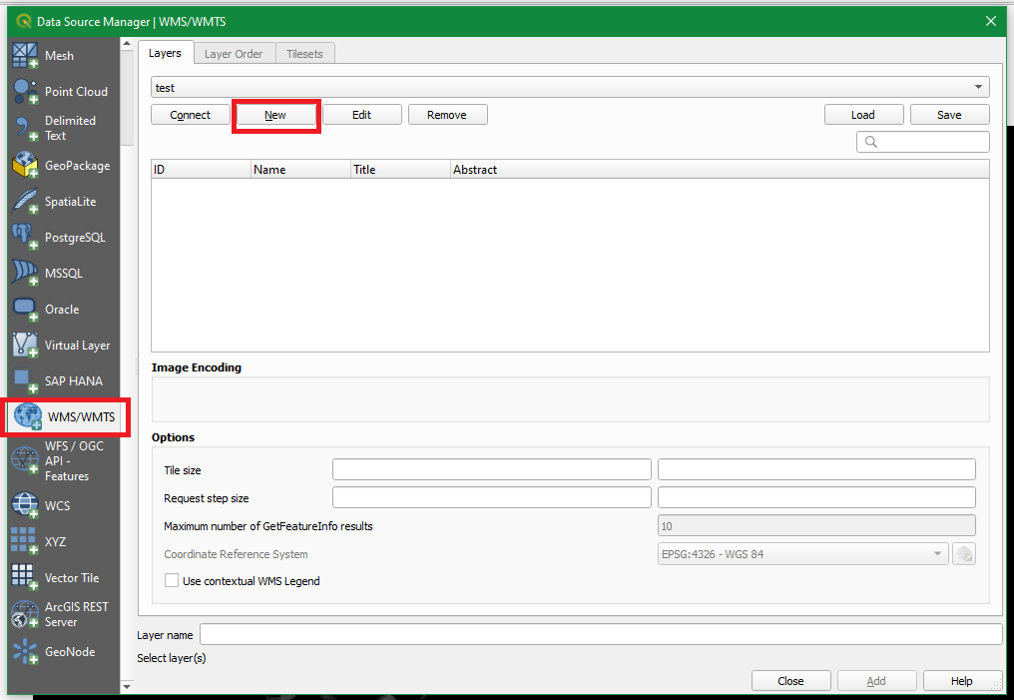

1. In the window that opens, next to ‘Name’ enter a name that corresponds with the service you are adding.
2. Enter the WMTS URL for the Vicmap 1m DEM Sample service you wish to connect in the ‘URL’ section (see Part A: Service Description).

For Example:

|  |  |
| --- | --- |
| **Service Name** | **Service URL** |
| **Vicmap 1m DEM Sample – Mount Buffalo** | https://tiles-ap1.arcgis.com/P744lA0wf4LlBZ84/arcgis/rest/services/Mount_Buffalo/MapServer/WMTS/1.0.0/WMTSCapabilities.xml?cacheKey=a746a0c2733adfa4 |

1. Do not enter anything in the ‘Authentication’ section.
2. Click ‘OK’

1. You will be returned to the Data Source Manager Window. Click ‘Close’ at the bottom of the window.

### Adding Services from a WMS/WMTS Connection

Following on from the steps for Adding a WMS or WMTS Connection

In the browser pane your added WMS/WMTS connection will appear underneath ‘WMS/WMTS’. It will appear as whatever you named it at step d. You can click to expand the server and the service folders hosted on the server. Services will appear with a checkerboard icon as shown below.

1. To add a service to your map, right click on it and select ‘Add Layer to Project’.

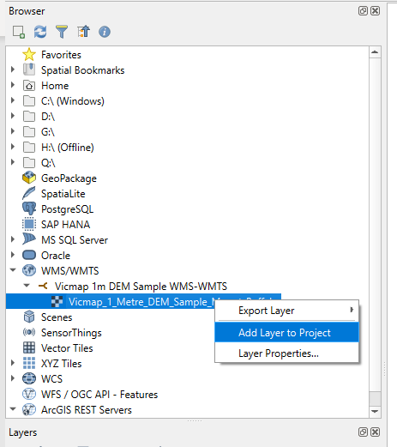

### Adding a Web Feature Service (WFS) Connection

1. Under ‘Layer’ menu select ‘Data Source Manager’

1. In the window that opens, in the left hand pane, scroll down and select ‘WFS/OGC API - Features’
2. In the right hand pane, underneath ‘Server Connections’, click the button labelled ‘New’

1. In the window that opens, next to ‘Name’ enter a memorable and descriptive name such as ‘1m DEM Web Feature Service’.
2. Enter the WFS URL of the desired WFS service you wish to connect in the ‘URL’ section (See Part A: Service Descriptions for URLs):

For example:

|  |  |
| --- | --- |
| **Service Name** | **Service WFS URL** |
| **Vicmap 1m DEM Footprints** | https://dservices-ap1.arcgis.com/P744lA0wf4LlBZ84/arcgis/services/Vicmap_1m_DEM_Footprints/WFSServer?request=getcapabilities&service=wfs |

1. Do not enter anything in the ‘Authentication’ section.
2. Click ‘OK’

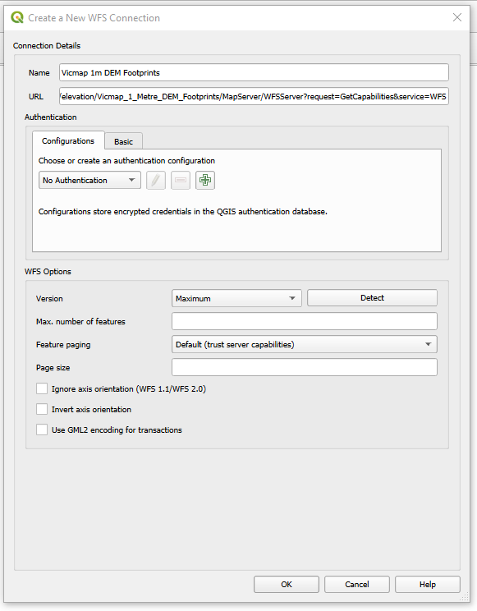

1. You will be returned to the Data Source Manager Window. Click ‘Close’ at the bottom of the window.

### Adding Services from a Web Feature Service (WFS) Connection

Following on from the steps for Adding a WFS Connection

In the browser pane your added WFS connection will appear underneath ‘WFS / OGC API - Features. It will appear as whatever you named it at step d. You can click to expand the server and the service folders hosted on the server. Services will appear with a checkerboard icon as shown below.

1. To add a service to your map, right click on it and select ‘Add Layer to Project’.

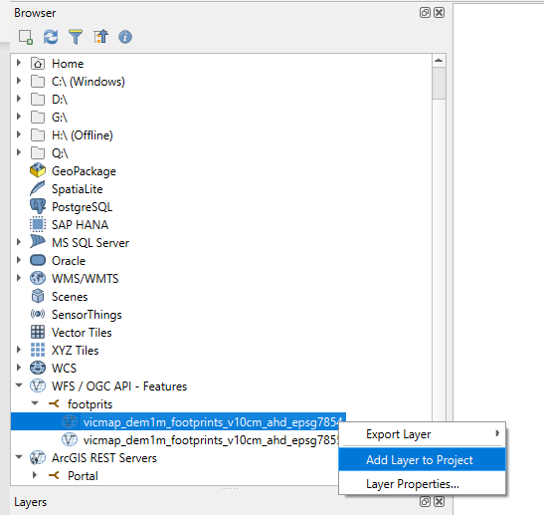

# Part C: Available Vicmap 1m DEM Sample Viewers

In addition to connecting directly to the Vicmap 1m DEM Sample and Footprint Services, the services are also available as pre-loaded features in the DTV Platform and the on the Vicmap 1m DEM Sample Viewer.

## DTV Platform

1. Navigate to the DTV Platform: <https://digitaltwin.vic.gov.au/public/>
2. Select “View Catalog”

1. Open up the “Vicmap” catalogue item by pressing the “up arrow”.

1. Similarly, open up the “Vicmap Elevation” catalogue item by pressing the “up arrow”. The Vicmap 1m DEM Sample and Vicmap 1m DEM Footprint services will be listed.

1. Press the “up arrow” on the service(s) you wish to add to the viewer. This will expose a “+” symbol.
2. Press the “+” symbol next to the service(s) to load the service into the viewer.
3. Press Done

## Vicmap 1m DEM Sample Viewer

The [Vicmap 1m DEM Sample Viewer](https://experience.arcgis.com/experience/08deb320c9ab4223a3d571258ece553f) - an online map that shows the Vicmap 1m DEM Sample Services as well as the Vicmap 1m DEM Footprints. The viewer can be found on the [Vicmap 1m DEM web page](https://www.land.vic.gov.au/maps-and-spatial/spatial-data/vicmap-catalogue/vicmap-elevation/1m-dem).

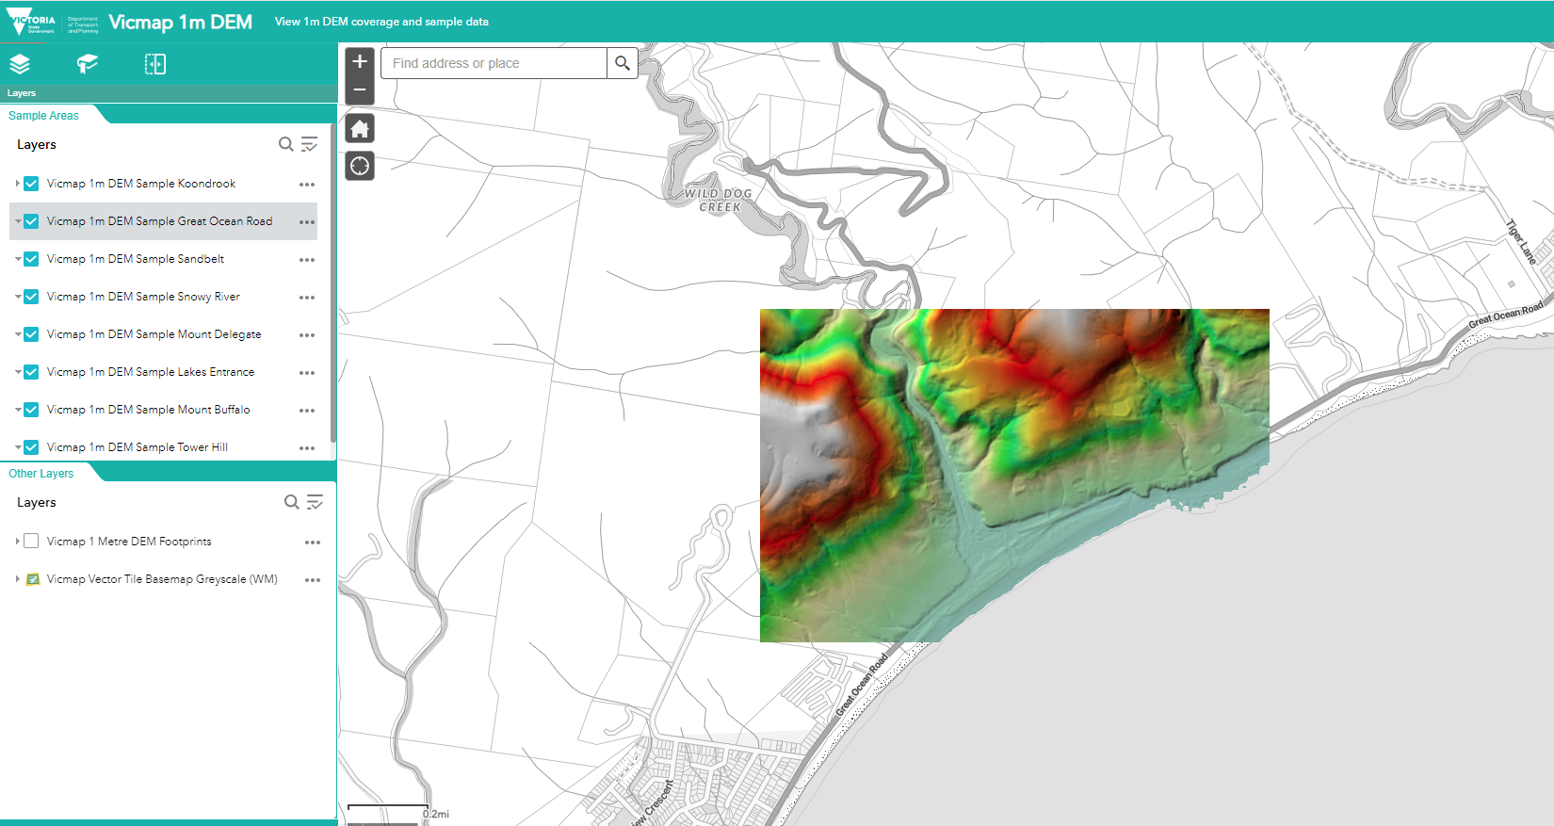

1. Navigate to the Vicmap 1m DEM Sample Viewer: https://experience.arcgis.com/experience/08deb320c9ab4223a3d571258ece553f