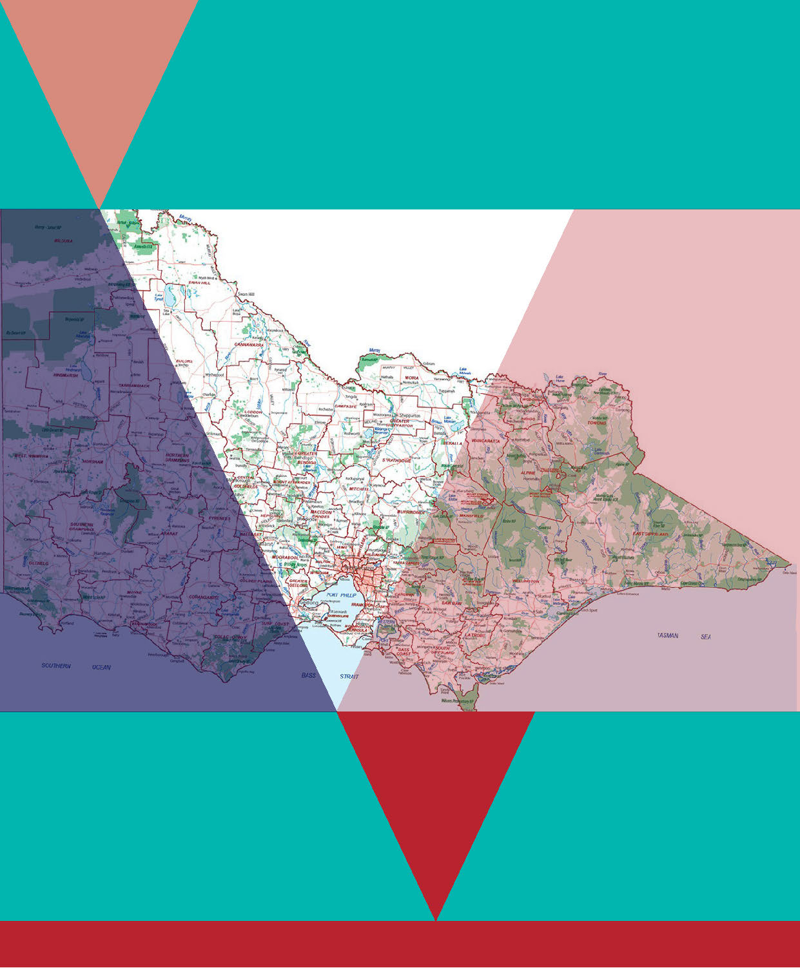
Naming rules for places
in Victoria
Statutory requirements for naming roads, features
and localities 2016

ISBN 978-1-76047-515-4 - Print
ISBN 978-1-76047-516-1 - Online

Land Use Victoria
Department of Environment, Land, Water and Planning
2 Lonsdale Street
Melbourne VIC 3000
Phone: (03) 9194 0282
Email: geo.names@delwp.vic.gov.au
Web: www.propertyandlandtitles.vic.gov.au/namingplaces

© The State of Victoria Department of Environment, Land, Water and Planning 2016

This work is licensed under a Creative Commons Attribution 4.0 Australia licence. You are free to re-use the work under that licence, on the condition that you credit the State of Victoria as author. The licence does not apply to any images, photographs or branding, including the Victorian Coat of Arms, the Victorian Government logo and the Department of Environment, Land, Water and Planning logo. To view a copy of this licence, visit http://creativecommons.org/licenses/by/4.0/
Accessibility
If you would like to receive this publication in an alternative format, please telephone the DELWP Customer Service Centre on 136186, email customer.service@delwp.vic.gov.au or via the National Relay Service on 133 677 www.relayservice.com.au.
Disclaimer
This publication may be of assistance to you but the State of Victoria and its employees do not guarantee that the publication is without flaw of any kind or is wholly appropriate for your particular purposes and therefore disclaims all liability for any error, loss or other consequence which may arise from you relying on any information in this publication.

Preface
The Office of Geographic Names (OGN) provides state-wide advice to Victorian naming authorities and the public about appropriate and compliant naming practices. As the Registrar of Geographic Names and through my management of OGN, I oversee the gazettal and registration of place names in Victoria.
Naming rules for places in Victoria – Statutory requirements for naming roads, features and localities 2016 (the naming rules) explains how a naming proposal must be undertaken. These naming rules have been reviewed in consultation with Victorian emergency service organisations, municipal councils, government departments and authorities, and relevant stakeholders.
The updated document is the result of extensive stakeholder consultation and the title emphasises the important role naming rules have under the Geographic Places Names Act 1998. The document has been reordered with duplications removed. Statutory requirements are also clearly identified so that compliant naming or renaming proposals can be submitted to OGN.
Victoria is unique in that it has a devolved naming process. The 79 Victorian municipal councils are the state’s primary naming authorities; however, a number of government departments, government authorities and private organisations also hold this role.
Public safety is paramount. For example, community facilities and infrastructure need to be officially named and registered with OGN to ensure emergency services can locate them. It is therefore very important that places already named but not registered be highlighted to OGN. Typically these names are considered legacy names.
The naming of new places and roads is largely generated by the rapid expansion of outer-metropolitan and regional residential developments. These developments provide opportunities for contemporary and historic Aboriginal naming themes to be adopted.
Victoria has a rich Aboriginal history, with 38 Aboriginal languages representing the diversity of Aboriginal cultural heritage and connection to Country. The uniqueness of language is based on location; each language is deeply rooted to the land and offers an ideal opportunity to connect a name to a place. To ensure the preservation of Aboriginal place names and languages across Victoria, we strongly encourage naming authorities to engage with Traditional Owners when assigning Aboriginal names to roads, features and localities.
Over the last couple of years, the ANZAC Commemorative Naming Project has honoured hundreds of war veterans and people who have displayed the Anzac spirit, with their names applied to roads, features and localities. Worthy individuals’ contributions to their communities have also been commemorated, with roads, sporting ovals and pavilions named in their honour.
Place names in Victoria are added to VICNAMES – the Register of Geographic Names, an online portal that holds all registered place names, including roads, features and localities. I encourage naming authorities and Victorians to submit through VICNAMES historical information and corroborating documents to provide people with background information about place names.
I trust that naming authorities and OGN’s stakeholders find these naming rules informative and useful in ensuring that geographic naming is appropriately administered.
John Tulloch
Registrar of Geographic Names

Contents
1 Introduction 5
1.1 The naming rules 5
1.2 Legislation that applies 5
1.3 Why there is a need for naming rules 6
1.4 What can be named or renamed using the naming rules? 7
1.5 Who can name or rename roads, features and localities in Victoria and who oversees the process? 7
1.5.1 Members of the public and other stakeholders 10
1.5.2 Naming authorities 10
1.5.3 Minister responsible for the Geographic Place Names Act 1998 10
1.5.4 Registrar of Geographic Names 10
1.5.5 Geographic Place Names Advisory Panel and committees 11
1.6 VICNAMES – the Register of Geographic Names 11
1.7 Status of names in VICNAMES 12
1.8 Updating the naming rules 13
1.9 How long is the naming process? 13
2 General principles 15
Principle (A) Ensuring public safety 15
Principle (B) Recognising the public interest 15
Principle (C) Linking the name to place 15
Principle (D) Ensuring names are not duplicated 16
Principle (E) Names must not be discriminatory 17
Principle (F) Recognition and use of Aboriginal languages in naming 17
Principle (G) Dual names 17
Principle (H) Using commemorative names 18
Principle (I) Using commercial and business names 19
Principle (J) Language 19
Principle (K) Directional names to be avoided 20
Principle (L) Assigning extent to a road, feature or locality 20
2.1 Results from a VICNAMES duplication search 20
2.1.1 Metropolitan duplication 21
2.1.2 Regional urban area 23
2.1.3 Rural or remote areas 24
2.2 Feature names not considered duplicates 25
2.2.1 Multiple names 26
2.3 Anzac commemorative naming project 27
3 Roads 28
3.1 What is a road? 28
3.2 Statutory requirements applied to roads 28
3.2.1 Rural and urban addressing 28
3.2.2 Extent: road course, start and end points 28
3.2.3 Road types 29
3.2.4 Unacceptable road names 30
3.2.5 Obstructed or altered roads 30
3.3 Roads that can be named 31
3.4 Who can name roads? 31
3.5 Roads with more than one naming authority 32
3.6 Council coordination of public roads’ naming 32
3.7 Government department or authority coordination of public roads’ naming 32
3.8 Naming roads in new residential or commercial subdivisions 32
3.8.1 Responsibility for naming roads in residential or commercial subdivisions 33
3.8.2 The naming process 33
3.8.3 Entering subdivision road names into VICNAMES 33
3.8.4 Road name history 33
3.8.5 Non-compliant names entered into VICNAMES 34
3.8.6 Maintenance and responsibility 34
3.9 Naming private roads on private property and within complex sites 34
3.9.1 The naming process 35
3.9.2 Entering a private road in VICNAMES 35
3.9.3 Maintenance and responsibility 35
4 Features 37
4.1 What is a feature? 37
4.2 Statutory requirements applied to features 37
4.2.1 Feature type 37
4.2.2 Waterways 37
4.2.3 Locational names 37
4.2.4 Base names 38
4.3 Features that can be named 38
4.3.1 Legacy names 38
4.4 Who can name features? 38
4.5 Features with more than one naming authority 39
4.6 Council coordination of feature naming 39
4.7 Features with State Government departments or authorities as the naming authority 39
4.7.1 Guidelines for specific departments or authorities 39
4.7.2 Cemeteries 39
4.8 Features on private land 40
4.8.1 The naming process 40
4.8.2 Entering a private feature in VICNAMES 40
4.8.3 Maintenance and responsibility 40
4.9 Features with Aboriginal names 41
5 Localities 42
5.1 What is a locality? 42
5.2 Statutory requirements applied to localities 42
5.2.1 Boundaries 42
5.2.2 Estate and subdivision names 46
5.2.3 Promoting a new estate 46
5.2.4 Size 46
5.2.5 Hyphens 47
5.2.6 Local government area boundary review 47
5.2.7 Locality names unique within Australia 47
5.3 Who can name localities and amend boundaries? 47
5.3.1 Creating a new locality 47
5.3.2 Reservation of locality names 48
5.4 Localities with more than one naming authority 48
5.5 New localities created by councils, government departments or authorities 48
5.6 Changes to existing locality name(s) or boundaries 48
5.7 What should not be done? 48
6 Initiating a proposal and checking required information 50
6.1 Initiating a proposal 50
6.1.1 General public 50
6.1.2 Emergency management or other public service providers 50
6.1.3 Councils 51
6.1.4 Government departments or authorities 51
6.2 Naming proposal process 52
6.2.1 Check information 52
6.2.2 Apply the principles 52
7 Consultation 54
7.1 Minimum requirements 54
7.1.1 Government departments and authorities 55
7.2 The consultation process 56
7.2.1 Prepare a naming proposal 56
7.2.2 Develop a consultation strategy 56
7.2.3 Determine who should be consulted 56
7.2.4 Build awareness of the proposal and invite feedback 59
7.2.5 Analyse negative and positive feedback from the community 67
7.2.6 Informing the community of the naming authority’s decision 68
7.2.7 When to re-consult 69
7.3 Developing an Aboriginal naming proposal 71
7.3.1 Introduction 71
7.3.2 Preparing a naming proposal 71
7.3.3 Determining Aboriginal group(s) for consultation 71
7.3.4 Selecting a consultative group 72
7.3.5 Building awareness within the Traditional Owner community 72
7.3.6 Feedback from the Aboriginal community and endorsement of name(s) 73
7.3.7 Building awareness of the proposal within the wider community 73
7.3.8 Feedback from the wider community 73
7.3.9 Reimbursement of costs 74
7.4 Process for a Traditional Owner group to develop an Aboriginal naming proposal 74
7.4.1 Identify the name 74
7.4.2 Locate other names 74
7.4.3 Verify the name 74
7.4.4 Contact the naming authority for the road, feature or locality 75
8 Objections and submissions 76
8.1 What to submit 76
8.2 Who can object or support a proposal? 76
8.3 Lodging a submission 76
8.4 How submissions are considered 76
8.4.1 Minimal community support for name 77
8.5 Informing the community of a decision 77
9 Finalising the proposal 79
10 Lodging a proposal with OGN 80
10.1 Information a naming authority must lodge with OGN 80
10.2 What the Registrar does 81
10.2.1 Seeking Registrar’s endorsement of a proposal 81
10.2.2 Registrar’s consideration of a proposal seeking referral to a Geographic Place Names Advisory Committee 81
11 Registrar’s consideration of a proposal 82
11.1 Appeals 83
12 Gazettal of a proposed name or boundaries 84
13 Implementation 86
13.1 Registration 86
13.2 Notification 86
13.2.1 OGN notifies stakeholders 86
13.2.2 Who the naming authority must notify 87
13.2.3 VICNAMES holds the gazetted and registration details 88
13.2.4 Updating other databases, including private companies 88
13.2.5 Updating emergency services databases 88
13.3 Signage 89
13.3.1 Requirements for road signage 89
13.3.2 Requirements for feature signage 91
13.3.3 Requirements for locality signage 92
13.4 History 92
13.4.1 Recording historical information in VICNAMES 92
APPENDIX 93
APPENDIX A Road types accepted for registration 93
APPENDIX B Feature types accepted for registration 96
APPENDIX C Checklists 97
APPENDIX D AS4819:2011 Rural and urban addressing 104
APPENDIX E Information for the public 108
GLOSSARY 109

1 Introduction

1.1 The naming rules
Naming rules for places in Victoria – Statutory requirements for naming roads, features and localities – 2016 (naming rules) sets out step-by-step information on naming, renaming or changing the boundaries of roads, features and localities in Victoria. It replaces the Guidelines for Geographic Names 2010 Version 2.
These naming rules are the statutory requirements allowed for under the Geographic Place Names Act 1998; they are therefore mandatory for all naming authorities in Victoria – councils, government departments and authorities – and include all government-owned or administered roads, features (natural or otherwise) and localities.
When a road or feature is not owned or maintained by a government department or authority (such as some cultural centres, sporting centres, education facilities or aged care facilities) the private owners are strongly encouraged to adopt the principles, requirements and procedures detailed in these naming rules. To ensure VICNAMES – the Register of Geographic Names (the state’s authoritative place names register) accurately reflects the status of named roads and features in Victoria, the names of these privately owned roads and features are recorded and these names are also available in Vicmap (the state’s authoritative spatial database).
Appropriate naming is essential to identify locations for managing emergencies and delivering goods and services in Victoria. The naming rules are based on national standards and policies. They provide a strong basis for standardised and unambiguous naming procedures across the state. They have been developed through detailed consultation with councils, government departments, emergency agencies and public service providers.
These naming rules have been developed to be inclusive to all Victorians.
These naming rules are aligned with national principles around the consistent use of place names within Australia, including the Permanent Committee on Place Names – Principles for the consistent use of place names (www.icsm.gov.au/publications/index.html), AS/NZS4819:2011 Rural and urban addressing and the United Nations Group of Experts on Geographical Names’ publications. The Office of Geographic Names (OGN) works closely with jurisdictions across Australia to achieve consistency in naming.

1.2 Legislation that applies
The naming rules are the guidelines provided for under s.5 of the Geographic Place Names Act 1998 (the Act), where it states that:
- The Governor in Council, on the recommendation of the Minister, by Order published in the Government Gazette, may make guidelines relating to procedures to be implemented in selecting, assigning or amending names of places.
- Without limiting the generality of subsection (1), the guidelines:
- must set out the rules and process to be followed in selecting, assigning or amending a name of a place;
- must set out the process to be followed before selecting or assigning an Aboriginal or Torres Strait Islander name of a place;
- must specify criteria for the assessment of cultural heritage or other significance in relation to the naming of places;
- must set out requirements for consultation before a name of a place is selected, assigned or amended; and
- may specify any other matter or thing appropriate in relation to the naming of places.
These naming rules provide details in relation to the Register of Geographic Names – VICNAMES (refer to Section 1.6), information on the role of the Minister responsible for the Act, the Registrar of Geographic Names, the Geographic Place Names Advisory Panel and various naming authorities.
The definition of ‘place’ under s.3 of the Act states:
Place means any place or building that is, or is likely to be, of public or historical interest and
includes, but is not restricted to:
- township, area, park, garden, reserve of land, suburb and locality;
- topographical feature, including undersea feature;
- street, road, transport station, government school, government hospital and government nursing home.
Refer to Section 11 Registrar’s Consideration of a proposal for the information regarding the registration of names under the Act.
Other legislation, regulations and policies relevant to geographic naming are:
- Local Government Act 1989 (at www.legislation.vic.gov.au)
- Road Management Act 2004 (at www.legislation.vic.gov.au)
- Aboriginal Heritage Act 2006 (at www.legislation.vic.gov.au)
- Aboriginal Heritage Regulations 2007 (at www.legislation.vic.gov.au)
- AS/NZS4819:2011 Rural and urban addressing (at www.saiglobal.com)
- Survey Co-ordination Act 1958 (at www.legislation.vic.gov.au)
- Subdivision (Procedures) Regulations 2011 (at www.legislation.vic.gov.au)
Note: Some naming authorities have their own naming policies or guidelines that augment these naming rules.
These naming rules should not be applied to past naming decisions, they only apply to current naming proposals (for the duration of this edition’s official circulation).
However, when renaming a road, feature or locality these naming rules will apply. If advised of a risk to public safety due to a place’s name, naming authorities should also seek to rename it (where practical) and apply these naming rules.

1.3 Why there is a need for naming rules
The naming rules provide a structure for ensuring that assigning names to roads, features and localities in Victoria is undertaken in a consistent way for the community’s benefit. Those benefits include:
- recognition and identification
- culture
- connection to country and place
- heritage
- landscape
- emergency service response and natural disaster relief
- communications, including postal and news services
- trade and commerce
- population censuses and statistics
- property rights and cadastre
- urban and regional planning
- environmental management
- map and atlas production
- navigation
- tourism.
The proper naming of any place enables it to be clearly identified and its precise location to be determined. The uniqueness and accuracy of a place name reduces the likelihood of delaying an emergency services vehicle due to inadequate or confusing location details, which might result in life threatening consequences. Proper naming also assists with service delivery by other agencies and companies.

1.4 What can be named or renamed using the naming rules?
Any public or private road, feature or locality within Victoria can be named, renamed or have its boundary changed, using the principles, requirements and procedures in these naming rules.
There are many different roads and feature types in Victoria (refer to APPENDIX A and APPENDIX B). The responsibility for preparing naming proposals and submitting them to the Registrar can vary. Please refer to the relevant sections and appendices in these naming rules to determine what is required. If you need help please contact OGN for advice.

1.5 Who can name or rename roads, features and localities in Victoria and who oversees the process?
The following are the four stages in the naming process for individuals or organisations.
Stage | Who can do it | Further information
STAGE 1:  Who can propose a new name?  Who can propose a name change?  Who can propose a boundary change? | Anyone (individuals, community groups, organisations, government departments or authorities) can propose a new name, change to an existing name or boundary change. | Section 1.5.1
STAGE 2:  Who can develop a naming, renaming or boundary change proposal? | A naming authority is often responsible for or administering the named location or feature and as part of that role provides the Registrar of Geographic Names with any naming proposals. Naming authorities include councils, government departments and authorities, and some private organisations.  Information on authorities responsible for road naming can be found in Section 3.4.  Details of authorities responsible for developing naming proposals for features are provided in Section 4.4.  For localities, the authority is usually the council(s) within which the locality is situated. See Section 5.  A Geographic Place Names Advisory Committee can develop or review a naming proposal if a road, feature, or locality is determined to have greater than local significance. | Section 1.5.2  Section 3  Section 4  Section 5  Section 1.5.5.
STAGE 3:  Who can appeal the naming proposal? | Anyone (individuals, community groups, organisations, government departments or authorities). | Section 8
STAGE 4:  Who has authority to endorse and enter a name in VICNAMES? | The Registrar of Geographic Names.  The Minister responsible under the Act may direct the Registrar to enter a name. | Section 1.5.4  Section 1.5.3  Section 1.5.5  Section 11

Diagram: People, organisations and processes involved in naming, renaming or changing the boundary of a road, feature or locality
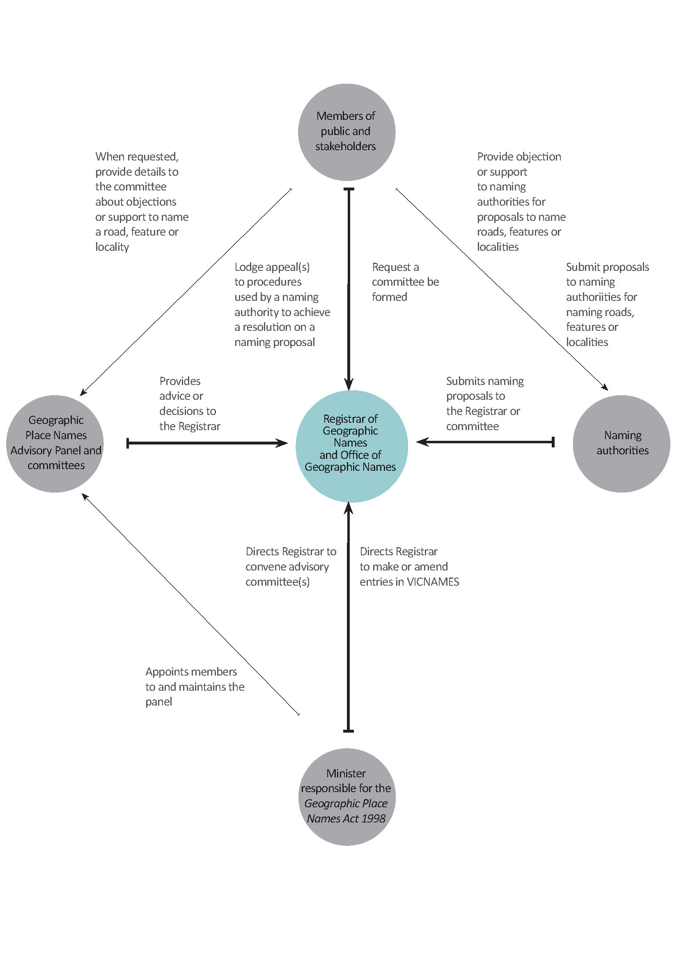
1.5.1 Members of the public and other stakeholders
Members of the public are encouraged to participate in the naming process by proposing a name, initiating a proposal or responding to a relevant naming authority regarding a naming proposal.
Other stakeholders include emergency service organisations, Australia Post, owners corporations, private institutions, Traditional Owners, historical societies and utility or other service providers. They can be involved in the naming process in three ways:
- propose a name or boundary for a road, feature or locality to the responsible naming authority
- alert a naming authority and the Registrar to an issue with an existing name or boundary for a road, feature or locality and request that the matter be investigated
- comment on whether a naming, renaming or boundary change proposal conforms to the naming rules.
The Aboriginal community in Victoria includes the descendants of Victoria’s various Traditional Owner groups, who, at the time of colonisation in 1835, maintained complex societies with languages, laws and customs, and a connection to their land. Traditional Owners today continue to assert their identity and connection to their Country and are a key stakeholder in the naming process. The use of Aboriginal languages to name roads, features and localities has played, and continues to play, a significant role in promoting Traditional Owners’ relationships with Victorian landscapes.
Further information is outlined in the relevant sections (specifically, Section 2 General Principles, Section 4 Features and Section 7 Consultation) of the naming rules.
Further information about how to identify local Aboriginal communities, convene consultation meetings and respond to issues that may arise is available in Section 7.3 Developing an Aboriginal naming proposal.
1.5.2 Naming authorities
Naming authorities are responsible for submitting naming proposals that comply with these naming rules to the Registrar of Geographic Names. Due to the variety of roads, features or localities that can be named, there are multiple types of naming authorities. Essentially, councils, government departments or authorities and private organisations are the naming authorities when they are responsible for a particular road or feature within their jurisdiction. This may apply even when they are not the owners and/or responsible for the maintenance of the road or feature, e.g. Crown Land Committees of Management or leased/licensed facilities with maintenance obligations.
1.5.3 Minister responsible for the Geographic Place Names Act 1998
The Minister responsible for the Geographic Place Names Act 1998 is responsible for all matters under the Act, including appointing the Registrar of Geographic Names (provided for under s. 7 of the Act) and members of the Geographic Place Names Advisory Panel (provided for under s. 14 of the Act).
Section 11(5) of the Act provides that the Minister may direct the Registrar to enter geographic names into VICNAMES, and under s. 12(1) of the Act may also direct the Registrar to refer a naming matter to a committee for its advice. When addresses are affected, the naming authority, which is typically a council, will be contacted. It is expected that the naming authority will engage with the community to seek comments, when necessary. The Minister has the power under the Act to overturn any decision made by a naming authority, the Registrar, or committee.
1.5.4 Registrar of Geographic Names
The powers and functions of the Registrar, as set out in s. 8 of the Act, include:
- To carry out the functions under the Act of registering names of places
- To keep and maintain the Register
- To advise the Minister on the establishment and development of the guidelines
- To disseminate information on the guidelines
- To monitor and review compliance with the guidelines
- Such other functions are conferred on the Registrar by or under the Act.
The Registrar has the necessary powers to carry out the functions of the Registrar under the Act.
The Registrar:
- oversees the OGN, whose primary role is to assist members of the public and naming authorities to develop robust naming proposals for roads, features or localities
- has the ability to determine a naming authority
- maintains VICNAMES in Victoria and enters and/or amends entries as required by the Minister, Geographic Place Names Advisory Committees or naming authorities
- is responsible for maintaining the Geographic Place Names Advisory Panel appointed by the Minister and for allocating members of the panel to select committees, as required from time-to-time by the Minister, or in instances of a naming proposal being considered to be of greater than local significance (refer to Principle C).
1.5.5 Geographic Place Names Advisory Panel and committees
The Geographic Place Names Advisory Panel and its committees are responsible for providing expert advice and recommendations to the Registrar on geographic place naming policies and principles; and, place naming issues of regional, state and national significance.
Committees may be convened by direction of the Minister or Registrar; or, at the request of a naming authority, if deemed appropriate by the Registrar.
The appointment of members to a Geographic Place Names Advisory Panel and procedures governing its processes and committees are outlined in s. 12 to s. 17 of the Act. Information on why a committee might be convened and what it considers are available online at www.delwp.vic.gov.au/namingplaces>Geographic place names advisory panel. Refer to Principle C Linking to place for when a committee can be formed.

1.6 VICNAMES – the Register of Geographic Names
S. 9 of the Act provides for a Register of Geographic Names, which includes place names and the names of streets and roads.
The Register of Geographic Names is an electronic system known as VICNAMES, available at maps.land.vic.gov.au/lassi/VicnamesUI.jsp.
VICNAMES stores information and data related to all officially gazetted, registered and recorded road, feature and locality names in Victoria. There are some differences in the data stored for place and road records in VICNAMES and the following information is typically available:
- name
- status of name (refer to Section 1.7)
- registration date
- historical name (if available)
- gazette notice date and reference
- feature descriptor
- Vicmap ID – persistent feature identifier (PFI)
- location description
- coordinates (centroid)
- council – local government area where the feature is located
- naming authority
- permalink – a persistent permanent link to the record
- history of the name (if available)
- supporting historical documents (if available)
- map source information.
VICNAMES is linked to Vicmap, the Victorian government spatial data set. Linking VICNAMES to Vicmap ensures that the information in VICNAMES is aligned to the spatial representation of roads, features and localities, and that Vicmap references all officially registered or recorded names for roads, features and localities. Vicmap includes data that may not be officially registered under the Act.

1.7 Status of names in VICNAMES
Seven categories are applied to names in VICNAMES:
Place name status | Description
Registered | This type is legally recognised for the purposes of the Act as an official name for a road, feature or locality administered or coordinated by a government authority. For example Watson Creek or Lorne.
Dual | This type consists of one name comprised of one non-Aboriginal and one Aboriginal name, which must be used together as the registered legally recognised name for the feature (refer to Principle (L)). For example Point Ritchie/Moyjil. For further information refer to Principle (G) Dual names.
Historical | This is a name no longer in official use but recorded for information purposes. For example Alexanders Head is now known as Brock Monument and Jeremal Creek is now known as Corryong Creek.
Base | This is a lifetime name for a feature, if the recorded name is subject to limited-term private contracts (refer to Section 4.2.4). For example Docklands Stadium is the base name and the current Registered name alters depending on the current site sponsor. For example Etihad Stadium.
Recorded | This is the name of a feature if a private entity has naming rights or the source of the name has yet to be confirmed with the naming authority (refer to Section 3.8). They are included in VICNAMES in the interests of public safety and information. For example Ault Beeac Falls or Amaroo Neighbourhood Centre.
Traditional | This is an Aboriginal name that is not in official use or used as a dual name for a feature (refer to Section 3.5). For example Wallermeryong Creek is the Aboriginal name for Main Creek.
Archived | Names no longer associated with the Register. For example Ascot Telephone Exchange.

1.8 Updating the naming rules
The Registrar must ensure that the naming rules, known under the Act as ‘the Guidelines’, are reviewed at least once every five years and that a report on any review is given to the Minister.
With constant improvements and changes in the spatial information sector, it may be necessary to occasionally amend the naming rules to ensure up-to-date standards are reflected. Updates need to be approved by the Governor in Council – naming authorities and other interested parties will be notified of any approved amendments.

1.9 How long is the naming process?
Each naming proposal is unique and timelines for completion are guides only.
If a proposed naming, renaming or boundary change is considered to be small-scale and only affects a limited number of residents, ratepayers and businesses, the process may be shorter than described below. If the road, feature or locality is known to a lot of people and is, or will be, used extensively by the wider community, the process may take longer.
Proposal | Proposal initiation | Consultation | Compliance checks and reporting | OGN audit, gazette and notification
New road | 1–2 weeks | 30–90 days | 30–60 days | 30–60 days
New feature | 1–2 weeks | 30–90 days | 30–60 days | 30–60 days
New locality | 3–4 weeks | 30–90 days | 30–60 days | 30–60 days
Renamed road | 1–2 weeks | 30–90 days | 30–60 days | 30–60 days
Renamed feature | 1–2 weeks | 30–90 days | 30–60 days | 30–60 days
Renamed locality | 3–4 weeks | 30–90 days | 30–60 days | 30–60 days
Boundary change of a road | 1–2 weeks | 30–90 days | 30–60 days | 30–60 days
Boundary change of a feature | 1–2 weeks | 30–90 days | 30–60 days | 30–60 days
Boundary change of a locality | 3–4 weeks | 30–90 days | 30–60 days | 30–60 days

The process can become extended if the naming authority is consulting on multiple names, if objections and appeals are received, or if OGN requires additional information.
The process can be reduced if the naming authority has a bank of pre-approved names. Councils will often have a bank of names relevant to an area.

The diagram shows the end-to-end process.

2 General principles
The following principles must be used in conjunction with the relevant statutory requirements outlined in the three other sections of the naming rules related to roads, features and localities. They are designed to ensure no ambiguity, confusion, errors or discrimination are caused by the naming, renaming or boundary change process. All general principles are equally important.

Principle (A) Ensuring public safety
Geographic names and boundaries must not risk public and operational safety for emergency response; or, cause confusion for transport, communication and mail services. Many emergency services and other public services (such as mail) are determined by locality boundaries or road extents, and proposals must ensure that operations will not be adversely affected.
For example, the boundary of a locality must be applied in a way that makes sense, not only for the local community but also for visitors. Similarly, the extent of a road name should ensure easy navigation for pedestrians and vehicles along the entire route, from one end to the other.

Principle (B) Recognising the public interest
Regard needs to be given to the long-term consequences and short-term effects on the wider community of naming, renaming or adjusting the geographic boundary of a place. Changes will affect not only the current community but also future residents, emergency response zones, land titles and addresses, property owners, businesses and visitors.
A proposal will only be registered if the long-term benefits to the community can be shown to outweigh any private or corporate interests, or short-term effects.

Principle (C) Linking the name to place
Place names should be relevant to the local area with preference given to unofficial names used by the local community. If named after a person (refer to Principle H Using commemorative names), that person should be or have been held in strong regard by the community.
Names that link the name to the place could relate to Aboriginal culture and occupation of the land, local flora and fauna, Australian war contributions (refer to Section 2.3 Anzac commemorative naming project), European exploration and settlement, local geography and geology, significant events, the cultural diversity of past and current inhabitants, or patterns of land usage and industrial/mineral/agricultural production.
Infrastructure features should use the name of the locality, for example Tarneit Railway Station. Features that use the name of locality are not considered duplicates, but must have a unique identifier that distinguishes the feature from other similarly named features. Refer to 4.2.3 Locational names for further information.
This principle is particularly relevant to new estates, where naming themes can provide a strong link to place. Names of estates should not be applied to roads, features or localities to avoid possible future issues related to address. Those that have a historical connection to place are preferred. Refer to Principle (I) Using Commercial and business names.
A place of greater than local significance should have a name relevant to the wider community. A road, feature or locality of greater than local significance will usually fall into one or more of the following categories:
- it is located in two or more municipal areas
- it is located in a significant tourist precinct
- it is proposed to be created as part of a State or Federal Government project
- it is a major waterway
- it is a major undersea or shoreline feature
- it has major cultural, natural or recreational landscape features
- it is linked to a significant Aboriginal feature, story or landscape. Refer to Principle (F) Recognition and use of Aboriginal languages in naming.
In these instances a naming authority can request that the Registrar convenes a Geographic Place Names Advisory Committee to develop or determine a decision on a naming proposal (refer to Section 1.5.5 for further details).

Principle (D) Ensuring names are not duplicated
Proposed names must not duplicate another name within the distances listed below, irrespective of locality and/or council boundaries. Duplicates are considered to be two (or more) names within close proximity, or names that are identical or have similar spelling or pronunciation. Examples of names that are similar and considered to be duplicates are White, Whyte, Wite and Wiet.
VICNAMES can be used to check for a duplicate road, feature and locality names. Select the road or place and select duplicate. Refer to the Guide to VICNAMES available at www.delwp.vic.gov.au/namingplaces>VICNAMES for further advice.
Note: the radius will default to either 5, 15 or 30 kilometres based on the location classification listed below. The defaulted radius provides the minimum required distance between duplications.
Duplication is not allowed within the same locality or the following default distances:
- metropolitan urban areas, within a 5 kilometre radius (metropolitan Melbourne and Geelong, city centres and surrounding suburbs)
- regional urban areas, within a 15 kilometre radius (a regional urban area consists of a town centre and its surrounding suburbs)
- rural or remote areas, within a 30 kilometre radius (a rural or remote area is an area located outside of towns).
Examples of duplicate name scenarios and solutions are available in Section 2.1.
Examples and scenarios of names not considered duplicates are available in Section 2.2.
If a naming authority is uncertain of which classification to apply, it should contact OGN for advice. Alternatively, apply a cautionary approach when checking for duplication and use the 30 kilometre radius search.
If the proposed name is duplicated, consider assigning it to something other than what you want to name (such as a park, reserve, road or a locality), outside of the duplicate search radius. If a feature or road is located near a state boundary, care should also be taken to avoid duplication with names in the other state, according to the distances prescribed above.
When considering the assignment of locality names, the above requirements are not applicable and naming authorities should refer to Section 5: Localities.
An exception to this principle is the assignment of multiple feature names within, for example, a park or reserve. The feature names must have a direct relationship with each other. Examples include Mildura Wharf Carpark adjacent to and servicing Mildura Wharf, Neulynes Carpark adjacent to Neulynes Mill Site, and Albert Park Lake and Albert Park Playing Fields located in Albert Park (the park). This exception is not allowed for the assignment of locality names or road names, which must be unique. Refer to Section 2.2.1 for further information. For further advice please contact OGN.
If naming authorities have a proposed name not duplicated within the same locality, but marginally within the radius deemed to be a duplicate, you may contact OGN for further advice.

Principle (E) Names must not be discriminatory
Place names must not discriminate. Refer to the Equal Opportunity Act 2010 for further information.

Principle (F) Recognition and use of Aboriginal languages in naming
The use of Aboriginal languages in the naming of roads, features and localities is encouraged, subject to agreement from the relevant Traditional Owner group(s). If the application of an Aboriginal name is being considered to be applied as a Dual name, then please also refer to Principle (G) Dual names.
Naming authorities are strongly encouraged to consult with the relevant Traditional Owner group(s) prior to any public consultation on the proposed name(s). In instances of more than one relevant Traditional Owner group, naming authorities must consult all parties.
Further information about how to identify the appropriate Traditional Owner group(s), convene consultation meetings and respond to issues that may arise, is available in Section 7.3 Developing an Aboriginal naming proposal.

Principle (G) Dual names
Australian states and territories use dual names as a way of recognising the names given to places by different enduring cultural and language groups. For further information refer to the Principles for the consistent use of place names (www.icsm.gov.au/publications/index.html).
In Victoria, the approach to giving simultaneous and joint recognition of Aboriginal and non-Aboriginal cultures through naming is to form a dual name with two distinct name parts, usually one part of non-Aboriginal language origin and the other of Aboriginal language origin.
Naming authorities wishing to develop dual naming proposals need to ensure the following issues are considered:
- Dual names can be applied to natural topographical features (e.g. islands, mountains, mountain ranges and rivers) and mapped or bounded areas such as state forests, national parks, Crown land reserves and open space recreation reserves.
To avoid possible confusion for addressing or the provision of emergency management, dual names cannot be adopted for:
    - localities, towns or rural districts
    - constructed features such as roads, highways, bridges or communication towers.
Note: roads and localities should only be assigned a name that is either an Aboriginal name or non-Aboriginal name.
- Dual naming is a priority consideration when a feature already has a widely accepted name of non-Aboriginal origin and newly available information indicates that an Aboriginal name could also apply.
- If a dual name is proposed, the non-Aboriginal name would appear first in the combined name, as long as it best reflects local community usage. For example, Point Ritchie / Moyjil (see maps.land.vic.gov.au/lassi/VicnamesUI.jsp?placeId=6743).
- If a non-Aboriginal name has weak support in the general community and the origin and application of an Aboriginal name is well supported, a dual name may be formed with the Aboriginal name part appearing first. In some cases, a single well-supported Aboriginal name could be substituted for the weakly supported non-Aboriginal name, instead of adopting a dual name.
Dual names will be formally registered without any distinction between non-Aboriginal and Aboriginal name parts other than sequence. If a visual separator is required for clarity, it should be a solidus (i.e. a /) preceded and followed by a space. The feature type should only be included with the non-Aboriginal name. The following examples would be acceptable:
- Gariwerd / Grampians National Park
- Grampians National Park / Gariwerd
- Nambruc / Aberfeldy State Forest
- Colquhoun State Forest / Boyanga Gidi.
Dual names once registered are to be used in full, particularly on maps, signs and legal documents. Shortened versions are not to be used.

Principle (H) Using commemorative names
Naming often commemorates an event, person or place. Examples include recognising Aboriginal people or cultural events, or following a theme such as Australian war contributions (refer to Section 2.3 Anzac commemorative naming project). When considering a commemorative name, the following points must be considered.
- If named after a person, that person should be or have been held in strong regard by the community, with preference given to unofficial names used by the local community.
When deciding on the assignment of a commemorative name, naming authorities should consider the person’s achievements, relevant history and association to the area, and the significance of the family/person to the area/land. For example, a family that has been associated with an area for at least 50 years.
- The names of people who are still alive must be avoided because community attitudes and opinions can change over time.
- A commemorative name applied to a locality or road should use only the surname of a person, not first or given names.
- A commemorative name applied to a feature can use the first name and surname of a person; although, it is preferred that only the surname be used.
- The initials of a given name are not to be used in any instance.
Note: if a name is duplicated you may consider using a first or middle name or a locally used name; however, the naming authority should contact the OGN for further advice.
This approach ensures that emergency and postal services are not delayed because of inconsistent application of a name. For example, Smith Park is a clearer name than John Edward Smith Park because it’s possible John Park, Edward Park, John Smith Park, J. E. Smith Park or J. E. S. Park might be used by the public.
Naming authorities should make every effort to gain consent from family members of the person being commemorated. Supporting evidence that shows a naming authority’s attempts to consult family members should be provided to OGN when lodging the proposal.
Supporting evidence is required, including copies of letters sent to the family, copies of newspaper advertisements calling for consent or contact details of the family and any response from the family. When a naming authority is unable to locate existing family members, the naming authority may use the newspaper notice advertising the proposed name to also call for consent from the family and/or request family contact details from the community. Refer to Section 7.2.4 The consultation process, Notices. Any response from the family should be included in the proposal sent to the Registrar.
If a naming authority has exhausted avenues to contact families and the proposal is the name of a person who passed away at least 70 years ago, the Registrar will consider the naming proposal.
In exceptional circumstances, if the naming authority wishes to name a road, feature or locality after a living person, it must apply in writing to the Registrar to seek an exemption from this principle. Consent from the person should be sought prior to any exemption request being submitted to OGN. The naming authority must outline the reasons for proposing a living person’s name, including but not limited to evidence about the person’s achievements, relevant history and association to the area. This exemption request must be sought prior to commencing any public consultation or reaching a decision on the final naming proposal.

Principle (I) Using commercial and business names
For similar reasons to those outlined in Principle (H), naming authorities should not name places after:
- commercial businesses
- trade names
- estate names (which are solely commercial in nature)
- not-for-profit organisations.
Names of estates should not be applied to roads, features or localities to avoid possible future issues related to addressing. Names with historical connections to places are preferred.
Note: Estate names include names applied to residential estates, commercial use estates, e.g. residential subdivisions and business parks or commercial/industrial zoned land. Where roads, features and localities are named using the estate name, that have no link to place, then the name will not be allowed.
Naming authorities should use their discretion as to whether an exemption request is required. For further advice contact the OGN.
Exceptions may apply if the business or organisation had an association with the area over a substantial period of time and is held in high regard by the community, e.g. Lions Park Mallacoota (maps.land.vic.gov.au/lassi/VicnamesUI.jsp?placeId=12026), Mantello Drive and Vegemite Way.
In these circumstances, the naming authority must apply in writing to the Registrar to seek exemption from this principle, including but not limited to evidence of the business’s or organisation’s association with the area and any known community views. This exemption request must be sought prior to commencing any public consultation or reaching a decision on the final naming proposal.

Principle (J) Language
The use of names from Australian English, Aboriginal names and names from other languages need to be given careful consideration. The following points must be considered.

- Geographic names, except when they are proper nouns, must be written in standard Australian English or a recognised format of an Aboriginal language local to the area of the road, feature or locality.
- Geographic names should be easy to pronounce, spell and write, and preferably not exceed three words (including feature or road type) and/or 25 characters.
An exception to this is in the use of Aboriginal languages, when it is accepted that Aboriginal names that initially appear complex will, over time, become familiar and easy to use.
- Names taken from a language other than English that represent geographical features generally use generic terms and will be allowed, unless the combination produces a duplication of sense. For example, Tor Mountain would not be allowed because Tor means mountain.
- ‘The’ is not a suitable prefix in naming of any road, feature or locality. For example, The Avenue is not acceptable.
- Hyphens can be used within place names that indicate the extent of the feature, for instance Mellick-Munjie Parish or Hattah-Kulkyne National Park. They can also be used when the name incorporates a hyphenated surname, for instance Kingsford-Smith Ulm Reserve.
- Diacritical marks (symbols such as ´, ¸ or ¯) will be omitted from names drawn from languages that use such marks. For example, Cape Reamur (not Cape Réamur).
- Punctuation marks such as commas and full stops are not allowed.
- An apostrophe must be deleted from geographic names written with a final ’s and the possessive ’s should not be included. For example, Wilsons Promontory (not Wilson’s Promontory) or OReilly (not O’Reilly).
- Abbreviations are not allowed. An exception applies to the use of the honorific Saint. For example, Mount must be registered or recorded in full, but Saint can be recorded as St if requested by the naming authority. For example, St Agness Hill, Saint Georges Point and Mount Alfred.
- For the purposes of consistency, names starting with Mc or Mac must not have a space included between the Mc or Mac and the rest of the name. For example MacKenzie Falls, McAdam Gap and McCarthy Spur.
- A name cannot be a numeric value. For example 1st Street; 101 Road, 5th Avenue, 12 Apostles or 9 Mile Creek. Though Twelve Apostles and Nine Mile Creek would be allowed.
- Roads and features must use approved road and feature types which are located in Appendix A and Appendix B.

Principle (K) Directional names to be avoided
Cardinal directions (north, south, east and west) must be avoided. A proposed name that uses a cardinal direction to distinguish itself from another similar name is considered to be a duplicate name. In these instances, a different name must be chosen to allow for a clear distinction between two or more roads, features or localities.
An example of an unacceptable name is Smith Street being renamed Smith Street West and Smith Street East – either one or both ends of the street must be renamed.

Principle (L) Assigning extent to a road, feature or locality
When a proposal to name a road, feature or locality is being developed, the naming authority must clearly define the area and/or extent to which the name will apply. As a minimum, a proposal for a road or waterway must include the line details, a feature (excluding a waterway) must include the centroid coordinates, and a locality must include the polygon attributes.
For example, the name of a road should apply from one end of the road to the other, i.e. to the points where the road finishes or intersects with other roads.
The name of a waterway should apply from the beginning of the watercourse to its confluence with another waterway or body.

2.1 Results from a VICNAMES duplication search
Proposed names must not be duplicated. Duplicates are considered to be two (or more) names within close proximity, and those which are identical or have similar spelling or pronunciation.
Not all results from a VICNAMES duplication search are duplicates. Common sense is required to determine similar sounding names. Sound out the name to ensure suitable difference.
Additionally, VICNAMES does not always pick up duplicates. For example, when checking a name ending with an s, the s is often omitted by the application.
As well as VICNAMES, naming authorities must use their local knowledge to avoid proposing duplicate names.
2.1.1 Metropolitan duplication
Duplication is not allowed in the same locality and in Melbourne and Geelong metropolitan urban areas, within 5 kilometres. Below are examples of metropolitan duplication.
Scenario: A naming authority has approved the development of a new subdivision that will be accessed via a road. In this example, the naming authority consulted the community about an appropriate name for the road and received a number of submissions. The preferred name is Taylor, which commemorates the Taylor family who were well respected in the area, ran a blacksmith shop on the site and lived in the municipality for over 50 years. As the proposed name is duplicated within a 5 kilometre radius it would not be allowed.
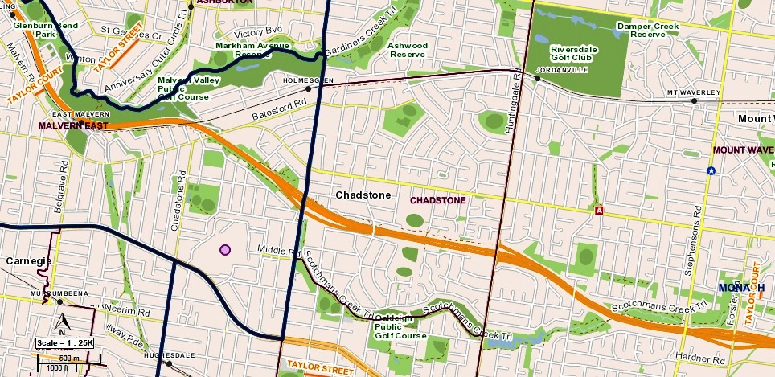

Solution: Consideration should be given to assigning the name to a feature or acknowledging the site or the goods sold. For example, Taylor Blacksmith manufactured nails, chains and repaired carriage wheels, you could consider the names below. Relevant history can then be added to the street signage, refer to Section 13.3. Examples of possible names:
- Blacksmith Court
- Carriage Place
- Nail Close.

Scenario: A naming authority has approved the development of townhouses that will only be accessible via a rear laneway. The naming authority has consulted the community about an appropriate name for the laneway and received a number of submissions. The preferred name is Smith, which commemorates the Smith family who were well respected in the area, ran a grocery store nearby and lived adjacent to the street. As the proposed name is duplicated within a 5 kilometre radius it would not be allowed.
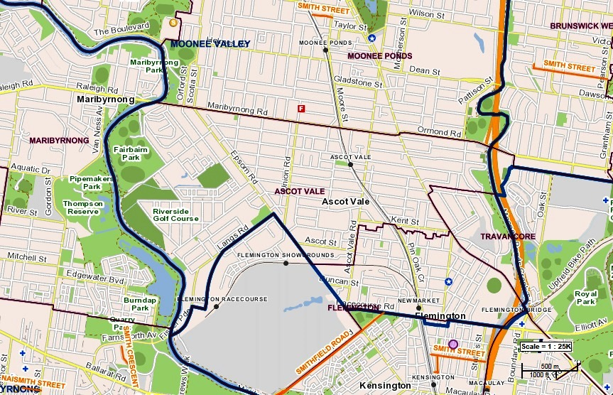

Solution: Consideration should be given to assigning the name to a feature or acknowledging the shop itself or goods sold. For example, if Smiths Grocery was the first store to sell pineapples in Victoria, you could consider the names below. Relevant history can then be added to the street signage, refer to Section 13.3. Examples of possible names:
- Grocery Lane
- Produce Lane
- Pineapple Lane.
2.1.2 Regional urban area
Duplication is not allowed in the same locality and in regional urban areas within 15 kilometres. Below is an example of regional urban duplication.
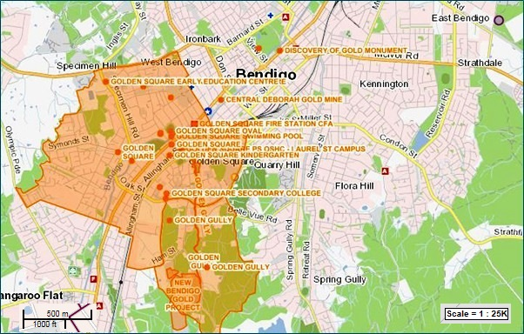

Scenario: A naming authority has received a request to name a picnic area in a local park Gold Picnic Ground to commemorate a location in Bendigo where gold was found. There are multiple places that use ‘gold’ in their names within the area. In this case, use of the word gold would not be allowed.
Solution: Consider assigning the name of the person who discovered the gold or the tool used that found the gold. Relevant history may then be added to the street signage, refer to Section 13.3. Examples of possible names are below:
- Shovel Picnic Reserve
- Pick Axe Picnic Reserve
- Nugget Reserve.

2.1.3 Rural or remote areas
Duplication is not allowed in the same locality and in rural or remote areas, within 30 kilometres. Below are examples of rural or remote area duplications.
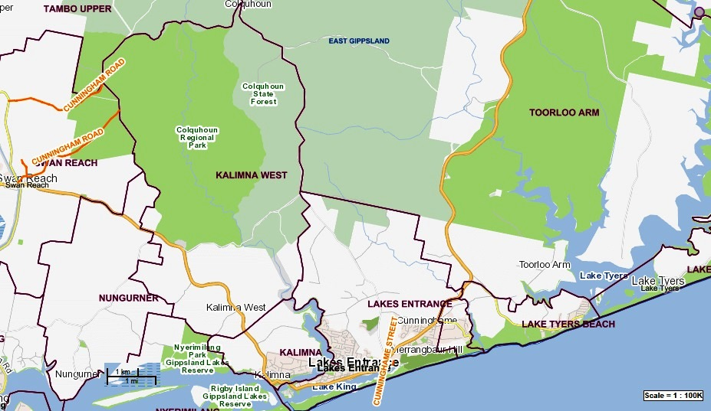

Scenario: The naming authority wishes to preserve the heritage of the area by naming a track after a well-known family that once owned the property to which it led. The proposed name for the track is Cunninghame. There are three roads with similar or direct duplicates; therefore, the naming of the track using the preferred name would not be allowed.
Solution: Consider acknowledging the Cunninghames by recognising their work, management of the land or country/place of origin, e.g. the Cunninghames emigrated from Bristol, England on the boat HMAS Berrima. Relevant history may then be added to the street signage, refer to Section 13.3. Examples of possible names are below:
- Bristol Way
- Berrima Lane.

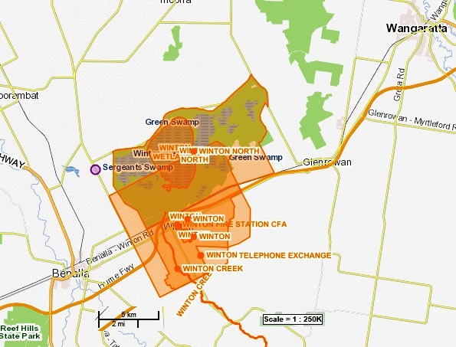
Scenario: A new bridge is being constructed, which will take traffic over the railway line. The proposed name for the bridge is Winston, after a deceased land owner and well-respected member of the community. However, there are multiple uses of the name Winton in the area; therefore, careful consideration should be given to using the name. Winton and Winston is considered a duplication and would not be allowed because they sound too similar and may be incorrectly identified between each other.
Solution: Consider the roles Mr Winston played in the community or how he used his land. For example, Mr Winston was chair of the local Landcare group for 12 years and his land was used to graze sheep and Jersey cows. Relevant history may then be added to the feature signage, refer to Section 13.3. Examples of possible names are below:
- Cow Bridge
- Jersey Bridge
- Sheep Bridge.

2.2 Feature names not considered duplicates
Naming authorities can use the following as a guide to determine feature names OGN might not consider duplicates. If naming authorities would like further advice, please contact OGN.
The names below are not considered duplicates because the feature names have unique identifiers that differentiate them from each other, or the feature type is different. In all examples, the requirement under 4.2.3 Locational names has been applied. The locality name in combination with the other parts of the name associate it to the area in which it is located.
These examples do not apply to roads – road names must be unique.

The creation of Craigieburn ANZAC Park (see maps.land.vic.gov.au/lassi/VicnamesUI.jsp?placeId=122246) in the locality of Craigieburn (see maps.land.vic.gov.au/lassi/VicnamesUI.jsp?placeId=100850) is not considered a duplication, even though within a 5 kilometre radius there are the following similarly named features:
- Craigieburn Bicentennial Park
- Craigieburn Gardens.
The creation of Briagolong Botanical Park in the locality of Briagolong is not considered a duplication, even though within a 15 kilometre radius there are the following similarly named features:
- Briagolong Forest Red Gum Reserve
- Briagolong Recreation Reserve.
The creation of Belvoir Lake Park in the locality of Wodonga is not considered a duplication, even though within 5 kilometres radius there are the following similarly named features. This also relates to the exception for multiple feature names:
- Belvoir Park
- Belvoir Oval.
A new school called Murrayville Community College in the locality of Murrayville is not considered a duplication, even though within a 15 kilometre radius there are the following similarly named features:
- Murrayville Preschool
- Murrayville Primary School.
2.2.1 Multiple names
The assignment of multiple feature names within, for example, a park or reserve is not considered duplication. The feature name must have a direct relationship with one another i.e. Mildura Wharf Carpark which is adjacent and services Mildura Wharf, Albert Park Playing Fields located in Albert Park.
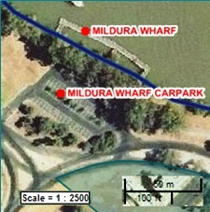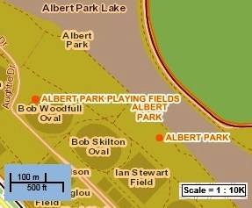

2.3 Anzac commemorative naming project
The OGN is managing the Anzac commemorative naming project (see www.delwp.vic.gov.au/ANZAC-namingproject). The project offers opportunities to name places with strong links to places and acknowledge the wartime service of municipalities local military people or civilians who supported Australia's military cause.
There are clear Commonwealth rules about using the word ‘Anzac’ under the Protection of Word ‘Anzac’ Act 1920 (see www.dva.gov.au/commemorations-memorials-and-war-graves/protecting-word-anzac). Penalties apply for the incorrect use of the term. Permission from the Federal Minister for Veterans’ Affairs is generally required to use the word ‘Anzac’ in a commercial context.
Under the Protection of Word 'Anzac' Regulations 1921 (Cth), the word ‘Anzac’ can be used in the name of a street, road or park containing or near a memorial to the First or Second World War.

3 Roads

3.1 What is a road?
For the purposes of these naming rules, a road is considered to be any public or private land-based thoroughfare or course navigable by vehicle or foot. It can be used for assigning addresses or allowing access between points or to a feature. Examples of roads include alleyways, streets, highways, fire tracks, bike paths and walking tracks.

3.2 Statutory requirements applied to roads
Naming authorities must ensure that a naming proposal conforms to all relevant principles outlined in Section 2 as well as the requirements outlined in Section 3 below, specifically Sections 3.2.1 – 3.2.5.
3.2.1 Rural and urban addressing
Except where provisions are already made in these naming rules, the naming of a road must conform to the provisions of AS/NZS 4819:2011 Rural and urban addressing (see infostore.saiglobal.com/store/Details.aspx?ProductID=1497944). The standard outlines how to derive datum points and how address numbers are assigned. Further advice is available in APPENDIX D.
3.2.2 Extent: road course, start and end points
Any proposal to name or rename a road needs to clearly indicate the extent to which the name will apply. The extent of a road is considered to be its start and end points, and the course (including bends, divided carriageway sections and curves) of the road between these two points.
A road name must not be applied in an ambiguous or confusing way for road users. For example, the road name should be applied to a single, unobscured and unobstructed roadway that leads from a start point to an end point, in a clear and logical manner. The road name should not be applied in a ‘disjointed’ or confusing way. Isolated road segments should be uniquely named.
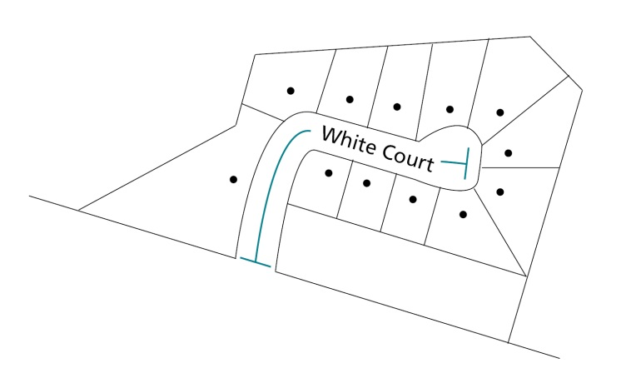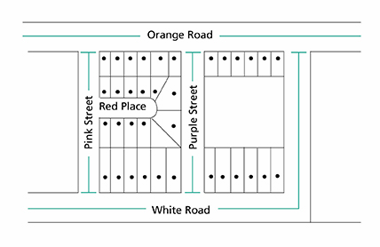
The examples above and below provide appropriate road types with clear extents. If you are unsure about which road type is appropriate and whether an extent is compliant you should contact OGN for advice.
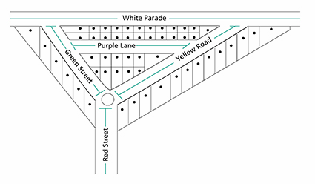
In some cases, a renaming will be proposed for only one section of a road. In these instances, the coordinating road authority must clearly indicate which section of the road will be renamed and which section will remain the same (usually with an annotated and, possibly, dimensioned map or schematic diagram). Renamed roads should see a naming proposal created and submitted to OGN. An error or past amendment not represented in Vicmap or VICNAMES should be submitted via NES (see nes.land.vic.gov.au), the notification for editing service.
If a proposed road is being constructed in multiple stages as part of a multi-lot subdivision development and the proposed road has been constructed at either end but the middle section is yet to be built, both ends of the road should have unique names applied. When the middle section of road is constructed, the two unique road names should extend from their datum points (refer to APPENDIX D) until they meet at a cross road on the newly constructed middle section.
If one name is to be assigned to the completed road, renaming of the two unique roads and renumbering should take place to recognise the full extent of the road.
Note: any current or pending residents and land owners should be advised of the plan to rename the road in the future and possible renumbering implications.
3.2.3 Road types
All roads must have a road type assigned that suitably describes the road’s characteristics. The road type must be selected from the list of acceptable road types provided in APPENDIX A. The list of road types is compliant to AS/NZS 4819:2011 Rural and urban addressing (see infostore.saiglobal.com/store/Details.aspx?ProductID=1497944).
In new estates, road types can be chosen with the ultimate estate configuration in mind. For example, a road that is initially a cul-de-sac may be given an open-ended road type if it can be demonstrated that the road will eventually become a through road.
Road types must not be used to distinguish different roads of the same, similar sounding or spelt names. For example, the roads White Street, White Crescent and White Lane are considered duplications and unacceptable. The same applies to, for example, Whyte Street, Wite Crescent and Wyte Lane (or similar combinations).

3.2.4 Unacceptable road names
There are many legacy names within Victoria that today would not be allowed. The following are examples of unacceptable road names.
- Use of the definite article ‘the’ is not acceptable for sole use as a road name (e.g. it is not acceptable to name a road The Avenue).
- Road types are not to be used in the formation of a road name (e.g. Back Street Road, Arcade Walk, Track Way or Boulevard Street are not acceptable).
- The use of numerals is unacceptable for a road name, either in full alphabetised or numeric format (e.g. Four, Fourth, 4 or 4th are unacceptable). This is because of the possible confusion between the road name and address number.
- A prefixed or suffixed extension of the name is not to be used as part of a road name, e.g. upper, lower, little, old or new and the cardinal directions north, south, east and west. The only exceptions are:
  - when the name is derived from a local feature such as Old Mine Hill, Upper Axedale Quarry Road or South Coal Mine Road
  - when the name is derived from a locality name that uses a cardinal direction, e.g. Geelong West Road is an acceptable name because Geelong West is a locality name; however, Smith South Road, South Smith Road and Lower Smith Road are unacceptable because they do not reflect a locality name.
- Destination-to-destination names, e.g. Melbourne-Geelong Road, are unacceptable. This is because there are too many possible aliases (e.g. Melbourne Road, Geelong Road, Geelong-Melbourne Road and perhaps even a local name such as High Street where the road runs through a township). Therefore, a single name is required.
- Hyphens and the word ‘and’ are not to be used.
- The naming of a road after an estate, which is solely commercial in nature, is non-compliant. Refer to Principle (I) Using Commercial and business names.
3.2.5 Obstructed or altered roads
If the course of a road is to be permanently obstructed or closed, perhaps due to construction of other roads or features, a new unique name must be applied to one end of the road. This is particularly important when an emergency service vehicle cannot navigate the entire course of the road from one end to the other.
It is not appropriate to apply a cardinal direction (north, south, east or west) to one or both ends of the road in these instances. The application of cardinal directions is not appropriate because community recognition of them as unique roads in the same area is limited. Emergency and postal service delivery can also be severely affected.
In the example below, some members of the community could omit the use of the cardinal directions when requesting emergency services or sending mail – this can impede the efficient delivery of these services.
7 Smith Street South  Melbourne  Victoria 3000 |  |  | 7 Smith Street North  Melbourne  Victoria 3000
If cardinal directions are applied to a road name, members of the public could mistakenly use the addresses below, which might apply to both the addresses above.
7 Smith Street  Melbourne  Victoria 3000 | or | 7 Smith Street  South Melbourne  Victoria |  | or | 7 Smith Street  North Melbourne  Victoria

3.3 Roads that can be named
All roads, whether they are public or private, should be named and registered in VICNAMES and Vicmap. This facilitates the application of standardised addressing and location identification across Victoria. Therefore, any land course navigable by vehicle or foot should be officially named according to the principles and procedures outlined in these naming rules.
Other than public roads, the following are some examples of roads that should be named and registered: access tracks to points of interest including rivers or levees, service roads between or behind buildings and private roads that give access to plantations or multiple properties.
Emergency services and public service providers rely on road names being officially registered and signed. This ensures that a road’s location and extent is uniquely identified in the Victorian government’s spatial databases, and is therefore accessible on the majority of relevant organisational and public mapping products. The registration of road names also means that properties or features located on or associated with the road can be assigned suitable and officially recognised street address numbers.
Addresses allocated through the official registration process are used for emergency and other service provision, as well as for the distribution of emergency warning notices to mobile and landline phones. Emergency and other services are often impeded from accurately locating residents and businesses when road names are not registered and addresses are not officially allocated.
Note: Driveways or common property do not need to be named if the sites themselves are addressed to the main road. Exceptions can be made when benefits –e.g. improved public safety, improved delivery of goods and services – can be expected.
Further information about naming roads on plans of subdivision, including street addressing, is available on the FAQ page (see www.spear.land.vic.gov.au/spear/pages/about/about-the-application/frequently-asked-questions.shtml) of the SPEAR website (see FAQ Street Addressing).

3.4 Who can name roads?
Subject to the provisions of the Local Government Act 1989 and the Road Management Act 2004, the main road naming authorities (coordinating road authorities) in Victoria are:
- councils
- VicRoads
- State Government departments or authorities (including Port of Melbourne, Alpine Resort Management Boards, Places Victoria and Parks Victoria).
Both the Road Management Act 2004 and the Local Government Act 1989 allow for coordinating road authorities to name and rename roads and publish gazette notices informing of official road naming. However, these Acts state that, in all instances, the road authorities must act in accordance with the naming rules (refer to Section 1.1).
Typically, OGN gazettes roads on behalf of a council. When coordinating road authorities publish a gazette notice, the authority must act in accordance with the naming rules.
Importantly, road authorities must seek the Registrar’s endorsement for the proposed road name prior to publishing a gazette notice. Information on the processes and procedures required to be undertaken prior to gazettal are provided in Section 10.
Private road naming can be initiated by an owner, developer, emergency service provider, council or public interest group; however, the registration of the name is a process that needs to be completed by the relevant naming authority. Details on the naming processes and procedures for private roads are outlined in Section 3.8.
Naming authorities’ staff should lodge the proposal with OGN using the Notification for Editing Service (NES at nes.land.vic.gov.au). This online facility allows for the easy submission and tracking of proposals from the naming authority through to the Registrar and onto the Department of Environment, Land, Water and Planning’s Information Services Division (ISD). Details on how to register for and use NES are on the website.
If a naming authority discovers a mistake with a road name, e.g. the name is correct in the gazettal and incorrect on the map base, then a NES request should be submitted to Vicmap to correct the mistake.
Note: if residents have been advised of the incorrect name and that name is in use, then changing it is regarded as renaming and the naming rules apply.

3.5 Roads with more than one naming authority
A checklist that naming authorities can use to prepare a proposal for the Registrar’s endorsement is available in APPENDIX C.
Naming authorities own or maintain numerous roads and sometimes share the responsibility for their maintenance with council, government departments and authorities.
If the road is situated across two or more municipal areas, the collaborating naming authorities should engage with staff from the respective organisations and coordinate the proposals based on these naming rules. They may contact OGN for advice and coordination assistance; or, consider referring a proposal to a Geographic Place Names Advisory Committee.

3.6 Council coordination of public roads’ naming
A checklist councils can use to prepare a proposal for the Registrar’s endorsement is available in APPENDIX C.
Refer to Sections 6–14 for the process to prepare a proposal.

3.7 Government department or authority coordination of public roads’ naming
A checklist government departments and authorities can use to prepare a proposal for the Registrar’s endorsement is available in in APPENDIX C.
Because of the varied nature of roads that fall under the responsibility of naming authorities under different State Government departments and authorities, the Registrar prefers to establish unique naming guidelines for each department or authority and, where applicable, adhere to the principles and requirements of these naming rules.
Naming authorities other than local government should have naming guidelines created in consultation with the Registrar. For example Parks Victoria, VicRoads and DELWP. These specific guidelines will complement the naming rules and apply to all roads within a naming authority’s jurisdiction. If a unique set of naming guidelines has not been established for a government department or authority and agreed with OGN, the general requirements set out in these naming rules apply.

3.8 Naming roads in new residential or commercial subdivisions
A checklist that can be used to prepare a proposal is available in APPENDIX C.
Typically, road names are entered via SPEAR.

3.8.1 Responsibility for naming roads in residential or commercial subdivisions
Road naming within plans of subdivision is usually the developer’s role; although, land surveyors often help to choose names and add them to plans of subdivision. It should be noted, however, that plans of subdivision need to be approved by the responsible road naming authority. This is the responsibility of the council or State Government department or authority charged with approving the subdivision plans.
The developer and road naming authority are encouraged to work collaboratively to develop compliant road names for the subdivision.
3.8.2 The naming process
Prior to council certification, developers should consult the road naming authority when preparing plans of subdivision. This consultation may incorporate discussion of possible names for roads in the area and whether the road naming authority might suggest suitable themes (such as Aboriginal heritage, Anzac-related (refer to Section 2.3) or other local historical events or figures) for the developer to consider.
Developers and land surveyors must ensure that road names included on plans of subdivision, for the purposes of certification, conform to the principles outlined in these naming rules. Failure to comply with these statutory requirements may result in a name needing to be changed either prior to or after registration of the subdivision.
Further information is available from the Quick reference guide for land surveyors (see www.delwp.vic.gov.au/namingplaces>Guidelines for naming or proposing to name or rename a place).
Further information on compliant road types is available in APPENDIX A.
During the certification stage of the subdivision process, the road naming authority or subdivision approval and certification body must ensure that the road names allocated to the plans conform to the principles of these naming rules. If any of the parties believe that one or more of the road names do not conform, it should seek to have the land surveyor, in consultation with the developer, change the unsuitable names to ensure compliance.
When plans of subdivision are lodged for registration with Land Use Victoria, an audit of the road names may be undertaken by OGN. If OGN determines that the road names on a lodged plan do not conform to the naming rules, OGN will send a request to the subdivision approval and certification body for the non-conforming names to be changed.
The OGN will not be responsible for any costs associated with changing or amending plans of subdivision.
3.8.3 Entering subdivision road names into VICNAMES
Once a plan of subdivision has been registered, the road names are entered into VICNAMES (see maps.land.vic.gov.au/lassi/VicnamesUI.jsp). Notification of registration is not formally supplied by the Registrar; rather, the act of entering the names into VICNAMES acts as a de-facto notification system.
3.8.4 Road name history
An optional form (available from www.delwp.vic.gov.au/namingplaces>Guidelines for naming or proposing to name or rename a place>Road name history form) can be uploaded to SPEAR with a plan of subdivision. Typically one form should be used per road name. Those looking to name multiple roads should liaise with the appropriate road naming authority to discuss the most efficient way to provide the information.
The form is not mandatory, but if the certifying authority requests that the form is filled in prior to any approval of the plan then the developer or land surveyor may be compelled to comply.
Providing detailed historical information will assist the approval process for the road naming authority. Also, if OGN chooses to audit the plan of subdivision, the information provided will help ensure that the name is appropriate and complies with the naming rules.
When the name has been officially registered in VICNAMES, the road naming authority or land surveyor should submit the historical information to VICNAMES. This will ensure the history behind the name is recorded.
3.8.5 Non-compliant names entered into VICNAMES
If the name of a road in a new subdivision is approved and entered into VICNAMES but is later shown to not comply with the naming rules, the Registrar has recourse to request the road naming authority change the name. The change should be undertaken through collaboration of the road naming authority and developer.
If it can be shown that the name as it is registered will cause an issue for emergency or other service providers, the name must be changed when requested by the Registrar. The naming authority must change the name to a compliant alternative within 90 days of receiving the Registrar’s request or outline to the Registrar the naming authority’s intended action to redress the issue.
The OGN will not be responsible for any costs associated with changing or amending plans of subdivision.
3.8.6 Maintenance and responsibility
Naming or renaming a road in a new subdivision, when the maintenance of that road is the responsibility of the developer and/or private land owners, does not imply or transfer responsibility for road maintenance to the road naming authority (council or State Government department or authority) processing the renaming proposal.

3.9 Naming private roads on private property and within complex sites
A checklist that can be used to prepare a proposal is available in APPENDIX C.
This section outlines the process for naming or renaming roads located on private properties for addressing or way-finding purposes. Private roads include (but are not limited to) roads in commercial logging sites, caravan parks, retirement villages, apartment complexes, shopping centres, schools, universities, hospitals, industrial estates or closed-gate communities. Refer to 3.9.3 Complex site addressing program for further information.
Private roads should be named and registered. It is particularly important if:
- the road gives access to one or more properties that cannot be assigned an unambiguous urban or rural address using the name of other public roads to the property
- the road provides a traffic thoroughfare between two other roads.
Roads on private properties are not usually open to public access (but this is not always the case) and, sometimes, they have restricted access through security gates. Even though these roads are not generally accessible by the public, they are usually named to allow for easy navigation within the complex.
The irregular and ungoverned naming of roads within complexes can lead to problems for emergency and other service providers, especially when the names do not conform to these naming rules and/or are not officially registered.
If a road on private property does not have a name registered in VICNAMES, the official address point for residences or businesses is defined as the primary address of the complex’s location. An example of this would be in a caravan park, when no matter what names were applied to particular roads within the complex, all sites may have the following address:
Ms R Smith
c/o Sunshine Caravan Park
457 Green Road
Melbourne
Victoria 3000
Or a complex address might be:
Ms R Smith
Site 4, Happy Street
c/o Sunshine Caravan Park
457 Green Road
Melbourne
Victoria 3000
The use of primary addresses and complex addresses in these situations is not ideal; therefore, the Registrar requires the official registration of road names within complexes.
Officially registering road names within complexes ensures that the details are stored in Vicmap and are therefore accessible on the majority of relevant organisational and public mapping products.
The registration of private road names also means that properties or features located on private roads can be assigned suitable and officially recognised address numbers. This means that the address for the example above may be:
Ms R Smith
4 Happy Street
Melbourne
Victoria 3000
Note: street number allocation should be in accordance with AS/NZS4819:2011 Rural and urban addressing standard.
3.9.1 The naming process
An owner of a private road or complex is advised to consult their naming authority when developing roads on their site. This consultation might incorporate a discussion of possible names for roads if the naming authority wants to suggest suitable themes for the owner’s consideration.
Owners must ensure that road names conform to the principles and requirements outlined in these naming rules.
An owner of a complex must submit to their naming authority a plan/map for naming the roads within their property. The naming authority will then check that the proposal conforms to the naming rules and, if suitable, send the proposal to the Registrar for endorsement.
If it can be shown that the proposed name will cause an issue for emergency or other service providers, the name must be changed within 90 days of receiving a request from the naming authority or the Registrar; or, the complex owner must outline to the Registrar their intended action to redress the issue.
3.9.2 Entering a private road in VICNAMES
Upon receiving a proposal to name or rename a private road on private property, OGN will upload details of the proposal on the Naming proposals webpage (see www.delwp.vic.gov.au/naming places>Naming proposals). A letter will also be sent to the naming authority advising of the proposal’s receipt.
When considering the proposal, the Registrar will check that the proposed names or name conform(s) to the principles of these naming rules. If the Registrar deems that the proposal conforms to the naming rules, OGN will gazette the proposal and update the Naming proposals webpage to reflect that stage in the procedure.
If the Registrar deems the proposal non-conforming, the proposal will be returned to the naming authority with a request for further information or advice about how the proposal should be redesigned for future consideration and registration. The new name will not be registered in VICNAMES. The OGN will update the naming proposals webpage to reflect that stage in the process.
3.9.3 Maintenance and responsibility
Registering the name of a road in a private property or complex, when the maintenance of that road is the responsibility of the land owner or body of management, does not imply or transfer responsibility for road maintenance to the road naming authority (council or State Government department) processing the renaming proposal.
3.9.4 Complex site addressing program
The OGN, with assistance from Vicmap's Information Services Division, emergency services and other stakeholder organisations, has launched the complex site addressing program.
The complex site addressing program aims to provide a unique address for each sub-address within large or complex sites such as retirement villages, universities, shopping centres, camping sites, sporting facilities, tourist venues, and caravan and residential parks.
By doing this, the program will improve the property addressing system in Victoria and support efficient and effective delivery of emergency and postal services, as well as a range of government activities.
A flyer is available online, primarily for municipal councils, who can then distribute it to managers of complex sites. The addressing information should then be provided by site managers to their councils for uploading to Vicmap. Further information is available online from: www.delwp.vic.gov.au/namingplaces.
For further information on initiating a naming/renaming proposal, refer to Sections 6–14 of these naming rules.

4 Features

4.1 What is a feature?
A feature is considered to be a unique geographical place or attribute that is easily distinguished within the landscape. For example, a feature can be a mountain, watercourse, building, prominent structure or park.
A list of features included in VICNAMES and the relevant naming authorities can be found in APPENDIX B or at www.delwp.vic.gov.au/namingplaces>Guidelines for naming or proposing to name or rename a place.

4.2 Statutory requirements applied to features
Naming authorities must ensure that a naming proposal conforms to all relevant principles outlined in Section 2, as well as the requirements outlined in Section 4 below, specifically Sections 4.2.1–4.2.4.
4.2.1 Feature type
The feature type should be included in a feature’s name and located after the unique feature name. This is to minimise possible confusion over the feature type to which the name applies. For example, the naming of Waterlands Park enables users to understand that the feature Waterlands is parkland.
An exception to this is the use of Aboriginal names or words if the Aboriginal name already includes details of the feature type. For example, Birrarung Marr is a park in Melbourne, with Marr translating from the Woiwurrung language to mean ‘park’ in English.
4.2.2 Waterways
For the purposes of complying with these naming rules, it is necessary for naming authorities to describe in exact detail the full extent of any waterway it is proposing to name or rename, which will ensure official records are unambiguous.
The name of a waterway must be applied from the beginning of the watercourse to its confluence with another waterway or body, but not including tributaries.
Naming authorities must also consult the immediate community that might be affected by the naming of a waterway. Refer to Section 7 for further details.
The naming of waterways may have implications under the Aboriginal Heritage Act 2006 and Aboriginal Heritage Regulations 2007.
4.2.3 Locational names
If choosing a name based on location, the feature should be given the name of the official locality. If the name of a locality is used to define and locate a feature, e.g. Ballarat Avenue of Honour, the locality’s name should appear first in the feature’s name.
The names of neighbourhoods, residential estates and subdivisions should not be applied to a feature. The reason for this approach is that if many features are named after a local estate or neighbourhood rather than the official locality, there can be public confusion about the official addresses in the area.
For example, an unnamed reserve located within an estate known as Blue Water Lakes within the locality of Smithurst should not be proposed with the name ‘Blue Water Lakes Reserve’. Instead, the name ‘Smithurst Reserve’ should be proposed or, if this is already in use, another name should be chosen (perhaps one that commemorates a local historical event or person).
For example, it is not appropriate to name a piece of infrastructure ‘North Yarra Community Centre’ if the officially gazetted locality is Yarra North. It is important that naming authorities preserve the officially gazetted locality name; alternatively, consider renaming the locality.
Refer to Principle D for information about the use of multiple names linked to one locational name.
Refer to Section 2.2 for information about duplicate names.
4.2.4 Base names
Features named under private sponsorship contracts that will attract high visitor numbers (such as sporting stadiums or concert halls) should also, for the purposes of emergency service management, be assigned a ‘base name’. The purpose of the base name is to provide a consistent name over the feature’s lifespan, particularly when the private sponsorship name may change.
An example would be the sporting stadium in Melbourne’s Docklands. Originally named Colonial Stadium then Telstra Dome followed by Etihad Stadium, the base name could be considered to be Docklands Stadium. The sponsorship names would be recorded in VICNAMES (see maps.land.vic.gov.au/lassi/VicnamesUI.jsp) only at the time the sponsorship contract applies, after which time the name would be converted to historical status. The base name would be registered in VICNAMES for the feature’s lifespan.

4.3 Features that can be named
The Registrar requires that naming authorities given the task of naming public and private features adhere to the principles and statutory requirements in these naming rules because it is important to ensure that features in Victoria are clearly and unambiguously named, especially for emergency and other service reasons (all features are defined in Appendix B).
Information contained in VICNAMES is considered to be the definitive data source for geographical names information, and is distributed regularly to a nationwide network of emergency service, postal, and spatial information and mapping agencies.
Providing details to the Registrar of publicly and privately named features ensures that all relevant organisations are aware of the existence and locations of features and correct spelling of their names.
4.3.1 Legacy names
Legacy refers to features that have been named by a naming authority and/or are locally known, but are neither officially registered nor added to VICNAMES. Naming authorities are encouraged to register these features. Naming authorities requiring further information should contact OGN for advice. OGN will determine whether the names are gazetted and what status is applied to the names in VICNAMES.

4.4 Who can name features?
Naming authorities (Refer to Section 1.5.2), companies and people who own or maintain a feature considered to be of public interest (such as a park, reserve, pavilion, sports stadium, concert hall, vineyard or a prominent structure) may name features and are required to submit the details of the feature’s extent and location along with background information on the name via NES (see nes.land.vic.gov.au) or in writing to the Registrar. Upon consideration of this information, the Registrar will determine appropriate action – whether to gazette and register or record the name in VICNAMES, and provide information to all relevant stakeholders (as detailed in Section 13).
Note: The Minister (or a delegate) administering the Water Act 1989 is the naming authority for waterways. Refer to the Water Act 1989 (at www.legislation.vic.gov.au) for the definition of a waterway.
Features named under private sponsorship contracts that will attract high visitor numbers (such as sporting stadiums or concert halls) might also, for the purposes of emergency service management, be assigned base names. The base name may be determined by government, a private entity or OGN (refer to Section 4.2.4).

4.5 Features with more than one naming authority
A checklist that naming authorities can use to prepare a proposal for the Registrar’s endorsement is available in APPENDIX C.
Naming authorities own or maintain numerous public features such as parks, reserves, picnic areas and bridges. A list of features to be included in VICNAMES and the relevant naming authorities can be found in APPENDIX B.
If the feature is situated across two or more municipal areas, the collaborating naming authorities should engage with staff from the respective organisations and coordinate the proposals based on these naming rules. They may contact OGN for advice and coordination assistance or consider referring a proposal to a Geographic Place Names Advisory Committee.

4.6 Council coordination of feature naming
A checklist that councils can use to prepare a proposal for the Registrar’s endorsement is available in APPENDIX C.
Refer to Sections 6–14 for the process steps in preparing a proposal.

4.7 Features with State Government departments or authorities as the naming authority
A checklist that government departments and authorities can use to prepare a proposal for the Registrar’s endorsement is available in APPENDIX C .
State Government departments or authorities that own or maintain public features such as schools and hospitals are the naming authorities for these features. Refer to APPENDIX B for a list of features considered to be owned or maintained by State Government departments or authorities.
Because of the varied nature of features that fall under the responsibility of naming authorities under different departments and authorities, the Registrar prefers to establish tailored naming guidelines for each department or authority and, where applicable, adhere to the principles and requirements of these naming rules.
State Government departments and authorities not covered by existing tailored naming guidelines should follow the procedures outlined in these naming rules.
4.7.1 Guidelines for specific departments or authorities
The following State Government departments and authorities have developed tailored naming guidelines in consultation with the Registrar. These guidelines apply to all features (and roads, as discussed in Section 3) under their jurisdictions.
The following list is only representative of the agreements reached at the time these naming rules were published.
- Department of Education and Training (see www.education.vic.gov.au/school/principals/spag/management/Pages/nameschool.aspx)
- Country Fire Authority.
4.7.2 Cemeteries
A cemetery is a place for the internment of bodily remains and cremated remains. Responsibility for naming cemeteries resides with the Department of Health and Human Services and individual cemetery trusts. For further information about amendment to or creation of a cemetery name, contact the Cemeteries & Crematoria Unit, Department of Health & Human Services on 1800 034 280 or email cemeteries@dhhs.vic.gov.au.

4.8 Features on private land
A checklist that can be used to prepare a proposal for the Registrar’s endorsement is available in APPENDIX C.
This section outlines the process for naming or renaming features located on private properties. There are many features with companies or people as their naming authorities. Examples include, but are not limited to, sporting stadiums and precincts, hospitals, aged care facilities, tourist attractions, features, entertainment complexes or shopping centres. A full list of feature types that should be included in VICNAMES is available in APPENDIX B or contact OGN for details.
Private features should be named and recorded if the feature has an unrecorded official name or a locally accepted name. The naming of features within private property is usually the role of the owner of the site in which the feature is situated. For further information refer to Section 1.7.
The irregular and ungoverned naming of features can lead to emergency response and other service provision interruptions and problems, especially when the names do not conform to these naming rules and/or are not officially registered.
4.8.1 The naming process
Owners of features on private property should contact their naming authority when considering the naming of features. This consultation might include discussions about possible names for the feature – the naming authority may know the locally accepted name and/or wish to suggest suitable themes for the owner’s consideration.
Owners must ensure that feature names conform to the principles and requirements outlined in these naming rules.
An owner of a feature must submit to the naming authority responsible for the feature a plan/map for naming the feature. The naming authority will then check that the proposal conforms to these naming rules and, if suitable, send the proposal to the Registrar for endorsement.
If it can be shown that the proposed name will cause an issue for emergency or other service providers, the name must be changed within 90 days of receiving a request by the naming authority or the Registrar; or, the owner must outline to the Registrar their intended action to redress the issue.
4.8.2 Entering a private feature in VICNAMES
Upon receiving a proposal to name or rename a private feature on private property, OGN will upload details of the proposal on the Naming proposals webpage (see www.delwp.vic.gov.au/naming places>Naming proposals). A letter will also be sent to the naming authority advising of the proposal’s receipt.
When considering the proposal, the Registrar will check that the proposed naming or renaming conforms to the principles of the naming rules. If the Registrar deems that the proposal conforms to the naming rules, OGN will record the name in VICNAMES and update the Naming proposals webpage to reflect this stage in the procedure.
If the Registrar deems that the naming or renaming proposal does not conform, the proposal will be returned to the naming authority with a request for further information or advice about how the proposal be redesigned for future consideration and registration. The new name will not be recorded in VICNAMES. The OGN will update the Naming proposals webpage to reflect this stage in the procedure.
4.8.3 Maintenance and responsibility
Registering the name of a feature in a private property, when the maintenance of that feature is the responsibility of the land owner or body of management, does not imply or transfer responsibility for a feature’s maintenance to the naming authority (council or State Government department) that is processing the naming proposal.

4.9 Features with Aboriginal names
A checklist that can be used to prepare a proposal is available in APPENDIX C.
There are numerous features in Victoria that have Aboriginal names. In many instances, these features are defined differently to western concepts of place (e.g. middens, rocky escarpments, sites on a mountain or beach, rocky outcrops or stone arrangements), but their names are just as important to include in VICNAMES (see maps.land.vic.gov.au/lassi/VicnamesUI.jsp).
Any person or organisation can develop a proposal to register a feature’s Aboriginal name, whether the feature has an existing registered name or not.
If approved the process involves one of the following:
- Recording the Aboriginal name as ‘Registered’ (see Section 1.7) or ‘Dual’ results in the Aboriginal name being recognised as the official name in use for the feature. The name will appear on Vicmap standard maps for the area.
- Recording the Aboriginal name as ‘Traditional’ or ‘Historic’ results in the Aboriginal name being recognised on Vicmap standard maps; the name can be located by researchers and be used on specialised maps.
All names, regardless of their status, will be held in VICNAMES.
For further information refer to Section 7.3 Developing an Aboriginal naming proposal and Section 7.4 Process for an Traditional owner group to develop an Aboriginal naming proposal.
For further information on initiating a naming/renaming proposal, refer to Sections 6–14 of these naming rules.

5 Localities

5.1 What is a locality?
A locality is a geographical area that has identifiable community and/or landscape characteristics. In urban areas, a locality is commonly referred to as a ‘suburb’.
Every locality should have a unique and unambiguous name. It must have recognised and registered boundaries and not overlap with other localities. A locality provides an official reference area for addressing purposes.
A named neighbourhood is not a locality because it does not have officially recognised and registered boundaries; therefore, a neighbourhood name cannot be used for addressing purposes.
A named residential estate is not recognised as a locality name – refer to sections 5.2.2 and 5.2.3.

5.2 Statutory requirements applied to localities
Naming authorities must ensure that a naming proposal conforms to all relevant principles outlined in Section 2, as well as the requirements outlined in Section 5 below, specifically Sections 5.2.1–5.2.7.
5.2.1 Boundaries
Locality boundaries must align with the cadastral fabric, road centre lines or easily distinguishable topographical features such as waterways or ridgelines. The following conventions must be applied.
- If major roads separate communities, the boundary of a locality should be along the road centre line. In cases of dual carriageways, please contact OGN to discuss boundary options.
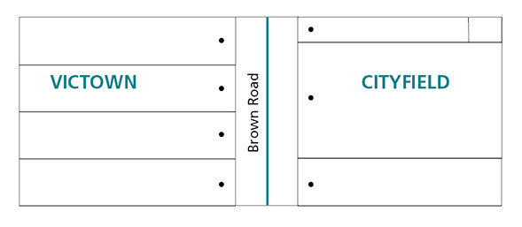
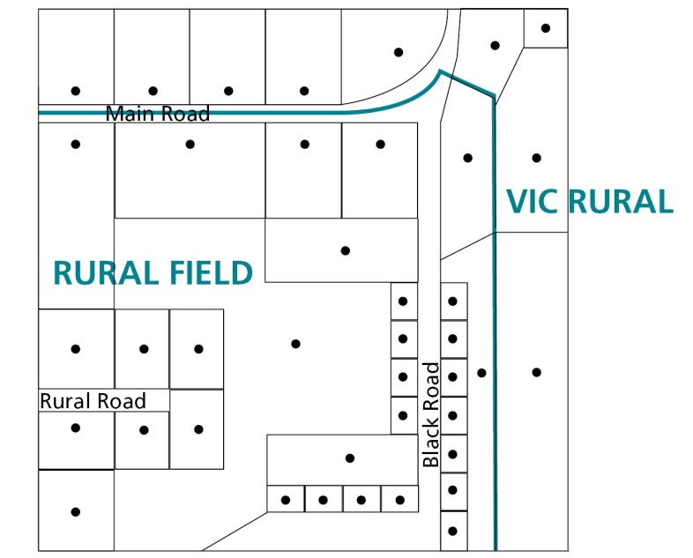

- If residents and businesses in minor roads are deemed to be part of the same community, it is advisable to place the locality boundary along the back boundary of properties facing the road.
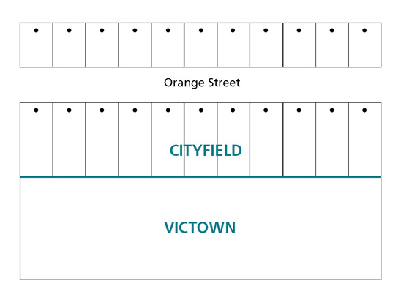
- In dead-end roads and culs-de-sac, the locality boundary should wrap around the properties at the end of the road so that all properties accessed from the same road are addressed to the same locality.
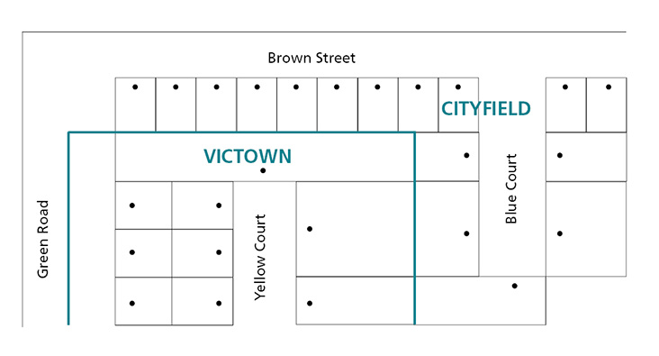

- The locality boundary for corner blocks should be the same as those for neighbouring properties accessed from the same road. There are four options for this location of boundaries, as shown in diagrams a., b., c. and d. below.
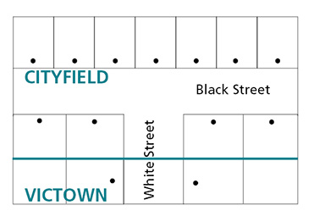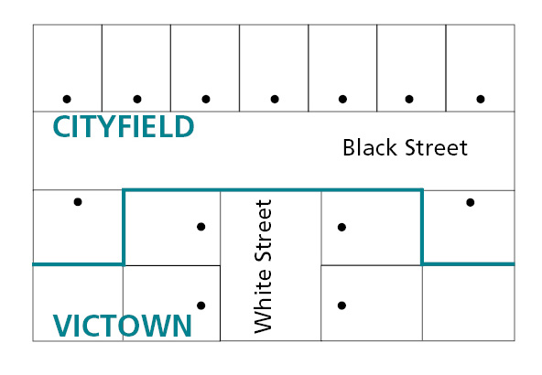
Diagram a. Diagram b.
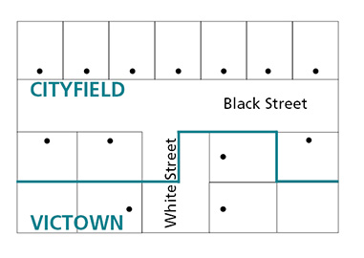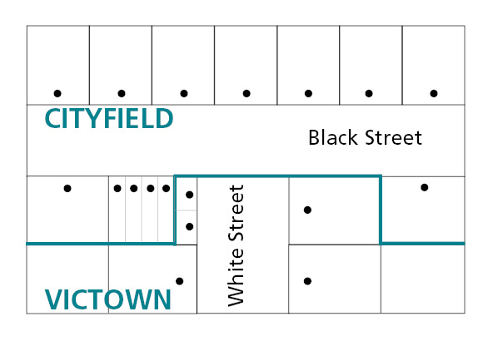
Diagram c. Diagram d.

Diagram a. shows how boundaries should be applied to properties on corner blocks accessed from Black Street.
Diagram b. shows how boundaries should be applied to properties accessed from White Street.
Diagram c. shows how boundaries should be applied to properties where one corner block is accessed from Black Street and the other is accessed from White Street.
Diagram d. shows one option on how to apply a locality boundary where multiple shop fronts or residences on one property have access to both Black Street and White Street. As there are multiple options in these cases, contact OGN for advice.

- If a property is situated on a corner and the block is subdivided with one or more of the new properties accessed from a road generally being addressed to a different locality, the locality boundary should be changed to incorporate the new subdivided properties.
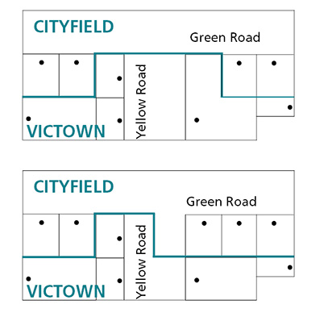
- Locality boundaries should take into account the location of battle-axe properties. Ideally, where a property is accessed through a right-of-way or private roadway from a road that forms part of a locality boundary, the locality boundary should incorporate the battle-axe property.
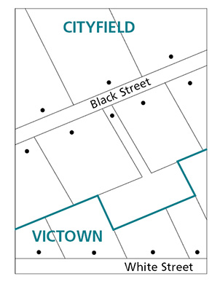

- If a natural feature such as a waterway or ridgeline is to be used as the boundary for a locality, the boundary should be applied to the centreline of the feature. Exceptions to this include the Murray River, lakes, major rivers and ocean or sea boundaries. In these instances, contact OGN for advice.
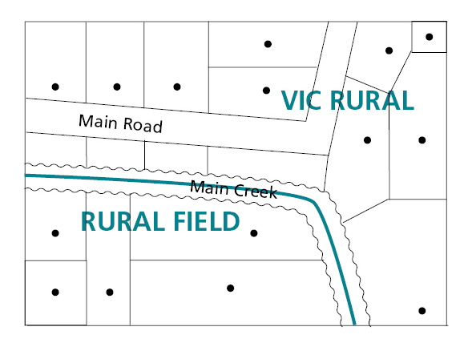
- A locality must not be defined as an island within another locality. For instance, all localities must have boundaries that run alongside two or more other localities, or one other locality and a state or sea boundary.
5.2.2 Estate and subdivision names
The names of estates and subdivisions are considered to be neighbourhood names; therefore, they are not officially recognised for addressing purposes. If a council is considering creating a new locality for an area that contains newly created estates and subdivisions, preference should always be given to creating a new unique name reflecting the landscape or history of the area. When an estate’s name has a historical connection to the area then this may be considered. The naming authority may determine whether there is a need to seek an exemption from the Registrar. Refer to Principles (C) and (I).
5.2.3 Promoting a new estate
The promotion of new estates by developers and land owners must use the correct locality name. The estate name must not conflict with current locality names.
If a land development is promoted as a new locality then this could be considered to be misleading and deceptive under the Competition and Consumer Act 2010 (see www.legislation.gov.au/Details/C2012C00103).
For example, promoting a new development as Green Hills Estate within the locality of Taylor is not misleading or deceptive. However, if a promotion claims that Green Hills will be a new locality where the new estate will be built, it is misleading and deceptive.
Precinct Structure Plan (PSP) names assigned by the Victorian Planning Authority are not to be used to create locality names, unless approval is provided from OGN.
5.2.4 Size
Community areas and landscape features vary in size and it is difficult to define the recommended size of a locality
Generally, a locality should be determined to facilitate emergency or postal service delivery. Therefore, a locality should not be so small that it would make it difficult to distinguish from the surrounding area. A locality also should not be so large that members of the public are confused about where the boundaries lie. Councils must be able to demonstrate that proposed boundaries for a locality will make sense to local residents, businesses and visitors.
A locality is an area that may contain a clear community hub that can be considered the focal point of the named locality. This sometimes consists of a shopping precinct and other economic, public, social infrastructure and provides services to the surrounding residential area.
5.2.5 Hyphens
Hyphens are not to be used in a locality’s name.
5.2.6 Local government area boundary review
Where an existing locality boundary extends across two or more local government area boundaries, the boundaries of the locality should be reviewed with the intention of aligning them within one local government area.
5.2.7 Locality names unique within Australia
Locality names must not duplicate any other locality name in Australia. For example, a new locality in Victoria should not be given the name of a locality that already exists in Queensland.
New locality names should not be similar in spelling or sound like any other existing locality names in Victoria (for example ‘White’ and ‘Whyte’) Refer to Section 2 Principle (D).
Locality names duplicated in other jurisdictions and proposed for a locality in Victoria will only be considered if there is a historical connection to the area, and with an appropriate suffix. Naming authorities should contact OGN, which will consider proposals on a case-by-case basis.
Naming authorities must contact OGN for national duplication checks, including checks against other state or territory reserved locality names. Typically, this process can take up to two weeks depending on jurisdictional availability. Once a unique name has been selected it may be reserved (refer to Section 5.3.2).

5.3 Who can name localities and amend boundaries?
In most instances, the administration of locality naming, renaming and boundary definition is the responsibility of the council within which the locality is situated. See below for the three exceptions to this.
- In some instances, an existing locality may cross two or more municipal areas. In this case, all affected municipalities need to coordinate the naming or renaming and any boundary changes. The final proposal will be assessed by a Geographic Place Names Advisory Committee (refer to Section 1.5.5).
- In other instances, an area being considered for a new locality name may lie within the jurisdiction of a government department or authority undertaking a major land redevelopment project, e.g. the Victorian Planning Authority.
- Victorian islands that are often beyond the councils area of governance. In these cases the matter may be sent to a Geographic Place Names Advisory Committee to be assessed. Relevant stakeholders may also be consulted, including councils, State government departments and agencies and affected private land owners.
5.3.1 Creating a new locality
As the Victorian population increases, new residential and business areas are being developed. Naming authorities play an important role in ensuring that all localities are properly defined and named.
Locality boundaries should be regularly reviewed and assessed to check they adequately reflect the existing situation.
Creating a new locality allows the area’s residents and businesses to use a unique name for addressing purposes. If several major developments are proposed in an area, for example a number of subdivisions distinguishable from the surrounding landscape, naming authorities should consider creating a new locality.
5.3.2 Reservation of locality names
If there could be significant time between consulting OGN about a suitable name or names of a new locality or localities, public consultations, endorsement by the naming authority and finalising the development, the naming authority can lodge the proposed name(s) with OGN to record the name(s) online and ensure other states and territories do not duplicate the name(s). Contact OGN for more details.

5.4 Localities with more than one naming authority
A checklist that naming authorities can use to prepare a proposal for the Registrar’s endorsement is available in APPENDIX C.
If the locality is situated across two or more municipal areas, the collaborating naming authorities should engage with staff from the respective organisations and coordinate the proposals based on these naming rules. They may contact OGN for advice and coordination assistance or consider referring a proposal to a Geographic Place Names Advisory Committee.

5.5 New localities created by councils, government departments or authorities
A checklist that naming authorities can use to prepare a proposal for the Registrar’s endorsement is available in APPENDIX C.
Naming authorities should ensure that the new locality’s proposed name conforms to all of the principles outlined in Section 2 and the requirements of Section 5; in particular, linking the name to the place and not naming places after commercial interests.
Government departments and authorities sometimes undertake major land redevelopment projects. If the development is of substantial size or in a prominent position, it should consider creating a new locality to define the area.
State Government departments and authorities that do not have existing tailored naming guidelines should follow the procedures outlined in Sections 6–14 of these naming rules.
The information provided in these sections should be used by government departments and authorities (e.g. the Victorian Planning Authority) as a step-by-step guide to creating a new locality.

5.6 Changes to existing locality name(s) or boundaries
As communities grow there is a need to ensure that a locality’s name and boundaries reflect community needs. A locality boundary change might be considered due to changes in the distribution of homes or businesses, or other demographic changes.
A checklist that naming authorities can use to prepare a proposal for the Registrar’s endorsement is available in APPENDIX C.
Sections 6–14 of these naming rules contain step-by-step guides to the implementation process for altering a locality name or boundary if that locality falls within one or more municipal areas.

5.7 What should not be done?
It is important to consider the following when assigning a locality or boundary:
- locality names should not be long or hard to pronounce
- proposed name/s should not be offensive, racist, derogatory or demeaning
- locality boundaries must not overlap any other locality boundary
- a locality should not cross municipal boundaries
- locality boundaries must not bisect properties or land – refer to the diagram below.
The below example shows how a locality boundary should not be defined. There is no clear boundary for properties on Brown Road or Orange Street.
If a locality boundary is not clearly defined, the naming authority should align the boundaries to definitive and distinguishable physical features, e.g. cadastral fabric, road centre lines, creeks, rivers and railways.
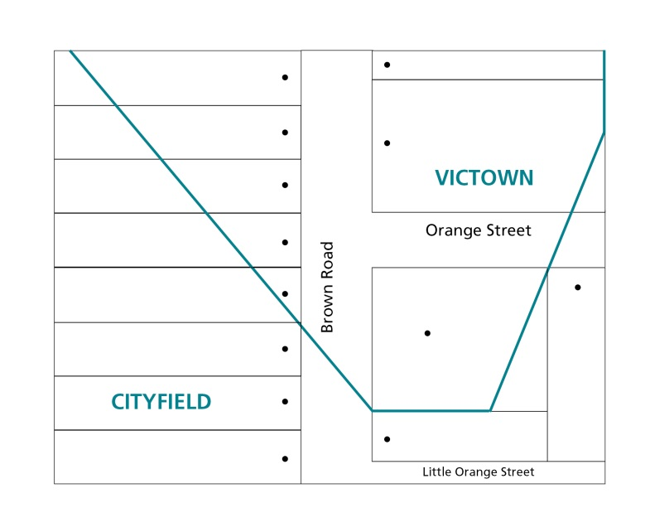

6 Initiating a proposal and checking required information

6.1 Initiating a proposal
6.1.1 General public
Members of the general public and community interest groups can develop a proposal to amend a name or change the name of a road, feature or locality, including a locality’s boundaries.
The proposal needs to be submitted to the naming authority responsible for the area in/across which the road, feature or locality is situated – it is important to note that the council or relevant naming authority should be contacted for advice because some naming authorities may have their own naming policies or guidelines that augment these naming rules and may need to be applied.
Proposals should include:
- the proposed name
- the location of the road or feature, including a map (and, if relevant, its current name)
- background information on why the naming authority should consider naming or changing the name or boundary, e.g. why the proposed name is considered appropriate (include any history or local relevance) – see Principle (C)
- the reason for the proposal (why the current name is not considered appropriate or any other relevant information)
- contact details of the proposer(s) and information on public consultation that has occurred and/or support and non-support that has been gathered from community members or groups
- a statement saying that the proposed name conforms to the relevant principles and requirements in the naming rules.
A checklist available in APPENDIX C can be used to help ensure appropriate information is provided to the naming authority.
If the proposal is in the form of a petition it must include the information above. Refer to glossary for the definition and requirements of a petition
Upon receiving the proposal from the public, the naming authority should initiate the formal proposal process detailed in Section 6.2. If a proposal is to change the name of a road, feature or locality located across two or more council administrative areas, the respective naming authorities need to coordinate the proposal’s processing. OGN can provide advice and, when necessary, recommend if the proposed naming needs to be referred to a Geographic Place Names Advisory Committee (refer to Section 1.5.5).
Once a naming proposal has been submitted to the naming authority, no further action is required by the member(s) of the general public or community interest group(s), unless the naming authority requires additional information or seeks to involve the public or group in the process.
6.1.2 Emergency management or other public service providers
If a request is made in the interests of public safety, the naming authority must respond to the request within 30 days, outlining intended action. Organisations that provide emergency or other services (such as postal or telecommunications) can submit a suggestion or proposal to name or change the name of a road, feature or locality to the relevant naming authority responsible for the area in/across which the road, feature or locality is located. The provider may only submit a proposal if it can be demonstrated to be in the community’s interest.
Proposals should include:
- the location and extent of the road, feature or locality (and if relevant its current name)
- background information on why the relevant naming authority should consider changing the existing name or registering the new name, or boundary amendments
- details on why a new name and/or boundaries are considered to be appropriate
- an indication that any proposed new name conforms to the principles and requirements outlined in Sections 2, 3, 4 and 5.
A checklist available in APPENDIX C can be used to help ensure appropriate information is provided to the naming authority.
Upon receiving the proposal from the emergency agency or other service provider, the naming authority should initiate the formal proposal process detailed in Section 6.2.
Often, emergency services or other public service providers will not provide a suggestion for the proposed new name. In these instances, the naming authority must find a suitable name.
6.1.3 Councils
Councils can generate a naming proposal in-house, including choosing an appropriate name. If a request is made of council in the interests of public safety, the council must respond to the request within 30 days, outlining intended action.
When preparing a proposal, the council should consider naming or renaming a road, feature or locality after a local historical figure or event, or a unique attribute of an event that occurs in the area.
Renaming should only be considered if the council can demonstrate that the proposal is being made in the community’s best interest.
Councils might consider meeting on a regular basis with local interest groups (such as historical societies and charitable organisations) to develop lists of appropriate names for future use.
It is possible for a council to hold a naming competition (but not a competition for the boundaries). In such instances, the council should contact OGN with a proposed approach. The OGN will provide an endorsement of the process prior to public consultation.
If the council wants to develop a naming or renaming proposal that uses an Aboriginal name or names, the relevant Traditional Owner group(s) should be contacted for input at the outset of the proposal’s development.
Information on this consultation process is available from Principle (F) and in Section 7.3.
Once a name has been chosen and/or boundaries redefined (if relevant), councils should initiate the formal proposal process outlined in Section 6.2.
If a proposal is to name, change the name or alter boundaries that cross municipal boundaries, the respective councils should coordinate the proposal’s processing. OGN can provide advice and where necessary recommend if the proposed naming needs to be referred to a Geographic Place Names Advisory Committee (refer to Section 1.5.5).
6.1.4 Government departments or authorities
State Government departments and authorities not covered by a unique set of road, feature or locality naming guidelines should follow the procedures outlined in these naming rules.
There are four possibilities for naming roads, features or localities owned or maintained by a government department or authority, described as follows.
- The department or authority can work cooperatively with OGN to make an in-house determination on an appropriate name. This option allows for endorsement of the proposal by the relevant Minister or a Geographic Place Names Advisory Committee, and ratification by the Registrar.
- The department or authority can develop a public consultation process and work with OGN to determine a final naming proposal. It also allows for the possibility of including a Geographic Place Names Advisory Committee to make a final determination on the proposal, or for the relevant Minister to make a final decision.
- To develop a name proposal through a public competition, the department or authority should contact OGN to discuss appropriate formats for the competition forum. Essentially, the competition should be advertised broadly, with reference made to these naming rules.
- The Minister responsible for the department or authority can seek a Ministerial direction by writing to the Minister responsible for Act to request that powers under s. 11(5) of the Act be excised and direct the Registrar to enter the name in VICNAMES.

6.2 Naming proposal process
6.2.1 Check information
Check all necessary information has been provided by the party proposing the name. If insufficient, request additional information within 30 days.
The decision to proceed with a name proposal rests with the naming authority.
6.2.2 Apply the principles
If the naming authority is not certain the naming proposal conforms to the naming rules (for instance, in cases of possible duplication or boundary confusion) the naming authority can consult OGN and emergency agencies and public service providers using NES. This consultation should be undertaken prior to any public consultation.
Details on how NES works to facilitate consultation with emergency services and public service providers are available from nes.land.vic.gov.au.
Upon selection of a name or shortlist of names and/or boundaries, the naming authority should confirm that the names and/or boundaries conform to all of the principles outlined in Section 2 and statutory requirements outlined in Section 3, 4 and 5.
A naming authority may decline to consider a naming or renaming proposal where a substantially similar application has already been decided upon by the naming authority.

The following process flow chart details the formal process in its entirety.

7 Consultation
Consultation is a key component in the process of naming and renaming roads, features and localities. Naming authorities must consult the public on any naming proposal, in accordance with these naming rules or as agreed with OGN. The level and form of consultation can vary depending on the naming proposal. The following procedure used for the naming of all roads, features and localities in Victoria, whether private or public.
There are two types of community groups to consult regarding a naming, renaming or boundary change proposal:
- The immediate community, which broadly includes people who live and work within the area and owners of properties or businesses; in particular, residents, ratepayers and businesses within the immediate area directly affected by the proposal.
- The extended community, which includes residents, ratepayers and businesses surrounding the area directly affected by the proposal; in particular, any visitor groups to the area such as shoppers, tourists, recreational or dining visitors; government (neighbouring councils) or non-government organisations with an interest in or who service the area, including Traditional Owner group(s), local historical societies and eminent individual historians; service clubs such as Lions and Rotary Clubs, Country Women’s Associations, farmers groups, school parents associations, Probus clubs, senior citizens centres, ethnic associations; Emergency Services Telecommunications Authority (ESTA) and Emergency Service Organisations (ESO).
Please note:
This section does not apply to the naming of new roads or features within new subdivisions where currently no one is directly affected – refer to Section 3.8.
For the use of Aboriginal names, Principle (F) applies – refer to Section 7.3.
In relation to a feature, if residents, businesses or ratepayers use the feature or its address will be affected, they must be consulted.

7.1 Minimum requirements
- When a proposed naming, renaming or boundary change will affect current addresses, the naming authority must contact the immediate community in writing (by letter or email).
- Letters must be sent to the ratepayers of the properties and, if the ratepayers are not the owner-occupiers, letters must also be sent to the residents and/or business occupants.
- A letter must include a survey or voting poll seeking a response from the residents, ratepayers and/or businesses – refer to Section 7.2.4.
- Consultation with the immediate and/or extended community should only occur once the naming authority is certain that the proposed name conforms to the principles of these naming rules. If the naming authority is uncertain, contact OGN for further advice.
- Consultation with the immediate and/or extended community must be a minimum of 30 days, though may be longer.
- If the proposed new name is an Aboriginal name, from the outset the naming authority should consult relevant local Traditional Owner group(s) and obtain their approval. Refer to Section 7.3.
- If a proposal will not affect current addresses the naming authority must consult the public by advertising the proposal in local or state-wide newspapers, unless OGN has given prior approval for an alternative process. The naming authority can also promote the proposal to the immediate and extended community on a website, through letters, newsletters, magazines, email contact lists and public notices.
- If proposing to name a road, feature or locality after a person, then every effort should be made to gain consent from the person’s family members. Supporting evidence demonstrating the naming authority’s efforts to consult family members should be provided to OGN with the proposal lodgement. Refer to Principle H for more information.
- Objections must be addressed when they suggest the proposal does not comply with the principles, requirements and procedures outlined in these naming rules. If it can be shown that the proposal does not conform, the naming authority must alter or abandon the proposal.
- If community support for a proposal is minimal, but the proposal has been made based on public safety and/or emergency response concerns, the naming authority should attempt to refine and/or change the proposal so that it meets community expectations.
If the naming authority believes community support will not be forthcoming and rejecting the proposal will maintain the risk to public safety, then it can either proceed with the proposal on the grounds of public safety (this is particularly important if raised by emergency services) and/or contact OGN for advice. The OGN can refer the matter to a Geographic Place Names Advisory Committee (refer to Section 1.5.5 for further information).
7.1.1 Government departments and authorities
The department or authority must consult the council(s) within which the road, feature or locality is or will be situated. The department or authority should seek to collaborate with the council on developing the proposal, or at a minimum inform the council of the naming/renaming plans. This will ensure the council, as the addressing authority, can assign new or altered addresses to properties on the road and/or assist with developing appropriate boundaries, consulting with the community and advising how the proposal will impact upon existing addresses in the area.

7.2 The consultation process
The consultation process by a naming authority involves six steps, which are illustrated in the diagram below:

7.2.1 Prepare a naming proposal
Ensure that any chosen name adheres to the principles and relevant sections of these naming rules.
After the naming proposal has been initiated and checked that it conforms to the principles and requirements, naming authorities must consult Traditional Owner group(s) if the proposed name is of Aboriginal origin.
After the initial processes have been completed, the procedures of the naming rules stipulate that community consultation is required. Refer to Section 7.2.2.
7.2.2 Develop a consultation strategy
Create a timeline and strategy for consulting the wider community to ensure any chosen name will have community support: who you will consult (refer to 7.2.3), how you will consult (refer to Section 7.2.4) and how you will compile the feedback (refer to Section 7.2.5). Information on each of these topics is provided below.
Preparing this information in advance means that it can be referred to in various information campaigns throughout the consultation process.
A comprehensive strategy will ensure the naming authority has a compliant process that OGN can quickly approve.
7.2.3 Determine who should be consulted
Communities that will be affected by the proposed naming/renaming or boundary adjustment of a road, feature or locality should be consulted. The naming authority must decide whether the immediate community or the extended community should be consulted.
- Roads: consult the owners of properties accessed from the road.
- Features (other than waterways): consult owners of the sites themselves, users of the site, surrounding properties and people from the localities within which they fall.
- Waterways: consult owners of properties adjoining and those within 200 metres of watercourses or with adjoining parcel boundaries.
- Localities: consult property owners within the current and proposed locality’s(ies’) boundaries and from a generous buffer zone of properties adjoining, or within 200 metres of the boundaries.
When the naming authority has ensured that the proposal adheres to the principles and statutory requirements of these naming rules, there should be no further need for consultation with emergency and other service providers. This is because the naming rules have been written in consultation with emergency services and public service providers, and the principles have been designed to ensure that name duplication and confusion are minimised. However, naming authorities should take particular note of Section 13 regarding notification and mail delivery services for addresses on a road with a new name.
The following guide should be used to identify which members of the community to consult.
Proposal | Who to consult | Type of consultation
New road | Immediate and extended community | - Letters  - Notices  - Surveys  - Voting poll  - Internet sites and social media  - Public meetings (if it is a large-scale proposal or potentially contentious issue)
New feature | Immediate and extended community | - Letters  - Notices  - Surveys  - Voting poll  - Internet sites and social media  - Public meetings (if it is a large-scale feature or potentially contentious issue)
New locality (suburb) | Immediate and extended community | - Letters to affected residents, ratepayers or businesses; and to residents, ratepayers and businesses in properties adjacent to the proposed new boundaries  - Notices  - Surveys  - Voting poll  - Internet sites and social media  - Public meetings (if it is a large-scale proposal or potentially contentious issue)
Renamed road | Immediate community | - Letters to affected residents, ratepayers or businesses  - Notices  - Surveys  - Voting poll  - Internet sites and social media  - Public meetings (if it is a large-scale proposal or potentially contentious issue)
Boundary change of a road | Immediate community | - Letters to affected residents, ratepayers or businesses  - Notices (if it is a large-scale proposal or potentially contentious issue)  - Surveys  - Voting poll  - Internet sites and social media  - Public meetings (if it is a large-scale proposal or potentially contentious issue)
Renamed feature | Immediate and extended community | - Letters  - Notices  - Surveys  - Voting poll  - Internet sites and social media  - Public meetings (if it is a large-scale proposal or potentially contentious issue)
Boundary change of a feature | Immediate and extended community | - Letters  - Notices  - Surveys  - Voting poll  - Internet sites and social media  - Public meetings (if it is a large-scale proposal or potentially contentious issue)
Renamed locality | Immediate and extended community | - Letters to affected residents, ratepayers or businesses  - Notices  - Surveys  - Voting poll  - Internet sites and social media  - Public meetings (if it is a large-scale proposal or potentially contentious issue)
Boundary change of a locality | Immediate community | - Letters to affected residents, ratepayers or businesses; and residents, ratepayers and businesses in properties adjacent to the proposed new boundaries  - Notices (if it is a large-scale proposal or potentially contentious issue)  - Surveys  - Voting poll  - Internet sites and social media  - Public meetings (if it is a large-scale proposal or potentially contentious issue)
7.2.4 Build awareness of the proposal and invite feedback
Building awareness of the proposal is key to engaging with the community. The following methods are discussed further. Each method has its own strengths and, prior to selecting one or more of the methods, naming authorities should consider the proposal’s aims and desired outcomes of community consultation. For example, a survey is conducted to investigate opinions; a voting poll is used to make a choice for one or more options.
The following methods can be used to build awareness of the proposal and invite feedback. Each one has its own advantages and conditions of use:
- Notices in newspapers
- Letters to the immediate or extended community
- Surveys (for use only with the immediate community)
- Voting poll
- Internet sites and social media
- Public meetings.
Notices
This includes newspapers (including local and Aboriginal newspapers), radio and television. If an advertisement is to be placed and the naming authority wants to minimise costs, it is possible to place an advertisement or notice with the basic details and refer readers to a website, phone number or council office for further details. The minimum requirements for notices are outlined below and shown in the second example notice. A reduced cost advertisement is shown in the first example notice. If using the first example, then all the information in the second list of dot-points below must be available online.
Advertisements in local newspapers alone are generally insufficient to draw people’s attention to a proposal. In addition to advertisements, notices can be placed in public places, for example:
- at the site to be named or renamed
- local council offices
- libraries and other council facilities
- TAFEs and universities
- community centres and learning exchanges
- shops with community noticeboards such as newsagents, bookshops, supermarkets, organic food stores
- tourist information centres.
At a minimum, these notices must include the following, or the information must be available online:
- the proposed (new) name/boundary and why it has been nominated
- where the road, feature or locality is located
- information about how to provide feedback – at a public meeting (give date, time and venue); or, by phone (provide phone number), mail (include address), or email (include email address and the website’s URL)
- The required date for response, within 30 days of the notice.
Alternatively, if there is no proposed name, notices must include:
- steps for nominating a name or names (in compliance with these naming rules)
- details of how the community can have input into endorsing or selecting a name (e.g. through a vote)
- information about how to provide feedback – at a public meeting (give date, time and venue); or, by phone (provide phone number), mail (include address), or email (include email address and the website’s URL).

Geographic naming proposal
[Insert naming authority name here] is proposing to name/rename a road, feature or locality or amend its boundary.
The road, feature or locality is located at [enter address and/or map].
Further information about the name is available at [must provide the proposal on naming authority’s website, including URL].
Reduced cost format for notices

Geographic naming proposal
[Insert naming authority name here] is proposing to name/rename a road, feature or locality, or amend its boundary.
This naming/boundary realignment is needed because…[enter in the reason for the change and any background to the name with a link to where further information can be found.]
The road, feature or locality is located at…[enter address and/or map].

Members of the public can provide feedback on the name or submit name nomination(s) by one of the following methods:
- public meeting [date, time and venue)
- phone [number]
- mail [address]
- email [address]
- website [URL].
Further information about the name is available at [must provide the proposal on naming authority’s website, include URL].
All name submissions must comply with Naming rules for places in Victoria – Statutory requirements for naming roads, features and localities – 2016.
All submissions must be received by [add date] within 30 days of this notice. [Or time frame determined by the naming authority, not less than 30 days.]

(Only include if using a commemorative name and unable to locate family members.) [Insert naming authority name here] has been unable to locate existing family members to seek permission to use the proposed name and calls for consent from the family or requests family contact details from the community.
Preferred format for notices
Letters
Letters to members of the immediate or extended community should be clear and precise. At a minimum, they must refer to the principles and requirements of the relevant sections of these naming rules and include the following information:
- the location and extent of the road, feature or locality proposed to be named or renamed (with a map and written description)
- the reason for choosing the proposed name
- the closing date for public feedback, which must be no less than 30 days from the date of the letter and/or public advertisement (whichever is later)
- an indication that, if the name or boundary change affects addresses, Australia Post may continue to record and recognise the old address for a period of six to 12 months to ensure a smooth transition from the old address to the new; however, it should also be stated that Australia Post might not guarantee the delivery of incorrectly addressed mail and customers should also be advised to use their official address
- a mail or email address for responses.
An example of a letter is below:
RE: Naming/renaming/boundary realignment letter
[Insert naming authority name here] is proposing to name/rename a road, feature or locality, or amend a locality’s boundary.
The location and extent of the road, feature or locality proposed to be named or renamed or boundary realignment [include a map and written description]
This naming/boundary realignment is needed because…[enter in the reason for the change and any background to the name with a link to where further information can be found].
Members of the public can provide feedback on the name and/or submit name nomination(s) by one of the following methods:
- public meeting [date, time and venue]
- phone [number]
- mail [address]
- email [address]
- website [URL].
Further information about the name is available at [must provide the proposal on naming authority’s website, include URL].
Australia Post may continue to record and recognise the old address for a period of six to 12 months to ensure a smooth transition from the old address to the new; however, it should be noted that Australia Post might not guarantee the delivery of incorrectly addressed mail and customers should also use their official address.
All name submissions must comply with Naming rules for places in Victoria – Statutory requirements for naming roads, features and localities – 2016.
All submissions must be received by [add date] within 30 days of this notice. [Or time frame determined by the naming authority, not less than 30 days.]
Surveys (for use only with the immediate community)
Surveys should be used to gain an indication of community support or opposition to a naming/renaming or boundary change proposal. They should be used with the immediate community if they will be affected by an address change arising from the successful outcome of a proposal.
If a survey is being used to gauge public opinion, owner-occupied properties should be afforded two responses, i.e. one response from the owner of the property and one response from the occupier of the property.
At a minimum, a survey must refer to these naming rules, and include the following details:
- a statement outlining the background of the proposal (often in the form of a cover letter)
- state that all name submissions must comply with Naming rules for places in Victoria – Statutory requirements for naming roads, features and localities – 2016
- state that all submissions must be received by (add date) within 30 days of this notice
- include the following question:
  - Do you agree or disagree with the proposal to name/rename/ adjust the boundaries of [enter name and display a map, as well as including space for respondents to include their name, address, email and phone number]?
If the naming authority is seeking to change a name and a boundary, for example a new locality name and a boundary change, the naming authority should include a specific question on each proposed change.
- Space for respondents to include their name, address and contact details.
Requesting a respondent’s name and address details will assist the naming authority to collate results and ensures a valid survey is undertaken.
Reponses from the community need to be clear to ascertain whether there is support for a proposal. It may therefore be beneficial to include the following in any survey used:
- If you do not support the proposal please indicate why and/or demonstrate why the proposal does not conform to Naming rules for places in Victoria – Statutory requirements for naming roads, features and localities – 2016.
- If you disagree, please explain why.
- If you would like to make any other comments in support of or in objection to the proposed name or boundaries, please do so.
Tacit approval is a way for the naming authority to help ensure a result can be achieved from the use of a survey. Tacit approval should only be used when the naming authority is seeking responses from the community for one proposed name. The naming authority can determine when to use tacit approval.
If the naming authority has multiple proposed names, they should issue two surveys. The first should seek response from the community about their preferred name. If no response is received then this should not be taken as tacit approval for any of the proposed names.
If a preferred name can be determined from the first set of results, the community should be re-surveyed about the preferred name, and the following statement used:
‘If you do not respond to this survey it will be taken as tacit approval of the proposed name’.
If after an initial or subsequent survey or vote on multiple names there is no clear preference, then the naming authority should choose a name in-house. The community must then be re-consulted and given 30 days to object to the naming authority’s preferred name.
If a naming authority is seeking to gain support from the extended community for a proposal, it should avoid using surveys and do it by publishing notices inviting written submissions. The naming authority could also consider establishing an online campaign site and facility for registering support, objections or comments (refer to the Internet and social media section for further information).

An example of a survey is below:
Naming/renaming/boundary realignment survey
[Insert naming authority name here] is proposing to name/rename a road, feature or locality, or amend its boundary.
The location and extent of the road, feature or locality proposed to be named or renamed, or boundary realignment [include a map and written description].
This naming/boundary realignment is needed because…[enter in the reason for the change and any background to the name, with a link to where further information can be found].
Do you agree or disagree with the proposal to name/rename/adjust the boundaries of [enter name and display a map]?
Agree [ ]
Disagree [ ]
[If the naming authority is seeking to change a name and a boundary, for example a new locality name and a boundary change, the naming authority should include a specific question on each proposed change.]
  - If you disagree please explain why.
  - If you would like to make any other comments in support of or objection to the proposed name or boundaries please do so.
[Optional] If you do not respond to this survey it will be taken as tacit approval of the proposed name.
All submissions must be received by [add date] within 30 days of this notice. [Or time frame determined by the naming authority, not less than 30 days.]

All name submissions must comply with Naming rules for places in Victoria – Statutory requirements for naming roads, features and localities – 2016.
Please provide your name, address and contact details, including any comments, objections or written support of the name.

Voting poll
A formal voting poll may be used to select a name or choose between two or more names.
A voting poll could be used to gain an indication of community support to a naming/renaming or boundary change proposal in the immediate community if it will be affected by an address change arising from a proposal’s successful outcome.
In the case of a voting poll being used to gauge public opinion, owner-occupied properties should be afforded two votes, i.e. one vote to the owner of the property and one vote to the occupier of the property.

At a minimum, the voting poll document must refer to these naming rules and include the following details:
- a statement outlining the background of the proposal, often in the form of a cover letter
- one or more names or boundary proposals, including background information on each proposal
- the opportunity to object
- the following statement:
Please cast your vote by [include date]. All votes will be counted, the name with the majority of votes will become the official name of the [road, feature, locality, and/or new boundaries], subject to [insert naming authority name here] approval
- An opportunity to record the respondents name and address.
Requesting a respondent’s name and address details will assist the naming authority to collate results and ensures a valid voting poll is undertaken.
Once a vote has taken place and the responses counted, with consideration given to any objections, there is no need to re-consult as the above statement indicates that the naming authority will approve the final name – refer to Section 9. Objections must be considered and addressed, where relevant, and all those that have objected must be given the opportunity to appeal to the Registrar – refer to Section 8.
An example of a voting poll is below:
Naming/renaming/boundary realignment vote
[Insert naming authority name here] is proposing to name/rename a road, feature or locality, or amend its boundary.
The location and extent of the road, feature or locality proposed to be named or renamed, or boundary realignment [include a map and written description].
This naming/boundary realignment is needed because…[enter in the reason for the change and any background to the name, with a link to where further information can be found].
Only fill in one voting slip per household. Please place a tick in the box next to your preferred name. Only tick one box.
- Proposed name 1
- Proposed name 2
- Proposed name 3
Please cast your vote by [include date here]. All votes will be counted, the name with the majority of votes will become the official name of the [road, feature, locality, and/or new boundaries], subject to [insert naming authority name here] approval.
If you wish to object to the name(s) please do so by making comment below. You must explain why you do not support the name(s).
All submissions must be received by [add date] within 30 days of this notice. [Or time frame determined by the naming authority, not less than 30 days.]

Please provide your name, address and contact details.
Internet and social media
Internet and social media sites can be valuable for collating all relevant information for the benefit of immediate and wider communities. A webpage can be developed within the naming authority’s existing website or as an additional page with its own domain name. Social media sites such as Facebook and Twitter can also be useful tools.
Websites also enable members of the extended community to lodge expressions of support or objection to a naming/renaming or boundary change proposal. They are also a practical facility for a naming competition.
When a website is used as a platform for a naming competition, clear information must be provided about the requirement for names to conform to the principles and requirements of these naming rules.
At a minimum, websites promoting a naming/renaming or boundary change proposal or competition must include the following information:
- background to the proposal
- maps indicating the location and extent of the feature, locality or road
- the closing date for submissions
- information about how expressions of support or objection can be lodged
- details on how and when naming proposals can be lodged, if relevant
- reference and links to these naming rules.
Public meetings
If it is considered necessary, a public meeting could be held. The need for this depends on how important the road, feature or locality is to the community and how controversial the naming/renaming/boundary change might be.
If a public meeting is held then it should be organised and chaired by the naming authority. Consideration must be given to the location and timing of any public meetings so that those in full-time work can attend.
The venue should be acceptable and accessible to all sections of the community and held at an appropriate time to maximise public attendance and views on the proposal.
If one or more public meetings are held, a reasonable amount of time between the last meeting date and the closing date for feedback submissions should be provided. This will give people time to think about the issue; talk it over with their families, colleagues and friends; and give feedback to the naming authority by letter, email or through the website.
Comments made at the meeting should be noted by a minute-taker and passed onto the naming authority for analysis and consideration.
If the awareness campaign results in some people from the community being opposed to the proposed name, a group may form to present a case against the name. If this occurs, care must be taken to take notice of concerns and determine to what extent the group is representative of the wider community.
It may be that the group represents particular interests that may not align with broader community values. The only time a group can be seen as representative of the whole community is when the community elects representatives to act on its behalf, specifically on the subject of a naming or renaming proposal.
Existing groups that have been formed for other purposes (e.g. charity and support or special interest groups) and generally represent a small proportion of the community cannot be seen to have a mandate to speak on behalf of the wider community. However, if groups have discussed the issue at a general meeting with a vote taken to tender a submission, this may be submitted to the consultation group for consideration.
If there is opposition, a new proposal may be put forward. In this instance, the naming authority will need to recommence the naming proposal process and should consider any impacts on public safety if left unchanged. Refer to Principle A and Sections 6.1.2; 6.1.3 and 8.4.1.
7.2.5 Analyse negative and positive feedback from the community
To assist in analysing the feedback, it is recommended that a spreadsheet or other analytical tool be developed to collate and organise the information. The itemised list of feedback should include:
- the source of the feedback (whether it is an individual or a community organisation, protest group, business or government department or authority)
- positive or negative responses to questions posed on the surveys or other methods, such as social media responses
- alternative suggestions provided by respondents.
All feedback must be considered by the naming authority.
If the community was consulted on one name or boundary amendment, the proposal by the naming authority has the support of the community and any objections have been addressed, then the proposal can be considered by the naming authority. Refer to Section 8 and Section 9 Finalising the proposal.
Analysing results – letters and surveys
Letters – confirming consent and objections from written submissions (immediate and extended communities)
If a naming authority is determining community support for a proposal, the statistics related to letters of support and objection are important to consider. The number of letters received should be categorised by their expressions of support or objection, and this information should then be represented as a percentage of the total amount of submissions received.
This information should then be further analysed. In particular, the statements of objection should be categorised in two ways:
- raising issues regarding the proposal not conforming to the principles, requirements and/or procedures of the naming rules;
- or, related to other topics, e.g. the name is not preferred.
For example:
Total submissions received 50
Submissions in favour 25 (50%)
Submissions against 25 (50%)
This proposal is split and the naming authority will have to make a decision about whether it will proceed, or re-consult.
Total valid submissions received 40
Submissions in favour 25 (62.5%)
Submissions against 15 (37.5%)
This proposal can be considered to have community consent.
Surveys – confirming consents or objections from survey material (immediate community only)
When a survey is sent to the immediate community, consent is considered to be achieved when the number of respondents expressing consent, added to the number of non-respondents (indicating, if applicable, tacit consent) is greater than 50 per cent of the total surveyed population.
For example:
Population in immediate community 100
Respondents who objected 30
Respondents who expressed consent 30
Non-responses (tacit consent) 40
Total community that consents 70%
This proposal can be considered to have community consent.
Population in immediate community 100
Respondents who objected 55
Respondents who expressed consent 40
Non-responses (tacit consent) 5
Total community that consents 45%
This proposal cannot be considered to have community consent.
7.2.6 Informing the community of the naming authority’s decision
A letter or email announcing the decision must be sent to all community members. It needs to respond directly to a naming proposal and/or a notice in the local newspaper (or other newspapers, as appropriate).
When objections have been received during the initial rounds of consultation, the community must be informed of the naming authority’s final decision. The exception is when a voting poll was used and the statement informs the community that the final decision is based on the votes received and subject to the naming authority’s approval.
Please refer to Section 8.5 –for examples of what to send to objectors and those that have not objected. Objectors must be informed of their ability to appeal a naming authority’s decision.
The naming authority must allow at least 30 days for final objections to be received. The notification of a naming authority’s decision may be done in the form of a letter or email, which is available in the example below.
RE: Naming/renaming/boundary realignment
[Insert naming authority name here] has made a decision on the name for the [road, feature or locality or amend its boundary].
[Include de-identified results of notices/letters/survey/vote/internet, if appropriate].
A report will now be presented to [insert naming authority name here] requesting the [insert proposed name/boundary] be endorsed.
[Insert naming authority name here] will consider the final proposed [insert proposed name/boundary] at its meeting on [enter, date, time, location of meeting].
You may object to this proposal by responding to this [notice/letter/email] or by attending the meeting above and voicing your objection.
All objections must be received by [add date] within 30 days of this notice.
If you plan to object you must address the following points:
- your interest in the naming proposal –e.g. if your address is affected or you have a personal link with the place and/or name
- reasons why the name is not appropriate, including how it is considered to not comply with the Naming rules for places in Victoria – Statutory requirements for naming roads, features and localities – 2016.
[Insert naming authority name here] will not consider objections that do not explain why the objector opposes the name.

7.2.7 When to re-consult
When the naming authority has surveyed the community to establish a set of suitable or preferred names or boundaries, the community must then be re-consulted on the final determined name/boundaries for the proposal. Any preferred names sent out to residents, ratepayers and businesses by the naming authority must comply with the principles of these naming rules.
Proposals where re-consultation has not taken place (except in the case of a voting poll when a naming authority tallies the results and makes a decision) will be rejected by the Registrar as not conforming to the principles of these naming rules.
If a specific name was not proposed by the naming authority, the consultation process may have generated a detailed list of possible names. Naming authorities should collate this information and check that the names conform to the principles and statutory requirements of these naming rules. Any names that conform should be shortlisted and then formed into a proposal for re-consultation with the community.
This will require one of the methods under Section 7.2.4 to be used for further community consultation to determine support for the final proposed name.
The naming authority must continue to consult until one name is reached and sent for consideration by the naming authority. The name will need to be approved by the naming authority before proceeding. Refer to Section 9.
Note: If the community has been notified that, dependant on community support, the proposed name will be sent to the naming authority for endorsement, the naming authority can then consider the community informed of its decision. All objections must be considered and addressed (if relevant) by the naming authority. Objectors should be advised they can appeal to the Registrar of Geographic Names about the naming authority’s decision.
If the naming authority receives objections during the consultation process and decides to uphold the objections, it can choose to abandon, refine or change the proposal to ensure it conforms to these naming rules. If the naming authority decides to refine and/or change the proposal it must then undertake another round of community consultation to determine community support.

The process for consultation and re-consultation is detailed below.

7.3 Developing an Aboriginal naming proposal
7.3.1 Introduction
Consultation is a key component in the process of naming and renaming roads, features and localities. The process below must be used when proposing to use a name from an Aboriginal language.
While there is a diverse range of Aboriginal organisations in Victoria – local Aboriginal networks, health organisations, arts organisations and local advisory groups – naming proposals should be directed to the relevant Traditional Owner group(s). In Victoria, Traditional Owner groups may be legally recognised through the Native Title Act 1993 as native title holders, the Traditional Owner Settlement Act 2010 as traditional owner group entities or the Aboriginal Heritage Act 2006 as Registered Aboriginal Parties.
For more information about Native Title and Traditional Owner Settlements, visit http://www.justice.vic.gov.au/home/your+rights/native+title/.
For more information on Registered Aboriginal Parties, including contact details, visit http://dpc.vic.gov.au/index.php/aboriginal-affairs/registered-aboriginal-parties.
In areas where a Traditional Owner group has not been legally recognised, please contact Aboriginal Victoria for advice about the relevant groups to consult.
Naming authorities wishing to name a road, feature or locality using an Aboriginal language must follow the steps below.

7.3.2 Preparing a naming proposal
Initially, the naming proposal must be prepared according to the relevant sections of these naming rules. Preparation will include identifying the road, feature or locality that is to be named or renamed and considering what type of naming process would be suitable.
If a naming authority is considering using an Aboriginal name or names in the proposal, it must consult the relevant Traditional Owner group(s) to determine an appropriate name and receive consent for the use of that name.
7.3.3 Determining Aboriginal group(s) for consultation
It is the responsibility of the naming authority to determine which Traditional Owner group(s) to consult.
When the naming authority identifies more than one group that must be consulted it should establish a consultative group with which to liaise and determine an appropriate name or names for the proposal.
7.3.4 Selecting a consultative group
When the road, feature or locality to be named or renamed could embrace more than one Traditional Owner group (e.g. a mountain range that includes more than one Registered Aboriginal Party), a special consultative group may need to be formed from members of two or more groups.
To establish the consultative group, the naming authority should contact the relevant Traditional Owner groups by phone or letter, and include the following information:
- background to the naming proposal
- location of the road, feature or locality to be named or renamed
- details of which Traditional Owner groups have been identified in the area
- information on the desirability of forming a consultative group, formed by members of relevant Traditional Owner groups
- details on how Traditional Owner groups can nominate members for the consultative group and what their responsibilities will be
- a proposed timeline for the naming program and a ‘reply-by’ date
- a contact officer within the naming authority and contact details for OGN.
The Traditional Owner groups will decide who should be appointed to the consultative group. In order to recognise the need for the naming authority to gain confirmation of the representative status of a nominee, letters or emails supporting the membership should be provided from the representative group Chief Executive Officer or board chairperson (if it is convenient).
Members of a Traditional Owner group selected to be members of the consultative group must have consent from their community to make decisions on naming or renaming roads, features or localities. Each member of the consultative group should have equal voting rights and be appointed to assist the naming authority with identifying an appropriate name or names for the naming proposal.
7.3.5 Building awareness within the Traditional Owner community
It is important that members represent their Traditional Owner and/or broader Aboriginal group and take responsibility for building awareness within their community of the proposed naming or renaming. Community awareness could be built in the following ways.
Media
Build awareness through Aboriginal radio stations and Aboriginal programs in the mainstream media. Radio stations can include (but are not limited to) 3KND 1503 AM.
Specific newspapers for Aboriginal and Torres Strait Islander audiences include the Koori Mail and National Indigenous Times. Local newspapers are also important media vehicles. Whatever media method is used, it is important that information is included on how the broader community might provide feedback to members of the consultative group.
Notices
Notices can be placed in public places, for example:
- the site to be named or renamed
- Traditional Owner organisations (including their premises, websites and newsletters, where applicable), Aboriginal co-operatives or organisations
- cultural centres
- Koorie Open Door Education Schools
- local council offices
- libraries
- TAFEs and universities
- community centres and learning exchanges
- shops with community notice boards.
Meetings
Members of the consultative group may hold meetings with the communities they represent (or raise the naming proposal during regular community meetings), and ensure that both women and men are invited and encouraged to provide input or feedback into the process.
7.3.6 Feedback from the Aboriginal community and endorsement of name(s)
The broader Aboriginal community may provide feedback to the consultative group.
The consultative group should establish a process to identify an appropriate name or names for the proposal and determine a method for achieving group consensus on the final name(s) to be endorsed and provided to the naming authority.
The process should include a final meeting of the consultative group. It will examine the feedback from appointed members who report feedback from their own communities or other Aboriginal people who have written, phoned or provided comments.
If there is consensus at this point, then the consultative group can endorse the name(s) and provide written or verbal advice to the naming authority.
If consensus is not reached on the name, the consultative group must contact the naming authority and/or OGN to discuss whether or not further support is required to reach a decision.
When a final decision is made, the naming authority and consultative group should work collaboratively to promote the naming proposal to the wider community. Information on how this can be achieved is outlined in the following section.
7.3.7 Building awareness of the proposal within the wider community
When a name or names is/are selected and approved by the relevant Traditional Owner group(s) and endorsed by the consultative group, the local community must be made aware of the proposed name and given the opportunity to provide feedback. Any publicity should build awareness and understanding of Aboriginal cultural heritage so the proposed name is seen in that context.
This is the responsibility of the naming authority, but it can be helpful to also involve the consultative group. At this step in the process naming authorities may continue with the process as outlined in Section 7.2.4 Build awareness of the proposal and invite feedback.
7.3.8 Feedback from the wider community
The wider community can provide feedback in a number of ways and could include letters, phone calls, an Internet site and/or email. This should be coordinated by the naming authority.
It has already been suggested that a public meeting should be held and that the awareness building may lead to such an event. However, this may be seen as excessive in some circumstances. It depends on how important the road, feature or locality is to the community and how controversial any naming or renaming might be.
If a public meeting is held then it should be jointly organised and chaired by the naming authority and the consultative group. Any comments made at the meeting should be noted by a minute-keeper and considered by the naming authority and consultative group for consideration.
An appropriate timeline for feedback should be established. When the feedback period ends, an analysis sheet should be prepared summarising the responses according to category of response and where the response came from: an organisation, individual or business. This sheet, together with the letters, phone log and emails should be passed onto the consultative group.
At this step in the process naming authorities may continue with the process as outlined in Section 7.2.5 Analyse feedback from the community.
7.3.9 Reimbursement of costs
The naming authority is expected to cover reasonable costs associated with the consultative group and public awareness campaign.
Limited financial assistance may be provided by the naming authority to facilitate the consultation process; however, reimbursement will not be available for consultative group meetings held when the naming or renaming is one of a number of agenda items.
If meetings are held by the consultative group to specifically discuss the naming issue, members’ travel costs may be reimbursed by the naming authority.
If a public meeting to gather feedback from the broader community is held, the person acting as co-chair may also have travel costs reimbursed.
It is not anticipated that a consultative group will need to establish a new Internet site. If one already exists, however, consideration should be given on a case-by-case basis to cover the cost of adjusting that site to record feedback on the issue.

7.4 Process for a Traditional Owner group to develop an Aboriginal naming proposal
If a Traditional Owner group wants to name a road, feature or locality but is unsure who the naming authority is and/or if there is an officially registered or locally known name, then follow the steps below or contact OGN for further advice.
7.4.1 Identify the name
The Aboriginal name for a road, feature or locality can be identified by any person, group or organisation using specific cultural knowledge or historical documentation relevant to the area in which the road, feature or locality is situated.
7.4.2 Locate other names
The proposer must check whether other names are officially registered or recorded (this can be checked using VICNAMES at maps.land.vic.gov.au/lassi/VicnamesUI.jsp). This will help identify the exact location of the road, feature or locality to which the proposed name will apply, and whether the wider community uses an unofficial name.
If an unofficial name exists, the proposer may submit the naming proposal as a Dual name with the existing registered or unofficial name. There are exceptions to a Dual name not being considered and, therefore, the assignment of an Aboriginal name may not proceed, e.g. to avoid possible confusion for addressing or providing emergency management (refer to Principle (G) Dual names).
If no other name is in use, the Aboriginal name can be recorded as registered, traditional or historic in VICNAMES. Refer to Section 1.7 Status of names in VICNAMES and for features Section 4.9 Features with Aboriginal names.
7.4.3 Verify the name
When an Aboriginal name has been identified, it must be verified by the Traditional Owner group(s) in the area in which the road, feature or locality is located. In some instances, this might be more than one group. In all instances, the name must be verified by all groups with recognised heritage in the area (for a list of these groups refer to Section 7.3). Further advice can be obtained from Aboriginal Victoria, Department of Premier and Cabinet (www.dpc.vic.gov.au).
All relevant Traditional Owner groups must give written consent to the name being registered for the road, feature or locality (either as a Dual name or single name). If written consent has not been provided by all groups, contact OGN for further advice.
7.4.4 Contact the naming authority for the road, feature or locality
The proposer should contact the naming authority for the road, feature or locality and submit directly to it a naming proposal. Refer to Section 6.1.1. The naming proposal must then be processed according to the steps in Section 7.2 or Section 7.3 if proposing to use a name from an Aboriginal language.

8 Objections and submissions
The consultation process allows members of the community to express an opinion about a naming or renaming proposal.
People can object to a naming proposal, support it or provide comment on it without expressing support or opposition.
Objections to or submissions about an existing named road, feature or locality outside an active naming consultation period should refer back to Section 6 – Initiating a proposal and checking required information.

8.1 What to submit
An objection or submission, is a way for members of the community to inform the naming authority that one or more people disagree/agree with a naming or renaming proposal. An objection or submission must explain why a proposal is opposed/supported. Simply lodging opposition/support without an explanation does not help the naming authority understand the underlying issues/benefits.
At a minimum, objections or submissions (including petitions and pro-forma documents) should explain:
- the person’s or group’s interest in the naming proposal – e.g. if their address is affected or whether they have a personal link with the place and/or name
- reasons for the name being inappropriate/appropriate, unsuitable/suitable or unsupported/supported, including how it does or does not comply with these naming rules.
Note: If a petition is used to object or support a naming proposal then a statement within the petition must, as a minimum, address the two points above. Signatories must include their printed name and property address

8.2 Who can object or support a proposal?
Any person or organisation can lodge a submission in objection or in support of a naming, renaming or boundary change proposal during the public consultation period administered by the relevant naming authority.

8.3 Lodging a submission
Submissions must be lodged directly with the naming authority within the minimum 30 days allocated for feedback. Naming authorities can, if necessary, provide for a longer feedback period.

8.4 How submissions are considered
Any submission received during the public consultation period must be considered by the naming authority. The naming authority is responsible for deciding the weight to be given to competing submissions, having regard to these naming rules and any other relevant matters it identifies.
All submissions must be included in an assessment report, stating the objection or support for a proposal, indicating relevance to the naming rules and the naming authority’s consideration/response to the submission.
The decision about whether or not to proceed with a naming proposal resides with the naming authority.
Note: The naming authority need not consider objections that don’t explain reasons for the objector opposing the name. If a voting poll is used, however, the naming authority must consider the numbers for and against a proposal , whether or not reasons for objections are provided.
If the naming authority accepts the proposal and lodges it with the Registrar for consideration, it must provide details of what the objections were and how they will be or have been dealt with.
If the naming authority decides to uphold the objections, it can choose to abandon the proposal or refine and/or change it to ensure it conforms to these naming rules. If the naming authority decides to refine and/or change the proposal, it must then undertake further community consultation in order to determine community support.
Naming proposals that have not addressed objections will be rejected by the Registrar as not conforming to these naming rules.
8.4.1 Minimal community support for name
If there is minimal support for the chosen name, the naming authority may decide to re-consult on a new name or abandon the proposal, regardless of the proposal being compliant to these naming rules.
Note: If the proposal has been made based on public safety and/or emergency management concerns, the naming authority should attempt to refine and/or change the proposal so that it meets community expectations. If the naming authority believes that community support will not be forthcoming, and non-approval of the proposal will maintain the risk to public safety, it can either proceed with the proposal on the grounds of public safety (particularly important if raised by emergency services) and/or contact OGN for advice. The OGN can refer the matter to a Geographic Place Names Advisory Committee (refer to Section 1.5.5 for further details).

8.5 Informing the community of a decision
In all instances (except a voting poll, refer to Section 7.2.6), any party who responded to the proposal must be advised of the naming authority’s decision. The naming authority must write to objectors, when they’re identified, informing them of the outcome of the naming proposal. The letter to objectors needs to indicate that an appeal to the Registrar must be lodged within 30 days of the naming authority accepting the proposal and/or sending the letter to the objector (whichever is later). Only those members of the community who have objected to a naming proposal are offered the ability to appeal to the Registrar.
If objections raise concerns about the proposal not conforming to the principles and statutory requirements of these naming rules, the response must outline:
- how objections have been dealt with
- why the naming proposal was accepted and sent to the Registrar for consideration and inclusion in VICNAMES; or if rejected, how it will subsequently be refined, changed or abandoned.
In cases of the naming authority accepting the proposal, the letter to objectors also needs to include details of how an appeal can be made to the Registrar. An appeal can only be made if the objector can demonstrate that either:
- the naming authority did not consider the objections during its deliberations
- the proposal does not reasonably conform to the principles and statutory requirements of these naming rules.
For further information refer to Section 11.1 Appeals.
Note: The naming authority must have already allowed the community to object to the initial proposal and the naming authority must address the issues raised in the objector’s objection, where relevant.
The letter below outlines what to include (where applicable) in the letter to objectors.

Naming/renaming/boundary realignment
[Insert naming authority name] has made a final decision on the name for the [road, feature or locality or boundary amendment].
A report was presented to [insert naming authority name] and endorsed on [insert date of endorsement and link to minutes if available].
[Explain how the objection has been dealt with, e.g.. there was overwhelming support for the name, the objection is not valid, the concerns raised will be mitigated because…]
[Explain why the naming proposal was accepted and sent to the Registrar for consideration and inclusion in VICNAMES; or if rejected, how it will subsequently be refined, changed or abandoned.]
[Insert naming authority name] will now send the proposal to the Registrar of Geographic Names.
As you previously objected, you are being advised that you have the opportunity to appeal the [insert naming authority’s name] decision.
All appeals must be made in writing and sent by mail to the Registrar of Geographic Names, Office of Geographic Names, DELWP, PO BOX 500, East Melbourne, Victoria 3002 or by email to geo.names@delwp.gov.vic.au.
All appeals must be received by [add date, which needs to be within 30 days (minimum) of this notice or timeframe determined by the naming authority].
An appeal will only be considered if the objector can demonstrate that either:
- the naming authority did not consider the objections during its deliberations
- the proposal does not reasonably conform to the principles and statutory requirements of Naming rules for places in Victoria – Statutory requirements for naming roads, features and localities– 2016.

Note: The above example must be used for informing objectors of a naming authority’s decision.

The letter below outlines what to include to those that have either made a submission, but had not objected or did not respond to the initial proposal.
Naming/renaming/boundary realignment
As you are aware, [insert naming authority name] has recently surveyed/notified the community of a proposal to name/rename a road, feature or locality or amend its boundary.
You have received this correspondence because you are affected by this proposal.
As a result of the survey/notice/letter, a preferred name of [insert preferred name] received the most support.
A report will now be presented to [insert naming authority’s name] requesting endorsement of [insert preferred name].
[Insert naming authority name here] will consider this request at its regular [insert meeting name here], scheduled to take place on [insert date, time and location of meeting].
[If an agenda is available, advise accordingly]
All objections must be received by [add date, which needs to be within 30 days (minimum) of this notice or timeframe determined by the naming authority].

9 Finalising the proposal
The naming authority must determine that the proposed name(s) and/or boundaries and the process undertaken to reach the final proposed name conforms with the Principles of Section 2 and relevant requirements in Sections 3, Section 4 or Section 5.
It is useful to prepare a report on the proposal, which will assist in determining compliance. The report should include:
- information about how the proposal conforms to the relevant principles and requirements of these naming rules
- discussion on and response to any objections/comments received during the consultation period(s).
The naming authority’s decision to accept or reject a proposal must be formally recorded. This may include councillors ratifying the name at council meetings, relevant Ministerial or CEO approval and/or when the decision has been made under delegated authority.

10 Lodging a proposal with OGN
Naming authorities should lodge the proposal with OGN using Notification for Editing Service (NES).
This online facility allows proposals to be easily submitted and tracked, from the naming authority through to the Registrar and the addition of data to VICNAMES and Vicmap. Details on how to register for and use NES are provided at nes.land.vic.gov.au.

10.1 Information a naming authority must lodge with OGN
When submitting a proposal through NES, naming authorities must provide the following information, (where relevant):
- details of the existing and proposed extent of the road (in accordance with requirements of Section 3)
- details of the feature (including, as an example, a park’s address and access points for emergency management)
- details of the proposed boundaries for the new locality and boundaries of the existing localities in the area (in accordance with requirements of Section 5)
- a map displaying the extent of the road, feature and/or locality
- background on the proposed name and/or boundaries and why they were selected
- details of why a renaming is proposed
- details of the consultation process:
  - a statement from the naming authority(ies) about how they reached their decision about who to consult, i.e. immediate and/or extended community
  - a statement on which method(s) of consultation was used, i.e. notice, letter, survey, website etc
  - analysis of outcomes of consultation
  - how any objections were considered and what responses were provided to the objector
- confirmation that the name and/or boundaries conform to the principles and statutory requirements of Sections 2, 3, 4, and 5 of these naming rules
- confirmation that the proposal has been accepted by the naming authority or is being submitted by a delegated officer
- the following information (where relevant):
  - a copy of consent from the relevant Aboriginal group(s)
  - details of consultation with emergency services and public service providers (if NES was used for consultation this evidence is automatically attached to the submission to OGN
  - copies of the notice, letter, survey or voting poll material
  - de-identified (i.e. personal details removed) objections received from the public
  - copies of letters sent to objectors, indicating their ability to lodge an appeal to the Registrar (as provided in Section 8)
  - a copy of council minutes indicating acceptance of the proposal, or that council staff have delegated authority.

10.2 What the Registrar does
The Registrar will follow the process in Section 11 unless a government department or authority requires either of the following.
10.2.1 Seeking Registrar’s endorsement of a proposal
If the proposed name and/or boundaries conform(s) to the principles and requirements of these naming rules, the Registrar will endorse the proposal and provide written evidence of this to the department or authority.
If the naming proposal does not conform to these naming rules, the Registrar will offer advice on how to amend the proposal to ensure that it will comply. The government department or authority can then amend the proposal and resubmit it to the Registrar for endorsement.
The government department or authority can use the Registrar’s endorsement to seek approval for the naming proposal from its Minister. If the Minister approves the proposal, the department or authority should then provide copies of this approval to the Registrar, who will then proceed to gazette and register the name utilising the processes outlined in Section 12.
10.2.2 Registrar’s consideration of a proposal seeking referral to a Geographic Place Names Advisory Committee
If the department’s or authority’s proposal is seeking the assistance of a Geographic Place Names Advisory Committee to make a final naming determination, the Registrar will convene a committee based on the provisions of s.12 to s.17 of the Act.
The committee will be convened at its committee members’ earliest possible convenience.
Further information about Geographic Place Names Advisory Committees is available in Section 1.5.5.

11 Registrar’s consideration of a proposal
Upon receiving a proposal from the responsible authority to name or rename a road, feature, or locality and/or its boundaries, OGN will advise the naming authority of the proposal’s receipt.
If the naming authority indicates that the proposal received objections during the consultation period, the Registrar will not consider approving the proposal until 30 days have elapsed since the naming authority accepted the proposal and notified objectors. This 30-day period is to allow time for objectors to lodge an appeal, as provided in Section 8 and refer to 11.1 Appeals below. If there are no objections then the Registrar will proceed with considering the proposal.
When considering the proposal, the Registrar will check compliance with all the principles and relevant requirements of these naming rules. In particular, the Registrar will check that the name is not duplicated, appropriate community consultation has occurred and the naming authority in the creation or alteration of a locality’s boundaries has considered any proposed change to be in the community’s long-term interests.
If the Registrar deems that the proposal conforms to the naming rules, OGN will proceed to gazette the proposal and update the Naming proposals webpage at www.delwp.vic.gov.au/namingplaces>Naming proposals.
The Registrar may consider the name is of greater than local significance and in this instance the proposal will be referred to a Geographic Place Names Advisory Committee for its advice. Further details on Geographic Place Names Advisory Committees are available in Section 1.5.5.
If the naming proposal does not conform to these naming rules, the Registrar will offer advice on how to amend the proposal to ensure that it will comply. Only compliant names will be gazetted and registered in VICNAMES.
Note: The Registrar has discretionary powers to enter any name into the Register.
Section 11 of the Act, Registration of names, states:
- The Registrar must enter in the Register each name for which an application for registration is made in accordance with this Act and the guidelines, other than an application that is referred to a Committee for advice.
- The Registrar must amend a geographic name in accordance with an application for amendment made in accordance with this Act and the guidelines, other than an application that is referred to a Committee for advice.
- The Registrar, upon receiving advice in accordance with this Act and the guidelines from a Committee to which a matter is referred under this Act, must make such entries or alterations in the Register as are necessary to give effect to that advice.
- The Registrar may make such entries in the Register as the Registrar determines are appropriate to record the names of places for which names are assigned by or under any other Act.
- The Registrar must comply with any directions given by the Minister from time to time concerning the registration of names in the Register and must not make an entry inconsistent with any such direction as in force from time to time.
- The Registrar must cause to be published in the Government Gazette, and in such newspapers circulating generally in the State as the Registrar thinks appropriate, a notice of each entry of a place name, and of each amendment of an entry, in the Register.

11.1 Appeals
The Registrar may only consider appeals from members of the community who have already objected directly to the naming authority’s proposal. An appeal to the Registrar can only be made if the objector can demonstrate that either:
- the naming authority did not consider the objections during its deliberations
- the proposal does not reasonably conform to the principles and statutory requirements of these naming rules.
All appeals must be made in writing and sent to the Registrar of Geographic Names, Office of Geographic Names, DELWP, PO BOX 500, East Melbourne, Victoria 3002 or via email to geo.names@delwp.gov.vic.au.
Appeals that do not respond/address one of the two points above will not be considered as valid appeals.
Petitions may be used to appeal a naming authority’s decision. If a petition is used to object to a naming proposal then a statement within the petition must, as a minimum, respond/address the two points above. Signatories must include their printed name and property address
OGN will formally acknowledged receipt of all appeals, either via letter or email.
The Registrar will consider all valid appeals and determine whether a naming authority has complied with the naming rules. Objectors will receive a formal response to an appeal outlining the Registrars decision to endorse and proceed with gazettal or reject a proposal.

OGN follows the below process when the Registrar considers a name proposal.

12 Gazettal of a proposed name or boundaries
When a name, new name and/or boundary(ies) is/are chosen and endorsed by the Registrar, it/they will be included in a weekly notice published in the Victoria Government Gazette (www.gazette.vic.gov.au), notifying registration of new or altered roads, features or locality names and/or boundaries in Victoria.
A name may also be endorsed prior to gazettal by the Minister of the department or authority from which the proposal was generated; or, through a proposal from a Geographic Place Names Advisory Committee.
The gazette notice will include the following items (where relevant):
- the NES change request number
- the pre-existing name of the road, feature or locality
- the new name of the road, feature or locality, (if private, will be indicated)
- the name of the private complex in which the road is located
- written details of the extent of the road, feature or locality
- the address of the feature
- the locality(ies) in which the road or feature is located
- the names of the existing localities within which the new locality is being defined
- the naming authority
- a web link to OGN’s website, where a map can be viewed.
The gazette notice acts as official notification that the name and/or boundaries will be registered in VICNAMES.
An example of a gazette notice is below.
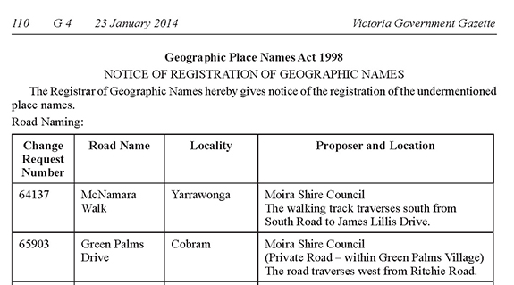

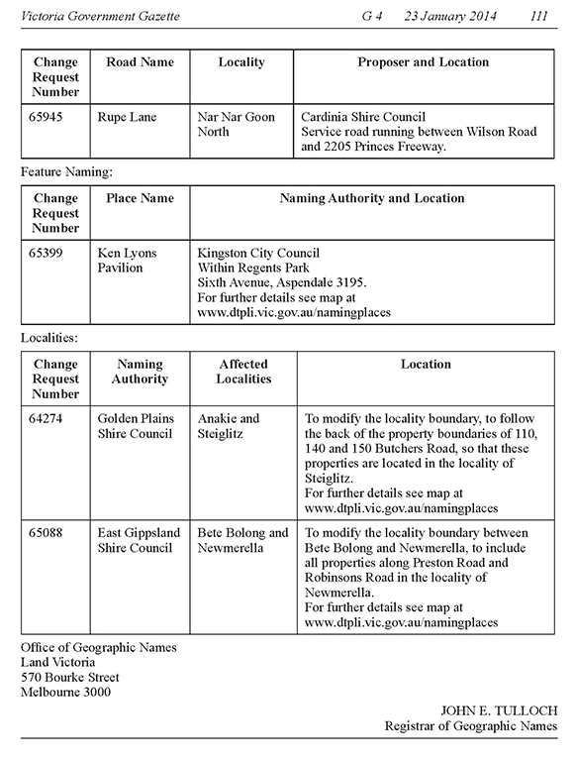

13 Implementation
The implementation of any name is very important. It ensures names are widely adopted and known by the immediate and extended community. Careful consideration should be given to promotion, communication and education about a name and/or boundaries. For example community members need to be officially told when to use a new road name for an address or a change in a locality name. The use of an Aboriginal name may see the community being educated about its meaning and pronunciation.
Ensuring correct notification to organisations and communicating the name widely will ensure state and federal government, emergency services and postal/goods delivery services are up-to-date.
All naming authorities including, municipal councils, government departments/agencies and authorities should consider creating a communications plan dependent on the scale of a naming proposal. They should also ensure naming authorities databases, websites, related documents, local mapping and imagery are updated.
A number of requirements are involved in the implementation of a name, these include registration, notification, signage and history. Further information is available below.

13.1 Registration
Only after a naming authority receives notification from the Registrar that an official naming or boundary change has been registered in VICNAMES can it notify affected members of the immediate and/or extended community and other interested stakeholders.

13.2 Notification
13.2.1 OGN notifies stakeholders
Upon registration, OGN will inform relevant stakeholders. The naming authority is also encouraged to inform local stakeholders as advised below.
Within 30 days of a proposal’s endorsement OGN will publish a notice on the Naming proposals webpage at www.delwp.vic.gov.au/namingplaces>Naming proposals and send notification to the naming authority. The notice will include a link to an electronic map that naming authorities can download and distribute to all local stakeholders, including local emergency and utility service providers.
OGN will organise for notification to be sent to state-wide and national bodies, including emergency and postal services, and spatial information or mapping organisations. These include:
- Australia Post
- EMSINA (Emergency Management Spatial Information Network Australia) – Victorian Committee members, including: Emergency Services Telecommunications Authority; Ambulance Victoria; Victoria Police; Country Fire Authority; Metropolitan Fire Brigade; State Emergency Service; Department of Environment, Land, Water and Planning; Department of Justice; and Department of Health and Human Services
- Real Estate Institute of Victoria
- Australian Bureau of Statistics
- Australian Electoral Commission
- Melway and other spatial information or mapping agencies.

OGN notification process

Road updates, including spatial extents and attributes are regularly published to the Vicmap Transport spatial layer, used by councils, State Government departments and authorities and mapping agencies.
13.2.2 Who the naming authority must notify
If addresses have been affected the naming authority must notify residents, ratepayers and businesses in the immediate community. Refer to the following example.
Naming/renaming/boundary realignment
As you are aware [insert naming authority] recently surveyed/notified the community of a proposal to name/rename a road, feature or locality, or amend its boundaries.
You have received this correspondence because you are affected by this proposal.
As a result of the notice/letter/survey/voting poll, the preferred name [enter preferred name] received the most support.
[Insert naming authority] considered the proposal at its regular [insert meeting name] meeting on [insert date, time and location of meeting].
[Insert naming authority] endorsed the name and requested that the name be sent to the Registrar of Geographic Names for gazettal and registration.
The name was gazetted on [insert date and gazettal reference]. [Insert naming authority] has been informed that the name has been registered and emergency services have been informed.
Signage will be installed in due course.
[If addresses affected, include the following]
Your old address [insert old address] has now changed to [insert new address].
Australia Post may continue to record and recognise the old address for a period of six to 12 months to ensure a smooth transition from the old address to the new. It should also be noted, however, that Australia Post cannot guarantee the delivery of incorrectly addressed mail and you should endeavour to use the new official address.

It is important to distribute details of the endorsed proposal to the following local organisations – they may have an interest in knowing the new or altered name and boundaries and there can be a delay between official notification to state-wide bodies and details filtering through various systems.
The naming authority should notify the following local organisations and stakeholders:
- Australia Post offices
- real estate agents
- gas, water and electricity suppliers
- council rates departments
- local mapping agencies
- local police stations
- local ambulance station
- local Country Fire Authority and/or Metropolitan Fire Brigade station
- State Emergency Service local headquarters
- tourist information centres.
13.2.3 VICNAMES holds the gazetted and registration details
Following the proposal’s gazettal, the Registrar will enter the gazette date, gazette reference and the details of the new or amended name and/or boundaries into VICNAMES.
Roads
The gazettal date for a road naming or renaming is available from the Victoria Government Gazette and will not be held in VICNAMES. The official date of registration will be the date the name is entered into Vicmap Transport or when the name was last edited; this information is viewable in VICNAMES.
If required, the naming authority may also wish to proceed with its own gazettal of the road naming, as provided under the various road acts. This is a decision for the naming authority to make. Refer to Section 3.4.
Road discontinuance notices are the responsibility of councils and VicRoads.
Features and localities
The gazettal date and reference for a feature or locality naming or renaming will be recorded in VICNAMES. The official date of registration will be the date the name is entered into VICNAMES.
13.2.4 Updating other databases, including private companies
While OGN, councils and State Government departments and authorities have a responsibility to update both state and national datasets, road, feature, locality and address information can take time to filter out to various companies’ databases. Databases belonging to satellite navigation, online address searches, companies that offer address searches on the internet and service providers (such as utility companies) can take months to update.
It is not the responsibility of the naming authority to update private organisations with address information.
The naming authority can provide official proof of an address on letterhead that the community can use to inform such private organisations of a change to an address.
13.2.5 Updating emergency services databases
Updates are provided to emergency services, in particular ESTA, who handles OOO calls, when a naming proposal is processed through NES or the SPEAR subdivision process. Typically, ESTA receives at least three updates a year from State Government. If naming authorities are concerned that information has not been updated or want to know when it is appropriate to inform members of the public, please contact OGN for advice.

13.3 Signage
Road, feature and locality signage in Victoria must conform to the requirements outlined in this section.
All signage for a road, feature or locality must be erected within 30 days of the name being gazetted and registered or within 30 days of being notified by OGN.
In all instances, naming authorities must not erect or display signage prior to receiving Registrar’s advice that the naming proposal has been endorsed, gazetted and entered in VICNAMES. Existence of signage prior to lodging a naming proposal with the Registrar is not a valid argument for the name to be registered.
It is recommended that naming authorities apply to the Registrar as early as possible to ensure names can be endorsed, gazetted and registered in VICNAMES and Vicmap. Appropriate and unambiguous signage will assist with delivery of goods and services and ensure adequate provision for emergency management.
The names of estates and subdivisions are considered to be neighbourhood names; therefore, they are not officially recognised for addressing purposes. They should not appear on council, State Government department or agency signage.
Signage design and display can differ for roads, features or localities. Specific information on signage is provided below.
13.3.1 Requirements for road signage
The size, font and colour of road signs are determined in AS1742 Manual of uniform traffic control devices, AS1744 Forms of letter and numerals for road signs (at infostore.saiglobal.com/store/details.aspx?ProductID=1757854) and AS/NZS 4819:2011 Rural and urban addressing (at infostore.saiglobal.com/store/Details.aspx?ProductID=1497944) and should be applied in all instances of road signage in Victoria.
The only acceptable road type abbreviations are provided in APPENDIX A and may be applied to road signage.
Diacritical marks should not be added to street signage, refer to Principle (J) and AS1742.5.
In addition, the location of signage is an important issue for naming authorities to consider. Road name signage should be placed at intersections and junctions, and in areas where it is not obscured from view or covered by objects such as trees and buildings. Road name signage should also be located at regular junctions and cross roads to allow members of the public to discern their location, especially in rural areas.
Signage for private roads should include reference to the fact that they are private roads, which implies they are not accessible to the general public. The cost is the responsibility of the property owner, developer, owners corporation (subject to local council’s provisions and guidelines).
If the site is under construction, signage must be erected within 30 days of infrastructure work commencing at the site (this is to ensure that emergency management services can respond to any incidents that might arise in the area during the construction phase). If the road is under construction, 30 days after the name is registered, temporary signs may be erected until such time as the road is open to traffic.
When road names are approved via the SPEAR subdivision process (at www.spear.land.vic.gov.au), signage must be erected after the certification of the plans and within 30 days of infrastructure work commencing at the site.

Refer to road signage examples below. 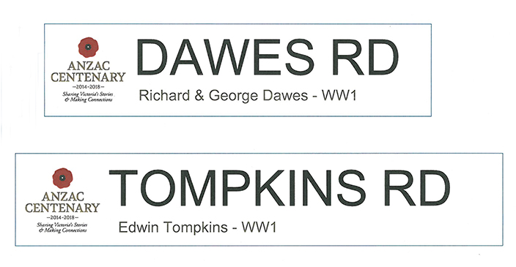 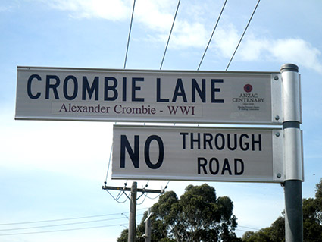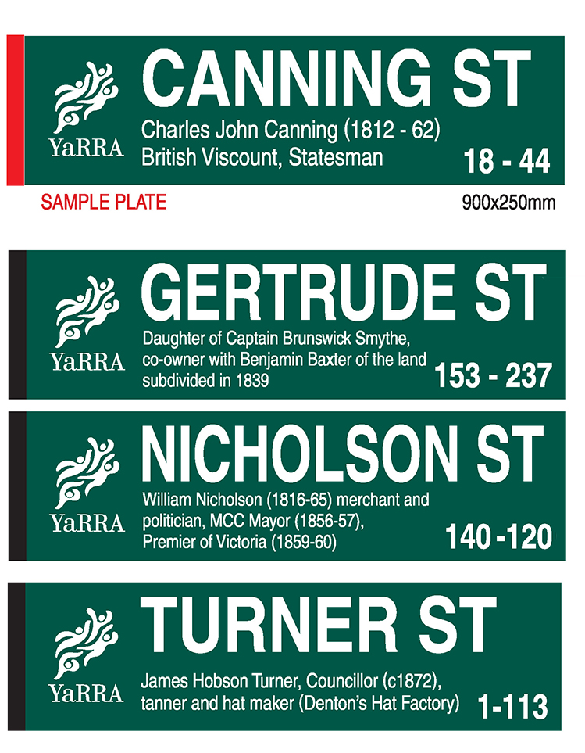

13.3.2 Requirements for feature signage
Signage for features can take whichever form or design the naming authority deems appropriate to ensure that the name can be easily located, identified and read by all members of the community.
At a minimum, the signage for a feature should be located at major access points to ensure people can readily identify the feature in an emergency.
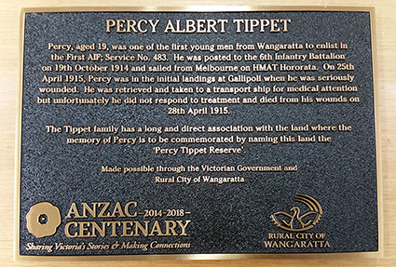
Example of feature signage
For features with addresses that visitors might find difficult to describe (e.g. barbecue sites in parks, swimming sites at beaches or walking tracks in state forests), there is an option to display an emergency marker. These markers are geocoded for the use of the ESTA (the organisation responsible for answering 000 calls) and can be useful for providing emergency services with accurate location information and specific directions on how to access the area.
Further information about emergency markers is available at www.esta.vic.gov.au/Our+Role/Our+Services/Emergency+Markers.
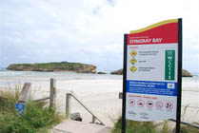
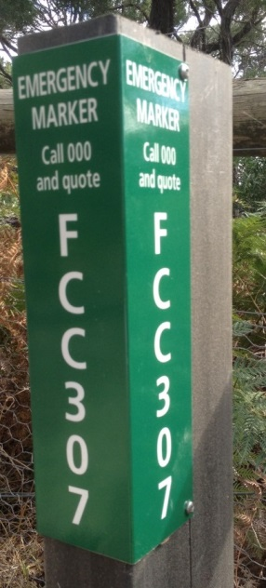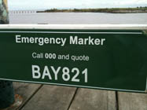

13.3.3 Requirements for locality signage
Adequate locality signage should be displayed on all major roads and thoroughfares. This is particularly important in rural and remote areas, where visitors may be unfamiliar with the area.

13.4 History
13.4.1 Recording historical information in VICNAMES
It is important to record information about why a road’s, feature’s or locality’s name was chosen. This will ensure historical information is available to future generations and provide transparency in the naming process.
When a name has been gazetted and registered, the naming authority should access VICNAMES and enter any historical information and, if desired, upload corroborating documents on the new name. This information should explain why the name was chosen and how the name has links to the local area.
It is expected that the historical information is submitted to VICNAMES by the naming authority.
Anyone can upload historical information to VICNAMES. The submission should relate to an appropriate source, which includes:
- books
- an edited book section
- journal
- manuscript
- oral history
- maps
- newspaper/magazine
- artefact
- website
- council
- OGN.
The Guide to VICNAMES is available at www.delwp.vic.gov.au/namingplaces>VICNAMES.
A historical content administrator (HCA) will review the submission and either approve, reject or request further information. Once approved, the submission will be viewable in VICNAMES. If a submission relates to multiple features or roads, then associations can be made by the HCA. The submitter will be notified of the submission’s approval or rejection.
Once a submission has been approved, corroborating historical information can be submitted. This could include copies of photos as jpegs or Microsoft Word or PDF documents. This information should be emailed to geo.names@dewlp.vic.gov.au, clearly indicating the record the information relates to. The HCA can then upload this content to the record.

APPENDIX

APPENDIX A Road types accepted for registration
As per Clauses 4.3, 4.6.2, 7.2 and 8.3.2(a) within the AS/NZS4819:2011: Rural and urban addressing standard, the road types specified within this appendix are the only road types that can be used.
Culs-de-sac
Road Type | Abbreviation | Description
CLOSE | CL | A short enclosed roadway.
COURT | CT | A short enclosed roadway.
MEWS | MEWS | A roadway in a group of houses.
PLACE | PL | A short, sometimes narrow enclosed roadway.
PLAZA | PLZA | A roadway enclosing the four sides of an area, forming a marketplace or open space.
RETREAT | RTT | A roadway forming a place of seclusion.
Either culs-de-sac or open-ended roads
Road Type | Abbreviation | Description
ALLEY | ALLY | Usually a narrow roadway in cities or towns. A minor roadway through the centre of city blocks or squares.
CHASE | CH | A roadway leading down to a valley.
CREST | CRST | A roadway running along the top or summit of a hill.
GLADE | GLDE | A roadway usually in a valley of trees.
GROVE | GR | A roadway that features a group of trees standing together.
LANE | LANE | A narrow way between walls, buildings or a narrow country or city roadway.
RISE | RISE | A roadway going to a higher place or position.
SQUARE | SQ | A roadway bounding the four sides of an area to be used as open space or a group of buildings.
TERRACE | TCE | A roadway usually with houses on either side raised above the road level.
VIEW | VIEW | A roadway commanding a wide panoramic view across surrounding areas.
VISTA | VSTA | A road with a view or outlook.
WHARF | WHRF | A roadway on a wharf or pier.

Open-ended roads
Road Type | Abbreviation | Description
APPROACH | APP | A roadway leading to an area of community interest, i.e. public open space, commercial area, beach etc.
AVENUE | AV | A broad roadway, usually planted with trees on each side.
BOULEVARD | BVD | A wide roadway, well paved, usually ornamented with trees and grass plots.
BREAK | BRK | A vehicular access on a formed or unformed surface, which was originally prepared as a firebreak.
BYPASS | BYPA | An alternative roadway constructed to enable through traffic to avoid congested areas or other obstructions to movement.
CIRCUIT | CCT | A roadway enclosing an area.
CONCOURSE | CON | A roadway that runs around a central area, e.g. public open space or a commercial area.
CRESCENT | CR | A crescent-shaped thoroughfare, especially where both ends join the same thoroughfare.
DRIVE | DR | A wide thoroughfare allowing a steady flow of traffic, without many cross streets.
ENTRANCE | ENT | A roadway connecting other roads.
ESPLANADE | ESP | A level roadway, often along the seaside or a river.
FIRETRAIL | FTRL | Vehicular access on a formed or unformed surface, which was originally prepared as a firebreak.
FREEWAY | FWY | An express, multi-lane highway, with limited or controlled access.
GRANGE | GRA | Roadway leading to a country estate, or focal point, public open space, shopping area etc.
HIGHWAY | HWY | A main road or thoroughfare; a main route.
LOOP | LOOP | Roadway that diverges from and re-joins the main thoroughfare.
PARADE | PDE | A public promenade or roadway that has good pedestrian facilities along the side.
PARKWAY | PWY | A roadway through parklands or an open grassland area.
PROMENADE | PROM | A roadway like an avenue with plenty of facilities for the public to take a leisurely walk; a public place for walking.
QUAYS | QYS | A roadway leading to a landing place alongside or projecting into water.
RAMP | RAMP | An access road to and from highways and freeways.
RIDGE | RDGE | A roadway along the top of a hill.
ROAD | RD | A place where one may ride; an open way or public passage for vehicles, persons and animals; or, a roadway forming a means of communication between one place and another.
STREET | ST | A public roadway in a town, city or urban area; especially a paved thoroughfare with footpaths and buildings along one or both sides.
TRACK | TRK | A roadway with a single carriageway and a roadway through a natural bushland region. The interpretation for both TRACK and TRAIL is limited to roadways; however, in many areas (e.g. Tasmania) these are more often associated with walking rather than vehicular movement.
TRAIL | TRL | See TRACK.
WAY | WAY | An access way between two streets. Usually not as straight as an avenue or street.
Pedestrian only roads
Road Type | Abbreviation | Description
ARCADE | ARC | A passage having an arched roof, or any covered passageway, especially one with shops along the sides.
BOARDWALK | BWLK | A promenade or path, especially of wooden planks, for pedestrians and sometimes vehicles along, or overlooking, a beach or waterfront.
MALL | MALL | A sheltered walk, promenade or shopping precinct.
PATH | PATH | A roadway used only for pedestrian traffic.
PASSAGE | PSGE | A narrow street for pedestrians.
STEPS | STPS | Route consisting mainly of steps.
SUBWAY | SBWY | An underground passage or tunnel that pedestrians can use for crossing under a road, railway, river, etc.
WALK | WALK | A thoroughfare with restricted access used mainly by pedestrians.
WHARF | WHRF | A roadway on a wharf or pier.

APPENDIX B Feature types accepted for registration
A full list of features accepted for registration is available at www.delwp.vic.gov.au/namingplaces>Naming rules.
Features associated with the feature types can be found in VICNAMES at http://maps.land.vic.gov.au/lassi/VicnamesUI.jsp.
Note: The agencies listed in the ‘Naming Authority’ column are identified as the most common bodies that act as the naming authorities for that feature type, but it is/they are not necessarily the sole agency(ies) responsible for naming the feature.

APPENDIX C Checklists
The checklists in this document should be used to ensure you have complied with:
- principles listed in Section 2
- relevant statutory requirements (as required) under Section 3, Section 4 and Section 5
- processes required for naming or renaming a road, feature or locality.
A copy of the completed checklist may be submitted with your naming proposal to OGN
Refer to Section 11 Lodging a proposal with OGN for further information about how to submit a proposal for the Registrar’s consideration.
Are you seeking:
 | The Registrar’s endorsement of the proposed name or shortlisted names?
 | Assistance from a Geographic Place Names Advisory Committee to make a final determination on a proposed name?
Is your naming proposal related to a:
 | Road? – complete sections 1, 2, 5, 6, 7, 8, 9 (of this checklist)
 | Feature? – complete sections 1, 3, 5, 6, 7, 8, 9 (of this checklist)
 | Locality? – complete sections 1, 4, 5, 6, 7, 8, 9 (of this checklist)
- General Questions
 |  | Yes | No | Not applicable
If proposing a new name or to change a name, does the proposal conform to the principles in Section 2?
Principle (A) Recognising the public interest
Principle (B) Ensuring public safety
Principle (C) Linking the name to the place
Principle (D) Ensuring names are not duplicated
Principle (E) Names must not be discriminatory
Principle (F) Recognition and use of Aboriginal languages in naming
Principle (G) Dual names
Principle (H) Using commemorative names
Principle (I) Using commercial and business names
Principle (J) Language
Principle (K) Directional names to be avoided
Principle (L) Assigning extent to a road, feature or locality

- General Questions continued
 |  | Yes | No |  | Not applicable
If the naming proposal originally came from a member of the public, does it include sufficient information on why the name would be appropriate?
If you are a State Government department or authority, have you checked with OGN to see if there are specific guidelines for your department? If there are no specific guidelines for your department, you should follow the principles and requirements of these naming rules.
- Roads
 |  | Yes | No |  | Not applicable
Have you referred to the Roads Management Act 2004 and the Local Government Act 1989 to determine if your organisation is the coordinating road authority for the road(s) in question?
Refer to Section 3.4 for more information.
If there is more than one coordinating road authority, are you preparing this proposal as a collaborative project?
Does the proposal conform with the statutory requirements in Section 3.2 Statutory requirements that apply to roads. If not, contact OGN for advice about how to make the proposal compliant.
3.2.1 Rural and Urban Addressing
3.2.2 Extent: road course, start and end points
Does the road have clear start and end points?
3.2.3 Road types
Does the road name use an acceptable road type?
3.2.4 Unacceptable road names
Have you checked the list of unacceptable road names? E.g. ‘the’ or ‘and’ is unacceptable, as are numbers, hyphens, directions or destinations
3.2.5 Obstructed or altered roads
If a delegation of authority has been used, have details of the relevant officer been officially provided to OGN?
Roads located in residential or commercial subdivisions
Are you aware that the road naming authority may not be the coordinating road authority; therefore, it is not responsible or liable for maintenance or other management of the road? Refer to Section 3.7.
Has a report on the naming proposal been discussed and signed off by the council prior to lodgement of the plans for certification?
If the naming or renaming proposal is being lodged after the plan of subdivision has been certified, please ensure the appropriate documentation is attached to the proposal. Refer to Section 9.

- Roads continued
 |  | Yes | No |  | Not applicable
Private Roads located on private property
Are you aware that the road naming authority may not be the coordinating road authority; therefore, it is not responsible or liable for maintenance or other management of the road? Refer to Section 3.9.3.
Has/have the private road/roads already been constructed?
If so, is/are the road name/s already in use by the immediate community?
Does Australia Post deliver mail to the general facility or individual sites within the complex? Contact should be made with Australia Post to discuss mail delivery options for the property.
Continue to Section 5
- Features
 |  | Yes | No |  | Not applicable
Is the feature of greater than local significance (e.g. located in more than two municipalities, in a tourist precinct or major waterway)? If so, a Geographic Place Names Advisory Committee may need to be convened. Refer to Principle (C) and Section 4.
Does the proposal conform to the statutory requirements in Section 4.2? If not, contact OGN for advice about how to make the proposal compliant.
4.2.1 Feature type
Is the feature type proceeding the feature’s name (e.g. Waterlands Park)? Refer to Section 4.2.1.
4.2.2 Waterways
If the feature is a waterway, has the extent been determined?
4.2.3 Locational name
If using a location-based name, is it the name of the locality rather than the name of the neighbourhood, estate or subdivision?
4.2.4 Base names
Is the feature privately owned or administered and subject to a naming sponsorship contract? If so, a base name should be assigned.
- Features continued
 |  | Yes | No | Not applicable
Aboriginal names for features Refer to Section 4.9.
What type of proposal is being considered:
 | Addition of an Aboriginal name as Registered or Dual?
 | Addition of an Aboriginal name as Traditional or Historical?
If recording an Aboriginal name, does the feature already have an officially registered name or an unrecorded and/or unregistered name? If yes, the Aboriginal name may be considered as a Dual name. Refer to Principle G.
When recording the Aboriginal name as Registered or Dual, are you aware that the name will be recognised as the official name in use for the feature?
The name will appear on regular maps for the area.
When recording the Aboriginal name as Traditional or Historical, are you aware that the name will be recognised on regular maps?
The name can be located by researchers and be used on specialised maps.
Are you aware that all names, regardless of status, will be held in VICNAMES? Refer to Section 4.9.
Has the Aboriginal name been verified by the area’s Traditional Owner group(s), and is there written evidence of this verification? Refer to Section 7.3.
Continue to Section 5
- Localities
 |  | Yes | No | Not applicable
Does the proposal conform to the statutory requirements in Section 5.2? If not, contact OGN for advice about how to make the proposal compliant
5.2.1 Boundaries
Have you checked the proposal against the requirements and explanatory boundary map diagrams in Section 5.2.1?
5.2.2 Estate and subdivision names
Have you checked that the name is not an estate or linked to a subdivision name? Refer to Section 5.2.2.
5.2.3 Size
Have you checked that the size is appropriate? Refer to Section 5.2.4.
5.2.4 Hyphens
The name must not contain hyphens. Refer to Section 5.2.5.

- Localities continued
 |  | Yes | No | Not applicable
5.2.5 Local government area boundary review
Have you checked that, if the locality boundary extends across municipal boundaries, the boundaries have been reviewed with the intention of aligning with the municipal boundaries? Refer to Section 5.2.6.
5.2.6 Locality names unique within Australia
Have you checked that the names are unique and not repeated elsewhere in Australia, or sought advice from OGN? Refer to Section 5.2.7.
Does the locality cover more than one municipal area, or is it part of a State Government project?
Does the proposal include a detailed map of the existing and proposed boundaries?
If relevant, has consideration been given to naming the locality after a local historical figure or event?
If the new locality relates to a major land redevelopment project, has a public naming competition been considered?
- Consultation
If the proposal affects addresses, have residents, ratepayers and businesses been consulted? Refer to Section 7.
If the proposed name is from an Aboriginal language, has/have the relevant Traditional Owner group(s) been consulted and given their approval? Refer to Principle (F) and Section 7.4.
If the naming proposal comes from a council and relates to the local area, has it been discussed with relevant interest groups such as historical societies and community groups?
If the naming proposal is being developed in-house by a State Government department or authority, have relevant interest groups been consulted?
If the naming proposal is being developed through a public competition, have you referred to the information contained in Section 7?
- Lodging, considering and addressing objections and submissions
Have the concerns or objections raised by residents, ratepayers and businesses been addressed? Refer to Section 8.
If the majority of immediate community members have opposed the proposal but there is an underlying service provision need to change the name or adjust the extent, do you require the assistance of OGN and emergency response or other service providers? If so, contact OGN for advice.
If a delegation of authority has been used, have details of the relevant officer, been officially provided to OGN?

- Notification of a naming decision
 |  | Yes | No |  | Not applicable
Has consideration been given to whom the naming authority should notify if the naming proposal is endorsed by the Registrar? Refer to Section 13.
- Signage and recording historical information
Has consideration been given to signage, if the naming proposal is endorsed by the Registrar? Refer to Section 13.3.
Has consideration been given to recording historical information in VICNAMES if the naming proposal is endorsed by the Registrar? Refer to Section 13.4..
- Naming proposal documentation
Has the naming authority prepared a report on the proposal, to help determine compliance? Refer to Section 9. Any report should include the following:
- information about how the proposal conforms with principles in Section 2 and statutory requirements in relevant sections
- discussion of and response to any objections/comments received during the consultation period(s).
Has the naming authority’s decision to accept or reject the proposal been formally recorded? This may involve councillors’, relevant Ministerial or CEO’s approval (if delegation of authority used). Refer to Section 9.
Are the following pieces of information attached to the naming proposal being lodged, using the online Notification for Editing Service (NES)?
Details of the existing name
Background of the proposed name and why it was selected. If the proposed name is traditional or historical, include Aboriginal language and, if possible, cultural heritage information.
Details of why a renaming is proposed (if relevant)
Details of a features location (including, if possible, the address and access points for emergency response).
Details of the consultation process:
A statement from naming authority about how they reached their decision to consult immediate and/or extended community
An analysis of the consultation’s outcomes
How any objections were considered and what responses where provided to the objectors.
Confirmation that the name conforms to the principles and statutory requirements of Section 2 and either Section 3, 4 or 5 of these naming rules.

Confirmation that the proposal has been accepted by the naming authority or is being submitted by a delegated officer.

- Naming proposal documentation continued
 |  | Yes | No |  | Not applicable
The following information (where relevant):
A copy of consent from relevant Traditional Owner group(s)
If undertaken, details of consultation with emergency response and public service providers (if NES was used for consultation, this evidence is automatically attached to the submission to OGN)
Copies of notice, letter, survey or voting poll material

De-identified (i.e. personal details removed) objections received from the public
Copies of letters sent to objectors, indicating their ability to lodge an appeal to the Registrar (as provided in Section 8.5)
A copy of council minutes indicating acceptance of the proposal, or that council staff have delegated authority.

APPENDIX D AS4819:2011 Rural and urban addressing
The following basic points must always be applied when developing addresses as part of a road naming or renaming proposal. These points represent only a small collection of rules as outlined in AS/NZS 4819:2011 Rural and urban addressing (see infostore.saiglobal.com/store/Details.aspx?ProductID=1497944), and road coordinating authorities are encouraged to refer to the standard for detailed advice.
Further information about naming roads on plans of subdivision, including street addressing, see the SPEAR FAQ Street Addressing at www.spear.land.vic.gov.au/spear/pages/about/about-the-application/frequently-asked-questions.shtml).
There are scenarios where neither AS/NZS 4819:2011 nor these naming rules provide a best fit solution to the problem. In these cases, naming authorities should contact OGN and Vicmap for a site specific solution.
- A unique address should be assigned to each separately owned area of land or building, whether residential or commercial – for example hospitals, railway stations, places of worship, parks, monuments, education facilities, etc.
The numbering and determination of the road must be relative to the access point from which the property, dwelling, structure or feature is accessed. The road name used in an address must be the named road nearest the main vehicular or pedestrian access to the front door or entrance of a property, building, dwelling structure or feature.
Address numbers and names should be assigned as early as possible in the development process, and well before occupation. This must be adhered to in order to ensure adequate auditing of any proposals and, more importantly, to aid responses from emergency services and delivery of goods and services.
In cases of a property or business being part of a complex (such as a shopping centre or recreational facility), the addressing rules as defined in AS/NZS 4819:2011 Rural and urban addressing should be applied. For the process of registering private roads within complexes, refer to Sections 3.8 and 3.9.
- A datum point must be chosen from which all address numbers will be applied. The origin or datum point for all address numbering should be the intersection at that end of the road from where access most commonly occurs, or is planned to occur. The origin or datum point for numbering major roads such as highways should be at the capital city end, or the major city if the road is not connected to the capital city.
- Numbering should be systematic and consistent along the extent of a named road, major road and highway throughout a locality. Address numbering standards and applications differ depending on whether the property is located in an urban or rural environment. Refer to AS/NZS 4819 Rural and urban addressing for specific directions and examples.
In urban areas, address sites on the left side of the road from the datum point should be numbered from one and increase sequentially using odd numbers. Address sites on the right side of the road from the datum point should be numbered from two and increase sequentially using even numbers. Refer to point 8 for culs-de-sac numbering.
If the opposite convention has been used throughout a defined area, it may continue to be used, provided it does not extend beyond that area.

The diagram below displays road extents, datum points and the assignment of numbers (note the reservation of numbers).
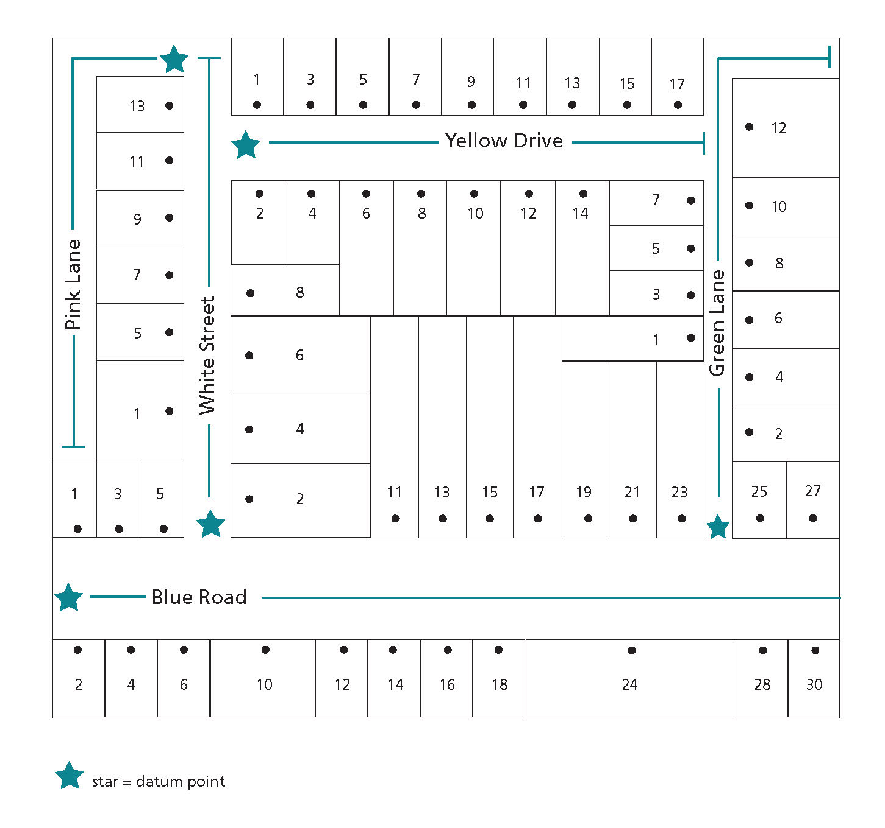
- Address numbers should be clear and logical and numbering should be sequential, ranging from the lowest to the highest. Numbers should be positive integers (no zero, fractions, or decimals). An address number should consist of no more than five numeric characters (i.e. up to 99999) and, if required, a single upper-case alphabetical suffix. The word ‘Lot’ should not precede any assigned address number.
- Do not avoid numbers; numbers must be assigned in a logical and sequential manner. However, it is possible to reserve numbers for future development.
- If a proposed road is being constructed in multiple stages as part of a multi-lot subdivision development, and the section that includes the datum point is not yet constructed, the naming and addressing authority should reserve address numbers for the first section of the road.
This does not apply when the proposed road has been constructed at either end and the middle section is yet to be built. In these instances, both ends of the road should have unique names applied. When the middle section of road is constructed, the two unique road names should extend from their datum points until they meet at a cross road on the newly constructed middle section.
If one name is to be assigned to the completed road, renaming of the two unique roads and renumbering should then take place to recognise the full extent of the road.
- If a road continues with the same name through more than one locality, it is preferable that the numbering be unique and continuous for its entire length. For exceptionally long roads, logical sections may be defined by focal points and the numbering system applied to each section. The focal point should be placed so that localities are completely within a logical section.
- A short cul-de-sac that has its own road name and five or fewer detached address sites can be numbered from the left, ignoring the normal odd and even numbering on each side. Alpha suffixes in this case may also be used to minimise any renumbering.
A cul-de-sac that has more than five detached address sites should be numbered with the odd numbers on the left and even numbers on the right. Alpha suffixes in this case should not be used.
- A VicRoads administrative road name should not be used for addressing purposes.
Address examples

Scenario 1: Residential redevelopment at number 37 Wyndham Street (highlighted) has resulted in four units, one fronting Wyndham Street and three fronting a section of Manor Street (highlighted by a red line). There are no numbers left on Manor Street for the three new units.
Option 1: Assign a new name to the section of Manor Street highlighted by a red line, a Cul-de-sac road type and assign new numbering accordingly.
Option 2: Re-number the full extent of Manor Street, taking into account possible future subdivisions at 39, 38 and 40 Wyndham Street; 39, 37, 36 and 34 High Street; and 33, 32 and 34 Margaret Street.
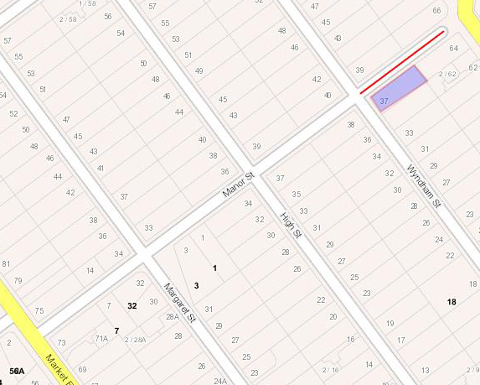

Scenario 2: It has been highlighted by emergency services that 87 Metung Road is not accessible from Metung Road. The property is accessed from Essington Close.
Option 1: Re-number 87 Metung Road to Essington Close with the address 2A Essington Close.
Option 2: Create a road that accesses 87 Metung Road and assign an appropriate name and number.
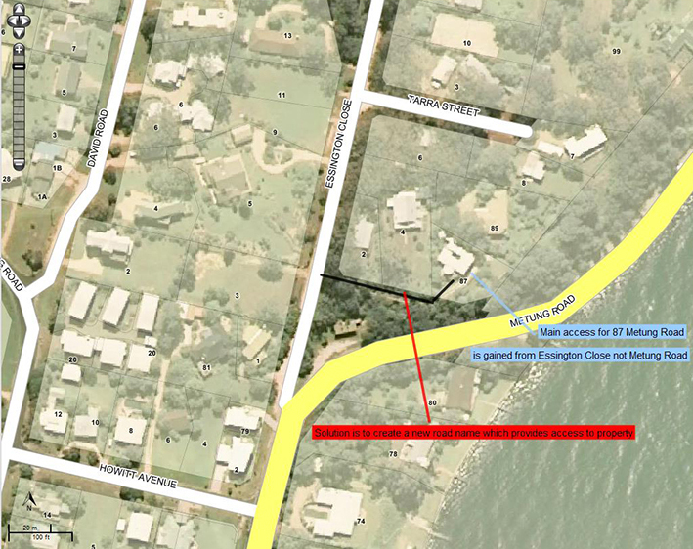

APPENDIX E Information for the public
There are two information brochures available online that can be provided to the public for their information:
- Information for residents
- Quick guide.
The brochures can be downloaded from www.delwp.vic.gov.au/namingplaces>Naming rules.
The diagram below shows the process a member of the public would follow when consulted by a naming authority.

GLOSSARY
Addressing authority | The authority responsible for addressing is typically the council.
Council | A municipal council is the local government of a municipality, known throughout this document as the ‘council’.
Cadastre | Is a comprehensive register of land property boundaries and tenure in Victoria.
Diacritical mark | A glyph or accent added to a letter that is used to change the sound values of the letters to which they are added.
Duplicate | Duplicates are considered to be two (or more) names within close proximity, and those which are identical or have similar spelling or pronunciation. See Section 2 Principle D.
Duplication radius | Refers to the radius that is covered under a duplication search within VICNAMES. The radius defaults to 5, 15 and 30 km, depending on the locality selected. The radius can be changed manually.
Estate names | Includes names applied to residential estates, commercial use estates, e.g. residential subdivisions and business parks or commercial/ industrial zoned land.
EMSINA | Emergency Management Spatial Information Network Australia (EMSINA) is a group of spatial practitioners in the emergency management sector.
Facility's Administrative Body | Is the appropriate naming authority in who may determine a name for a given place name.
Geographic name | The name registered in VICNAMES as the name for that place.
Geographic Place Names Advisory Committee (GPNAP) | Geographic Place Names Advisory Committee, which is formed from the Geographic Place Names Advisory Panel, appointed under Section 12 of the Geographic Place Names Act 1998 (the Act).
Guidelines | The guidelines having an effect under Part 2 of the Act. In this case, the guidelines are now known as Naming rules for places in Victoria – Statutory requirements for naming roads, features and localities – 2016. The title of this document is abbreviated to ‘naming rules’.
Legacy | Legacy refers to roads and features that have been named by a naming authority and/or are locally known, but are neither officially registered nor have been added to VICNAMES. OGN will determine whether the names are gazetted and what status is applied to the names in VICNAMES.
Naming authorities | Councils, government departments or authorities and private organisations are considered to be naming authorities when they are responsible for a particular feature or road within their jurisdiction. This may apply even when they may not be the owners and/or responsible for the maintenance of the feature or road e.g. Crown Land Committees of Management or leased/licensed facilities with maintenance obligations.
Naming rules | The abbreviated name for Naming rules for places in Victoria – Statutory requirements for naming roads, features and localities – 2016. This document is known as ‘Guidelines’ under the Geographic Place Names Act 1998. Refer to ‘Guidelines’ above.
Notification for Editing Service (NES) at nes.land.vic.gov.au. | NES facilitates improvement of spatial data quality. Provides simple, efficient, effective, low-cost maintenance process. Creates fully transparent maintenance process for all participants. Supplies maintenance processes to any potential data maintainer.
Place | Means any geographic place or building that is, or is likely to be, of public or historical interest and includes, but is not restricted to:  - township, area, park, garden, reserve of land, suburb and locality  - topographical feature, including undersea feature  - street, road, transport station, government school, government hospital and government nursing home.
Petition | A petition is a request signed by people seeking to change a name, submitting a naming proposal or appealing a naming authority’s decision. The printed name and property address for each signatory must be included.
RAPs – Registered Aboriginal Parties | Registered Aboriginal Parties (RAPs) are organisations that represent the Traditional Owners and hold decision-making responsibilities under the Aboriginal Heritage Act 2006 for the protection, management and preservation of Aboriginal cultural heritage in a specified geographical area.
Register | The Register of Geographic Names, known as VICNAMES, was established under Section 9 of the Geographic Place Names Act 1998.
Registrar | The Registrar of Geographic Names appointed under s. 7 of the Geographic Place Names Act 1998.
Solidus (/) | Another term for a slash or break.
Tacit approval | By not responding to a naming proposal the affected party is giving implied consent to the proposal.
the Act | The Geographic Place Names Act 1998 referred to as the Act throughout these naming rules. These naming rules are the ‘Guidelines’ provided for under s. 5.
Topographic | Refers to land’s height, shape and features, such as mountains and rivers in an area of land.
Traditional Owners | The primary guardians, keepers and knowledge holders of Aboriginal cultural heritage,  including language. Under the Aboriginal Heritage Act 2006, Traditional Owners may be appointed as Registered Aboriginal Parties (RAPs).
VicRoads Administrative Road Name | A name VicRoads applies to roads they manage and may consist of multiple names and/or the extent of gazetted roads.

SPEAR is an acronym for Surveying and Planning through Electronic Applications and Referrals. The system allows users to process planning permits and subdivision applications online, including the submission of associated road names and addresses.
An exception to this is in the use of Aboriginal languages when it is accepted that Aboriginal names may appear at first to be complex will, over time, become familiar and easy to use within the community.
ESO encompasses agencies that include Country Fire Authority (CFA), State Emergency Services (SES), Metropolitan Fire Brigade (MFB), Victoria Police (VicPol), Ambulance Victoria (AV). If consulting Emergency Service agencies. Contact local, regional and corporate/State headquarters, as well as ESTA.
Naming authorities should exercise discretion when deciding who to consult. If a proposed naming, renaming or boundary change is considered small-scale and will only affect a handful of residents, ratepayers and businesses, consultation should focus on these people. If the road, feature or locality is known to a lot of people and is, or will be, used extensively by the wider community, the consultation should extend to all possible stakeholders.
‘New’ includes legacy roads and features that have been named by a naming authority and/or are locally known, but are neither officially registered nor added to VICNAMES.
In some instances, council might prefer to provide a ‘delegation of authority’ for the naming process to a relevant officer within their organisation. In this case, approval for the name does not need to be granted by the councillors. It is important that the council forwards details of the delegated authority and whether this relates to roads, features and/or localities – on official letterhead signed by the CEO – to the Office of Geographic Names (OGN) for filing and future reference.
SPEAR is an acronym for Streamlined Planning through Electronic Applications and Referrals. The system allows users to process planning permits and subdivision applications online.

