


Land Registry
Services Business
Activity Report

2025-2026 Financial Year
Version 1.0

Contents
Land Registry Services 4
Business activity report 2025-2026 financial year 4
1 Lodgments 4
1.1 Number of dealings lodged 4
1.2 Yearly lodgments (1945-2026) 5
1.3 Monthly lodgments 5
1.4 Average daily lodgments (with trend line) 6
1.5 Financial year lodgments from 2021-2022 to 2025-2026 (by month) 7
2 Search 8
2.1 Title searches 8
2.2 Financial year title searches (by month) 8
2.3 Planning certificates 9
2.4 Instrument searches 9
2.5 Property certificates 10
2.6 Land Index searches 10
3 Lodgment and Support Services 1 (LSS1) 11
3.1 LANDATA® statistics with trend lines 11
4 Water Register 12
4.1 Water share transactions 13
5 Lodgment by specific dealing types 14
5.1 Discharges of mortgage or charge 14
5.2 Transfers of land 14
5.3 Mortgages 15
5.4 Differences in lodgment levels and percentages of discharges, transfers, and mortgages 15
5.5 Plans of subdivision 17
5.6 All Plans lodged under the Subdivision Act 1988 17
5.7 Number of new parcels created from plans of subdivision 18
5.8 General law conversion 18
5.9 Crown Land Dealings 19
5.10 Top 40 dealing types, by number lodged 20
6 Other measures of Land Registry Services activity 21
6.1 Number of dealings registered 21
6.2 Percentage of dealings registered within 5 days 21
6.3 Number of plans of subdivision registered 21
6.4 Number of dealings refused 21
6.5 Number of dealings waiting to be processed 21
7 Electronic transactions processing 22
7.1 Electronic Conveyancing (including SPEAR) 22
7.2 Percentage of transactions lodged electronically 23

Land Registry Services

Business activity report 2025-2026 financial year
This report provides statistics for land registration and property information services delivered by Land Services Victoria. Figures for the 2025-2026 financial year and previous years are provided.

1 Lodgments

1.1 Number of dealings lodged
The number of dealings lodged for the financial year was 1,017,051. This is a 9.1 per cent increase from the 2024-25 financial year and is the second highest lodgment volume on record for the Land Registry. Past financial years’ lodgments have been:
Table 1: Number of Dealings Lodged
by Financial Year
Year | Total | Year | Total
2006-2007 | 727,464 | 2016-2017 | 876,482
2007-2008 | 777,542 | 2017-2018 | 917,385
2008-2009 | 675,640 | 2018-2019 | 885,058
2009-2010 | 743,389 | 2019-2020 | 853,227
2010-2011 | 720,649 | 2020-2021 | 896,843
2011-2012 | 677,708 | 2021-2022 | 1,022,585
2012-2013 | 669,214 | 2022-2023 | 951,576
2013-2014 | 747,598 | 2023-2024 | 923,235
2014-2015 | 792,335 | 2024-2025 | 932,188
2015-2016 | 857,497 | 2025-2026 | 1,017,051

1.2 Yearly lodgments (1945-2026)
This graph represents the yearly lodgments for each year since 1945. Since 1945, there has been an average growth of 3.02 per cent increase per year.
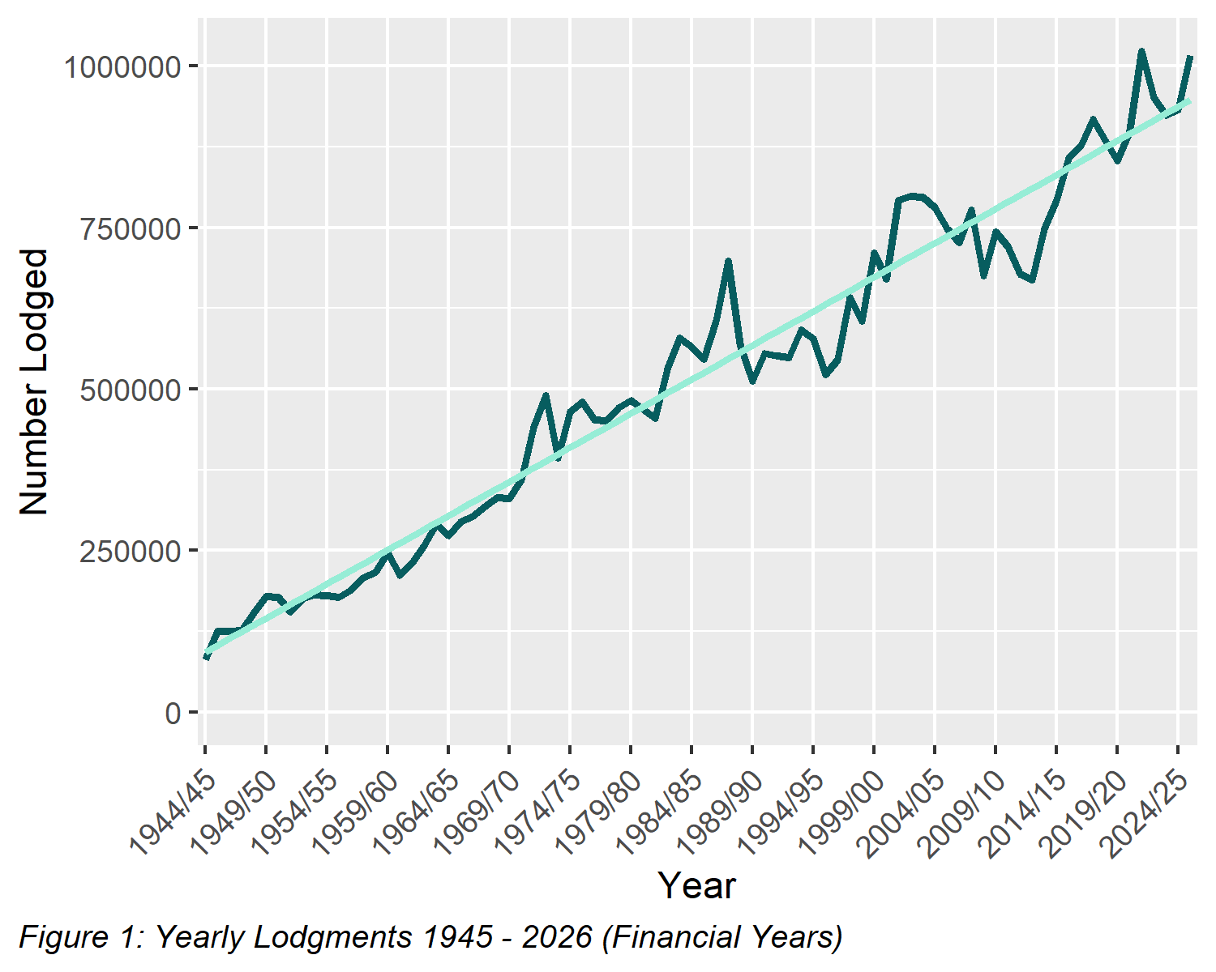

1.3 Monthly lodgments
This graph shows the number of lodgments received for each month of the financial year. In the 2025-2026 financial year, the average number of lodgments was 84,754 per month.
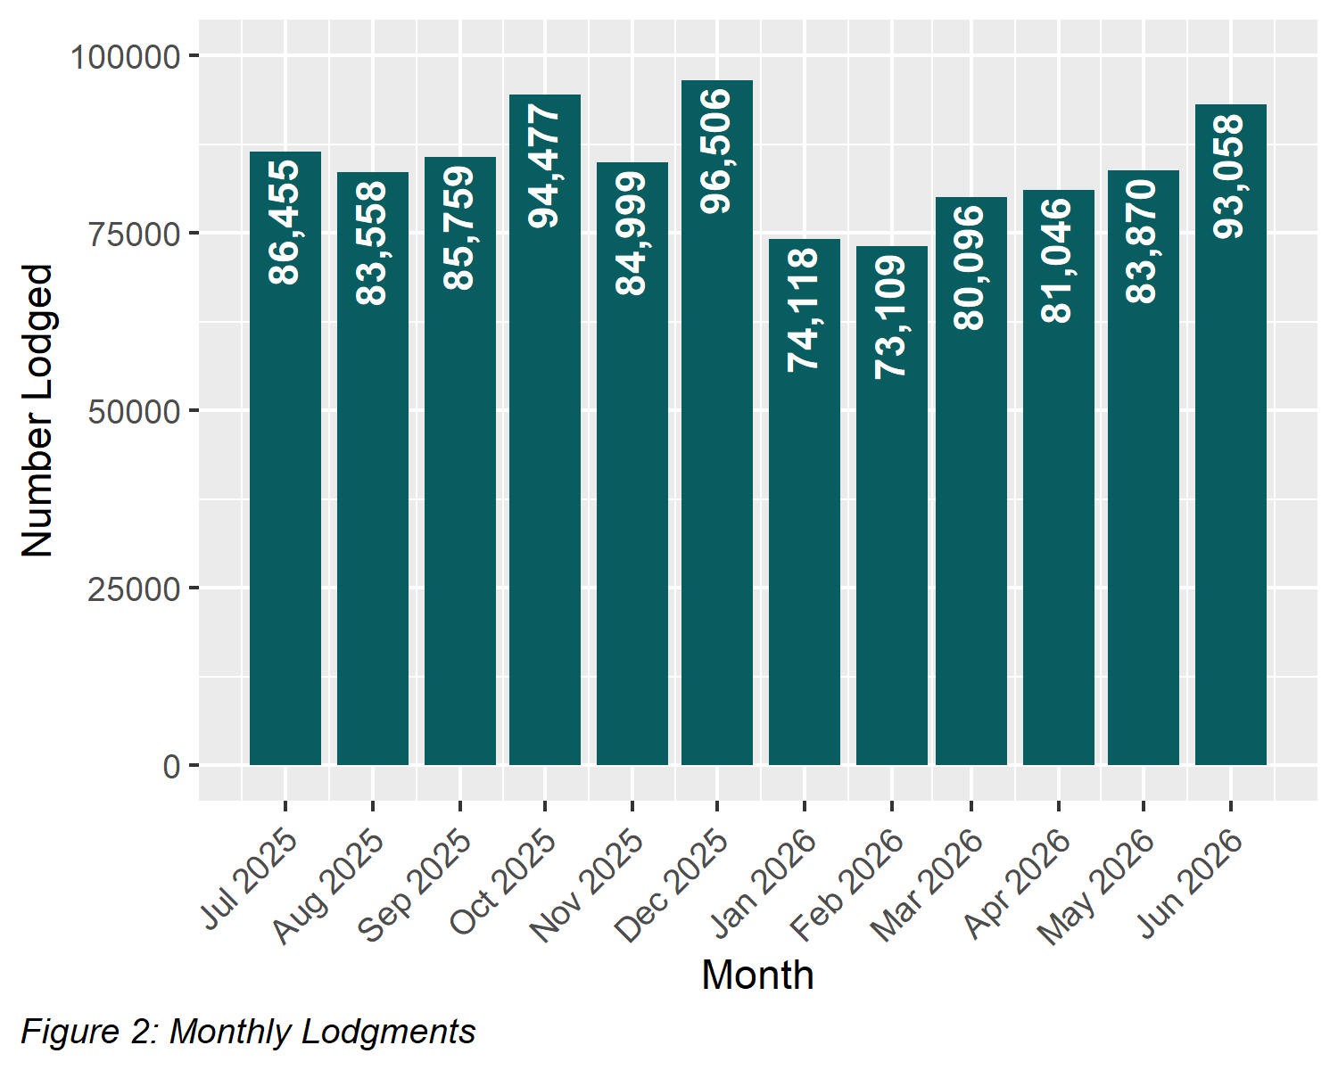

1.4 Average daily lodgments (with trend line)
This graph shows the average daily lodgments for each week of the 2025-2026 financial year. The overall average for the financial year was 4,068 lodgments per day. The daily lodgment activity is continuously monitored, including short term trends using moving averages.
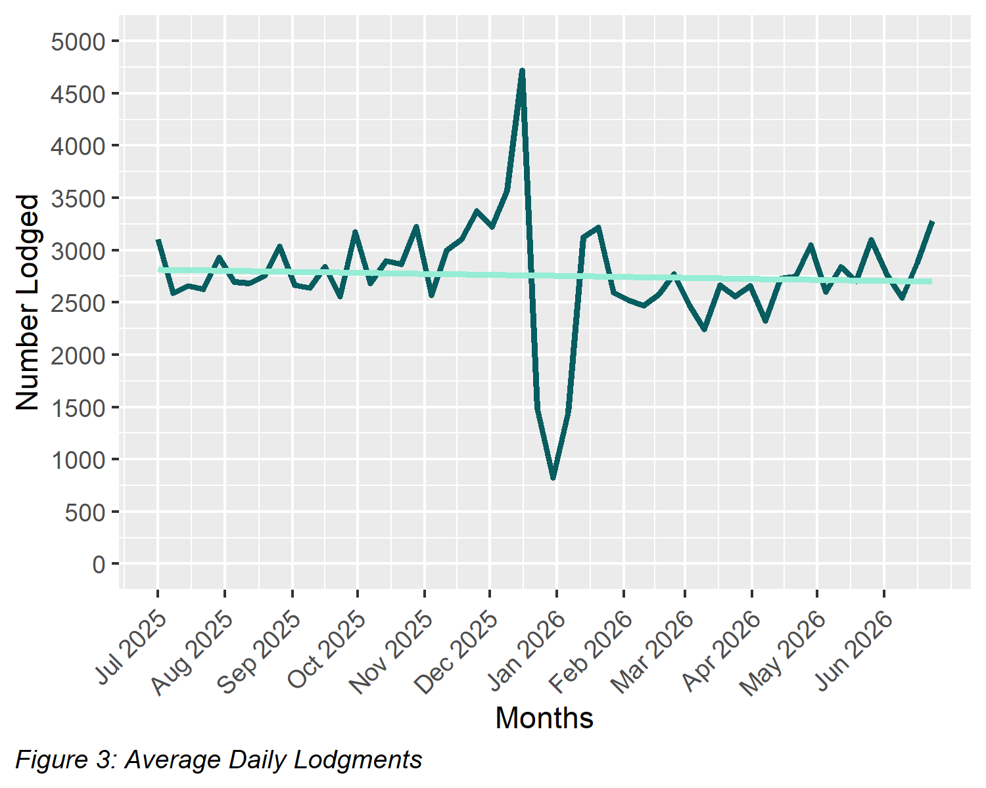

1.5 Financial year lodgments from 2021-2022 to 2025-2026 (by month)
This graph compares monthly lodgments since the 2021-2022 financial year.
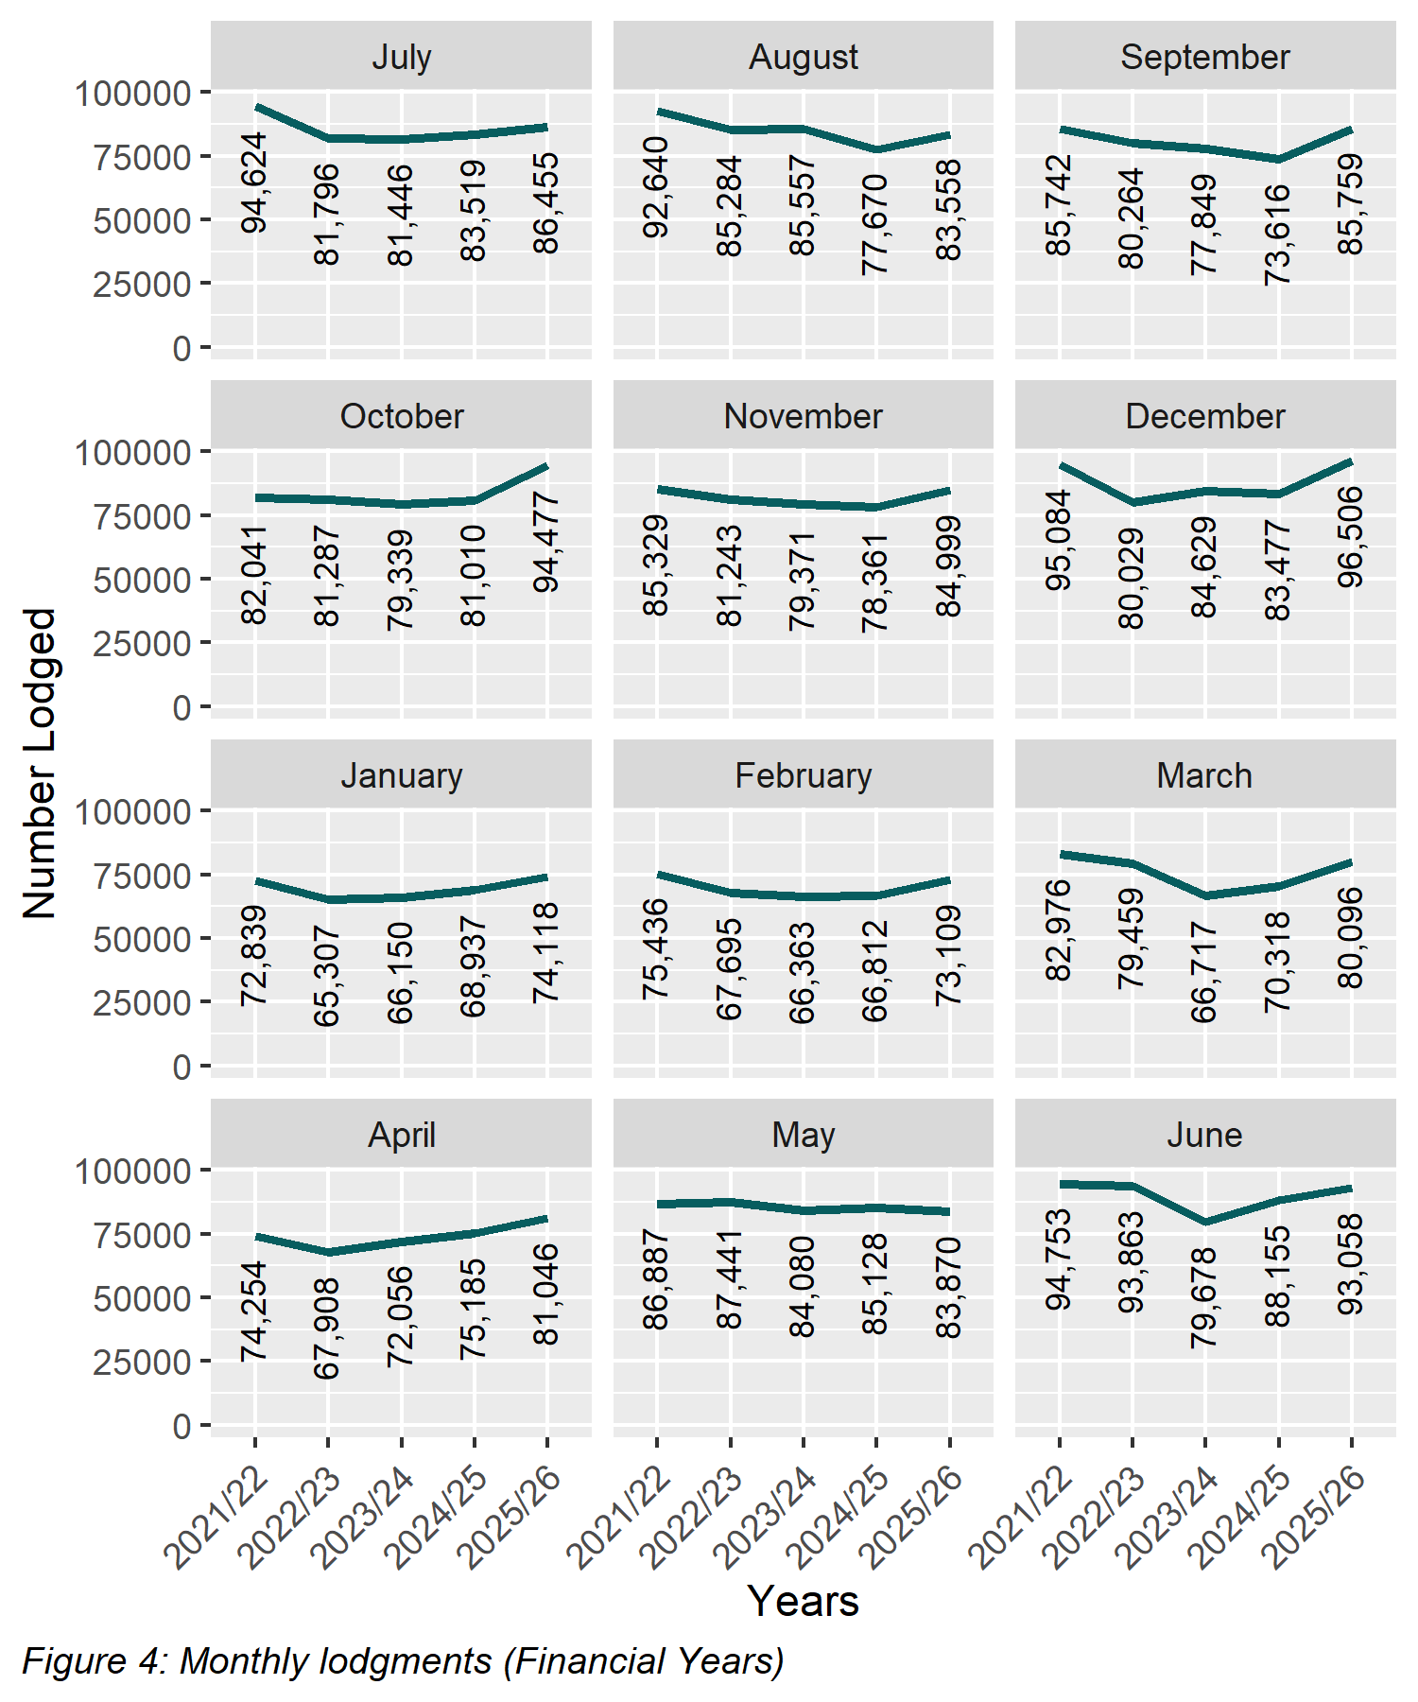

2 Search
Search categories are listed below with historical trend information.

2.1 Title searches
The number of title searches supplied during the 2025-2026 financial year was 3,296,668. This is a 9.06 per cent increase from the 2024-25 financial year.
Table 2: Number of Title Searches
by Financial Year
Year | Quantity | Year | Quantity
2006-2007 | 2,050,786 | 2016-2017 | 2,463,249
2007-2008 | 2,169,427 | 2017-2018 | 2,866,297
2008-2009 | 2,023,852 | 2018-2019 | 2,483,433
2009-2010 | 2,200,297 | 2019-2020 | 2,540,297
2010-2011 | 2,218,043 | 2020-2021 | 2,797,895
2011-2012 | 2,192,819 | 2021-2022 | 2,977,311
2012-2013 | 2,169,973 | 2022-2023 | 2,717,540
2013-2014 | 2,205,947 | 2023-2024 | 2,727,641
2014-2015 | 2,242,562 | 2024-2025 | 3,022,764
2015-2016 | 2,232,051 | 2025-2026 | 3,296,668

2.2 Financial year title searches (by month)
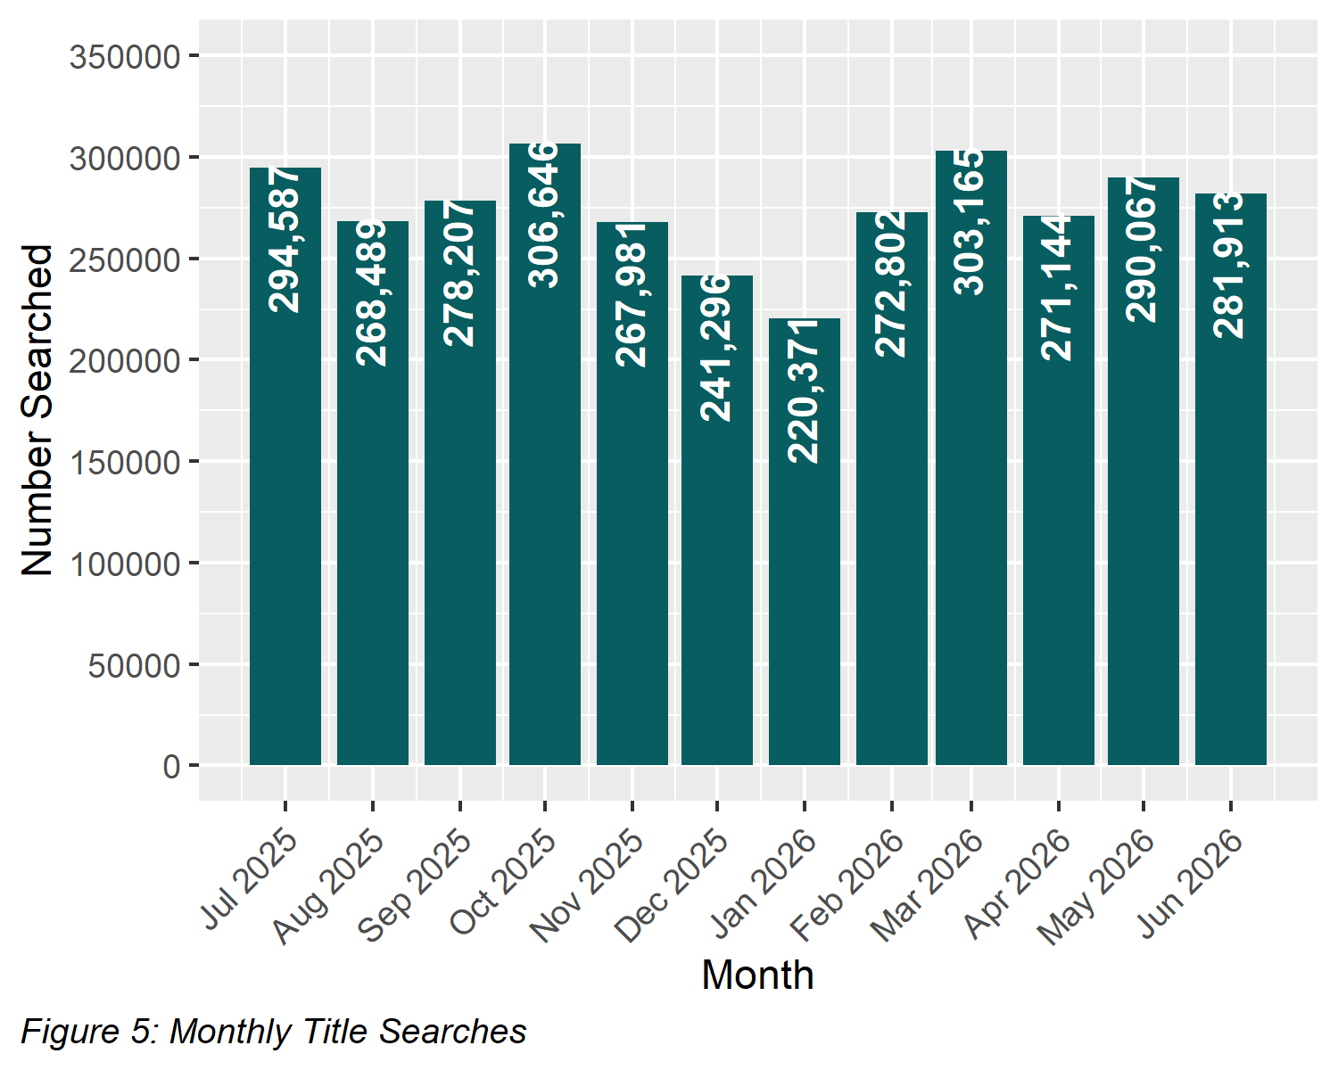

2.3 Planning certificates
Planning certificates increased by 7.41 per cent in the 2025-2026 financial year to 115,516.
Table 3: Number of Planning Certificates
by Financial Year
Year | Quantity | Year | Quantity
2006-2007 | 33,259 | 2016-2017 | 63,161
2007-2008 | 40,716 | 2017-2018 | 71,771
2008-2009 | 32,893 | 2018-2019 | 67,658
2009-2010 | 37,695 | 2019-2020 | 75,695
2010-2011 | 37,131 | 2020-2021 | 90,139
2011-2012 | 38,196 | 2021-2022 | 98,092
2012-2013 | 42,018 | 2022-2023 | 86,441
2013-2014 | 50,090 | 2023-2024 | 102,018
2014-2015 | 55,461 | 2024-2025 | 107,546
2015-2016 | 57,078 | 2025-2026 | 115,516

2.4 Instrument searches
Instrument searches increased by 2.31 per cent in the 2025-2026 financial year to 532,743.
Table 4: Number of Instrument Searches
by Financial Year
Year | Quantity | Year | Quantity
2006-2007 | 587,682 | 2016-2017 | 673,628
2007-2008 | 613,296 | 2017-2018 | 677,407
2008-2009 | 618,854 | 2018-2019 | 582,125
2009-2010 | 757,195 | 2019-2020 | 466,912
2010-2011 | 721,380 | 2020-2021 | 604,336
2011-2012 | 668,858 | 2021-2022 | 545,272
2012-2013 | 683,604 | 2022-2023 | 482,361
2013-2014 | 682,478 | 2023-2024 | 525,057
2014-2015 | 667,648 | 2024-2025 | 520,693
2015-2016 | 667,018 | 2025-2026 | 532,743

2.5 Property certificates
Property certificates increased by 11.12 per cent in the 2025-2026 financial year to 1,165,516.
Table 5: Number of Property Certificates
by Financial Year
Year | Quantity | Year | Quantity
2006-2007 | 109,355 | 2016-2017 | 619,212
2007-2008 | 134,288 | 2017-2018 | 630,885
2008-2009 | 126,380 | 2018-2019 | 622,465
2009-2010 | 188,155 | 2019-2020 | 663,119
2010-2011 | 243,917 | 2020-2021 | 815,614
2011-2012 | 213,692 | 2021-2022 | 938,347
2012-2013 | 271,449 | 2022-2023 | 821,604
2013-2014 | 367,172 | 2023-2024 | 968,283
2014-2015 | 521,891 | 2024-2025 | 1,048,844
2015-2016 | 541,176 | 2025-2026 | 1,165,516

2.6 Land Index searches
Land index searches increased by 2.72 per cent in the 2025-2026 financial year to 1,870,146.
Table 6: Number of Land Index Searches
by Financial Year
Year | Quantity | Year | Quantity
2006-2007 | 1,466,544 | 2016-2017 | 1,345,345
2007-2008 | 1,488,230 | 2017-2018 | 1,374,961
2008-2009 | 1,278,727 | 2018-2019 | 1,319,785
2009-2010 | 1,137,876 | 2019-2020 | 1,352,415
2010-2011 | 1,103,887 | 2020-2021 | 1,440,211
2011-2012 | 1,053,140 | 2021-2022 | 1,618,908
2012-2013 | 1,056,131 | 2022-2023 | 1,704,251
2013-2014 | 998,803 | 2023-2024 | 1,725,930
2014-2015 | 1,070,323 | 2024-2025 | 1,820,652
2015-2016 | 1,153,439 | 2025-2026 | 1,870,146

3 Lodgment and Support Services 1 (LSS1)
This statistic refers to services provided to Electronic Lodgment Networks (ELN) on the creation of a workspace. The service, known as LSS1 provides pre-population of title data, title activity checks and lodgment verification. The statistic below shows the number of LSS1s which is directly related to the number of workspaces created.
Table 7: Number of Lodgment and Support Services 1 (LSS1)
by Financial Year
Year | Quantity
2019-2020 | 476,167
2020-2021 | 528,675
2021-2022 | 570,488
2022-2023 | 553,606
2023-2024 | 536,442
2024-2025 | 543,381
2025-2026 | 573,547

3.1 LANDATA® statistics with trend lines
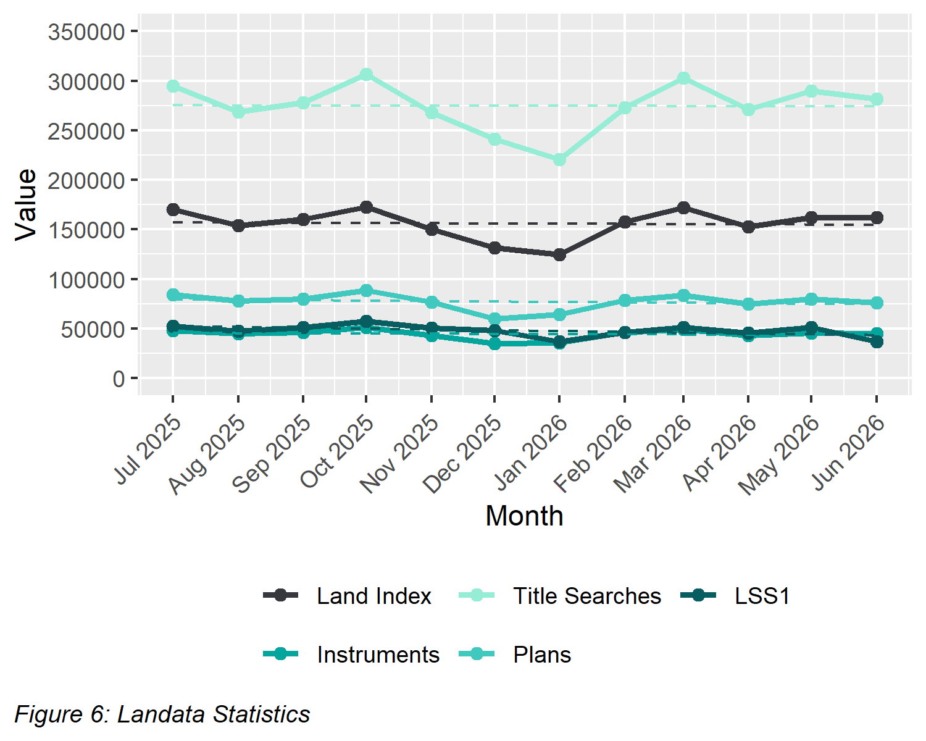

4 Water Register
The number of water share transactions increased by 6.01 per cent in the 2025-2026 financial year. This compares to previous years as follows:
Table 8: Number of Water Share Transactions
by Financial Year
Year | Quantity | Year | Quantity
2007-2008 | 5,259 | 2017-2018 | 9,648
2008-2009 | 13,391 | 2018-2019 | 11,876
2009-2010 | 10,983 | 2019-2020 | 7,491
2010-2011 | 9,990 | 2020-2021 | 7,083
2011-2012 | 9,871 | 2021-2022 | 8,195
2012-2013 | 8,800 | 2022-2023 | 9,368
2013-2014 | 7,529 | 2023-2024 | 7,328
2014-2015 | 7,670 | 2024-2025 | 7,191
2015-2016 | 7,013 | 2025-2026 | 7,623
2016-2017 | 6,162

4.1 Water share transactions
The Water Registrar is responsible for the recording of transactions on water shares under the Water Act 2007. The table below shows the breakdown of the water share transactions.
Table 9: Water Share Transactions Recorded
(Financial Year 2025-2026)
Transfers
Transfer of a water share (including limited term transfer) | 2,852
Total Transfers | 2,852
Party amendments
Name and address amendment and party merge | 3,515
Total Party Amendments | 3,515
Mortgages
Mortgage create | 234
Mortgage discharge | 674
Mortgage variation | 1
Mortgage amendment | 15
Mortgage priority | 0
Create MCP | 1
Total Mortgages | 925
Survivorships
Recording of LPR | 191
Recording of survivorship | 130
Recording of trustee in Bankruptcy | 3
Total Survivorships | 324
Registrar notification on water share
Create notification | 0
Remove notification | 7
Total Notifications | 7

5 Lodgment by specific dealing types

5.1 Discharges of mortgage or charge
In the 2025-2026 financial year, discharges of mortgage or charge accounted for 32.1 per cent of all dealings lodged.
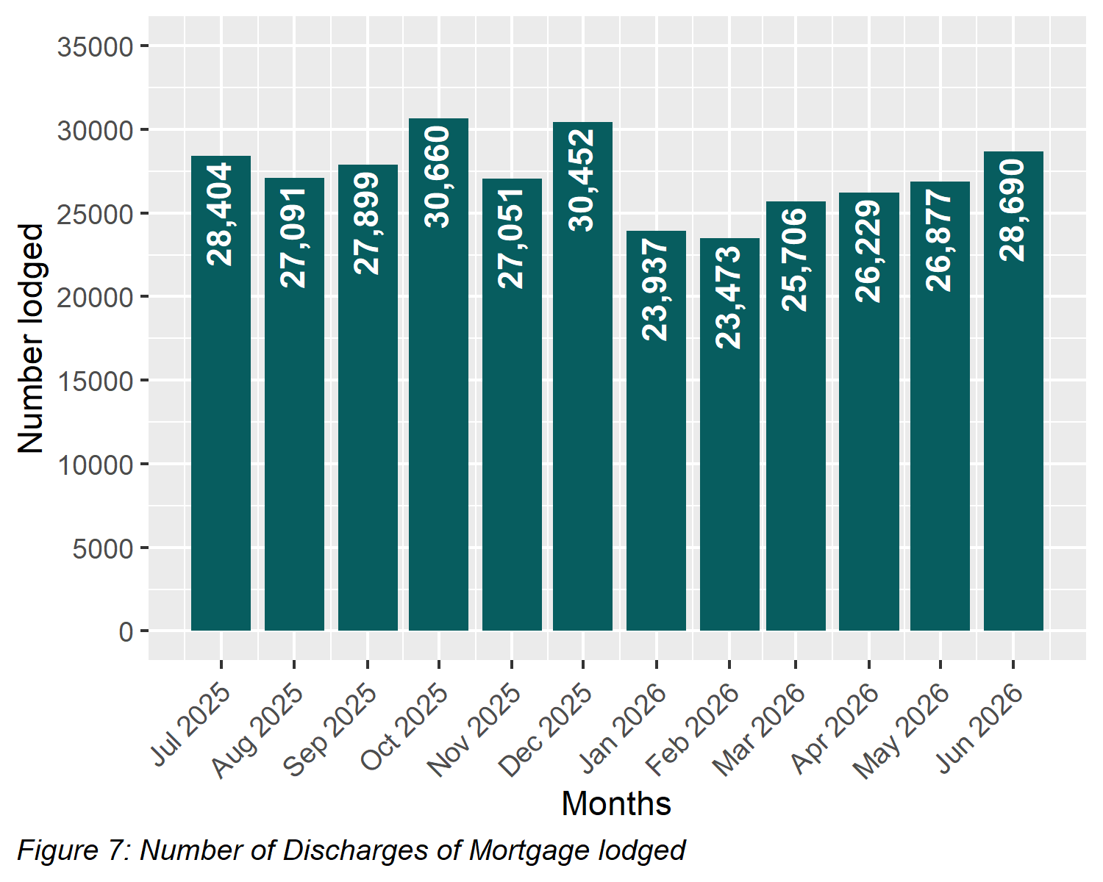

5.2 Transfers of land
In the 2025-2026 financial year, transfers for both monetary and non-monetary consideration made up 23.53 per cent of all dealings lodged.
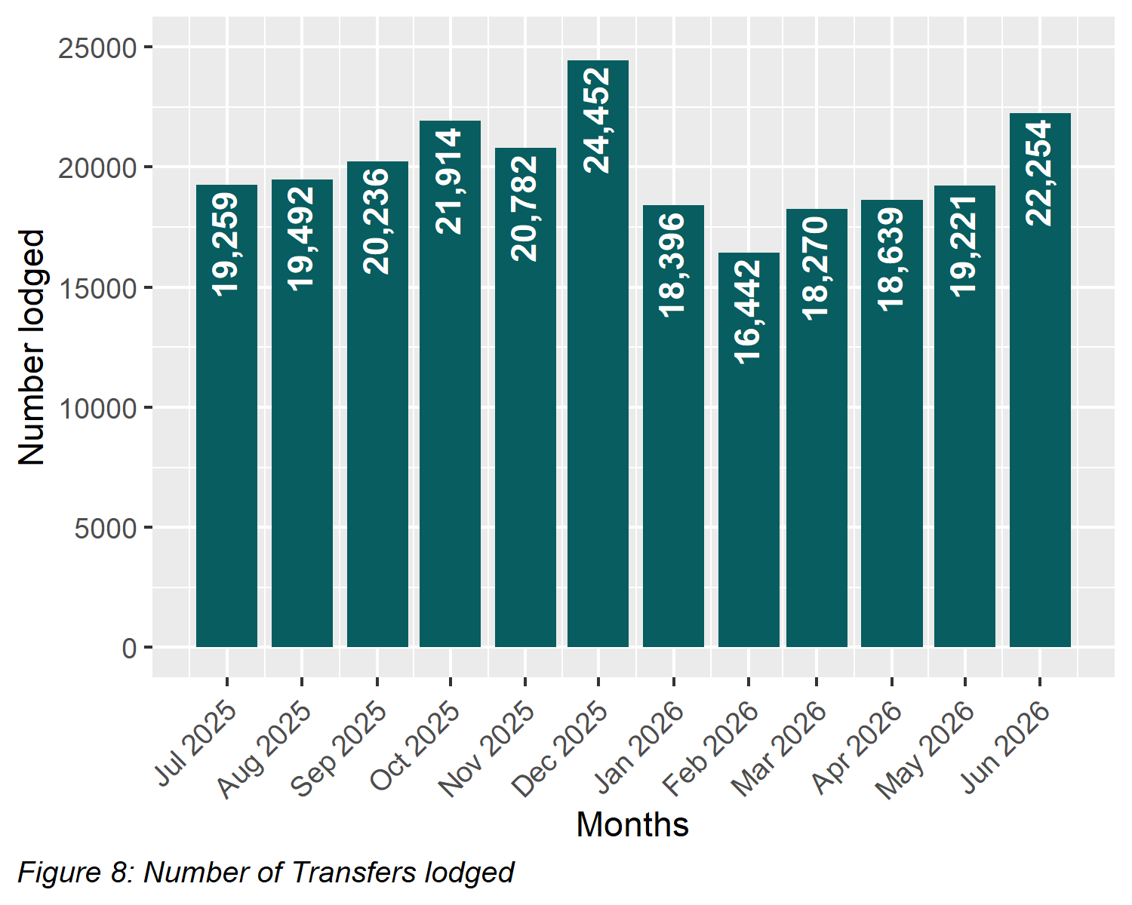

5.3 Mortgages
In the 2025-2026 financial year, mortgages and charges accounted for 32.32 per cent of all dealings lodged.
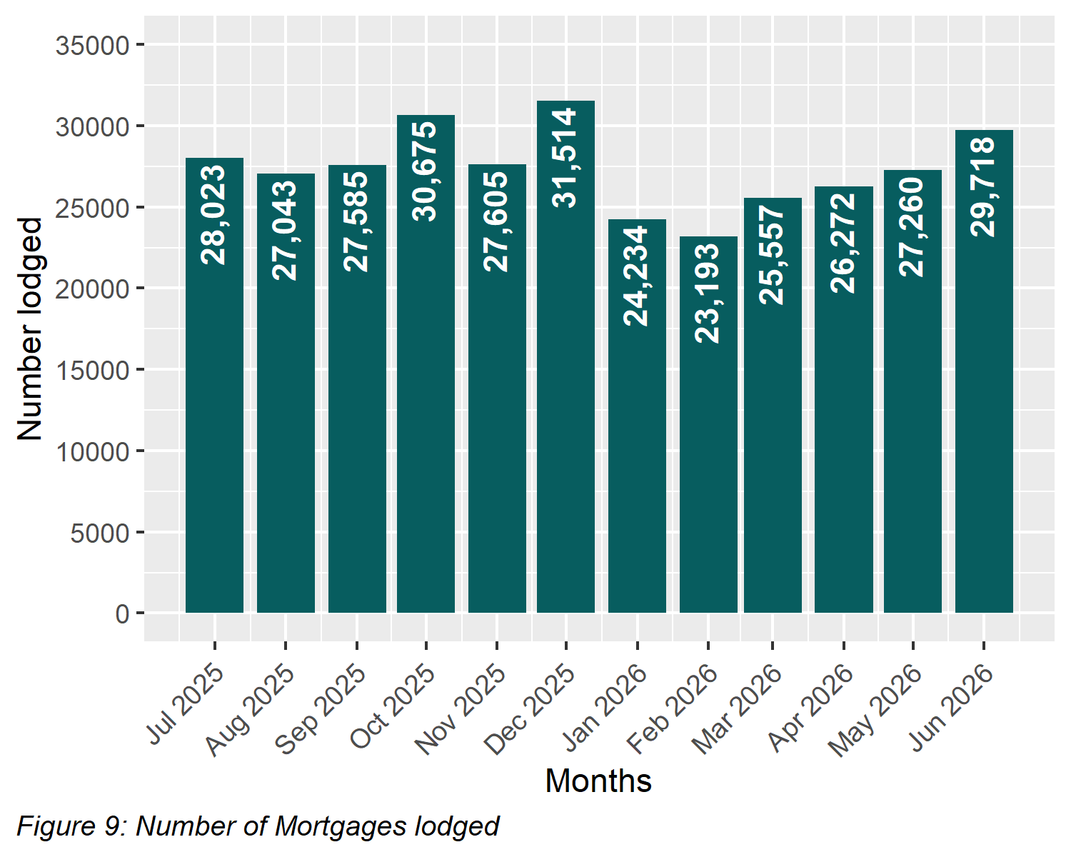

5.4 Differences in lodgment levels and percentages of discharges, transfers, and mortgages
Over time, the number and proportion of the three most common transaction types varies. The chart below shows how these have changed across financial years. For 2025-2026 financial year, the percentage for each dealing type is as follows:
Table 10: Percentage of Dealing Types Lodged
(Financial Year 2025-2026)
Dealing type | Percentage
Transfers | 23.53
Discharges | 32.10
Mortgages | 32.32

The three main dealing types as a percentage of all dealings lodged since 2006-2007 is shown below.
Table 11: Percentage of Dealing Types Lodged
by Financial Year
Year | Transfers (%) | Discharges (%) | Mortgages (%)
2006-2007 | 25.87 | 28.13 | 29.85
2007-2008 | 26.27 | 27.59 | 29.19
2008-2009 | 25.95 | 27.21 | 28.42
2009-2010 | 26.87 | 27.16 | 28.62
2010-2011 | 26.22 | 27.20 | 27.68
2011-2012 | 25.24 | 28.28 | 28.05
2012-2013 | 25.04 | 28.15 | 27.80
2013-2014 | 25.76 | 28.54 | 27.74
2014-2015 | 25.44 | 29.15 | 28.25
2015-2016 | 23.90 | 29.90 | 29.20
2016-2017 | 28.05 | 30.60 | 28.69
2017-2018 | 25.90 | 30.57 | 28.66
2018-2019 | 23.03 | 29.22 | 27.72
2019-2020 | 23.72 | 31.98 | 30.80
2020-2021 | 25.75 | 33.35 | 33.25
2021-2022 | 25.24 | 32.65 | 32.44
2022-2023 | 21.02 | 34.37 | 32.98
2023-2024 | 22.40 | 33.18 | 32.26
2024-2025 | 23.16 | 32.38 | 32.07
2025-2026 | 23.53 | 32.10 | 32.32
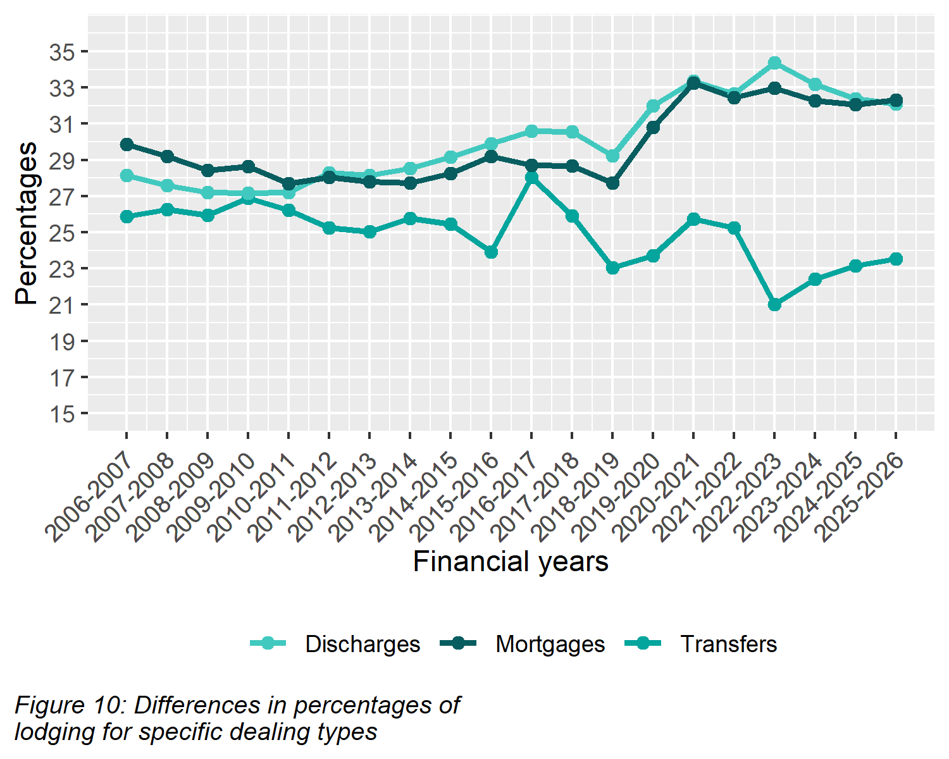

5.5 Plans of subdivision
There were 6,185 plans of subdivision lodged in the 2025-2026 financial year, representing 0.61 per cent of all dealings lodged. This figure does not include other plan types lodged under the Subdivision Act 1988 such as acquisition plans and redevelopment plans. During the same period, 143 acquisition plans and 211 redevelopment plans were lodged.
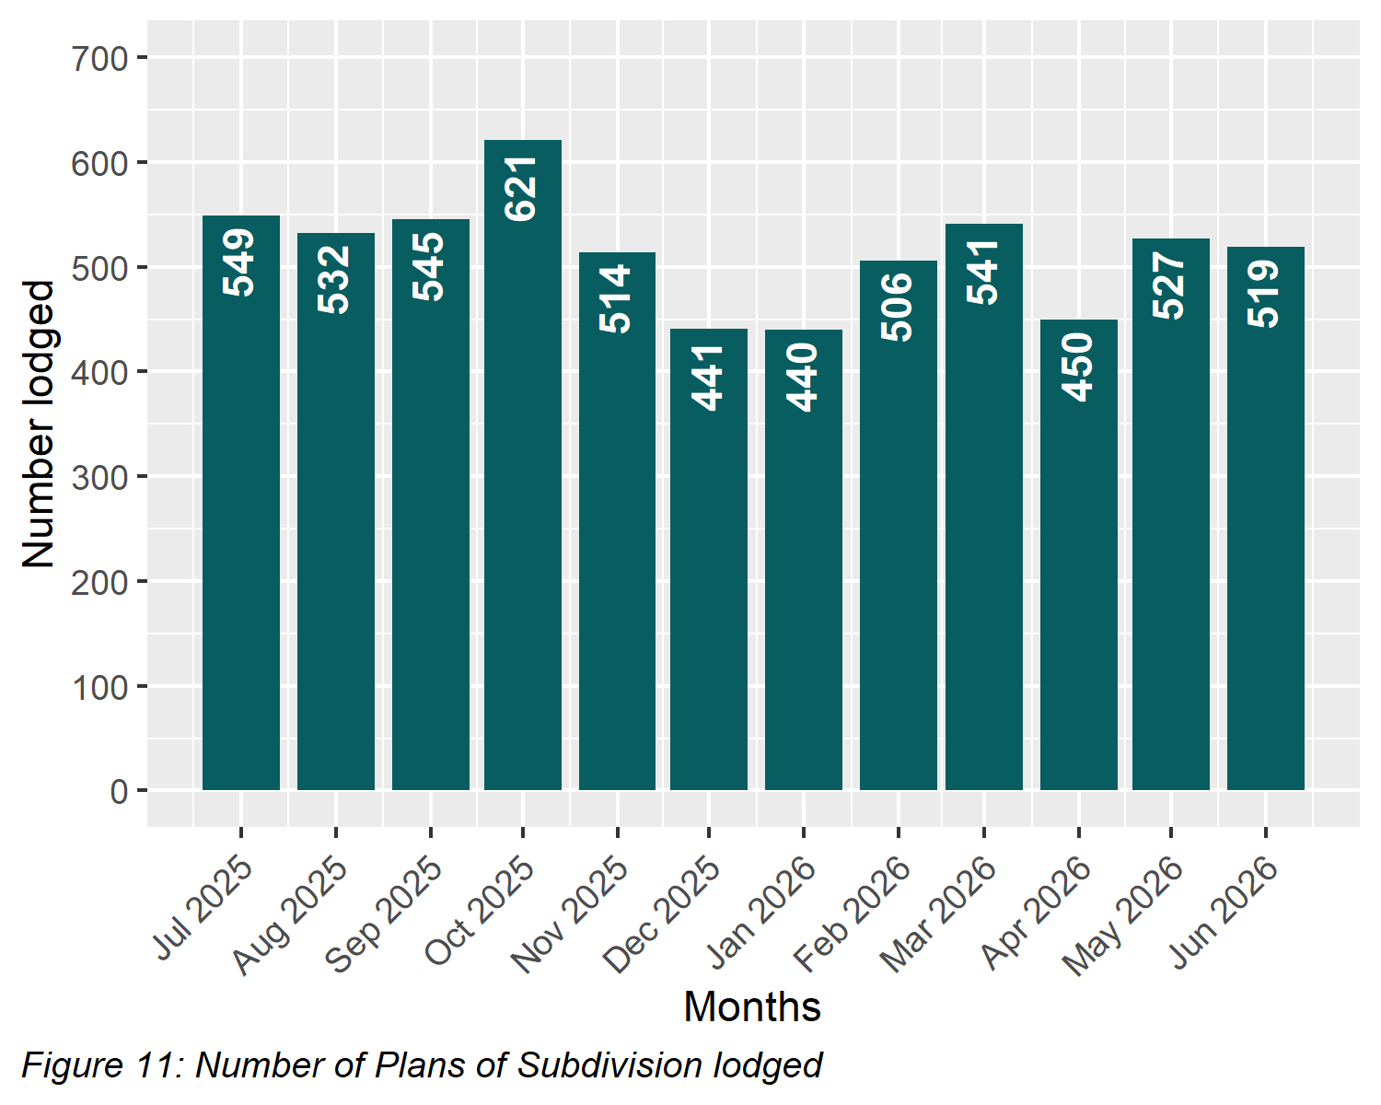

5.6 All Plans lodged under the Subdivision Act 1988
The total number of plans under the Subdivision Act 1988 lodged in the 2025-2026 financial year were 6,662. Lodgment volumes for recent financial years are as follows:
Table 12: Total Number of Plans Lodged
by Financial Year
Year | Quantity | Year | Quantity
2006-2007 | 8,304 | 2016-2017 | 8,376
2007-2008 | 8,048 | 2017-2018 | 8,340
2008-2009 | 7,719 | 2018-2019 | 8,249
2009-2010 | 7,988 | 2019-2020 | 8,541
2010-2011 | 7,699 | 2020-2021 | 8,220
2011-2012 | 8,088 | 2021-2022 | 7,536
2012-2013 | 7,896 | 2022-2023 | 7,064
2013-2014 | 8,001 | 2023-2024 | 7,019
2014-2015 | 8,252 | 2024-2025 | 6,981
2015-2016 | 8,970 | 2025-2026 | 6,662

5.7 Number of new parcels created from plans of subdivision
In the 2025-2026 financial year, 49,522 parcels were created from plans of subdivision lodged under the Subdivision Act 1988. The comparison below focuses on parcels created from plans lodged under section 22 of the Act, excluding those related to acquisition, redevelopment, or consolidation, across recent financial years:
Table 13: Number of New Parcels Created from Section 22 Subdivisions
by Financial Year
Year | Quantity | Year | Quantity
2014-2015 | 61,669 | 2020-2021 | 74,352
2015-2016 | 75,351 | 2021-2022 | 60,803
2016-2017 | 79,034 | 2022-2023 | 67,021
2017-2018 | 77,014 | 2023-2024 | 61,695
2018-2019 | 77,602 | 2024-2025 | 50,873
2019-2020 | 82,898 | 2025-2026 | 48,313

5.8 General law conversion
The number of parcels created from General law conversions during the 2025-2026 financial year was 215. This compares to previous financial years as follows:
Table 14: Number of Parcels Created from General Law Conversions
by Financial Year
Year | Quantity | Year | Quantity
2006-2007 | 1,309 | 2016-2017 | 3,228
2007-2008 | 1,238 | 2017-2018 | 1,922
2008-2009 | 1,023 | 2018-2019 | 1,575
2009-2010 | 1,559 | 2019-2020 | 1,468
2010-2011 | 2,559 | 2020-2021 | 482
2011-2012 | 1,303 | 2021-2022 | 378
2012-2013 | 1,997 | 2022-2023 | 409
2013-2014 | 3,774 | 2023-2024 | 373
2014-2015 | 2,018 | 2024-2025 | 398
2015-2016 | 2,868 | 2025-2026 | 215

5.9 Crown Land Dealings
The number of Crown land dealings registered during the 2025-2026 financial year was 3,962. Transactions are typically related to boundary changes and changes to status of Crown land. This compares to previous years as follows:
Table 15: Number of Crown Land Dealings Registered
by Financial Year
Year | Quantity
2019-2020 | 1,707
2020-2021 | 1,346
2021-2022 | 1,337
2022-2023 | 1,736
2023-2024 | 1,550
2024-2025 | 2,894
2025-2026 | 3,962

5.10 Top 40 dealing types, by number lodged
Below is the list of the top 40 dealing types lodged with Land Registry Services during the financial year.
Table 16: Top 40 Dealing Types Lodged
(Financial Year 2025-2026)
Dealing type | Description | Lodged
84M | Discharge of mortgage | 326,469
74 | Mortgage | 321,092
45 | Transfer | 215,779
89 | Caveat | 37,583
45NM | Transfer without monetary consideration | 23,578
89W | Withdrawal of Caveat | 18,769
49 | Transmission Application | 15,776
50 | Survivorship Application | 11,883
74D | Mortgage with name change | 7,587
PS | Plan of Subdivision | 6,185
31 | Application to replace lost Certificate of Title | 3,665
LTD | Discharge of land tax charge | 2,711
LTC | Land tax charge | 2,603
XEN | Expiry of encumbrance | 2,089
173 | Planning Agreement | 1,935
PN | Priority Notice | 1,566
27A | Change of proprietor name | 1,449
77 | Transfer by Mortgagee | 894
89A | Removal of caveat | 832
MTPFA | Major Transport Projects Facilitation Act Acquisition | 741
MCP | Memorandum of Common Provisions | 731
PC | Plan of consolidation | 645
45M | Transfer of Mortgage | 470
113A | Amendment of address on folio | 460
45E | Creation of easement | 407
183W | Removal of Planning Agreement | 351
106C | Removal of encumbrance | 338
52-2 | Warrant | 336
32-2 | Application for a new folio of the Register | 293
45N | Transfer with new title | 290
47MSA | Removal of encumbrance | 281
60 | Adverse Possession | 272
106AR | Registrar’s caveat | 253
RGCAV | Action - Registrar's Caveat | 249
NARF | Notice of action in respect of a folio | 238
32-1 | Application for a new folio of the Register | 234
SA32PS | Plan of Subdivision X32 | 211
OCR | Owners Corporation rules | 194
75A | Variation of Mortgage | 170
RVC | Statutory charge | 164

6 Other measures of Land Registry Services activity

6.1 Number of dealings registered
The number of transactions registered in the 2025-2026 financial year was 1,013,786.

6.2 Percentage of dealings registered within 5 days
The average percentages achieved were greater than 99 per cent for the entire financial year.

6.3 Number of plans of subdivision registered
The number of plans of subdivision registered under the Subdivision Act 1988 in the financial year was 6,755. The average percentage of plans registered within 15 days was 99.5 per cent for the financial year.

6.4 Number of dealings refused
The number of dealings refused during this financial year was 3,039 representing 0.3 per cent of all dealings presented for acceptance at Land Registry Services. In comparison, the 2024-25 financial year saw 3,639 refusals representing 0.39 per cent of all dealings presented.

6.5 Number of dealings waiting to be processed
The number of dealings waiting to be processed has stabilised. At the start of the financial year, the holding level was 2,687. For most of the year, this figure remained below 2,004. The majority of these dealings are either awaiting customer action or are on hold until a statutory period has elapsed. As of 1 July 2026, the number stood at 2,171.

7 Electronic transactions processing

7.1 Electronic Conveyancing (including SPEAR)
The number of transactions lodged electronically in the 2025-2026 financial year was 1,007,902, up from 912,519 in 2024-25. This figure includes, for the first time, transaction lodged using the SPEAR Electronic Lodgment Network. Electronic lodgments accounted for 99.1 per cent of all lodgments in 2025-2026, compared to 97.89 per cent in the previous year (which did not include transactions lodged using SPEAR). The figure for 2025-2026 includes the following transaction types:
Table 17: Number of Transactions Lodged Electronically
by Type
(Financial Year 2025-2026)
Transaction Type | Quantity
Mortgage | 328,372
Discharge of Mortgage | 325,851
Transfer | 237,838
Caveat | 37,219
Withdrawal of Caveat | 18,611
Transmission Application | 15,599
Survivorship Application | 11,627
Plan of Subdivision | 6,248
Application Lost Title | 3,611
Discharges of Land Tax Charges | 2,711
Land Tax Charges | 2,603
Expiry of Encumbrance | 2,089
Agreement | 1,962
Priority Notice | 1,566
Change of Proprietor Name | 1,505
Transfer by Mortgagee | 879
Removal of Caveat | 827
Mtpfa Acquisition | 741
Memo of Common Provisions | 731
Plan of Consolidation | 646
Miscellaneous | 6,666

7.2 Percentage of transactions lodged electronically
