Victorian EDM Baseline Booking System User Guide

Main Site Entry 2
Step 1: Click ‘Book Now’ 2
Step 2: Select preferred calibration site 3
Step 3: Select ‘Half Day’ or ‘Full Day’ 4
Step 4: Select Date 4
Step 5: Select Time 7
Step 6: Client Login 8
Step 7: Confirm booking 9
Step 8: Complete 10
Viewing Existing Bookings 12
Step 1: Login 12
Step 2: My Bookings 13
Additional Help: 13

Main Site Entry

Step 1: Click ‘Book Now’

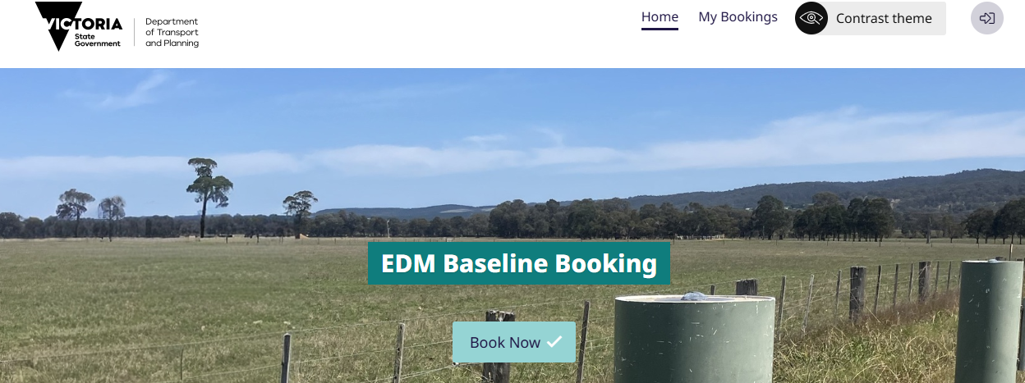

Step 2: Select preferred calibration site

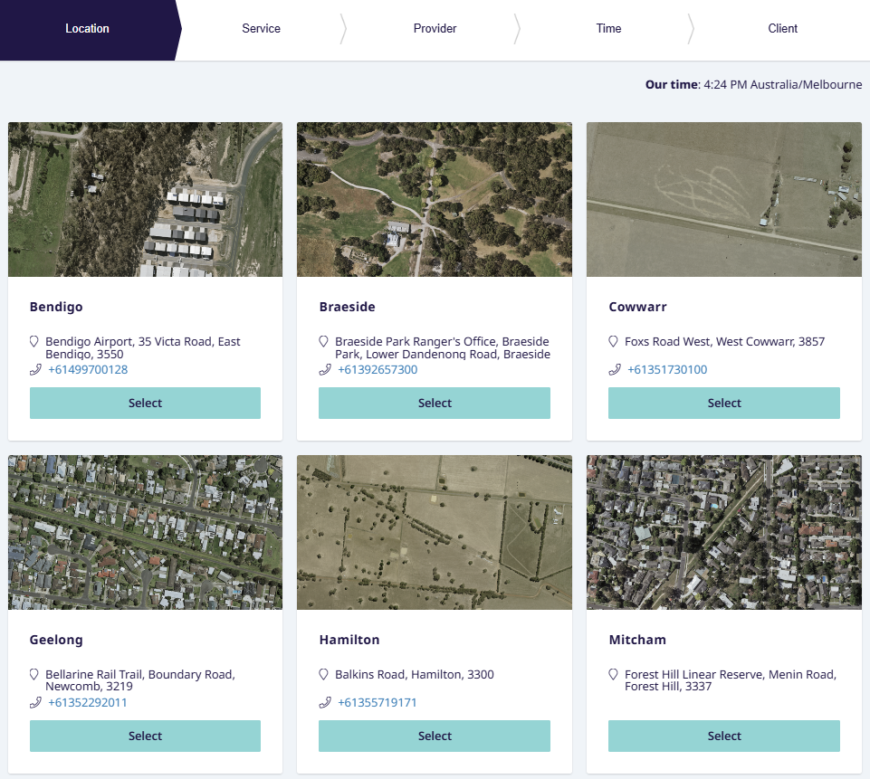

Step 3: Select ‘Half Day’ or ‘Full Day’

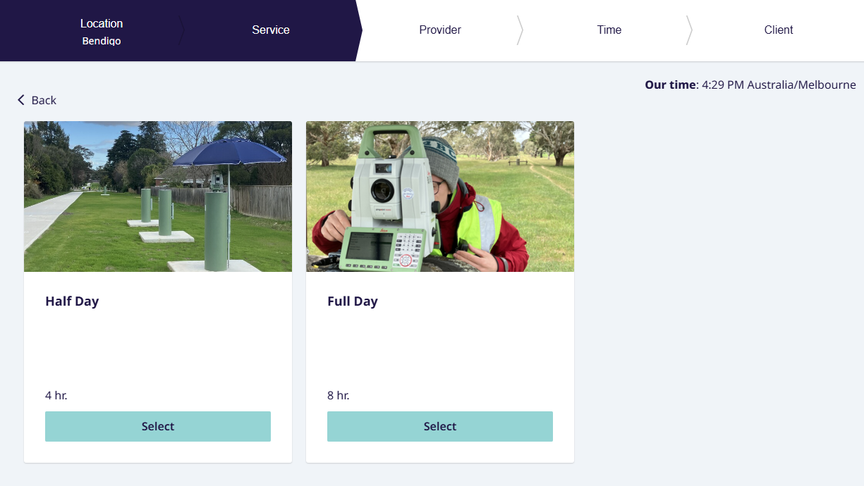

Step 4: Select Date
A calendar picker will default to today’s date, and the area below will show available start times.
For ‘full day’ bookings, the only possible start time is 9am.
For half day bookings, there are two start times, 9am OR 1pm.

Half Day Example: Both Times available (morning and afternoon)
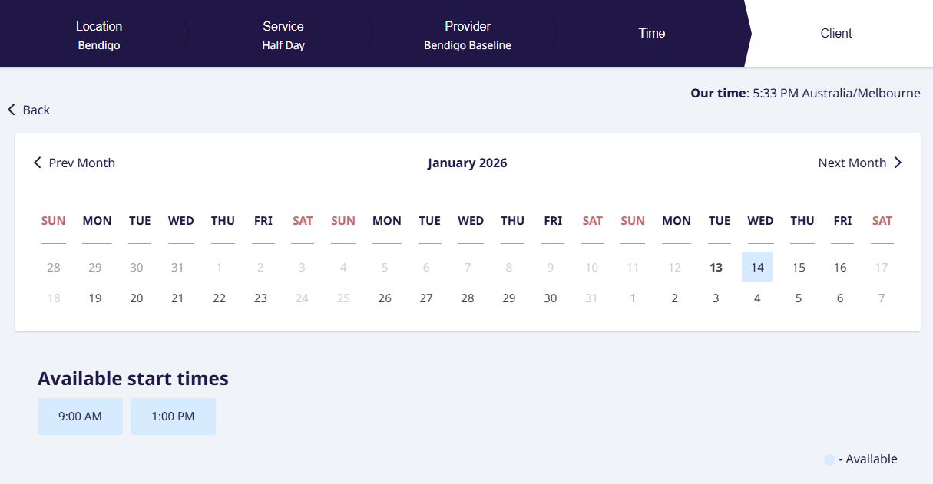

Half Day Example: One Space Available
For example, the 1pm session was already booked, so only the 9am session is available.
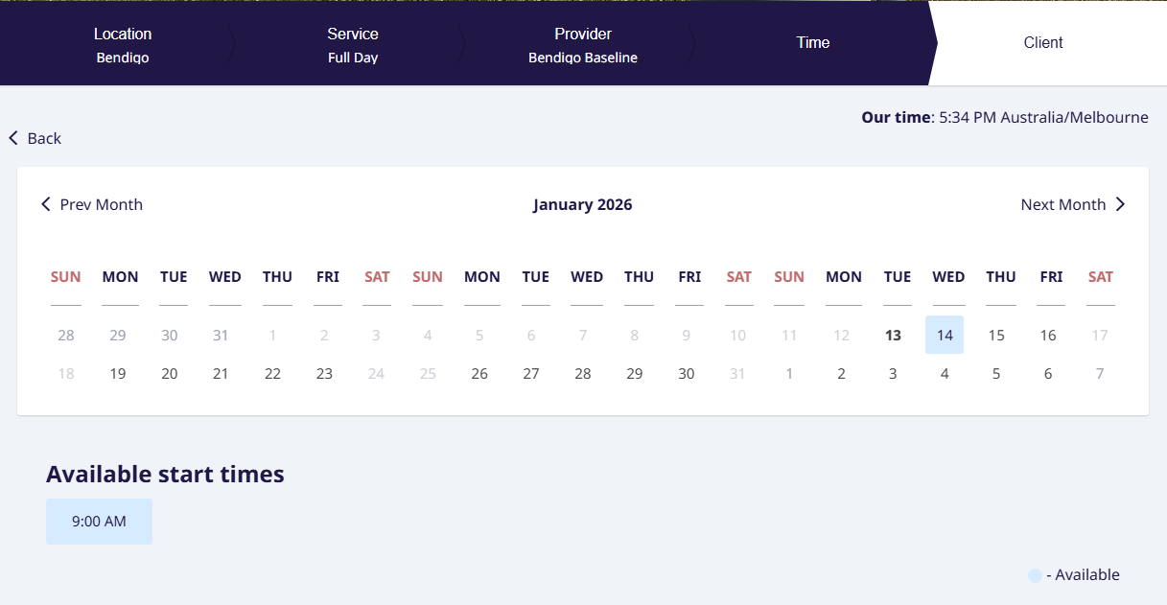

No Space Available
No sessions available on the selected date Mon 19 Jan 2026.
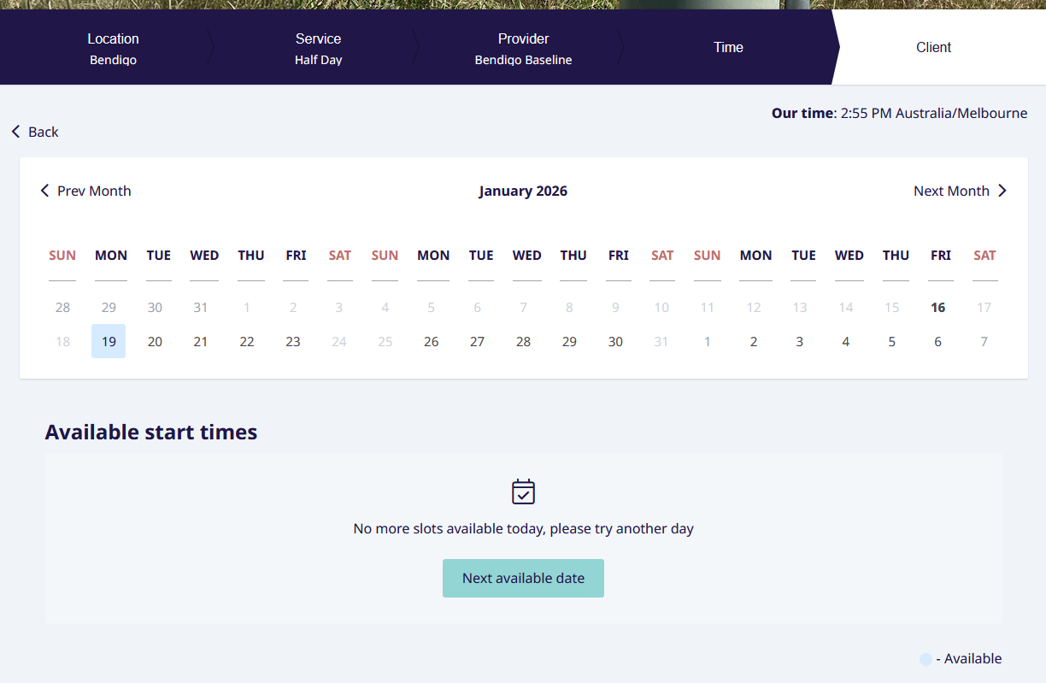

By clicking on “Next available date”, users can view the available bookings for that site.
In the below example, the following day Tuesday 20 Jan 2026 is available.

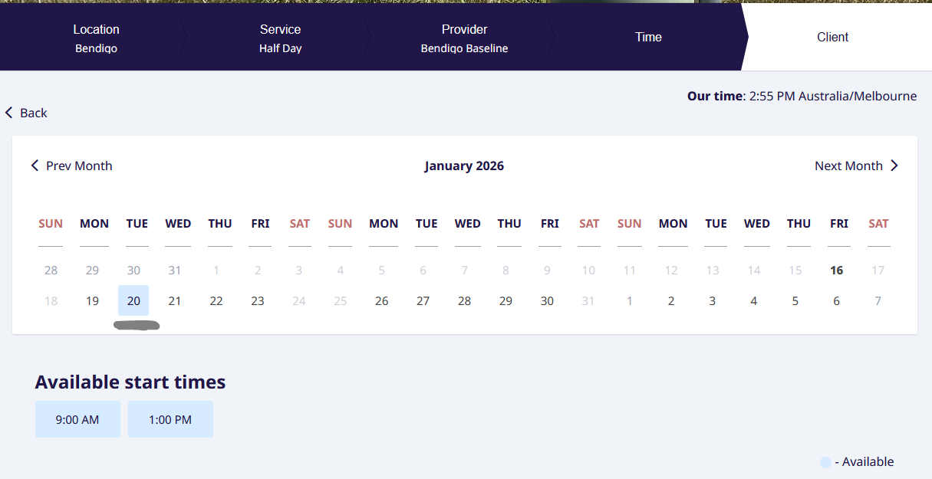

Step 5: Select Time
After selecting a Start Time, users will be directed to the ‘Sign In’ screen
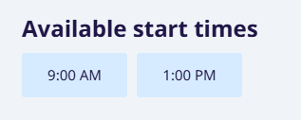

Step 6: Client Login
Sign In if you are an existing user or Sign Up to proceed with the booking.
Please enter valid contact details.

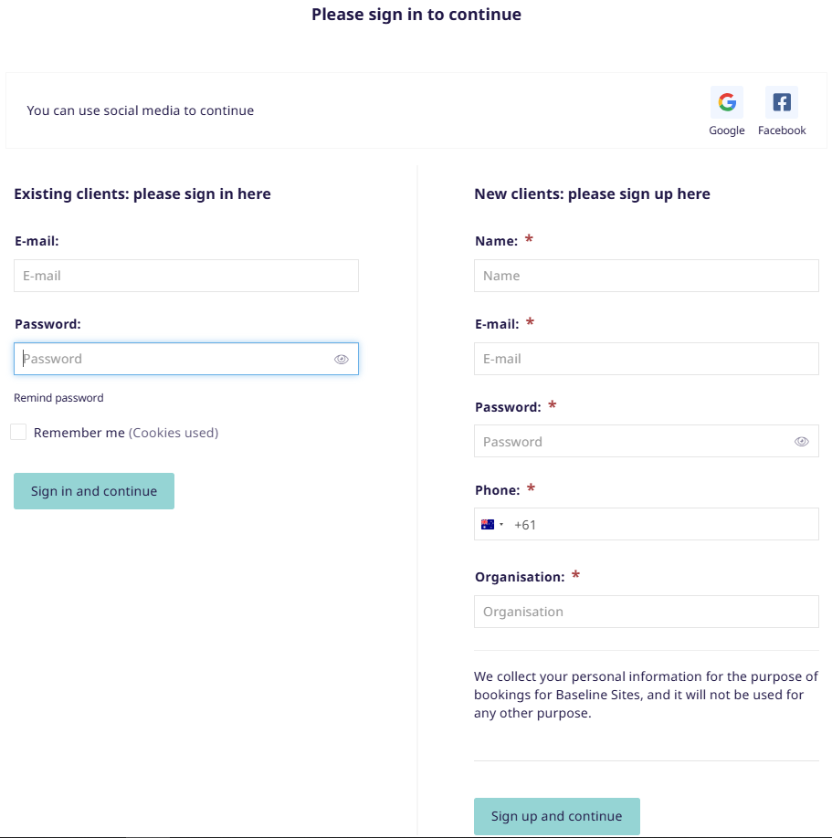

Step 7: Confirm booking
After either providing an existing login, or creating a new login, users will be directed to the ‘Confirm Booking’ screen below.
'Optional Notes for this Booking' is available to both users and SMES administrators to record additional information. For example:
- An organisation who books on behalf of their surveyors may want to make a note of the surveyor attending on site.
- A SMES administrator booking on behalf of a client may wish to enter notes such as who contacted them to arrange
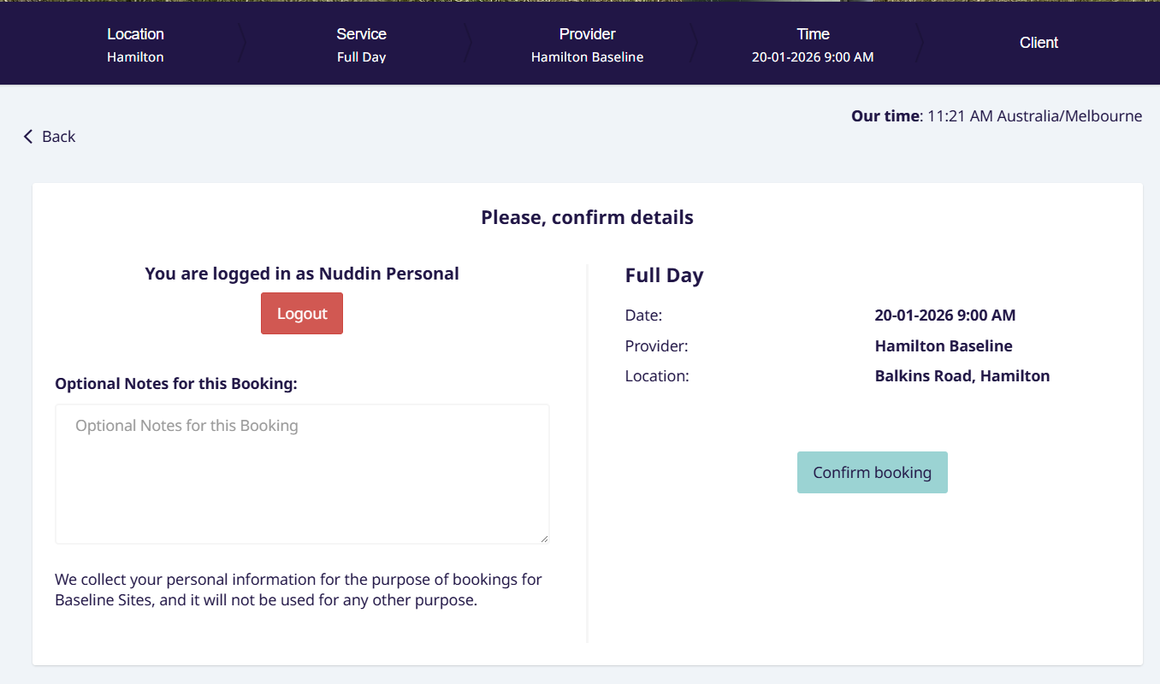

Step 8: Complete
The user will receive the success message below and an email notification.
EDM Baseline Booking <no-reply-vicbaselines.net@simplybook.me>
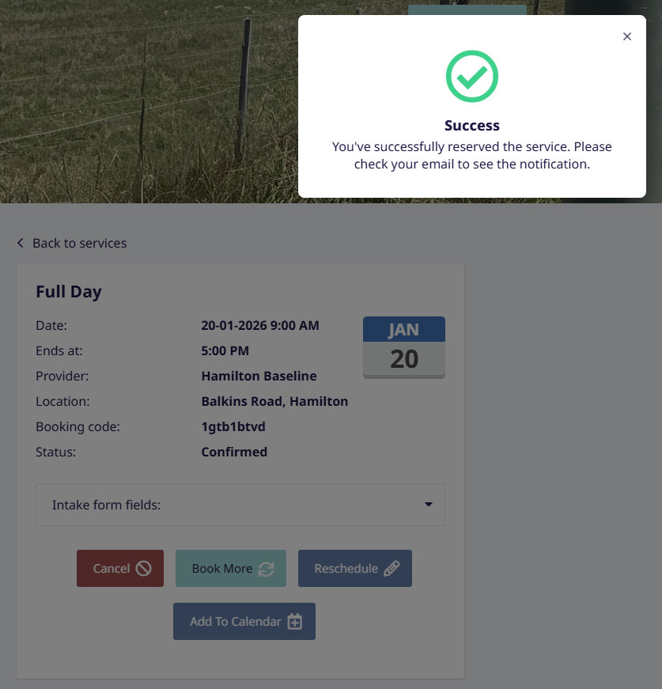

After closing the ‘Success’ window, the booking details are shown. Users can cancel, book additional times, reschedule, or add to their calendar. Users can also click ‘Show all bookings' to list all previous and future bookings.
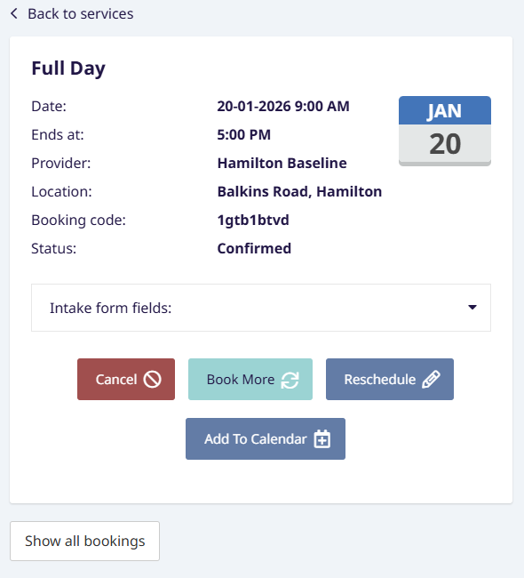

Viewing Existing Bookings
Below details how users can view their existing bookings.

Step 1: Login
Users can login to the site using the icon at the top right of the site (highlighted in yellow).
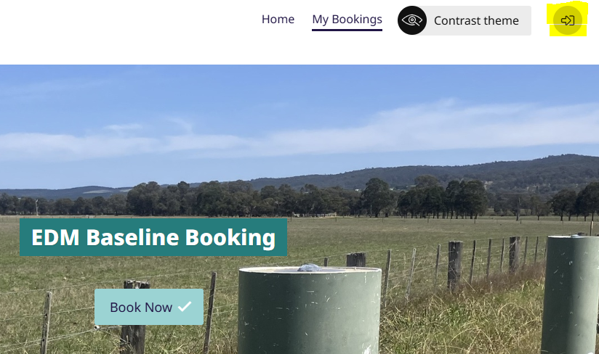

Step 2: My Bookings
After logging in, users can click ‘My Bookings’ at the top to take them to the page below. Users can view upcoming bookings, or all bookings using the links at the top. Users can also get to bookings by clicking the user icon at top right, clicking ‘My profile’, then ‘Bookings’.
The bookings displayed have the same display as after making a booking, with options to cancel, book another, reschedule or add to calendar. The ‘Optional Notes for this booking’ information is available by clicking ‘Intake form fields:’ dropdown menu.
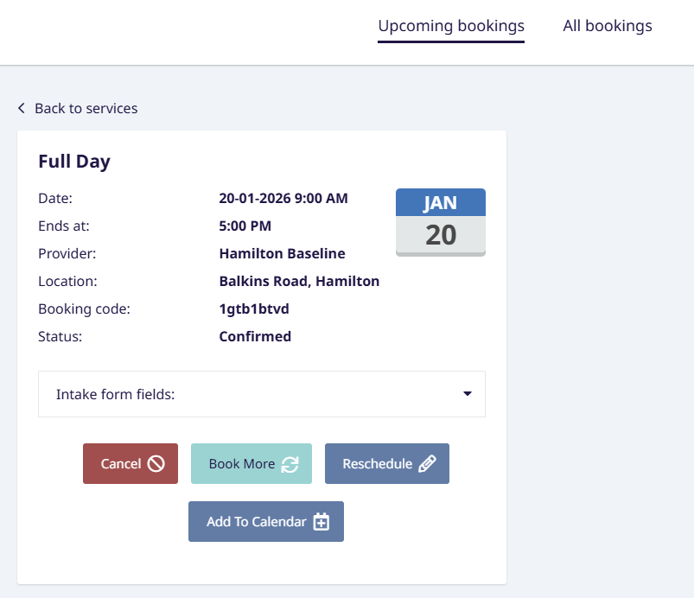

Additional Help:
Please contact SMES Support for any issues or questions.
Email: smes.support@transport.vic.gov.au
Phone: 03 9194 0770

